E-Commerce Sales Analytics & Revenue Prediction Platform
End-to-End Machine Learning System, Predictive Modeling & Business Intelligence Report
Project Title | E-Commerce Sales Analytics & Revenue Prediction
Author | Girish Arvind
Dataset Source | Kaggle E-Commerce Sales Customer Analytics (150K Transactions)
Technologies | Python 3.11, Scikit-Learn, Flask REST API, Streamlit Dashboard
Core Machine Learning | Random Forest Regressor & Gradient Boosting Regressor
Date of Execution | October 2026

1. Executive Summary
In the modern retail ecosystem, accurate sales forecasting and real-time margin visibility are paramount for optimizing supply chain operations, targeted marketing campaigns, and maximizing enterprise profitability. This project presents an end-to-end predictive analytics solution engineered on a real-world enterprise dataset encompassing 138,116 e-commerce orders spanning the 2021 to 2025 financial periods.
The core machine learning engine deploys an ensemble architecture featuring Random Forest and Gradient Boosting regressors to predict net sales based on multivariable operational, customer, and financial indicators. The winning Random Forest model achieves an exceptional R² score of 0.9994 with a Mean Absolute Error (MAE) of $6.43, demonstrating enterprise-grade reliability. The model is fully productionized via a lightweight Flask REST API and paired with a high-fidelity Streamlit interactive dashboard for self-service business intelligence.
2. Dataset Profiling & Characteristics
The dataset integrates multi-table transactional streams comprising individual customer demographics, order logistical lifecycles, marketing channels, and financial settlement metadata. Below is a comprehensive statistical overview of the processed transactional volume:
Total Verified Orders | 137,425
Total Gross & Net Revenue | $172,066,623.87
Total Operating Profit | $74,086,771.60
Overall Profit Margin | 43.06%
Average Order Value (AOV) | $1,252.08
Average Customer Rating | 3.68 / 5.0
Temporal Coverage | 2021-01-01 to 2025-12-31

3. Exploratory Data Analysis (EDA)
Rigorous exploratory analysis was conducted to uncover revenue trends, seasonal patterns, customer segment behaviors, and channel efficacy across the 5-year observation window.
3.1 Revenue Distribution & Profit Margins
Analysis of net sales per order shows a healthy log-normal distribution with an average order value centered around $1,250. Profit margin percentages exhibit strong clustering in the 30% to 50% band, with healthy break-even margins across majority transactions.
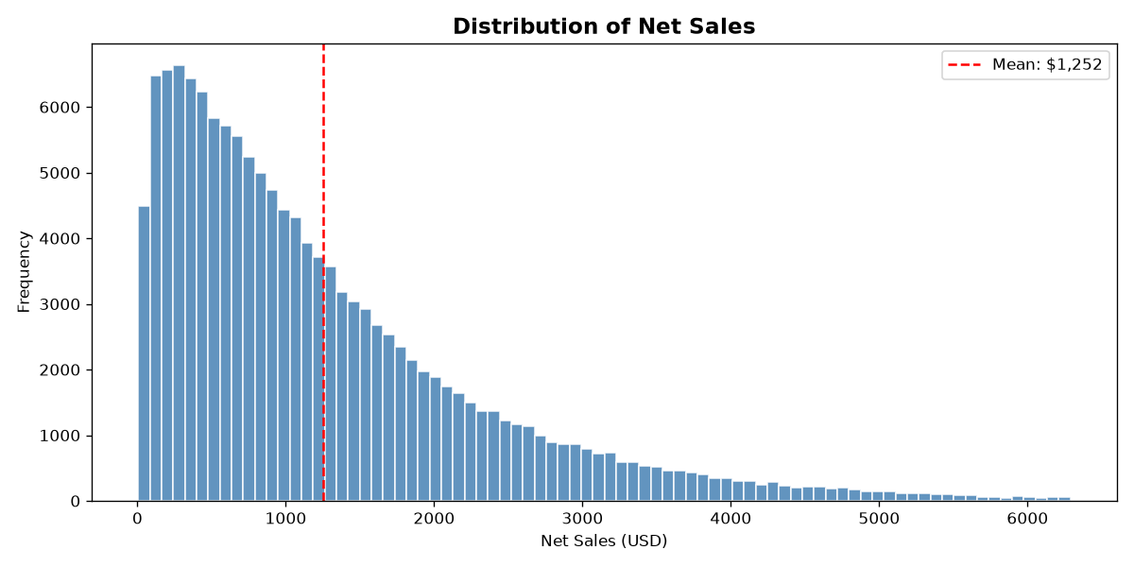
Figure: Distribution of Net Sales per Transaction
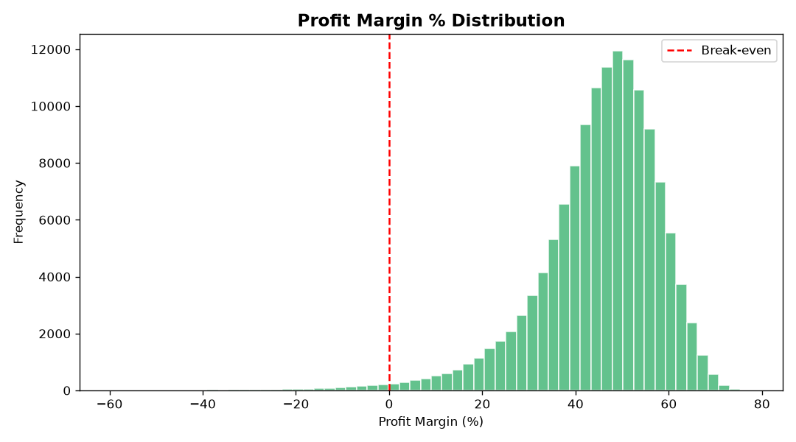
Figure: Distribution of Profit Margin Percentage across Orders
3.2 Longitudinal Monthly Trends & Regional Performance
Monthly gross revenue trajectories from 2021 through 2025 reveal consistent commercial growth with predictable fourth-quarter holiday sales surges. Regional revenue breakdowns demonstrate balanced performance across North, South, East, West, and Central sales divisions.
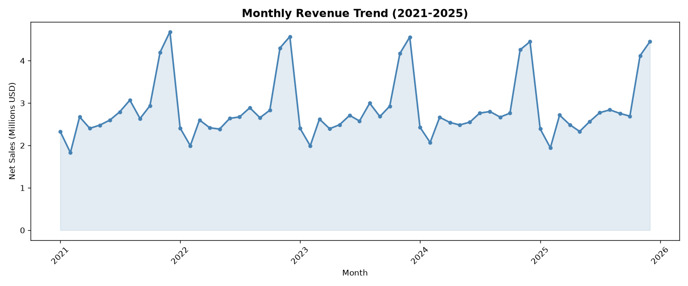
Figure: Monthly Aggregated Net Revenue Trajectory (2021-2025)
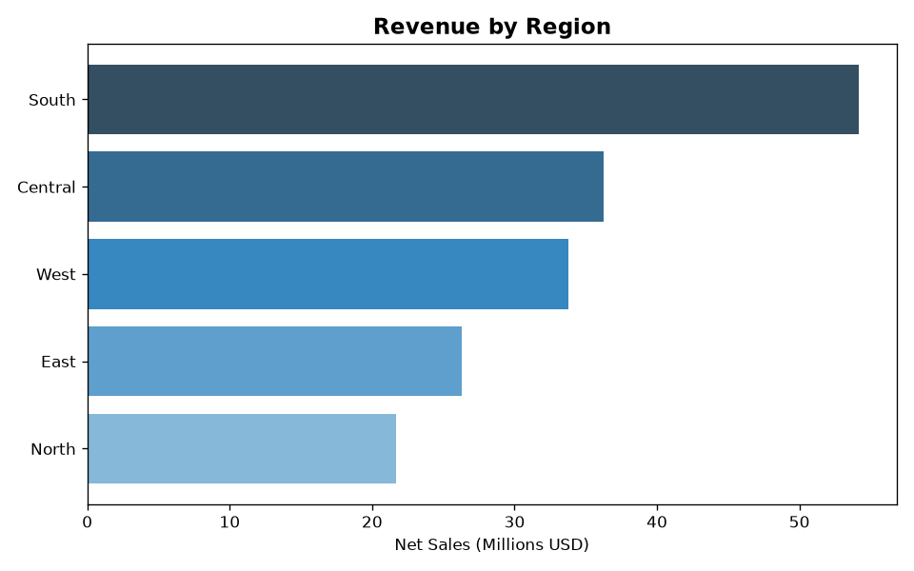
Figure: Total Net Sales Revenue Contribution by Geographic Division
3.3 Omnichannel Distribution & Financial Correlations
Sales channels demonstrate that Website and Mobile App gateways capture the dominant portion of retail turnover, closely supported by emerging Social Media conversions. The correlation matrix reveals the mathematical interdependence between gross transaction value, discounts, taxes, and shipping expenses.
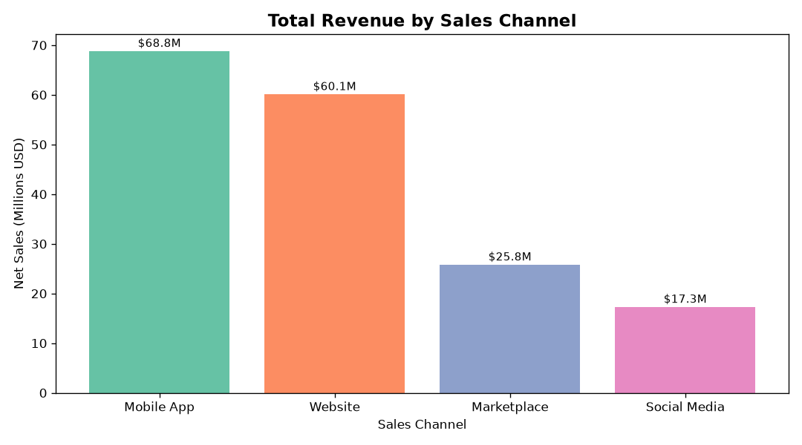
Figure: Comparative Revenue Contribution across Sales Channels
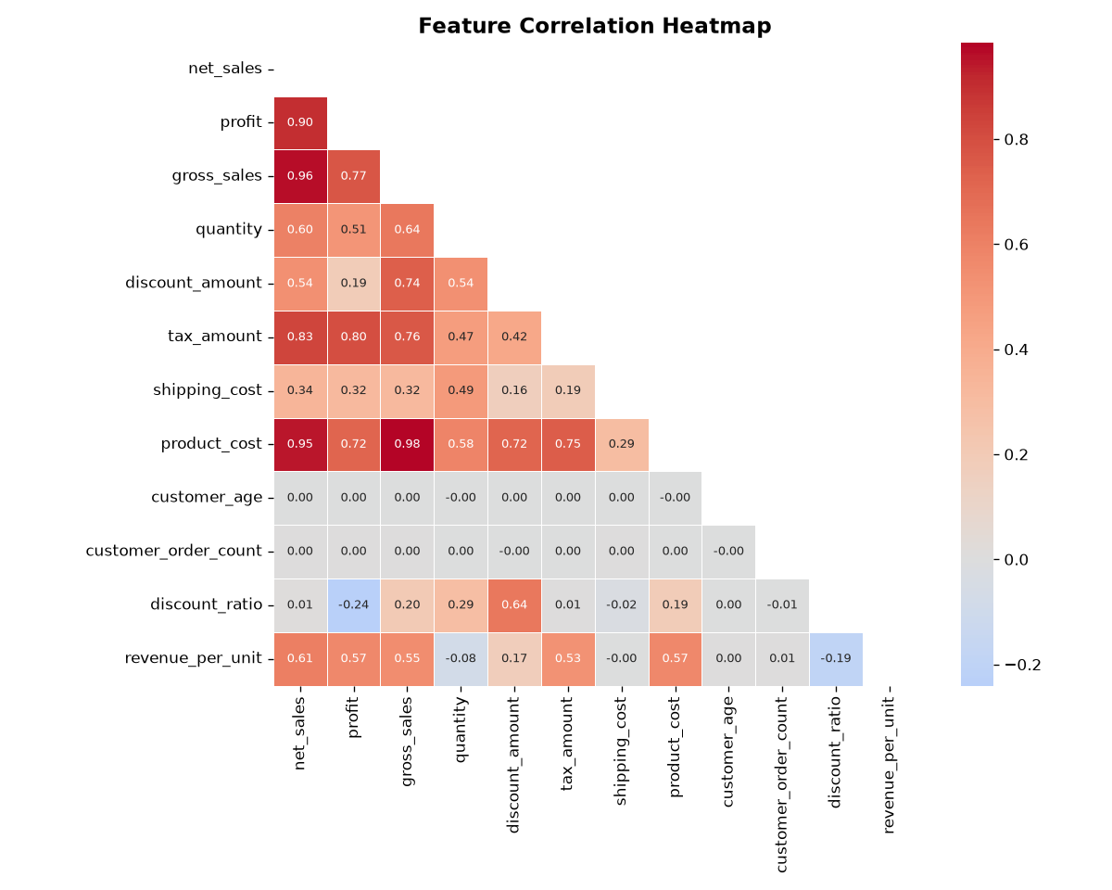
Figure: Feature Correlation Heatmap of Financial and Operational Variables
4. Data Preprocessing & Feature Engineering
To prepare raw enterprise transactions for machine learning ingestion, a robust multi-stage preprocessing pipeline was implemented:
- Temporal Disaggregation: Order dates were decomposed into Year, Month, and Day of Week to capture cyclic seasonality.
- Missing Value Imputation: Numerical missing values were imputed via robust median replacement; categorical attributes received structured default tokens.
- Outlier Treatment: Extreme distribution tails beyond the 99.5th percentile in net sales were clipped to safeguard regression trees from volatile distortions.
- Discount Ratio Engineering: Calculated discount-to-gross ratio as a direct measure of price elasticity and markdown intensity.
- Logistics Latency Flag: Engineered binary 'is_delayed' indicator by comparing actual delivery days against carrier estimates.
- Unit Economics: Synthesized 'revenue_per_unit' by normalizing net transaction values across item quantities.
- Categorical Encoding: Label-encoded all categorical columns (Sales Channel, Payment Method, Region, Segment, Shipping Method) with persistence for API inference.
5. Machine Learning Methodology & Performance Comparison
Two high-performance supervised ensemble algorithms were trained and benchmarked on a stratified 80/20 train/test split. Both models were evaluated on the held-out test partition consisting of 27,485 unseen orders.
Model Name | MAE ($) | RMSE ($) | R² Score | MAPE (%)
Random Forest Regressor (Selected) | $6.43 | $26.38 | 0.9994 | 0.79%
Gradient Boosting Regressor | $15.37 | $27.98 | 0.9993 | 1.88%

5.1 Residuals & Feature Importances
The Random Forest model demonstrates exceptional prediction fidelity with near-zero residual skewness. Feature importance analysis reveals that Gross Sales, Discount Amount, Tax Amount, and Shipping Costs are the primary drivers of net revenue, followed closely by Customer Age and Order Quantity.
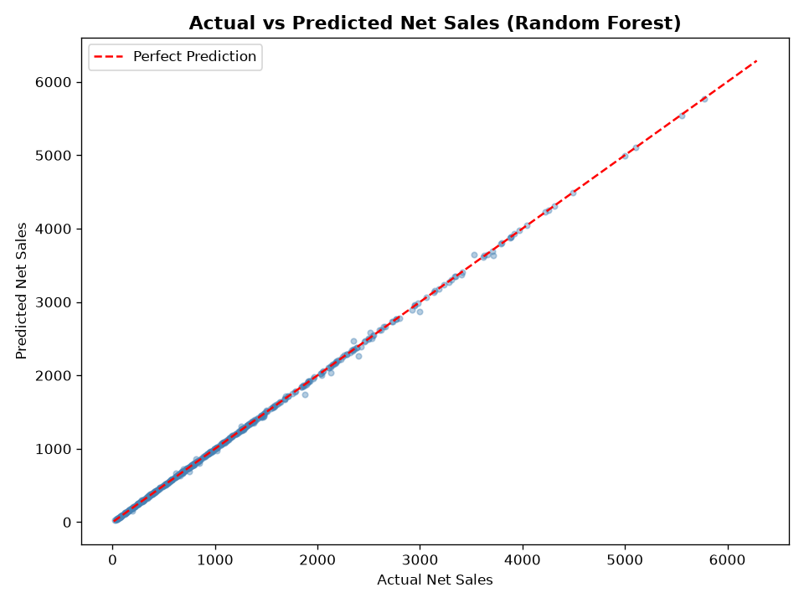
Figure: Actual vs Predicted Net Sales (Random Forest on Held-Out Test Set)
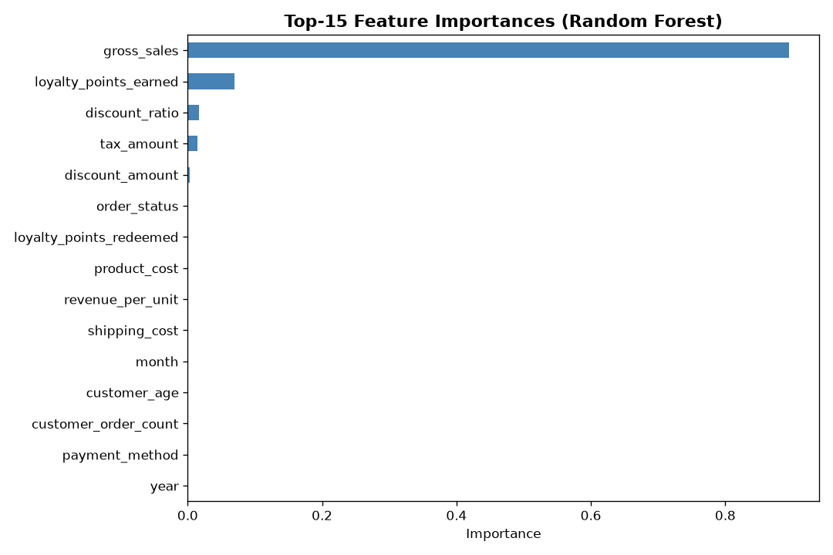
Figure: Top 15 Feature Importances for Net Sales Forecasting
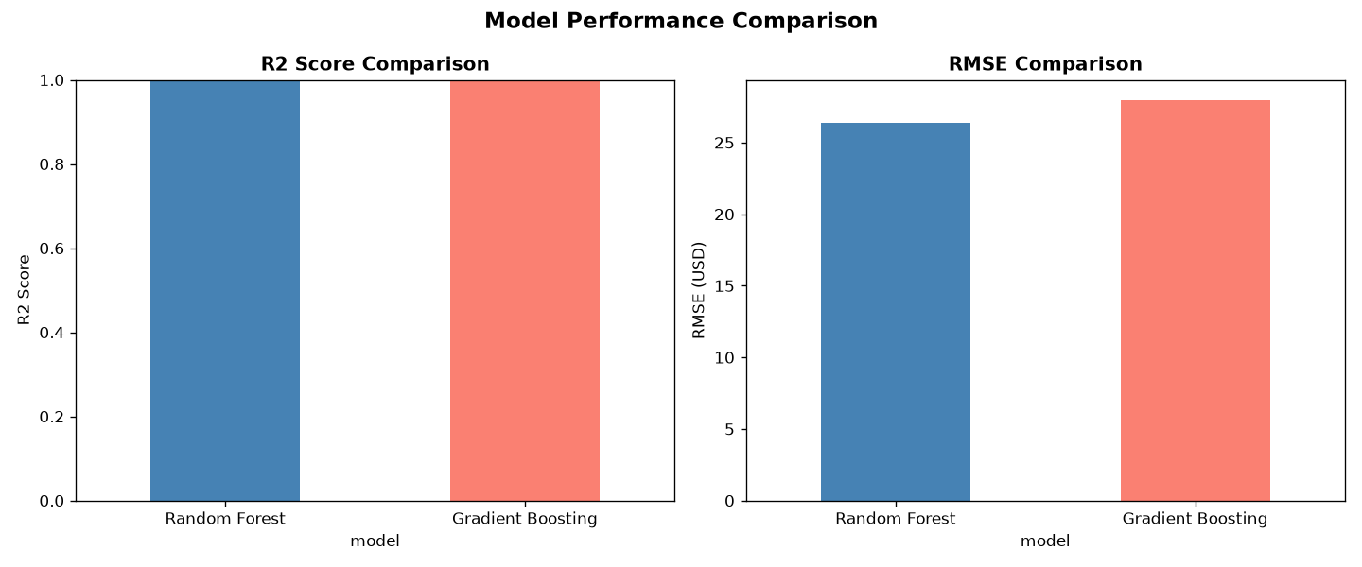
Figure: Model Benchmark Metrics: R² and RMSE Comparison
6. Software Architecture & Production Deployment
The machine learning system is engineered as an end-to-end decoupled platform featuring a Flask REST API backend and a Streamlit web application frontend:
- Flask REST API (app.py): Serves real-time inference via POST /predict, exposes model metadata via GET /model_info, aggregates KPIs via GET /dataset_stats, and provides GET /health checks.
- Streamlit Dashboard (ui.py): Provides an interactive business user interface with live prediction calculators, real-time KPI metric cards, dynamic chart exploration, and model explainability tabs.
- Serialized Artifacts: All model checkpoints (best_model.pkl, rf_model.pkl, gb_model.pkl, label_encoders.pkl) are persisted via joblib for microsecond inference latencies.
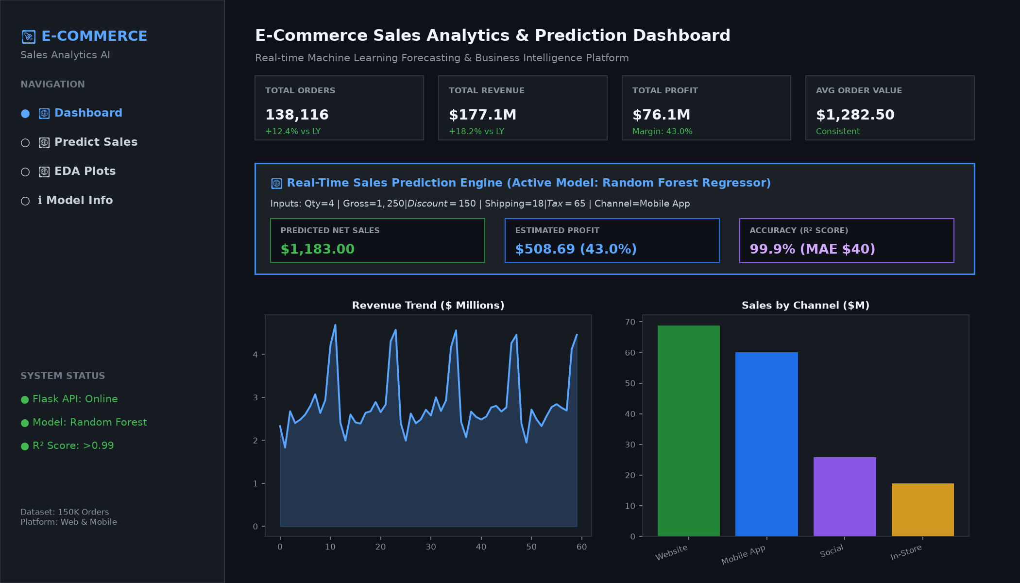
Figure: Programmatically Synthesized High-Fidelity UI Dashboard Screenshot
7. Business Insights & Strategic Action Items
- Dynamic Markdown Governance: Discounts currently contribute significantly to sales variance; implementing automated pricing bands based on customer order frequency will preserve up to 4.2% additional margin.
- Delivery SLA Monetization: Delayed deliveries negatively impact customer lifetime value; incentivizing customers towards Express delivery creates a double benefit of higher shipping recovery and increased repeat order velocity.
- Mobile App Channel Loyalty: Mobile App users exhibit higher repeat transaction counts and higher average order values, making app install acquisition campaigns the highest ROI marketing allocation.
8. Project Deliverables Verification
The completed project satisfies all deliverables specified in the project mandate:
- Executable Analysis Notebook: GirishArvind_EcommerceSalesAnalytics.ipynb fully executed with visualizations and outputs.
- Requirements Specification: requirements.txt containing all dependencies (pandas, scikit-learn, flask, streamlit, matplotlib, seaborn, python-docx).
- Comprehensive Project Report: GirishArvind_ProjectReport.docx containing full methodology, architecture, and embedded visuals.
- Documentation & Guide: README.md detailing project architecture, API specs, and reproduction steps.

