DUTCH BLOOD BOWL ASSOCIATION SEASON 2027
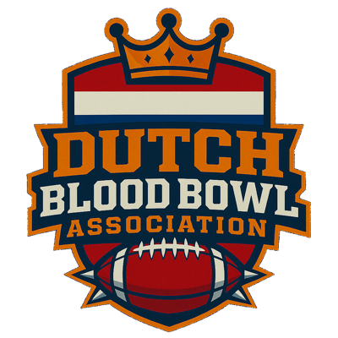
RECOMMENDED
RULESPACK
Blood Bowl Sevens tournament rules for DBBA qualifiers
BB2025 · SPIKE! #22 VERSION 1.0 · OCTOBER 2026

These are the DBBA’s recommended rules for Blood Bowl Sevens tournaments. Tournament organisers add their own schedule, prizes, venue and entry details in the sections marked “To be completed by the TO”.

01 RULESET
- Blood Bowl 2025 rules, with the Sevens rules from Blood Bowl Spike! Magazine #22, and official errata.
- The tournament is NAF sanctioned.

02 FORMAT
- Resurrection: every match starts with the team as registered. No SPP or injuries carry over between matches.
- Swiss pairing: winners play winners and losers play losers. Rematches are avoided where possible.

03 TEAM BUILDING
- Team value: up to 600,000 gold pieces.
- Permitted teams: the teams listed in the tier table.
- Star Players: not allowed.
- Inducements: bought at team creation from your 600,000 gold, and kept for the whole tournament. Tourplay shows which inducements are available to your team.

04 IMPROVEMENT PACK
On top of the 600,000 gold, each team adds extra skills based on its tier.
TIER | PRIMARY | SECONDARY | MAX. ELITE
Tier 1 | 2 | – | 1
Tier 2 | 3 | – | 1
Tier 3 | 2 | 1 | 1
Tier 4 | 2 | 2 | 2

- No player may receive more than one extra skill.
- A Primary skill may always be taken instead of a Secondary skill.
- Banned skills: Leader and Pro, as per Spike! #22.

05 TEAM TIERS
TIER 1 | TIER 2 | TIER 3 | TIER 4
Amazon | Bretonnian | Black Orc | Gnome
Chaos Dwarf | Dwarf | Chaos Chosen | Goblin
Dark Elf | Imperial Nobility | Chaos Renegade | Ogre
Elven Union | Lizardmen | Halfling | Snotling
Human | Nurgle | Khorne
High Elf | Orc
Necromantic Horror | Shambling Undead
Norse | Tomb Kings
Old World Alliance | Vampire
Skaven
Underworld Denizens
Wood Elf

06 SCORING
PER MATCH | POINTS
Win | 20
Draw | 10
Loss | 0
Touchdown (max. 5 per match) | 1 each
Casualty (max. 5 per match) | 1 each
Perfect Defence (no TDs conceded) | 3
Casualties count when you cause them on your opponent’s players: blocks, fouls, crowd pushes, Secret Weapons, and thrown or kicked players.

07 TIEBREAKERS
When coaches finish on equal points, these decide the ranking, in order:
- Score in direct matches
- Touchdown difference in direct matches
- Touchdown difference
- Casualty difference in direct matches
- Casualty difference
- Team value (lowest wins)
This is the default tiebreaker order in Tourplay.

TO BE COMPLETED BY THE TO
Replace the grey text in each box with your own tournament details, then remove this note.

08 TOURNAMENT DETAILS
Tournament name: …
Date: …
Venue and address: …
Entry fee: … (including the €1 Dutch Super Sevens Showdown contribution)
Tickets and registration: … (e.g. buy a ticket at … and register your team on Tourplay)
Contact: … (e-mail, Discord, phone)

09 SCHEDULE
00:00 – Registration
00:00 – Round 1
00:00 – Lunch break
00:00 – Round 2
00:00 – Round 3
00:00 – Round 4
00:00 – Awards and closing

10 PRIZES AND AWARDS
List the prizes and awards for your tournament, for example:
1st place, 2nd place, 3rd place
Most casualties, most touchdowns, Best Painted, Wooden Spoon

