Samantha Freeland
Internet of Things
Lab 10: Step Counter

Overview:

In Lab 10, I built a step counter based on the data that was logged on the MPU-6050 Accelerometer and Gyroscope. The MPU-6050 works by tracking motion in 6-axises. For set up, I used slides from the Lab10 PowerPoint To display output, I set up an LCD display. This is a Fritzing model of my setup. I also included an image of my real-life setup.

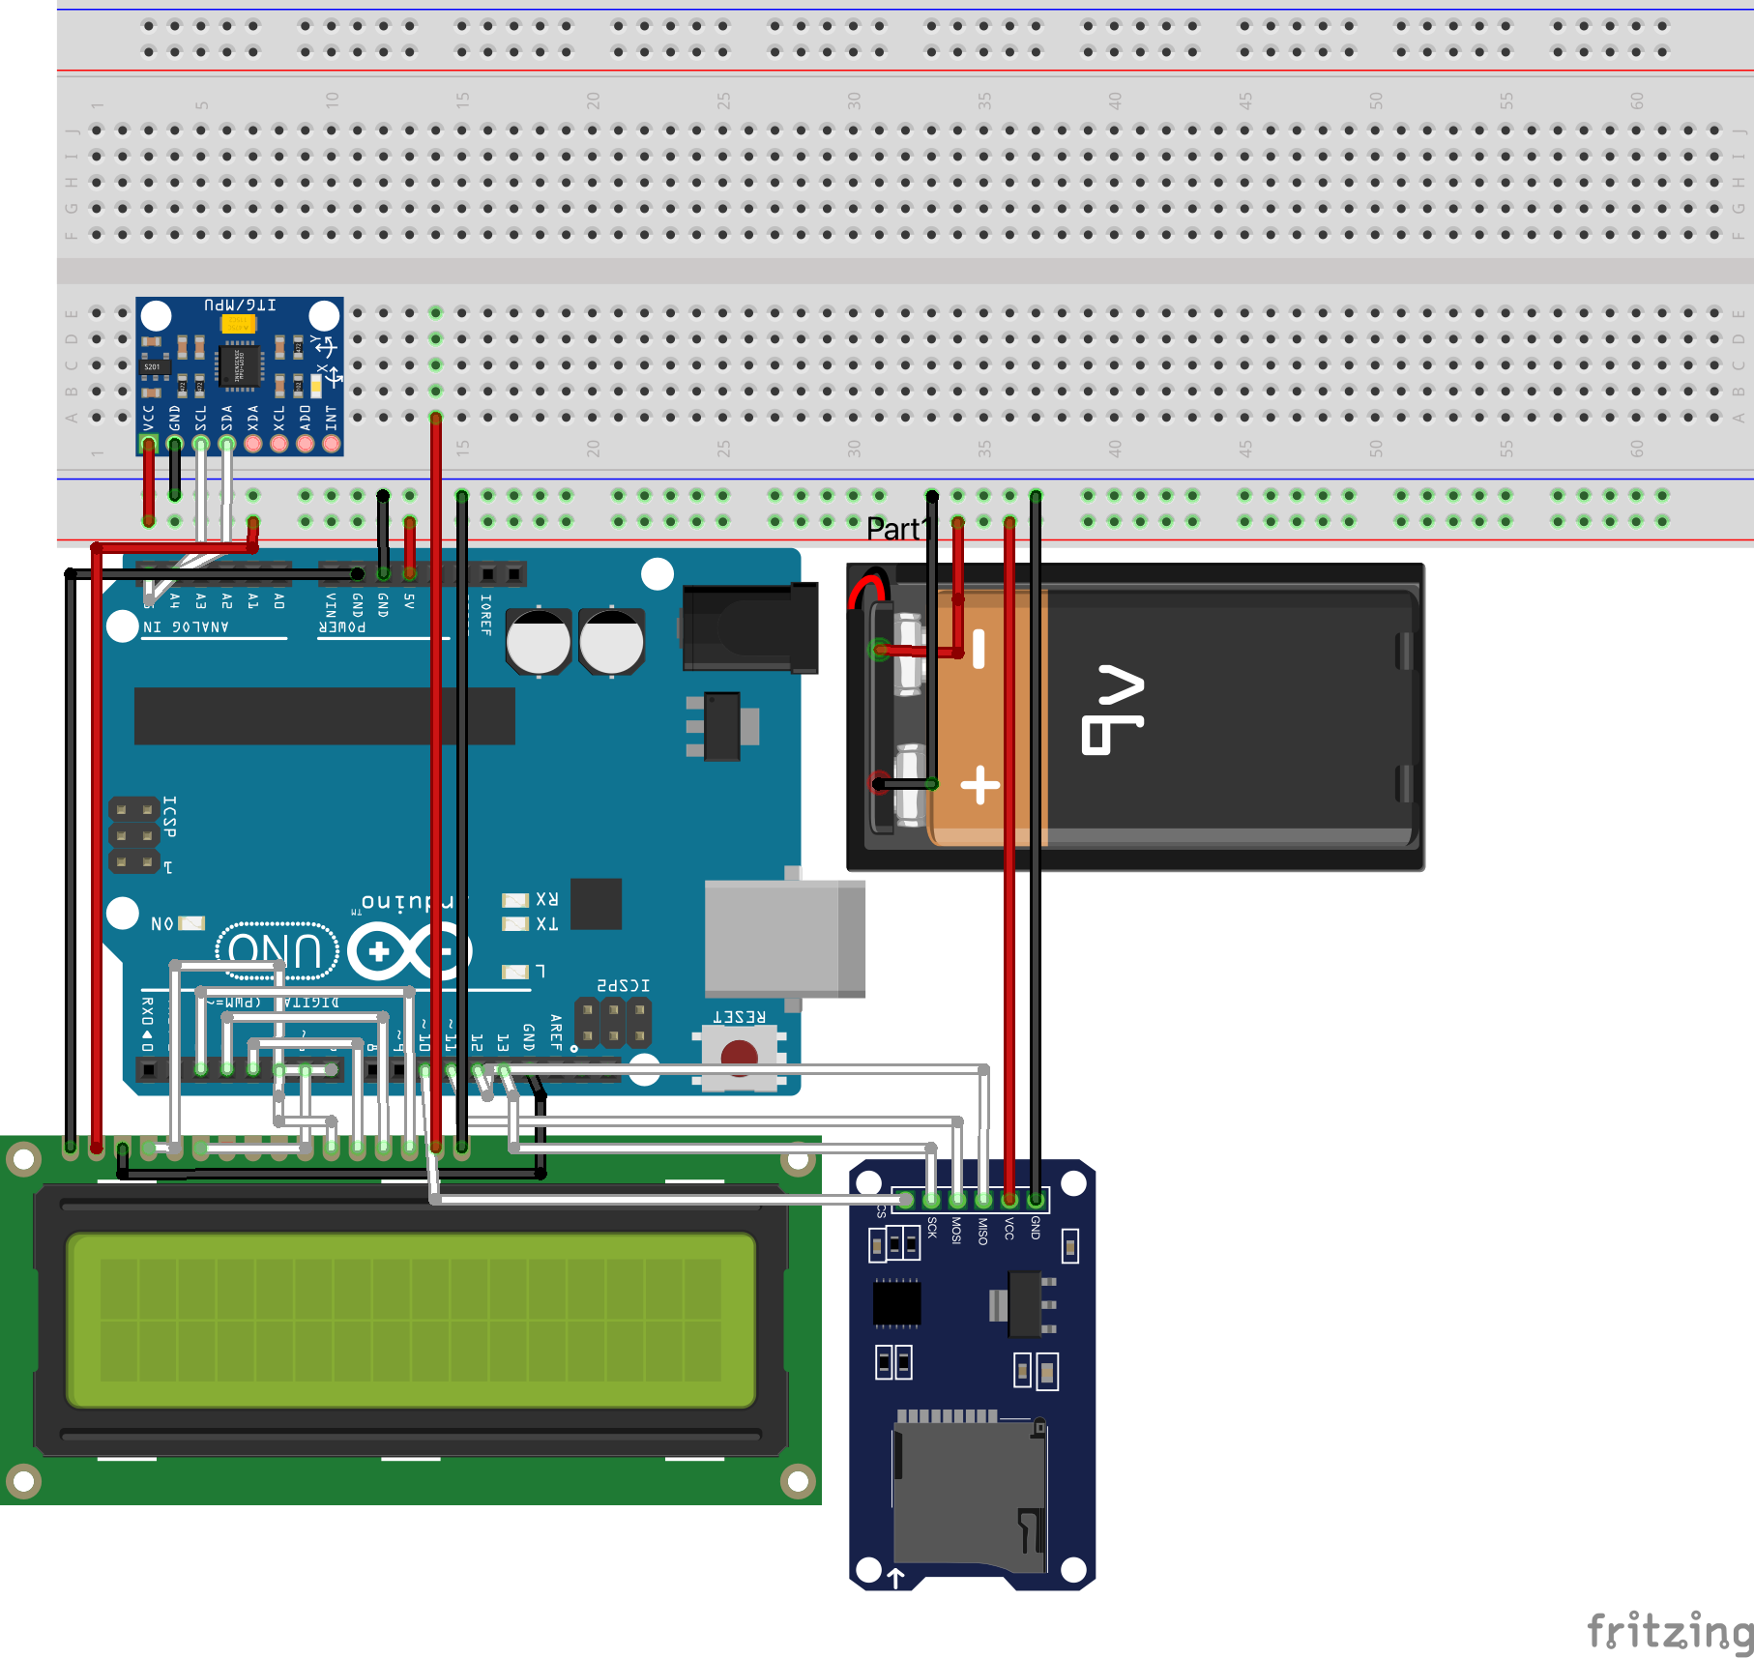
Figure 1: Fritzing Diagram of setup
The setup was powered via USB and securely placed on a flat surface before being moved by hand to simulate walking or tilting motions. At that point I switched to 9V battery. Acceleration and angular velocity data were collected and logged to a CSV file for analysis in Python.
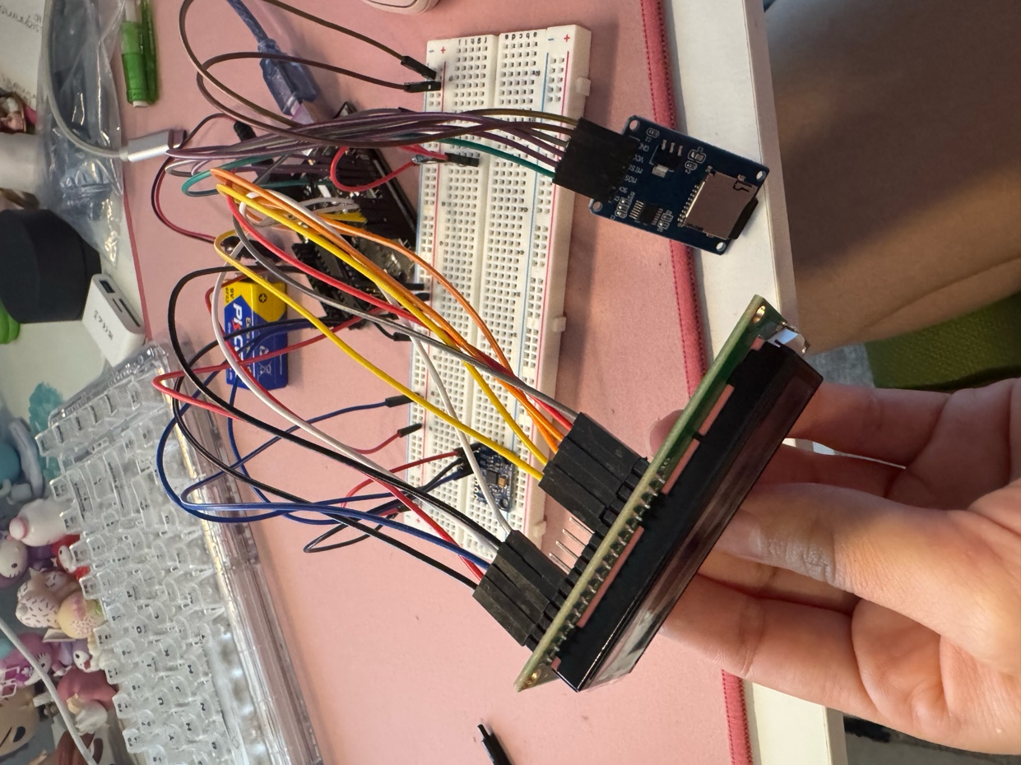
Figure 2: Real-life Setup
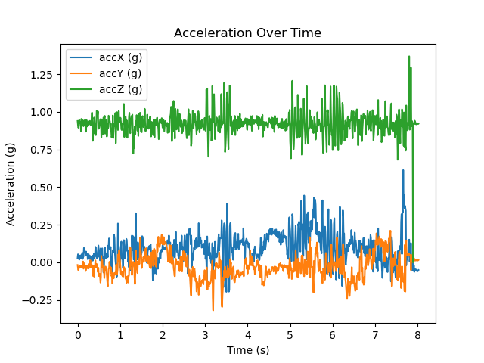
The acceleration graphs show how the sensor experienced changes in linear acceleration along the X, Y, and Z axes over time. These changes correspond to physical movements or tilts of the sensor. For example, spikes in the Z-axis acceleration may represent steps or impacts when the sensor was moved vertically.
Figure 3: Acceleration Graphs
The angular velocity graphs show how quickly the sensor rotated about the X, Y, and Z axes, measured in degrees per second. These values help us understand the rotational dynamics of the sensor during motion. Peaks in these graphs indicate moments of rapid rotation or tilting.

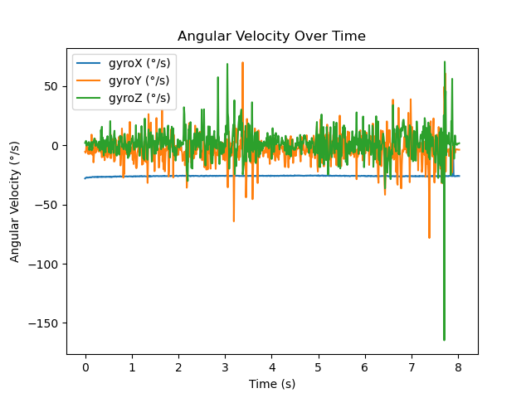
Figure 4: Angular Velocity Graphs

Together, these datasets provide a complete picture of both the linear and rotational movements of the sensor, which could be used in real-world applications like step counting, motion tracking, or activity recognition.

