Point Cloud Processing

# Point Cloud Registration

## Test Dataset Challenges

## A set of raw point clouds with color information was provided for two different scenes, likely generated through an image-based 3D reconstruction method. The first set captures a hair dryer held by a human arm, while the second is an outdoor scene. Each point cloud includes detailed color information but also exhibits common reconstruction challenges such as noise, incomplete geometry, and partial overlaps between scans. Although most of the data exhibits smooth transitions between scans, there are also abrupt changes that complicate the registration process.

### Hair dryer scene

The captures of these scene present certain overlap between them for the first ones; however, at some point, they present hard transitions and noticeable non-rigid motion for the arm. The image below shows some partial scans illustrating these challenges.

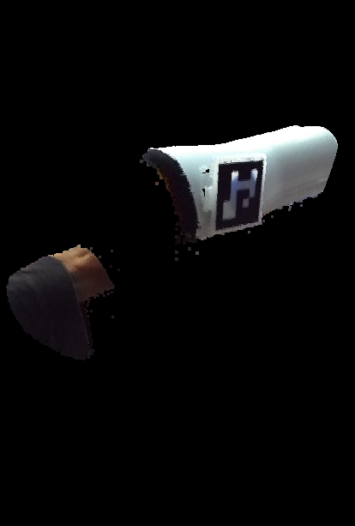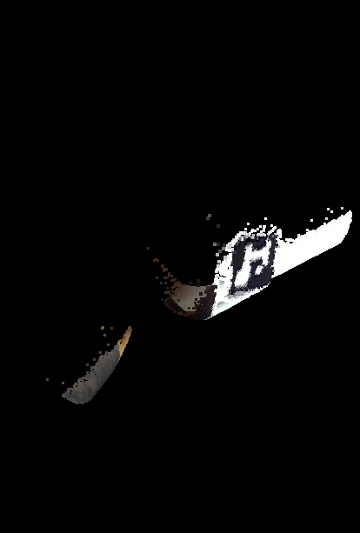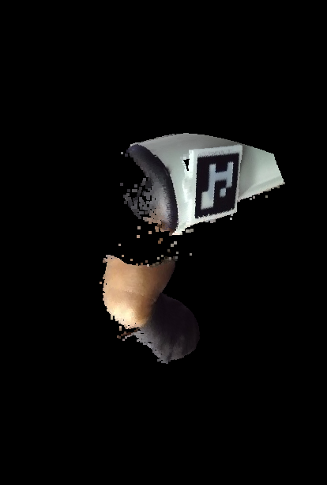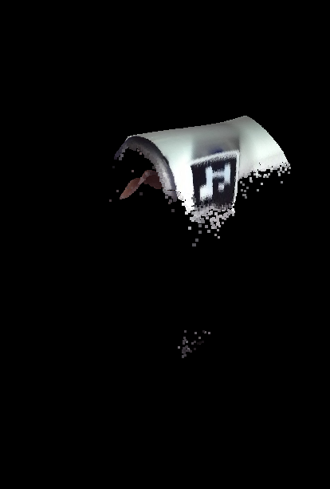

Also, the scans are not consistent maybe due to acquisition limitations. For example, in the image below, we can see one scan with a gap between the marker and the rounded surface, while in the other scan we can see a continuous rounded surface that connects smoothly with the marker.

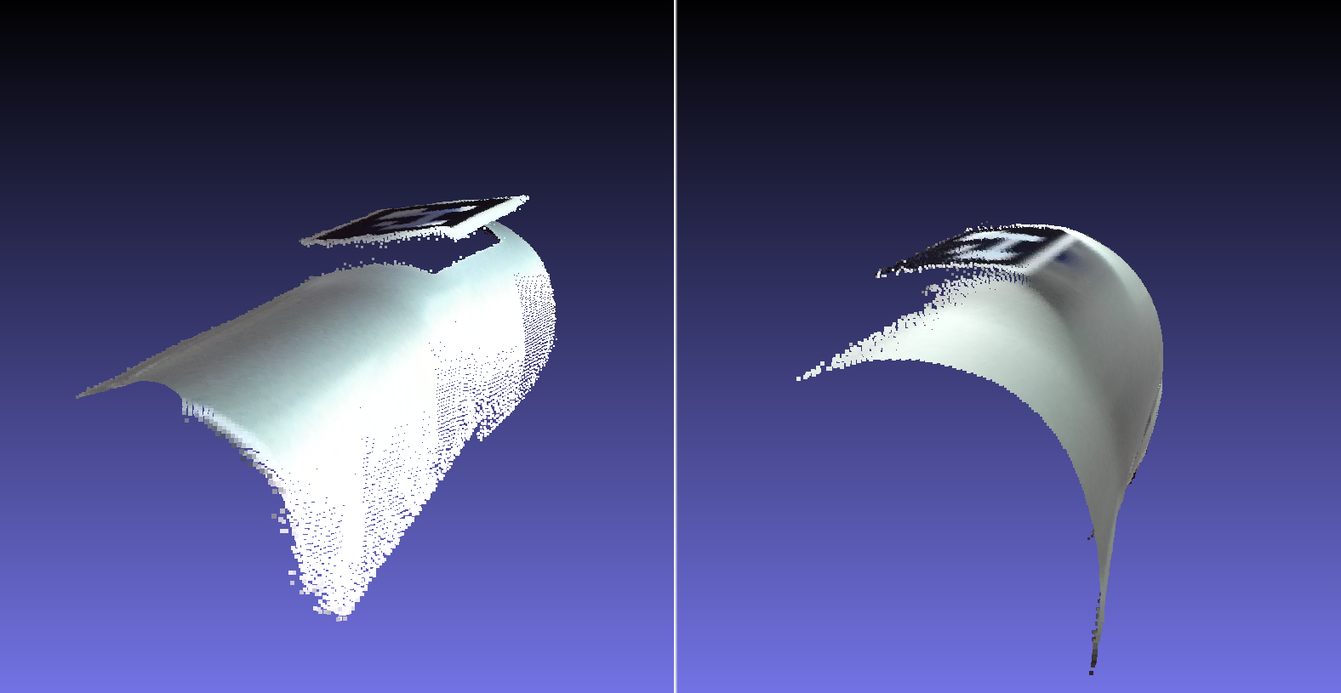

### Outdoor scene

This scene captures multiple objects encompassing a complex and large environment difficult to register. The image below shows some of the scans, presenting several and partial shapes of objects. Further, it presents some shadows that can hinder color-based alignment.

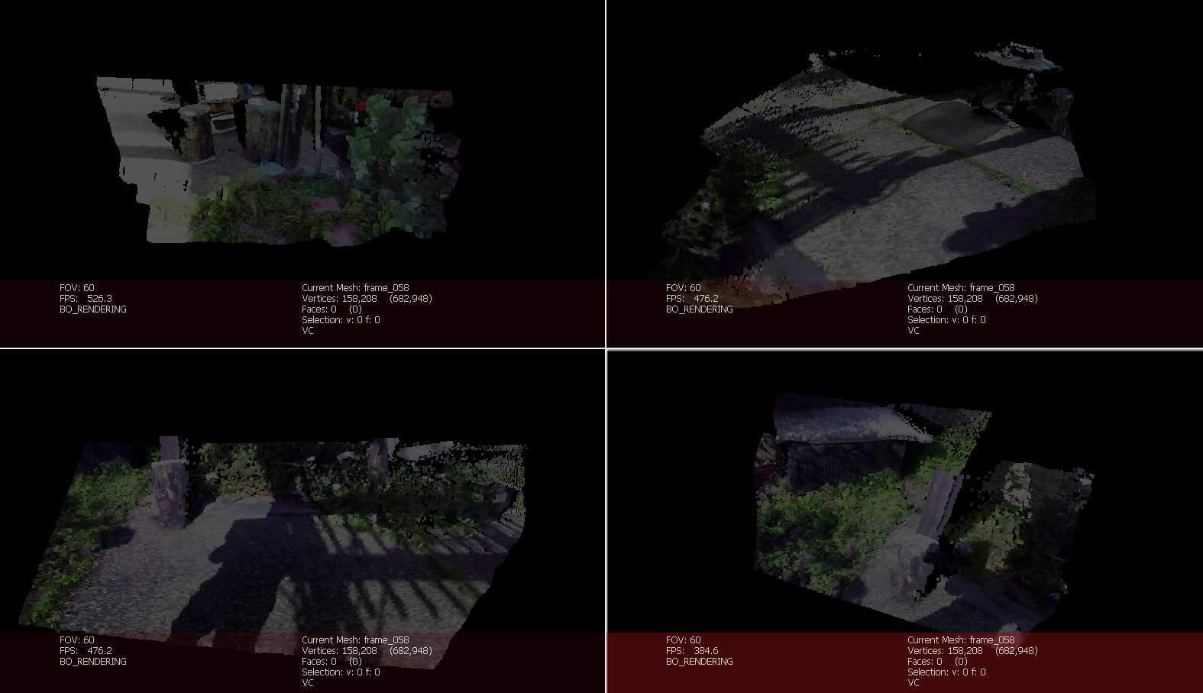

## Tested Approaches

Several methods and combinations of methods were tested, including the following methodologies:

* ICP point to point
* ICP point to plane
* ICP point to plane + color matching
* Coarse to fine registration considering ICP-based methods
* Coarse to fine registration using feature-based RANSAC for coarse alignment (FPFH features)
* Multiway registration using pose graph estimation and optimization, and considering the different registration methodologies
* Multiway registration using sequential alignment considering different registration methodologies
* Global and sliding window processing for multiway registration
* Multiscale registration using different tolerance and down sampling parameters
* Double-sided registration
* Preprocessing using outlier removal, largest component selection, down voxel, repeated points removal, radius-based normal estimation, tangent plane normal consistency, fixed parameters using average distance between points, etc.
* During registration: normal orientation correction, normal error measurement,

## Selected Approach

The proposed approach relies on certain assumptions about the input data: each point cloud should contain color information and be part of a sequential acquisition, ensuring substantial overlap with preceding scans. This sequence order is represented by the corresponding positions of an input list of point clouds. The method can be summarized by the following pseudocode:

|  |
| --- |
| **ALGORITHM 1: MULTIWAY REGISTRATION** |
| **Input:** a list of point clouds with color information (without coupled normals) |
| **Output:** the list of registered point clouds |
| Compute the average distance between points for all the point clouds  Compute a voxel size using the average distance: voxel size = average distance * 1.5  Compute a maximum coarse correspondence distance: voxel size * 15  Compute a maximum fine correspondence distance: voxel size * 1.5  Preprocess each point cloud:   1. Remove repeated points (very small distance) 2. Outlier removal 3. Select maximum connected component (with high tolerance for connectivity) 4. Estimate normal using regular neighborhoods 5. Consistent normal orientation using tangent planes   For each point cloud:   1. Register the current point cloud with the previous registered point clouds. The preferred alignment direction is to set as source the smaller point cloud and as target the larger point cloud. For all the steps, we use the source point cloud with the current and inverted normals. From these possible results, we pick the registration that better fits the target points and target normals. A normal error function was designed for this purpose. The final score is composed as follows: score = 0.2 distance-based score (fitness) + 0.8 normal-based score.    1. Coarse registration using point to plane ICP and considering multiple initializations (translations of the source on the axes x, y and z). Optionally, we can simply apply a point to point ICP.    2. Fine geometric registration using point to plane ICP.    3. Fine point to plane + color matching ICP    4. If the final fitness (distance-based overlap) is below a given threshold, the registration is not acceptable. 2. Correct normal orientation of the registered point cloud by checking the normal similarity regarding the previously aligned point clouds. 3. Combine the registered point cloud with the previous one (if the registration is acceptable) 4. Downsample this combination using voxel size * 0.1 5. Attach the current registered point cloud to a list of registered point clouds (if the registration is acceptable). This list will contain all the registered point clouds as independent sets.   Return the merged point cloud and a list of point clouds of all the registered point clouds |

In our implementation, the combined point cloud and the isolated registered point clouds will be exported to the folder data/results/<name>. Notice that just the point clouds that presented an acceptable registration will be considered.

## Results

For the dryer scans, we noticed a stable behavior from _frame002.ply to _frame021.ply. The other scans are not stable, continuous, and accurate. So, we decided to split this sample into two datasets: one containing the full scans, and the other containing just the samples from _frame002.ply to _frame021.ply. For these sets, we consider acceptable registrations when the fitness is over 0.7. The images below show the registration result considering the stable captures, which are named hair_dryer_part_1.

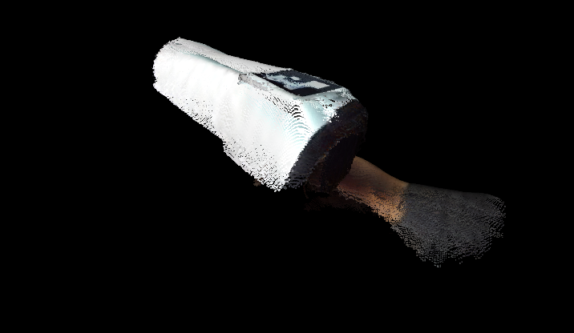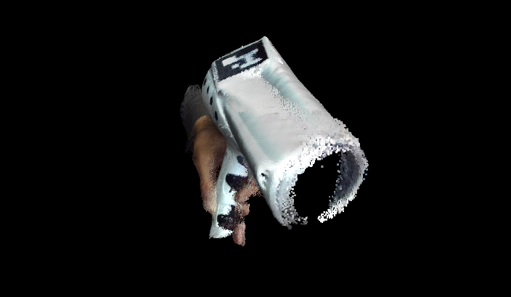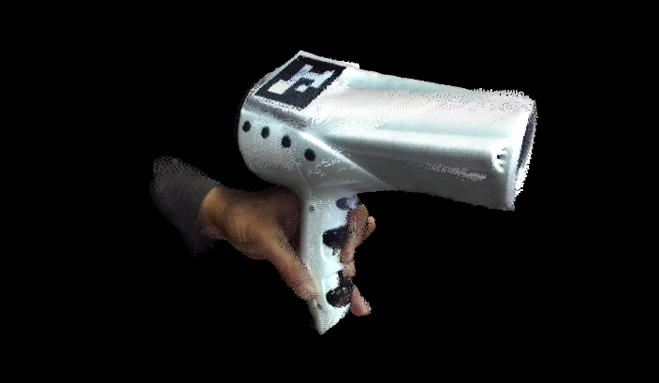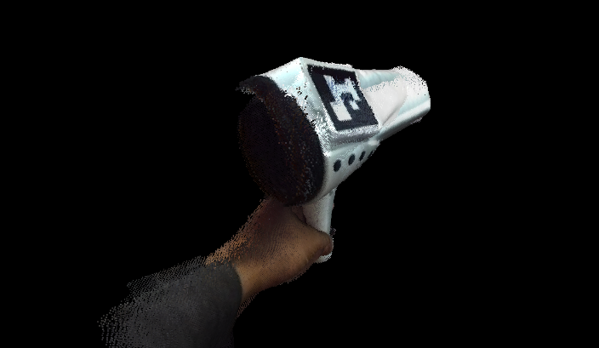

The image below shows the result of using all the captures, where we can notice some misalignments that are introduced due to the inconsistency with the first set of scans.

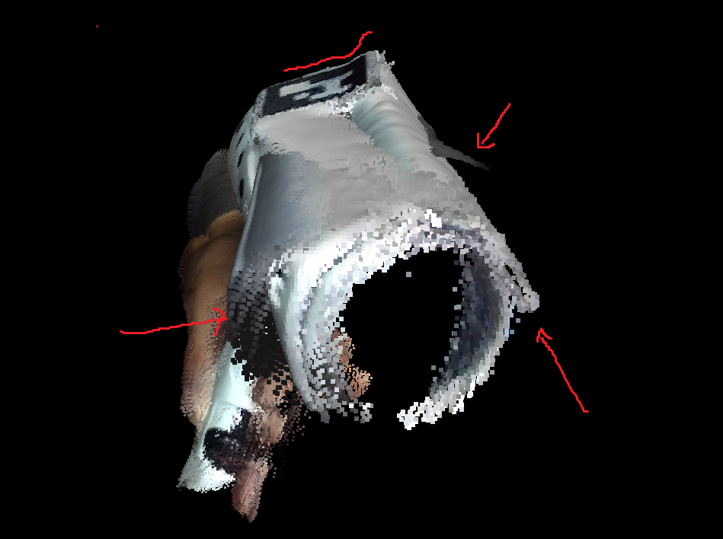

For the outdoor scene, we use the simple point to point ICP with a tolerance fitness of 0.4. In the image below, we show some captures of these scans.

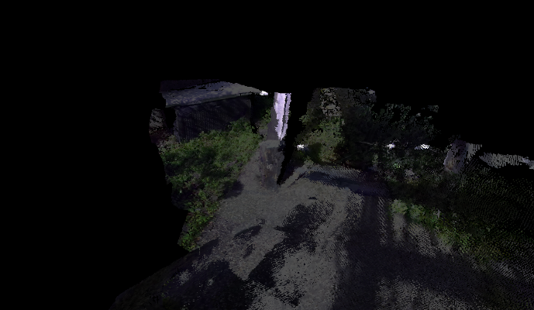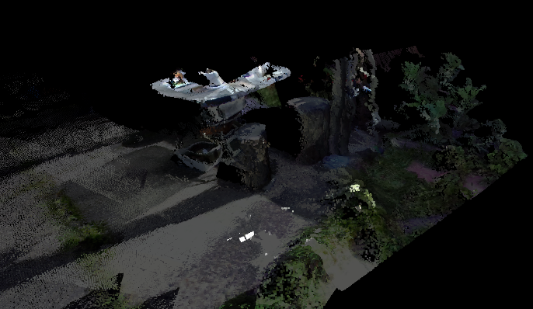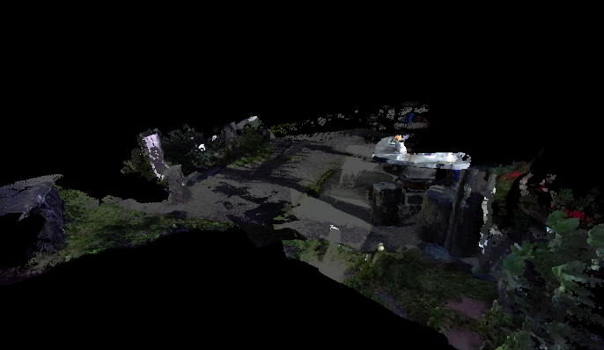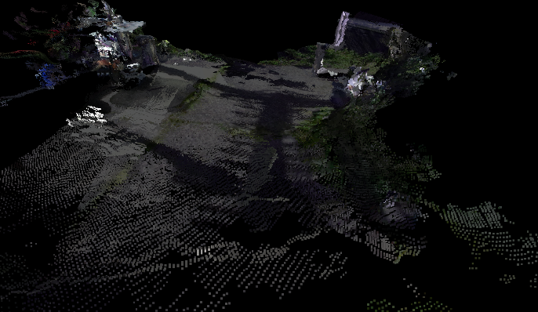

These are the recommendations for the parameter setting:

# Set registration options

    fitness_threshold = 0.7 # 0.7 for objects with high overlap like the dryer. 0.4 for large scenes with low overlap between sections.

    use_simple_coarse = False # False for objects. True for scenes that present several regions of floor.

These parameters and the input specification at hardcoded at this moment; however, the idea is to align the implementation in the following milestones.