************************ Finding Similarity ************************

*********************************************************************

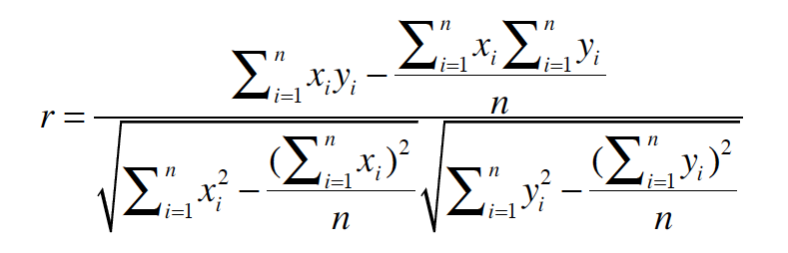

float PearsonSimilarity(User rating_x[ ], User rating_y[ ])

{

sum_xy = 0;

sum_x = 0;

sum_y = 0;

sum_xx = 0;

sum_yy = 0;

for(int i=0; i<n; i++)

if (rating_x[i] && rating_y[i] ) // when there is some rating of x and y

{

x = rating_x[i];

y= rating_y[j];

sum_xy += x * y;

sum_x += x;

sum_y += y;

sum_xx += x*x;

sum_yy += y*y;

}

denominator = sqrt ( sum_xx - (sum_x ^ 2) / n ) * sqrt ( sum_yy - (sum_y ^ 2) / n);

if (denominator = 0)

return 0;

else

return ( sum_xy - (sum_x * sum_y / n ) / denominator;

}

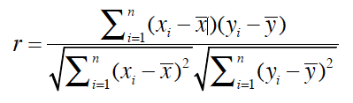

float PearsonSimilarity ( User rating_x[ ], User rating_y[ ] )

{

for (i=0; i<n; i++) // sum of rating of users x & y

{

if (rating_x[i] )

x + = rating_x[i];

if (rating_y[i] )

y += rating_y[i];

}

avg_x = x / n; avg_y = y / n; // calculate mean value of x & y

for (i=0; i<n; i++)

{

if (rating_x[i] )

diff_x = rating_x[i] - avg_x;

if (rating_y[i] )

diff_y = rating_y[i] - avg_y;

sum_xy += diff_x * diff_y;

sum_xx += diff_x * diff_x;

sum_yy += diff_y * diff_y;

}

denominator = sqrt ( sum_xx * sum_yy );

if (denominator = 0)

return 0;

else

return (sum_xy / denominator);

}