exerciseF.R

freewill

Sat Oct 08 16:29:14 2016

library(ggplot2)  
library(ggthemes)  
library(scales)  
  
# Exercise F  
hiv <- read.csv("./data/pakistan.childHIV.csv")  
sa <- read.csv("./data/southasia.csv")  
  
# A bar graph representing children with HIV in Pakistan from 2001 to 2013  
ggplot(hiv, aes(Year, childHIV)) +  
 geom_bar(stat="identity") +  
 ggtitle("Children Living with HIV in Pakistan from 2001 to 2013") +   
 scale_x_continuous(breaks = seq(2001,2013, 1)) +  
 ylab ("Children Living with HIV (Ages 0-14)")

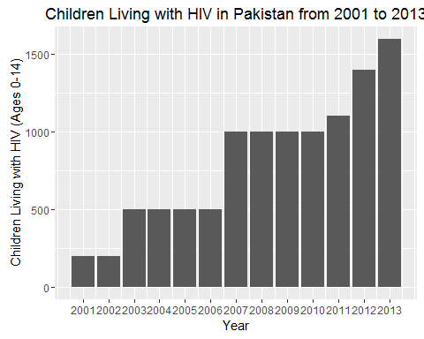

# A histogram representing children with HIV in Pakistan from 2001 to 2013  
ggplot(hiv, aes(childHIV)) +  
 geom_histogram(stat = "bin", binwidth = 75) +  
 ggtitle("Children Living with HIV in Pakistan from 2001 to 2013") +   
 scale_x_continuous(breaks = seq(2001,2013, 1)) +  
 xlab ("Children Living with HIV (Ages 0-14)") +  
 ylab("Frequency")

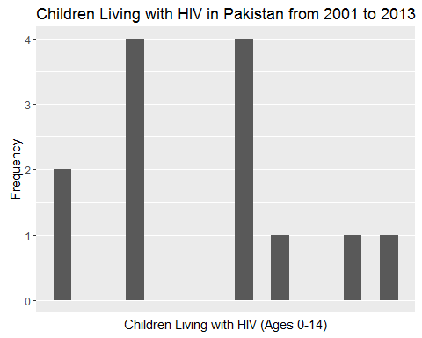

# A line graph representing the trend of children with HIV in Pakistan from 2001 to 2013  
ggplot(hiv, aes(Year, childHIV)) +  
 geom_line() +  
 ggtitle("Children Living with HIV in Pakistan from 2001 to 2013") +   
 scale_x_continuous(breaks = seq(2001,2013, 1)) +  
 ylab ("Children Living with HIV (Ages 0-14)")

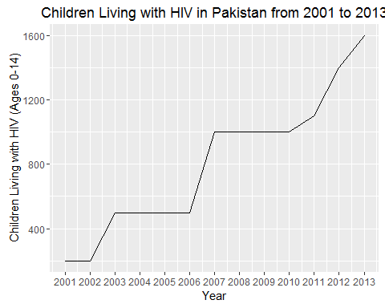

# A pint graph representing the trend of children with HIV in Pakistan from 2001 to 2013  
ggplot(hiv, aes(Year, childHIV)) +  
 geom_point() +  
 ggtitle("Children Living with HIV in Pakistan from 2001 to 2013") +   
 scale_x_continuous(breaks = seq(2001,2013, 1)) +  
 ylab ("Children Living with HIV (Ages 0-14)")

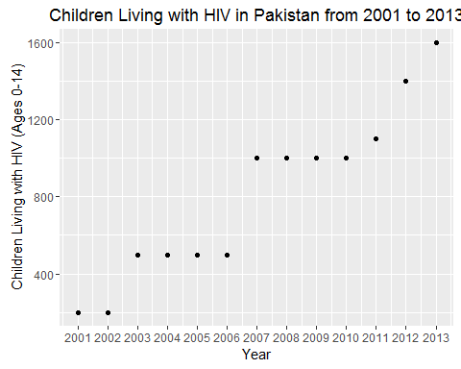

# Density plot of life expectancy at birth to indicate the number of years a newborn infant would live  
ggplot(data=sa[9:16, 1:2], aes(Life.expectancy)) +   
 geom_density(kernel= "gaussian") +   
 xlab("Life expectancy at birth, total(years) in 2013")

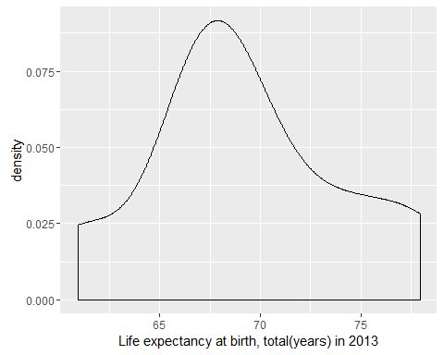

# Box plot of life expectancy at birth to indicate the number of years a newborn infant would live  
ggplot(data=sa[1:16, 5:6], aes(Year, Southasia.life.expectancy.avg)) +   
 geom_boxplot() + labs(title= "Life Expectancy in Developing South Asian Countries", x = NULL, y = "Life Expectancy")

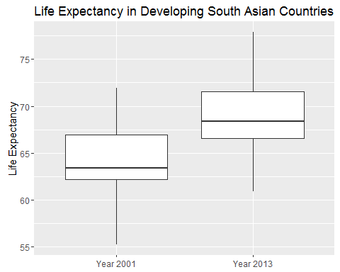

# Cartesian Coordinate  
ggplot(data=hiv, aes(childHIV)) +   
 geom_bar(binwidth=50) + xlab("Children Living with HIV (Ages 0-14)") +   
 coord_cartesian(xlim=c(-2000, 2000), ylim=c(-5, 5))

## Warning: `geom_bar()` no longer has a `binwidth` parameter. Please use  
## `geom_histogram()` instead.

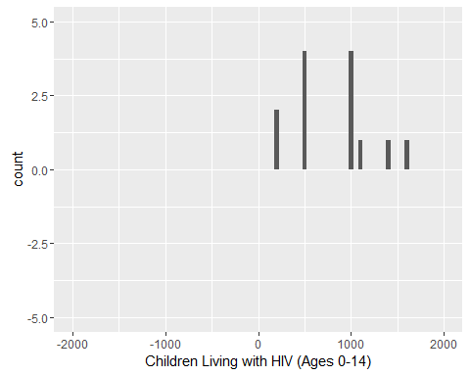

# Flipped Cartesian coordinates  
ggplot(data=hiv, aes(childHIV)) +   
 geom_bar(binwidth=50) + xlab("Children Living with HIV (Ages 0-14)") +   
 coord_flip(xlim=c(-2000, 2000), ylim=c(-5, 5))

## Warning: `geom_bar()` no longer has a `binwidth` parameter. Please use  
## `geom_histogram()` instead.

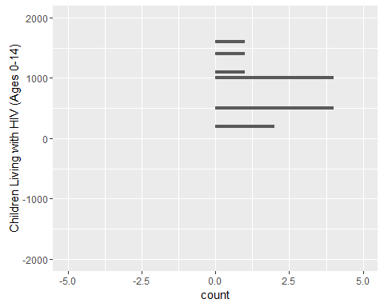

# Facet into columns  
ggplot(data=sa[9:16, 1:4], aes(Out.of.pocket.health.expenditure, Infant.deaths)) +   
 geom_point() + facet_grid(.~Country) +   
 theme(axis.text.x = element_text(angle = 90, hjust = 1)) +   
 scale_y_continuous(labels=comma) +   
 labs(x = "Out of Pocket Health Expenditure (% of total expenditure on health)", y = "Number of Infant Deaths")

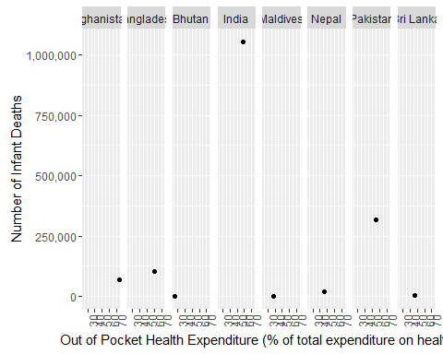

#Facet into rows   
ggplot(data=sa[9:16, 1:4], aes(Out.of.pocket.health.expenditure, Infant.deaths)) +   
 geom_point() + facet_grid(Country~.) +   
 scale_y_continuous(breaks=c(0, 500000, 1000000), labels=comma) +   
 labs(x = "Out of Pocket Health Expenditure (% of total expenditure on health)", y = "Number of Infant Deaths")

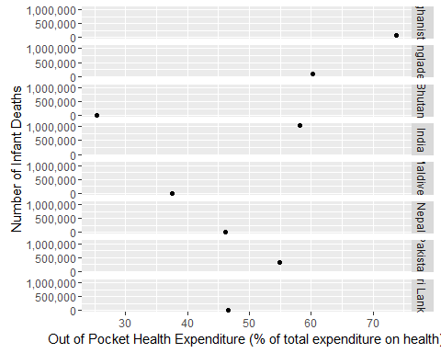

# Change bar graph fill color  
ggplot(hiv, aes(Year, childHIV)) +  
 geom_bar(stat="identity", fill= "red") +  
 ggtitle("Children Living with HIV in Pakistan from 2001 to 2013") +   
 ylab ("Children Living with HIV (Ages 0-14)")

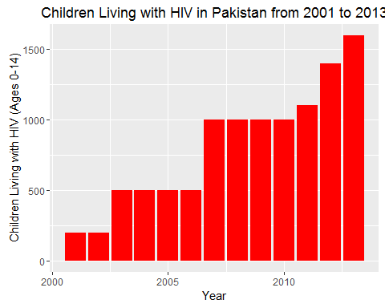

# Change point graph color scale to value  
ggplot(hiv, aes(Year, childHIV)) +  
 geom_point(aes(colour = Life.expectancy)) +  
 ggtitle("Children Living with HIV in Pakistan from 2001 to 2013") +   
 ylab ("Children Living with HIV (Ages 0-14)")

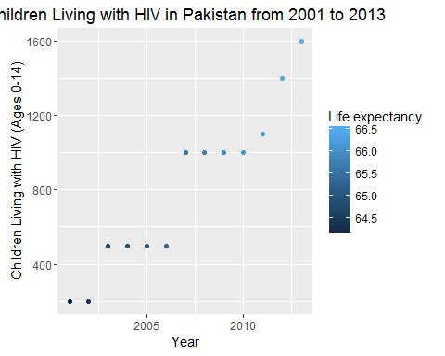

# Change point graph size scale to value  
ggplot(hiv, aes(Year, childHIV)) +  
 geom_point(aes(size = Life.expectancy)) +  
 ggtitle("Children Living with HIV in Pakistan from 2001 to 2013") +   
 ylab ("Children Living with HIV (Ages 0-14)")

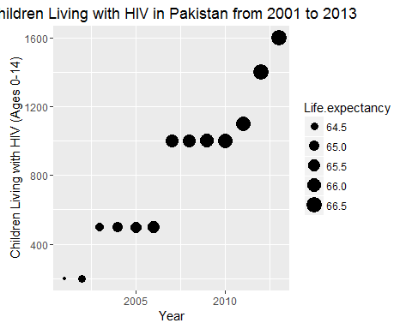

# Apply classic theme  
ggplot(hiv, aes(Year, childHIV)) +  
 geom_bar(stat="identity") +  
 ggtitle("Children Living with HIV in Pakistan from 2001 to 2013") +   
 ylab ("Children Living with HIV (Ages 0-14)") +  
 theme_classic()

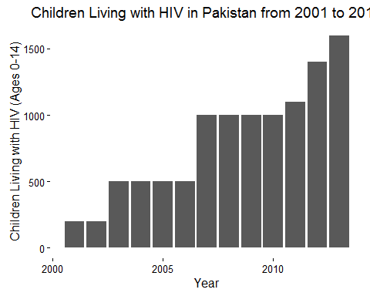

# Apply black and white theme  
ggplot(hiv, aes(Year, childHIV)) +  
 geom_bar(stat="identity") +  
 ggtitle("Children Living with HIV in Pakistan from 2001 to 2013") +   
 ylab ("Children Living with HIV (Ages 0-14)") +  
 theme_bw()

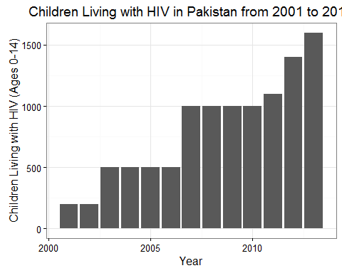

# Apply minimal theme  
ggplot(hiv, aes(Year, childHIV)) +  
 geom_bar(stat="identity") +  
 ggtitle("Children Living with HIV in Pakistan from 2001 to 2013") +   
 ylab ("Children Living with HIV (Ages 0-14)") +  
 theme_minimal()

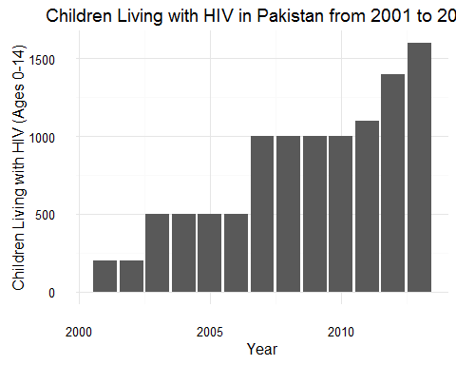

# Apply economist theme  
ggplot(hiv, aes(Year, childHIV)) +  
 geom_bar(stat="identity") +  
 ggtitle("Children Living with HIV in Pakistan from 2001 to 2013") +   
 ylab ("Children Living with HIV (Ages 0-14)") +  
 theme_economist()

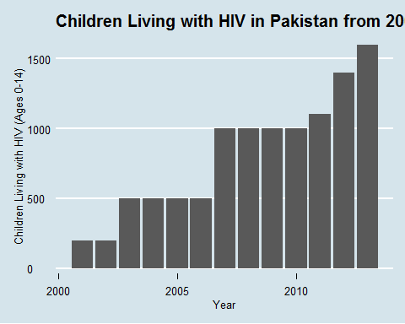

# Apply Tufte theme  
ggplot(hiv, aes(Year, childHIV)) +  
 geom_bar(stat="identity") +  
 ggtitle("Children Living with HIV in Pakistan from 2001 to 2013") +   
 ylab ("Children Living with HIV (Ages 0-14)") +  
 theme_tufte()

