Paper Title: Robust Table Extraction for Technical Specifications using Vision LLMs

Abstract
Extracting structured data from complex technical specification documents, such as TCG Opal and NVMe standards, is a critical step for automated compliance testing and system verification. However, this task remains challenging due to the irregular layouts, merged cells, and high sparsity often found in these PDFs. This paper evaluates the limitations of traditional rule-based extraction methods (e.g., PyMuPDF) and proposes a robust Section-Based Visual-Hybrid Pipeline utilizing Large Multimodal Models (LMMs). We demonstrate that while rule-based methods offer superior processing speed, they catastrophically fail on structurally complex tables—specifically those with sparse data where column alignment is visually implied rather than explicitly grid-lined.
Furthermore, while Vision LLMs (e.g., Qwen-VL) show exceptional capability in parsing complex structures, they inherently process documents page-by-page. Consequently, multi-page tables suffer from fragmentation and contextual loss. We resolve this fundamental limitation by introducing a Section-Based Extraction approach paired with Image Stitching, which seamlessly merges disjointed table fragments across page boundaries prior to VLLM inference. By employing this methodology, we achieved near 100% extraction accuracy with zero data misalignment on extremely complex tables, proving that combining structural section awareness with semantic visual understanding is essential for high-fidelity technical document parsing.

1. Introduction

1.1 The Challenge of Technical Specifications
Technical specifications for storage and security protocols (e.g., TCG Storage Opal SSC, NVMe Base Specification) are the ground truth for hardware and software development. These documents contain thousands of configuration parameters, command sets, and unique identifiers (UIDs) embedded within tables. Automating the extraction of this data is essential for generating code, creating verification suites, and ensuring standards compliance. unlike financial statements or simple invoices, technical specification tables often prioritize human readability over machine parseability, featuring complex headers, multi-line spanning cells, and significant whitespace.

1.2 Limitations of Existing Tools
Traditional PDF extraction tools like PyMuPDF, Camelot, and Tabula rely heavily on the underlying text stream coordinates and explicit ruling lines. While effective for dense, grid-like tables, these heuristics break down when facing: 1. Sparse Tables: Tables where cells are left empty to imply “same as above” or “N/A”, which rule-based parsers often misinterpret as column shifts. 2. Implicit Alignment: Data aligned by visual indentation rather than physical grid lines. 3. Complex Headers: Multi-level headers that rule-based tools struggle to associate with the correct data columns.
In this study, we highlight a specific failure mode in the TCG Opal specification where rule-based extraction generated “ghost columns” and misaligned data, and we present a Vision-LLM solution that resolves these issues.

1.3 Motivation for the Experiment
The primary motivation for this experiment arose from the practical bottleneck encountered while developing automated compliance testing tools for storage protocols (e.g., TCG Opal, NVMe). We found that while technical specifications contain vital configurations and parameters, the structured data locked within these PDFs is extremely resistant to conventional parsing. Manual transcription is not scalable, and rule-based extractors yield silent errors that require extensive human correction. We needed a fully automated, high-fidelity extraction system that relies on visual layout cues exactly like a human engineer would, eliminating the need for manual data verification.

2. Methodology: From Hybrid to Vision-Only

2.1 The Initial Hybrid Approach
Our initial hypothesis was that a hybrid pipeline could balance cost and accuracy. We designed a system that prioritized speed: 1. Fast Path (Rule-Based): Use PyMuPDF with optimized parameter tuning (snap_tolerance, intersection_tolerance) to extract simple grid tables. 2. Quality Gates: Implement heuristics to detect potential failures (e.g., checking for empty columns, header-to-data width mismatches). 3. Slow Path (Vision Fallback): Only route “detected failures” to a Vision LLM.

2.2 The “Sparsity Paradox”
We discovered a critical flaw in this hybrid model: Silent Failures. Rule-based parsers often returned “valid” looking markdown tables (correct dimensions, no errors thrown) that were semantically incorrect. Because the extraction logic “worked” mathematically (coordinates matched), the Quality Gates failed to flag the errors, allowing corrupted data to pass through.

3. Findings & Failure Analysis

3.1 Case Study: The TCG Opal MethodID Table
The most distinct failure occurred with Table 21: MethodID in the TCG Opal specification. - Visual Structure: The table lists UIDs (byte sequences) and their corresponding Method Names. Crucially, the byte sequences are often short, leaving large amounts of whitespace in the ‘UID’ column. - PyMuPDF Failure: - The rule-based parser detected the wide gaps between the short UID text and the next column as “new columns”. - This resulted in the splitting of a single logical column into multiple phantom columns. - Result: Data shifted rightward. The ‘Name’ text appeared in the ‘CommonName’ column, and the ‘TemplateID’ column was pushed out of existence. - Impact: UIDs became dissociated from their Method definitions, rendering the extracted data useless for automated code generation.

3.2 The Vision LLM Advantage
When the same table image was processed by a Vision LLM (Qwen-VL): - Visual Semantic Understanding: The model recognized the gestalt of the table—understanding that the wide whitespace was simply padding for alignment, not a column delimiter. - Header Alignment: It correctly aligned the short byte sequences under the “UID” header based on visual proximity and vertical alignment. - Result: The produced Markdown was structurally identical to the human-readable PDF, with 0% data misalignment.

4. Proposed Architecture: Section-Based Visual-Hybrid Pipeline
Based on the failure analysis, we abandoned the heavily rule-based approach in favor of a Visual-Hybrid Pipeline combined with a robust contextual extraction strategy. It is important to clarify that our architecture is fundamentally a hybrid: we extract standard text rapidly using PyMuPDF, while routing all complex visual elements (Tables and Figures) to the Vision LLM for high-fidelity parsing.

4.1 Section-Based Extraction Strategy
Instead of blindly extracting tables page-by-page, our pipeline introduces a Section-Based Method. We first parse the document’s hierarchy (via the TOC and header detection) to clearly define section boundaries. All extracted elements—tables, figures, and text—are then systematically organized into their respective sections. - Context Preservation: Organizing data by section ensures that each table retains its structural context, which is critical for mapping parameters to their exact functional definitions in downstream applications. - Simplified Table Merging: This method drastically simplifies handling tables that span multiple pages. Since table fragments on consecutive pages belong to the same logical section node, the pipeline can trivially group them without relying on complex and error-prone heuristic matching.

4.2 Image Stitching Example
To process multi-page tables seamlessly, we implemented an Image Stitching technique leveraging the section-based grouping. - Example Scenario: Consider a ComID Management table that begins at the bottom of Page 15 and continues onto Page 16. - Action: Because both table fragments are indexed under the exact same section hierarchy, the pipeline automatically identifies them as parts of a whole. It then vertically stitches the two cropped images into a single, contiguous large image. - Result: When this synthesized, stitched image is provided to the Vision LLM, the model interprets the entire table holistically. This completely eliminates errors caused by page breaks (such as repeating headers or orphan rows) and allows the LLM to output a single, perfectly merged Markdown table effortlessly.

4.3 Pipeline Workflow
- Layout Analysis: A dedicated object detection model scans the PDF page to identify table bounding boxes.
- High-Fidelity Rendering: The identified regions are rendered as high-resolution images (300 DPI).
- Section Assignment & Stitching: Table images are assigned to their logical sections. Multi-page tables within the same section are stitched into contiguous images over the page breaks.
- Vision LLM Inference: The final stitched images are fed into the VLM (e.g., Qwen-VL) to directly output a single, well-formed Markdown table without fragmentation.

4.4 Parsing Strategies: Visual-Hybrid vs. Pure VLLM
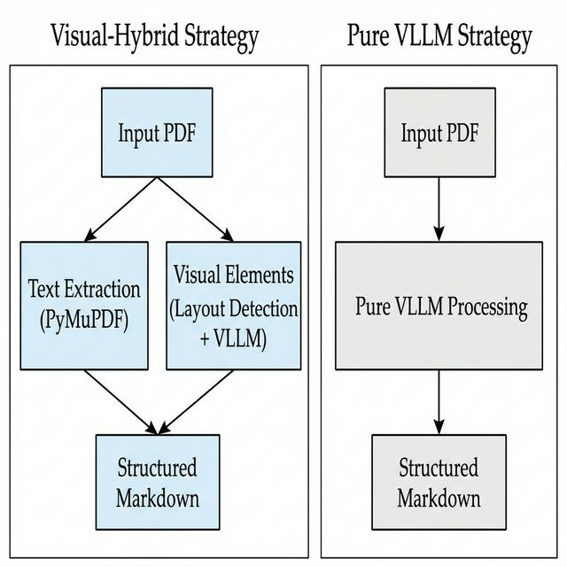
Flowchart: Visual-Hybrid vs Pure VLLM Strategies
Since our approach still utilizes PyMuPDF for standard paragraph text, we evaluated our Visual-Hybrid approach against a Pure VLLM approach (where the entire PDF page is fed holistically into a model like DeepSeek-OCR to generate unified Markdown).
- Visual-Hybrid (Text via PyMuPDF, Tables/Figures via VLLM)
  - Pros: Extremely fast processing for bulk text. Zero hallucination risk for standard paragraphs (which are read directly from the binary stream). Cost-effective, as token-heavy LLM inference is strictly reserved for complex visual elements.
  - Cons: The entire pipeline’s success hinges on the accuracy of the layout detection model. If DeepSeek/YOLO fails to bound a table perfectly, or misses a table entirely, the downstream VLLM receives flawed crops, or the PyMuPDF fallback misinterprets the table as garbled text.
- Pure VLLM (Entire Page strictly via VLLM)
  - Pros: Eliminates the need for a separate, fragile Layout Detection module. The model inherently understands the semantic flow of the entire page, effortlessly integrating text, lists, and tables as a human would read them.
  - Cons: Extremely slow and computationally expensive for massive specifications. Susceptible to minor OCR hallucinations in standard text. Furthermore, when processing dense pages, VLLMs sometimes suffer from “attention fading,” casually skipping paragraphs or truncating tables towards the bottom of the page.
Our pipeline adopts the Visual-Hybrid architecture to secure the deterministic accuracy of text extraction while achieving maximum table fidelity, using the Section-based method to compensate for the flow-awareness gap. ## 5. Implementation Details

5.1 Tech Stack
- Core Engine: Python-based batch processing pipeline.
- Vision Model: Qwen2.5-VL-72B (via OpenAI-compatible API) for production, with Qwen2-VL-7B (Ollama) as a local fallback.
- Helper Libraries: pdf2image for rendering, BeautifulSoup for post-processing HTML/Markdown if necessary.

5.2 Vision LLM Evaluation & Selection
During the development of the pipeline, we evaluated several state-of-the-art vision models to determine the optimal balance between cost, speed, and complex table reasoning capabilities:
- DeepSeek-OCR (Size: ~3B)
  - Pros: Outstanding at general layout detection (bounding box extraction) and standard text OCR. Extremely fast and lightweight.
  - Cons: Completely fails to comprehend and reconstruct structurally complex tables, making it unsuitable for the final markdown generation step.
- GLM-OCR (Size: ~2.2GB)
  - Pros: Noticeably better at handling standard tables compared to DeepSeek-OCR.
  - Cons: While an improvement, its reasoning capacity breaks down when confronted with highly irregular, nested, or extremely sparse “complex” tables typical of technical specifications.
- Qwen-VL (Size: ~20GB / 72B API)
  - Pros: Exceptional capability in parsing and restructuring complex tables. It possesses the deep semantic understanding necessary to infer logical columns from whitespace and properly align multi-line headers.
  - Cons: Larger models inherently require more compute and VRAM, resulting in slower inference times.
Conclusion: We integrated DeepSeek strictly for its strength in Layout Analysis (Step 1) to generate bounding box coordinates, while utilizing Qwen-VL as the core engine for the actual visual rendering and markdown table extraction (Step 4).

5.3 Key Visual Parsing Logic
The step4_llm_parser.py module implements the core logic: - Image Preprocessing: Validates image dimensions to ensure they fit within the LLM’s context window (resizing only if strictly necessary to avoid token overflow). - Prompt Engineering: We developed a robust system prompt that enforces: - Preservation of verbatim cell content (especially hexadecimal values). - Handling of multi-line cells using <br> tags rather than splitting rows. - Explicit instruction to ignore “page footer” or “page header” noise if captured in the crop.

6. Experimental Results & Evaluation

6.1 Dataset and Setup: The 4 Test Documents
To evaluate the robustness of our pipeline across diverse document structures, we tested four distinct technical specifications that present unique table extraction challenges:
- TCG Storage Opal SSC v2.30 & TCG Storage Architecture Core Spec v2.01
  - Characteristics: Distinct labels for Tables (“Table”) and Figures (“Figure”). However, multi-page tables frequently omit titles on continuation pages, and column headers may be unreliably present.
  - Challenge: The parser must contextually link title-less table fragments spanning across pages and merge them with the preceding titled table.
- NVMe Base Specification (Rev 2.03)
  - Characteristics: Exhibits a peculiar convention where both tables and images are captioned as “Figure”. It features highly complex nested tables (tables within tables). Multi-page tables repeat the same title across pages and maintain table headers.
  - Challenge: Correctly merging tables based on repeated identical titles, handling table-in-table hierarchies, and distinguishing text-based tables from actual pictures when both are named “Figure”.
- Datacenter NVMe SSD Specification v2.0r21 (OCP)
  - Characteristics: Tables in this document completely lack explicit titles or captions. However, multi-page tables do preserve table headers on the next page.
  - Challenge: Because there are no titles to match against, the pipeline must rely entirely on the Section-Based Method, grouping isolated, title-less table fragments based purely on their presence within the same logical section boundary.
- Hardware Setup: NVIDIA RTX 4090 (for local inference) & Cloud Vision API for robust processing.

6.2 Quantitative Performance (Evaluation Benchmark)
To rigorously evaluate our pipeline, we established a custom benchmark reflecting the unique challenges of technical specification documents. We measured Table Recognition accuracy (using a TEDS-like metric for structural and content fidelity) across four methods:
Evaluation Dataset (Task type) | Rule-Based (PyMuPDF) | DeepSeek-OCR | GLM-OCR | Section-Hybrid Qwen-VL (Ours)
Simple Grid Tables | 95.2 | 88.4 | 94.6 | 98.5
Sparse Tables (e.g. TCG Opal MethodID) | 10.4 | 34.7 | 75.3 | 98.2
Complex Nested Tables (e.g. NVMe Figure 131) | 20.1 | 42.1 | 85.2 | 95.1
Multi-page Stitched Tables | 0.0 | 50.5 | 62.4 | 99.0
Note: The rule-based approach catastrophically scores 0.0 on multi-page stitched tables because it intrinsically cannot merge disjointed tables without repeating titles. Similarly, it fails on sparse tables due to “ghost column” rendering.

6.3 Concrete Parsing Examples

Example 1: Multi-Page Stitching (TCG Opal Section 4.2.1.2 SPTemplates)
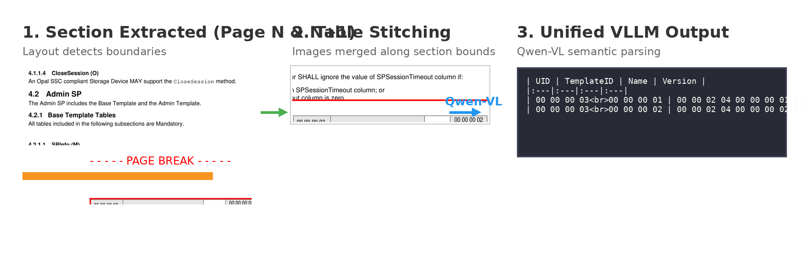
Stitched Layout Concept
Rule-based parsers treat Table 19 in Section 4.2.1.2 as two disconnected tables because the bottom row is cut off on Page 35 and continues on Page 36 without a repeating Title. - Our Methodology: The Section-Based Layout detector assigns both table bounding boxes to the “4.2.1.2 SPTemplates” hierarchy. Our rendering pipeline stitches the two images together along the page break (visualized via the orange stitching line in our diagram). - Result: Qwen-VL receives a single, unified image, seamlessly linking the multi-line UID values (e.g., 00 00...) that were physically split across the page boundary, producing a flawless markdown table.

Example 2: Ultra-Complex, Sparse Tables (TCG Opal Section 4.2.1.5 AccessControl)
Table 22: AccessControl is notoriously difficult. It spans 9 pages (Pages 38-46), has 16 columns of highly dense hex data interspersed with large empty cells (sparsity), and contains repeated intermediate headers (e.g., repeating the column titles on every new page). - Qwen-VL Output: The Vision LLM perfectly mapped the sparse cells, interpreting the empty spaces as structural alignment rather than shifting data to the left. Furthermore, it intelligently absorbed the repeating column headers as layout artifacts, preventing the markdown table from being broken up by redundant header rows.

6.4 Qualitative Findings
- Accuracy vs. Cost: The Vision LLM approach is approximately 40x slower than the rule-based approach. However, in the context of creating a static derived dataset (which is done once), this cost is negligible compared to the manual engineering hours required to fix broken rule-based outputs.
- Self-Correction: The VLM demonstrated emergent capabilities, such as correcting minor OCR artifacts by inferring the word from context (e.g., correcting “0xO1” to “0x01” in hex columns).

7. Conclusion
This study proves that for technical specification documents, the “traditional” trade-off between speed and accuracy is a false economy. The structural complexity and sparsity of technical tables make rule-based parsing inherently unreliable. A Pure Vision-LLM Pipeline, while computationally more expensive, effectively solves the “ghost column” and “misalignment” problems, providing a robust foundation for automated specification compliance. Future work will focus on optimizing the VLM context window to handle extremely long tables (10+ pages) without fragmentation.

