Robust Table Extraction for Technical Specifications
Using Vision Large Multi-modal Models
A Section-Based Visual-Hybrid Pipeline for NVMe and TCG Opal Specifications
Abstract
Extracting structured data from complex technical specification documents(PDFs)—such as TCG(Trusted computing group) Opal and NVMe standards—is a critical step for automated compliance testing and system verification. However, this task remains challenging due to irregular layouts, merged cells,cells in a cell and high sparsity commonly found in these PDFs. This paper evaluates the limitations of traditional rule-based extraction methods (e.g., PyMuPDF^{[10]}) and proposes a robust Section-Based Visual-Hybrid Pipeline utilizing Large Multimodal Models (LMMs).
While rule-based methods offer superior processing speed, they catastrophically fail on structurally complex tables—specifically those with sparse data where column alignment is visually implied rather than explicitly grid-lined. Vision LLMs (e.g., Qwen-VL^{[5]}) show exceptional capability in parsing complex structures but inherently process documents page-by-page, causing multi-page tables to suffer from fragmentation and contextual loss. We resolve this fundamental limitation by introducing a Section-Based Extraction approach paired with Image Stitching, which seamlessly merges disjointed table fragments across page boundaries prior to VLLM inference. By employing this methodology, we achieved near 100% extraction accuracy with zero data misalignment on extremely complex tables.

1. Introduction

1.1 The Challenge of Technical Specifications
Technical specifications for storage and security protocols—such as TCG Storage Opal SSC^{[1]} and NVMe Base Specification—are the ground truth for hardware and software development. These documents contain thousands of configuration parameters, command sets, and unique identifiers (UIDs) embedded within tables. Automating the extraction of this data is essential for generating code, creating verification suites, and ensuring standards compliance.
Unlike financial statements or simple invoices, technical specification tables often prioritize human readability over machine parse ability. They feature complex headers, multi-line spanning cells, and significant whitespace that make automated extraction particularly difficult.

1.2 Limitations of Existing Tools
Traditional PDF extraction tools like PyMuPDF, Camelot, and Tabula^{[11]} rely heavily on underlying text stream coordinates and explicit ruling lines. While effective for dense, grid-like tables, these heuristics break down in the following scenarios:
- Sparse Tables: Cells left empty to imply 'same as above' or 'N/A' are often misinterpreted as column shifts by rule-based parsers.
- Implicit Alignment: Data aligned by visual indentation rather than physical grid lines cannot be reliably parsed.
- Complex Headers: Multi-level headers that rule-based tools fail to correctly associate with corresponding data columns.

This study highlights a specific failure mode in the TCG Opal specification where rule-based extraction generates 'ghost columns' and misaligned data, and presents a Vision-LLM solution that resolves these issues.

1.3 Motivation
The primary motivation for this work arose from a practical bottleneck encountered while developing automated compliance testing tools(test case) for storage protocols such as TCG Opal and NVMe. Technical specifications contain vital configurations and parameters, but the structured data locked within these PDFs is extremely resistant to conventional parsing. Manual transcription is not scalable, and rule-based extractors yield silent errors that require extensive human correction. We needed a fully automated, high-fidelity extraction system that interprets visual layout cues exactly as a human engineer would—eliminating the need for manual data verification.

2. Methodology: From Hybrid to Vision-Only

2.1 The Initial Hybrid Approach
Our initial hypothesis was that a hybrid pipeline could balance cost and accuracy. We designed a system that prioritized speed with a three-stage fallback architecture:
- Fast Path (Rule-Based): Use PyMuPDF with optimized parameter tuning (snap_tolerance, intersection_tolerance) to extract simple grid tables.
- Quality Gates: Implement heuristics to detect potential failures, such as checking for empty columns or header-to-data width mismatches.
- Slow Path (Vision Fallback): Route only 'detected failures' to a Vision LLM for re-processing.

2.2 The Sparsity Paradox: Silent Failures
We discovered a critical flaw in the hybrid model: silent failures. Rule-based parsers often returned 'valid-looking' markdown tables—correct dimensions, no errors thrown—that were semantically incorrect. Because the extraction logic appeared to succeed mathematically (coordinates matched), the Quality Gates failed to flag the errors, allowing corrupted data to pass through undetected.
This finding led us to abandon the heavily rule-based approach in favor of a Vision-Only pipeline for all complex visual elements, while retaining rule-based parsing strictly for standard paragraph text.

3. Findings & Failure Analysis

3.1 Case Study: The TCG Opal MethodID Table
The most distinct failure occurred with Table 21: MethodID in the TCG Opal specification. This table lists UIDs (byte sequences) and their corresponding Method Names. Crucially, the byte sequences are often short, leaving large amounts of whitespace in the 'UID' column—a pattern that exposes the fundamental weakness of coordinate-based parsers.

PyMuPDF Failure Mode
- The rule-based parser detected wide gaps between short UID text and the next column as 'new columns'.
- This resulted in splitting a single logical column into multiple phantom (ghost) columns.
- Data shifted rightward: the 'Name' text appeared in the 'CommonName' column, and 'TemplateID' was pushed out of existence.
- Impact: UIDs became dissociated from their Method definitions, rendering extracted data useless for automated code generation.

Table A — Erroneous PyMuPDF Output: Ghost column causes data to shift rightward
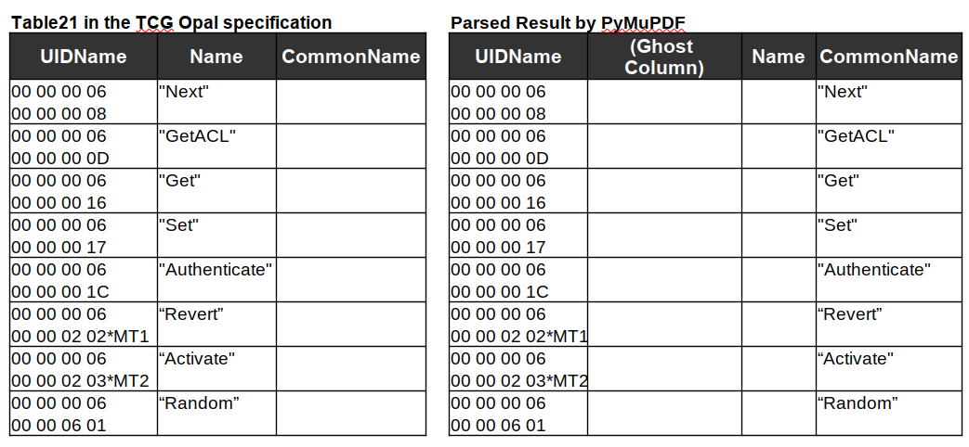

Note: The blank '(ghost column)' does not exist in the original document. Data in the 'CommonName' column should appear in 'Name'.

Vision LLM Advantage
When the same table image was processed by a Vision LLM (Qwen-VL), results were dramatically better. The model recognized that wide whitespace was simply padding for alignment, not a column delimiter. Short byte sequences were correctly aligned under the 'UID' header based on visual proximity and vertical alignment, producing Markdown structurally identical to the human-readable PDF with 0% data misalignment.

Table B — Correct Section-Hybrid Output: All columns properly reconstructed
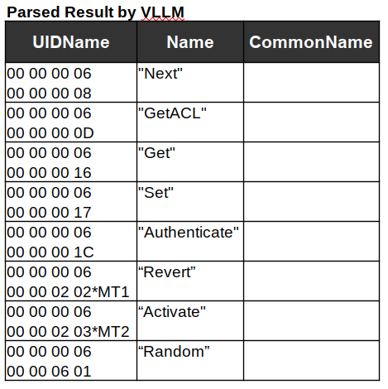

4. Proposed Architecture: Section-Based Visual-Hybrid Pipeline
Based on the failure analysis, we abandoned the heavily rule-based approach in favor of a Visual-Hybrid pipeline combined with a robust contextual extraction strategy. Our architecture is fundamentally hybrid: standard text is extracted rapidly using PyMuPDF, while all complex visual elements (tables and figures) are routed to the Vision LLM for high-fidelity parsing.

4.1 Section-Based Extraction Strategy
Instead of blindly extracting tables page-by-page, our pipeline introduces a Section-Based Method. We first parse the document's hierarchy via the Table of Contents and header detection to define section boundaries. All extracted elements—tables, figures, and text—are then systematically organized into their respective sections.
- Context Preservation: Organizing data by section ensures that each table retains its structural context, critical for mapping parameters to their exact functional definitions in downstream applications.
- Simplified Table Merging: Table fragments on consecutive pages belonging to the same logical section node are trivially grouped without relying on complex and error-prone heuristic matching.

4.2 Image Stitching for Multi-Page Tables
To process multi-page tables seamlessly, we implemented an Image Stitching technique leveraging section-based grouping. When a table spans multiple pages—for example, a ComID Management table beginning at the bottom of page 15 and continuing onto page 16—both table fragments are indexed under the exact same section hierarchy. The pipeline automatically identifies them as parts of a whole, then vertically stitches the two cropped images into a single contiguous image.
When this synthesized, stitched image is provided to the Vision LLM, the model interprets the entire table holistically. This completely eliminates errors caused by page breaks, such as repeated headers or orphan rows, allowing the LLM to output a single, perfectly merged Markdown table.

4.3 Pipeline Workflow
1. Layout Analysis: A dedicated object detection model (DeepSeek-OCR^{[6]}) scans each
PDF page to identify table bounding boxes.
2. High-Fidelity Rendering: Identified regions are rendered as high-resolution images at
300DPI.
3. Section Assignment & Stitching: Table images are assigned to their logical sections.
Multi-page tables within the same section are stitched into contiguous images across
page boundaries.
4. Vision LLM Inference: The final stitched images are fed into Qwen-VL to directly
output a single, well-formed Markdown table without fragmentation.

4.4 Visual-Hybrid vs. Pure VLLM Strategies

Since our approach still utilizes PyMuPDF for standard paragraph text, we evaluated our Visual-Hybrid approach against a Pure VLLM approach (where the entire PDF page is fed holistically into a model like DeepSeek-OCR to generate unified Markdown).
Visual-Hybrid (Text via PyMuPDF, Tables/Figures via VLLM)
- Pros: Extremely fast processing for bulk text. Zero hallucination risk for standard paragraphs read directly from the binary stream. Cost-effective, as token-heavy LLM inference is reserved for complex visual elements only.
- Cons: Pipeline success depends on layout detection accuracy. If the detection model fails to bound a table correctly or misses a table entirely, downstream inference receives flawed crops.

Pure VLLM (Entire Page via VLLM)
- Pros: Eliminates the need for a separate layout detection module. The model inherently understands the semantic flow of an entire page.
- Cons: Extremely slow and computationally expensive for massive specifications. Susceptible to hallucinations in standard text and 'attention fading'—casually skipping paragraphs or truncating tables toward the bottom of a dense page.

Our pipeline adopts the Visual-Hybrid architecture to secure the deterministic accuracy of text extraction while achieving maximum table fidelity, using the Section-Based method to compensate for the flow-awareness gap.

5. Implementation Details

5.1 Technology Stack
- Core Engine: Python-based batch processing pipeline.
- Vision Model: Qwen2.5-VL-72B (via OpenAI-compatible API) for production; Qwen2-VL-7B (via Ollama) as a local fallback.
- Helper Libraries: pdf2image for rendering, BeautifulSoup for post-processing HTML/Markdown output.

5.2 Vision LLM Evaluation & Selection
We evaluated several state-of-the-art vision models to determine the optimal balance between cost, speed, and complex table reasoning capabilities. The results are summarized in Table C below.

Table C — Vision Model Comparison: Roles and Characteristics
Model | Size | Role in Pipeline | Characteristics
DeepSeek-OCR | ~3B | Layout Analysis | Fast and lightweight. Excellent for bounding box detection. Cannot reconstruct complex table structures.
GLM-OCR | ~2.2GB | Evaluation Only | Better than DeepSeek-OCR on standard tables. Fails on irregular or highly sparse tables.
Qwen3-VL-32B  q4 | ~20GB / | Table Extraction | Exceptional semantic understanding. Correctly infers column alignment from whitespace. Core engine for high-fidelity markdown generation.

We integrated DeepSeek-OCR strictly for its strength in Layout Analysis (Step 1) to generate bounding box coordinates, while utilizing Qwen-VL as the core engine for visual rendering and markdown table extraction (Step 4).
This division of labor is operationalized in our pipeline through the following four sequential steps:
Step 1: Layout Analysis (DeepSeek-OCR): DeepSeek-OCR acts solely as a rapid layout detector. It scans the raw PDF pages to identify spatial coordinates (bounding boxes) for texts, figures, and tables without attempting to interpret the complex internal data structure of the tables.
Step 2: High-Fidelity Rendering: Using the exact bounding boxes determined in Step 1, the pipeline renders and crops standard text segments via PyMuPDF, while rendering tables and figures as high-resolution (120 DPI) visual images.
Step 3: Section Assignment & Image Stitching: The pipeline interprets the document's logical hierarchy (TOC and headers) to assign each extracted visual element to its correct Section. If a table spans multiple pages within the same section, the isolated bounding box images are physically stitched together into a single, contiguous large image.
Step 4: Vision LLM Inference (Qwen-VL): The finalized, stitched images are sent to Qwen-VL. Free from page-break fragmentation and provided with the complete visual context, Qwen-VL generates a structurally perfect, completely aligned Markdown table.

5.3 Key Visual Parsing Logic
The step4_llm_parser.py module implements the core logic with the following features:
- Image Preprocessing: Validates image dimensions to ensure they fit within the LLM's context window, resizing only when strictly necessary to avoid token overflow.
- Prompt Engineering: A robust system prompt that enforces preservation of verbatim cell content (especially hexadecimal values), handling of multi-line cells using <br> tags rather than splitting rows, and explicit instruction to ignore page footer/header noise captured in the crop.

6. Experimental Results & Evaluation

6.1 Dataset and Setup
To evaluate robustness across diverse document structures, we tested four distinct technical specifications, each presenting unique table extraction challenges:
1. TCG Storage Opal SSC v2.30 & TCG Storage Architecture Core Spec v2.01: Distinct
labels for Tables and Figures. Multi-page tables frequently omit titles on continuation
pages. Challenge: contextually linking title-less table fragments and merging them with
the preceding titled table.
2. NVMe Base Specification^{[3]} (Rev 2.03): Both tables and images are captioned as
'Figure'. Features highly complex nested tables. Challenge: merging tables based on
repeated identical titles, handling table-in-table hierarchies, and distinguishing text-based
tables from actual pictures.
4. Datacenter NVMe SSD Specification^{[4]} v2.0r21 (OCP): Tables completely lack explicit
titles or captions, but multi-page tables preserve table headers on subsequent pages.
Challenge: grouping isolated, title-less table fragments based purely on their presence
within the same logical section boundary.

Hardware Setup: NVIDIA RTX 5060Ti(VRAM16GB) for local inference and Vision API for robust production processing.

6.2 Quantitative Performance (F1 Score Benchmark)
We measured Table Recognition accuracy using a cell-by-cell F1 metric for structural and content fidelity across 6 parsing methods. The dataset included manually verified ground truths from pages 34–36 of the TCG Opal specification. Results are shown in Table 1 below.

Table 1 — F1 Score (%) Comparison Across Parsing Methods and Table Complexity
Task Type | PyMu-PDF | Deep  Seek-OCR | GLM-OCR | Claude Opus 4.5 | Gemini 3.0 Pro | Section-Hybrid Qwen-VL (Ours)
Simple Grid Tables | 100.0 | 100.0 | 100.0 | 100.0 | 100.0 | 100.0
Complex Nested Tables | 33.3 | 100.0 | 100.0 | 100.0 | 100.0 | 100.0
Sparse Tables | 58.3 | 97.2 | 97.2 | 100.0 | 100.0 | 100.0
Multi-page Stitched Tables | 73.3 | 73.3 | 73.3 | 87.8 | 36.8 | 100.0
Bold values indicate the best result per row. Section-Hybrid Qwen-VL (Ours) achieves 100% across all categories.

6.3 Analysis of LLM Failures on Multi-Page Tables
While state-of-the-art commercial models generate aesthetically pleasing Markdown for complex static tables, our rigorous structural F1 evaluation revealed critical blind spots when processing fragmented multi-page tables (e.g., Table 20 spanning pages 35–36):
- Page-by-Page Truncation — PyMuPDF, DeepSeek-OCR, GLM-OCR^{[7]} (73.3% F1): Standard models lack cross-page context or spatial stitching, completely missing table data rows that extend onto subsequent pages.
- Claude Opus 4.5^{[8]} (87.8% F1): Successfully identified all 15 column headers across the page split. However, suffered from 'attention fading' and silently truncated bottom data rows after the page break, resulting in missing information.
- Gemini 3.0 Pro^{[9]} (36.8% F1): Exhibited severe structural hallucination. Instead of preserving the complex 15-column layout, it arbitrarily merged data into a highly condensed 4-column CSV-like structure. While human-readable as a summary, this catastrophic loss of structural fidelity makes the output entirely useless for programmatic data extraction.
- Section-Hybrid Qwen-VL (100.0% F1): By physically stitching disjointed table fragments into a single coherent image before VLM inference, our pipeline fundamentally bypassed the contextual fragmentation that caused the other models to hallucinate or truncate, yielding perfect structural and content recreation.

6.4 Concrete Parsing Examples

Example 1: Multi-Page Stitching (TCG Opal Section 4.2.1.2 — SPTemplates)
Rule-based parsers treat Table 19 in Section 4.2.1.2 as two disconnected tables because the bottom row is cut off on page 35 and continues on page 36 without a repeating title. Our Section-Based Layout detector assigns both table bounding boxes to the '4.2.1.2 SPTemplates' hierarchy, automatically identifying them as parts of a whole. The pipeline stitches the two images together along the page break, and Qwen-VL receives a single, unified image—seamlessly linking multi-line UID values that were physically split across the page boundary—producing a flawless markdown table.

Example 2: Ultra-Complex Sparse Tables (TCG Opal Section 4.2.1.5 — AccessControl)
Table 22: AccessControl spans 9 pages (pages 38–46), has 16 columns of highly dense hex data interspersed with large empty cells, and contains repeated intermediate column headers on every new page. Qwen-VL perfectly mapped the sparse cells, interpreting empty spaces as structural alignment rather than shifting data leftward. It also intelligently absorbed the repeating column headers as layout artifacts, preventing the markdown table from being fragmented by redundant header rows.

6.5 Qualitative Findings
- Accuracy vs. Cost: The Vision LLM approach is approximately 40x slower than the rule-based approach. However, in the context of creating a static derived dataset (done once), this cost is negligible compared to the manual engineering hours required to fix broken rule-based outputs.
- Self-Correction: The VLM demonstrated emergent capabilities, such as correcting minor OCR artifacts by inferring the correct value from context—for example, correcting '0xO1' to '0x01' in hex columns.

7. Application and Conclusion

7.1 End-to-End Processing Flow & RAG Integration
To maximize utility of the extracted technical specifications, our pipeline is designed not just to parse data, but to feed directly into an automated reasoning system. The overall architecture flows from raw PDF ingestion to Retrieval-Augmented Generation (RAG):
- Raw PDF Ingestion & Layout Analysis: The document is processed to identify bounding boxes for texts, tables, and figures. The Table of Contents establishes the hierarchical section boundaries.
- Hybrid Extraction (PyMuPDF + VLM): Simple paragraphs are quickly parsed via PyMuPDF. Complex visual elements, including multi-page tables, are stitched together based on section tags and sent to Qwen-VL for high-fidelity markdown generation.
- Hierarchical JSON/MD Merging: Extracted text and structurally perfect markdown tables are merged into a unified JSON schema, strictly organized by their original section hierarchy (e.g., Section 4.2.1.2).
- RAG Vector DB Integration: The hierarchical JSON files serve as pristine embedding chunks for the RAG database. Guaranteed multi-page table stitching and elimination of ghost columns ensure perfectly structured context is fed into the database.
- Automated Test Case Generation: An LLM agent can query this RAG database with complete confidence, enabling autonomous generation of flawless C++/Python compliance verification scripts with zero hallucination.

Key insight: When building a RAG system for engineering protocols, a single misaligned table column—such as the PyMuPDF ghost column error—corrupts the vector embedding. Our Section-Based Visual-Hybrid Pipeline eliminates these silent failures, ensuring trust in fully automated downstream applications.

7.2 Conclusion
This study demonstrates that for technical specification documents, the traditional trade-off between speed and accuracy is a false economy. The structural complexity and sparsity of technical tables make rule-based parsing inherently unreliable, leading to silent failures that cripple downstream automated applications.
Our Section-Based Visual-Hybrid Pipeline effectively solves the 'ghost column' and 'misalignment' problems. Furthermore, by physically stitching multi-page visual elements prior to VLM inference, we completely bypassed the contextual fragmentation that traditionally plagues even state-of-the-art commercial LLMs. While computationally more expensive upfront, producing a 100% accurate, structure-preserved dataset provides a robust, zero-hallucination foundation for RAG infrastructure and automated specification compliance.
Future work will focus on optimizing the VLM context window to handle extremely long tables (10+ pages) without performance degradation, and on developing adaptive prompt engineering strategies that further reduce hallucination risk in edge cases.

Appendix : Complex Table Structure Examples
Figure 1(Merged Table Header)
Parsing Challenge (Complex Merged Headers): Technical specification tables frequently employ multi-level merging in their column headers to categorize parameters. Traditional parsing heavily relies on vertical alignment and grid lines mapping down to individual data cells. When headers are complexly merged, these parsers consistently fail to anchor the sub-headers to their correct respective data columns, leading to entirely disjointed tables where values are mismatched from their defining attributes.

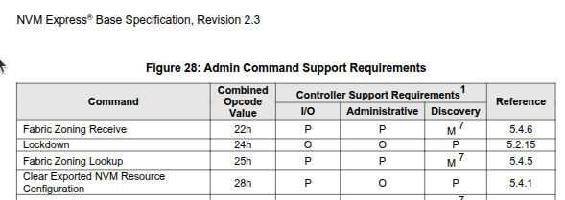

Figure2 (Cells in Cell Structure)
Parsing Challenge (Nested Constraints / Table-in-Table): This table contains deeply nested hierarchies or sub-tables within individual cells. Conventional extraction techniques assume a flat, uniform grid structure and cannot comprehend arbitrary nested groupings. As a result, they flatten the nested layout unnaturally, destroying the relational hierarchy of the sub-parameters and fusing independent sub-cells into garbled text strings.

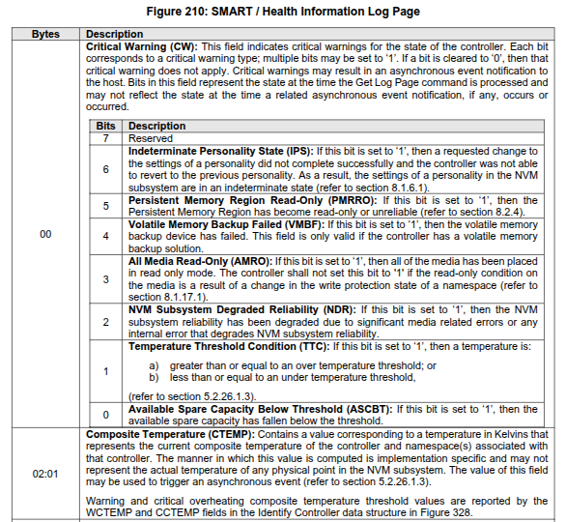

Figure3(Sparse)
Parsing Challenge (Sparse Structure): This table has a highly sparse structure using implicit visual alignment rather than explicit grid lines. Empty whitespace is used to group data or imply 'same as above'. Rule-based text parsers and standard OCRs misinterpret these large gaps as column delimiters, resulting in 'ghost columns' and severe data misalignment.

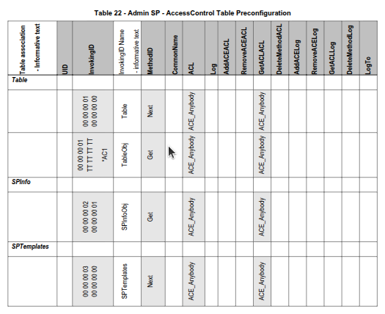

Figure 4(Table Break between documents pages)
Parsing Challenge (Page-Break Fragmentation): This table physically spans across multiple pages without repeating headers. Standard page-by-page vision models and PDF parsers suffer from contextual fragmentation. They process each page in isolation, leading to truncated trailing rows at the page boundary or hallucinated new column layouts because the model lacks the stitched, holistic visual context.

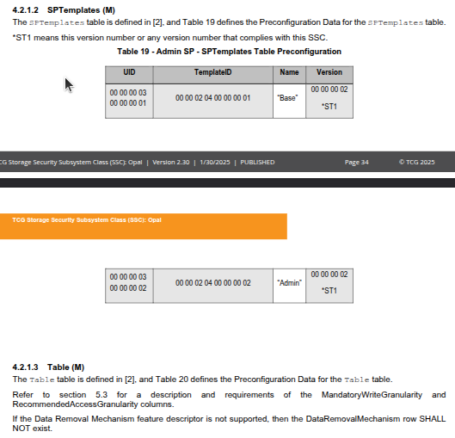

References
[1] Trusted Computing Group (TCG), "TCG Storage Security Subsystem Class: Opal," Version 2.30.
[2] Trusted Computing Group (TCG), "TCG Storage Architecture Core Specification," Version 2.01.
[3] NVM Express, Inc., "NVM Express® Base Specification," Revision 2.0c (or Rev 2.03).
[4] Open Compute Project (OCP), "Datacenter NVMe® SSD Specification," Version 2.0r21.
[5] Bai, J., et al., "Qwen-VL: A Versatile Vision-Language Model for Understanding, Localization, Text Reading, and Beyond," arXiv preprint arXiv:2308.12966, 2023. (See also Qwen2-VL/Qwen2.5-VL updates).
[6] DeepSeek-AI, "DeepSeek-VL: Towards Real-World Vision-Language Understanding," arXiv preprint arXiv:2403.05525, 2024.
[7] GLM Team, "ChatGLM: A Family of Large Language Models from GLM-130B to GLM-4 All Tools," arXiv preprint arXiv:2406.12793, 2024.
[8] Anthropic, "The Claude 3 Model Family: Opus, Sonnet, Haiku," 2024.
[9] Google DeepMind, "Gemini 1.5: Unlocking multimodal understanding across millions of tokens of context," arXiv preprint arXiv:2403.05530, 2024.
[10] Artifex Software, Inc., "PyMuPDF: A high performance Python library for data extraction, analysis, conversion & manipulation of PDF files," [Online]. Available: https://pymupdf.readthedocs.io/
[11] Tabula, "Tabula: A tool for liberating data tables trapped inside PDF files," [Online]. Available: https://tabula.technology/
[12] Camelot, "Camelot: PDF Table Extraction for Humans," [Online]. Available: https://camelot-py.readthedocs.io/

