HV tests during SQ 16 step 4; SQ 17 step 20 (SQ18 is running when SQ17 is active). I don’t plan to have a HV test in GHe. I’m not sure we regulate on the TTs during SQ 16; SQ 17-18, but PTs are important.

We want to keep a constant flow and a constant regulation during the tests

SQ8 and SQ19 are running during the tests

**Here is the list of the sensors I want to disconnect:**

TT:

* TT650[1] used to control EH650A, EH650B (CURRENT LEADS)
* TT651 used to control EH651A, EH651B (CURRENT LEADS)
* TT652 used to control EH652A, EH652B (CURRENT LEADS)
* TT653 used to control EH653A, EH653B (CURRENT LEADS)
* TT654 used for TIC654 PID (CV650 control) (CURRENT LEADS)
* TT655 used for TIC655 PID (CV651 control) (CURRENT LEADS)
* TT656 used for TIC656 PID (CV652 control) (CURRENT LEADS)
* TT657 used for TIC657 PID (CV653 control) (CURRENT LEADS)
* TT654x; 655x; 656x; 657x (CURRENT LEADS) - **not used for control**
* TT690-TT693 – used for status sent to MAG LPS (CURRENT LEADS Temp OK)
* TT670A; 670B; 670C used to control EH670AC (SHIELD HEATERS)
* TT 660A; 660B; 660C used to control EH660AC (LP HEATERS)
* TT 661A; 661B; 661C used to control EH661AC (MAGNET HEATERS)
* TT 681A; 6810B; 681C used to control EH681AC (MAGNET HEATERS)
* TT 682A; 682B; 682C used to control EH682AC (MAGNET HEATERS)
* TT 689A; 689B; 689C used to control EH689AC (MAGNET HEATERS)

#PLC.magnet_insert bit is set when the cables are disconnected for the HV tests. (in steps 6 to 8 of SQ4)

* TT666_M used in SQ8 N22 &N23 to secure LT683 measurement
* TT667_M-TT669_M, TT671_M-TT679_M - **not used for control**
* TT694M-TT699_M - **not used for control** (EXTRA)
* TT684 used in SQ8 N22 &N23 to secure LT683 measurement
* TT683, TT687, TT688 - **not used for control**
* TT685
  + used in SQ15 step 8 in condition for proceeding to step 6 but SQ15 is not active in SQ16-17 (when the HV test is allowed)
  + Used for setting EH680 ExtCmd when < 50 K (to turn on the heater in SQ23 when TT680 is out of range).
* TT686 - **not used for control** (2K)
* TT680 used to control EH680, used in SQ15 step 6 in condition for proceeding to step 8 but SQ15 is not active in SQ16-17 (when the HV test is allowed) (2K HEATERS)
* TT662_M
  + used in SQ15 to check the magnets dT/dL (together with TT665M) and dT/dt but SQ15 is not active in SQ16-17 (when the HV test is allowed)
  + used in SQ8 to secure LT660 measurement
* TT663_M - **not used for control**
* TT664_M
  + used in SQ14 together with TT665M in SQ14 step 4 in condition for proceeding to step 6, in step 6 to step 8 and in step 8 to 6 but SQ14 is not active in SQ16-17 (when the HV test is allowed)
  + Used for setting EH681, EH682 and EH689 ExtCmd when < 50 K (to turn on the heater when corresponding PT100 sensors are out of range.
* TT665_M
  + used in SQ14 together with TT664M in SQ14 step 4 in condition for proceeding to step 6, in step 6 to step 8 and in step 8 to 6 but SQ14 is not active in SQ16-17 (when the HV test is allowed) (MAGNET)
  + used in SQ15 to check the magnets dT/dL (together with TT664M) but SQ15 is not active in SQ16-17 (when the HV test is allowed)

PT:

* PT660M (2K)
  + Used in SQ13 (not used with magnet insert)
  + Controls (enables/disables) ramping of CV581 in SQ15 step 6
  + Controls (turns it on/off) FIC581 PID in SQ15 step6
  + Used in SQ17 in condition for transition from step 18 to 20
  + Used in SQ17 mini sequence in condition for transition from step 1 to 2 (we should not perform the test when stopping 2K operation)
  + Used in SQ17 step 20 for choosing which PT (660 or 661) use for regulation – this shouldn’t be a problem when we reset the simulation mode in SQ4 step 10.
  + Used in SQ24 in condition for transition from step 6 to 8
  + Used by PIC660A (CV582) in SQ13,
  + Used by PIC660 (**CV581**) in SQ10, SQ12 (both not used for magnet insert), SQ14, SQ15, SQ16 and SQ20
  + Used in SQ13 and SQ17 for choosing which PT (660 or 661) use for regulation
  + Controls CV582 in SQ17 step 18
* PT661M (2K)
  + Used by PIC660A (**CV582**) in SQ13 and SQ17 step 20
  + Used in SQ17 step 20 for choosing which PT (660 or 661) use for regulation
* PT680 (INSERT) - **not used for control**
* PT681 (INSERT)
  + Used in PIC681 (**CV583**) in SQ15, SQ16 (step 4 and 6), SQ18 (step 4, 6, 8, 10, 12, 14) and SQ20
  + Used in creating the SQ15_LIC682_conditions in SQ15
  + Used in SQ24 in condition for transition from step 6 to 8

EH:

* EH681AC, EH682AC, EH689AC, EH661AC (MAGNET HEATERS) - used in SQ23
* EH660AC (LP HEATERS) - used in SQ23
* EH670AC[2] (SHIELD HEATERS) – used in SQ8 and SQ23
* EH650A/B-EH653A/B (CURRENT LEADS) – used in SQ19 and SQ23
* EH 680 (2K HEATERS) – used in SQ23

FV:

* FV680[3] (LP)
  + Used in SQ15 in condition for transition from step14 to 0
  + Used in SQ15, SQ16 step4, SQ18 step 4, 6, 8, 10, 12 and 14, SQ20, SQ22 and SQ23

 CV:

* CV680[4]
  + SQ16
    - in stopping step – checking if it’s set to 0
    - step 6 – setting to 0
  + In SQ2
  + Controlled by LIC683 when it’s active (#DATA_PID.LIC683.XH_API=1). It is active in SQ15 step 12, SQ16 step 4, SQ18 steps 4,6,8,10,14
    - SQ15 – set to the parameter SP_LT683
    - SQ16 – set to parameter SP LIC683 (called SP_CV680_LT in the PLC)
    - SQ18 – set to SP LIC683 (called SP_CV680_LT in the PLC)
  + SQ15
  + SQ18
    - Step 12 – setting to 0 (when stopping SQ18 or SQ17
    - Step 20

**Stay connected:**

LT:

* LT680; 681; 682; 683

At 2K we probably must freeze CV582, after connecting back the cables we should check on how to proceed with the pumping of 2K tank.

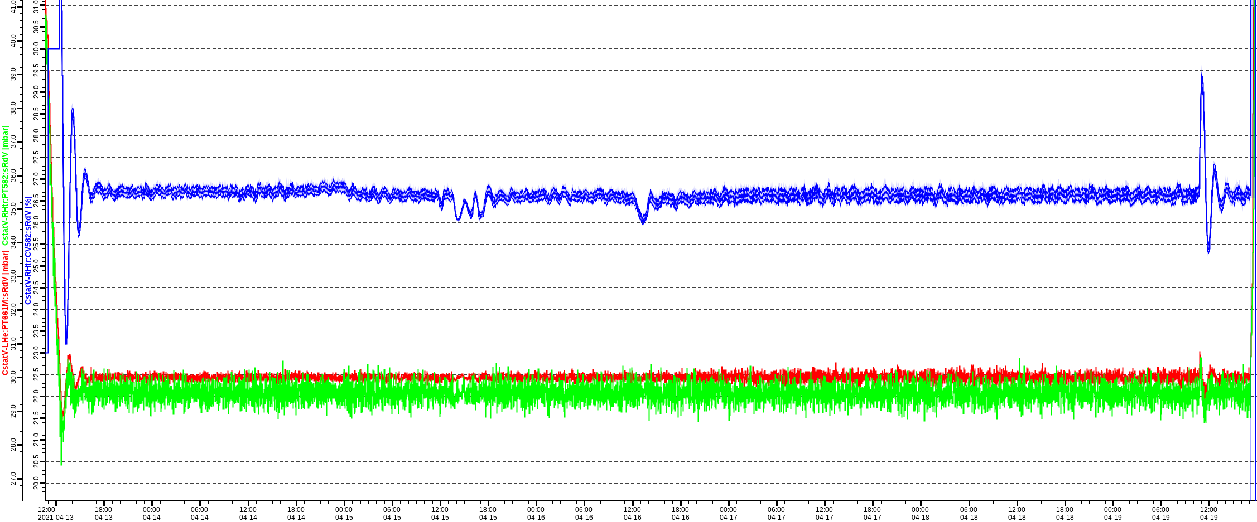 From the graphs it looks like the CV582 is pretty stable but during normal run the LI683 is maintained by LIC683 (CV680). IN SQ4 CV680 will be closed. An alternative is to use PT582 instead of PT5661M as a readback for PIC660A. **To be tested!**

At 4K we may use FT581 and FIC581 to control the flow using CV581

General ideas about the sequence:

**Initial conditions:** “SQ16 step 4” or “SQ17 step 20”

**Step 4:** Waiting for the operator to start the test

**Transition to 6:** by the operator

**Step 6** : setting all PV to simulated mode, set mode of regulation for CV650-CV653 to flow (values set from SQ4’s parameters, disabling PIDs or changing the mode, turning off the heaters, freezing the settings of the valves.

We need to save the state of the sensors/actuators/modes before changing them to be able to restore to the original settings after the completed test.

The following states must be saved:

* Simulate state for all TT
* Simulate state for all PT
* Modes of regulation of the current leads cooling CstatV-Ctrl:SQ19:sP_RegCV650- sP_RegCV653
* LHe levels

**Transition to 8:** automatic after 1 s delay and operator’s confirmation that the cables are disconnected

**Step 8:** HV tests, Cables disconnected   
Keep the pressure/flow (how?) We need to control CV581 (SQ16), CV582 (SQ17) and CV583. Possible solutions:

* Keep them at the last position (risky if the regulation requires big changes of the actuators and the last settings are not good) **Implemented in the first version. We will test it and see how we can do better in the future.**
* Have them as parameters to the sequence – easiest to implement and might be ok but requires manual operation
* CV583 – use PT583 instead of PT680/681
* CV581 – use PT581/582 instead of PT660M/661M
* CV582
  + use PT581/582 instead of PT660M/661M
  + in 2K mode open fully (or as a parameter to any value) and use 2K pumps’ Auto mode

The LHe levels should be kept constant by the regulators LIC683 (operating CV680) and LIC682 (operating CV602).   
Show the warning message when the LHe drops too much

**Transition to 10:** on operator’s Stop the sequence command after connecting back the cables

**Step 10:** Cables reconnected. Check if it’s safe to reset the Simulation mode and restore settings for the actuators and PIDs

Opening CV680 with slope (parameters in COMM_PAR.SQ4)

Step 12 -18 reserved for safe restoring the normal operation (changing settings of CV581-CV583 and CV680 valves.

Step 20 – Stopping

Transition to step 0 – directly from 20

1. Analog input PVs in blue – set to SIMULATED mode during the test
2. Heaters in blue – On command reset in SQ4 steps 6 and 8
3. Valves in blue – Open command is reset in SQ4 steps 6 and 8
4. CV680 set to 0 in SQ4 step 6, opened with ramp in step 10