SQ20 – Emptying of the cryostat

**Sensors and actuators used:**

- Level: LI670, LI680, LT590

- Pressure: PT590, PT660, PT681

- Valve: FV602, FV640, FV641, FV642, FV643, FV680, FV681, Switch valves

- Control valve: CV601, CV602, CV603, CV680, CV581, CV583, CV590, CV591

- Temperature: TT645, TT591

|  |  |
| --- | --- |
| **The user chooses:** | **Initial conditions:** |
| - Level: LI670setpoint, LI680setpoint, LT590setpoint | - Liquid or Magnet insert selected  - Sequences from 1 to 3 stopped  - Sequences 10,12, 13, 14 stopped  - Sequences from 15 to 19 stopped  - Sequence 8 in operation |
| - Pressure: PT660setpoint, PT681setpoint, PT590setpoint |
| - Valve: CV581%opening, CV583%opening, CV590%opening |
| - Temperature: TT645setpoint |

Liquid mode

Start

Stop

CV601 closed

Close CV601, CV602, CV603

Close FV642, FV643

Stop

FV641 closed

Close FV602

Prepare to L021 connection

FV602 closed

No

Yes

“The cryogenic Line L021 is it connected to the cryostat?”

“Do you want to stop the emptying?“

No

Yes

TT645 OR TT590 < TT645setpoint

Isolate Valve Box tank

Open FV640, FV641

CV590 opens with a slope

Cool down

L021

LT590 > LT590setpoint

Stop

LI670 < LI670setpoint

CRYOSTAT EMPTY

“Do you want to stop the emptying or define a new level setpoint?“

DEWAR FULL

“Do you want to stop the emptying or define a new level setpoint?“

LI670 < LI670setpoint OR LT590 > LT590setpoint

New setpoint

Stop

New setpoint

Filling Stopped

Close FV641

CV581 regulated

PT660=PT660setpoint

Pressurization

Cryostat

CV581 regulated

PT660=PT660setpoint

DEWAR FULL

“Have you defined the new level setpoint?“

Yes

CRYOSTAT EMPTY

“Have you defined the new level setpoint?“

Yes

Stop LHe transfer

Close FV640, CV590

FV641 opened

FV640, FV641 opened

CV590 regulated

PT590=PT590setpoint

Start LHe transfer

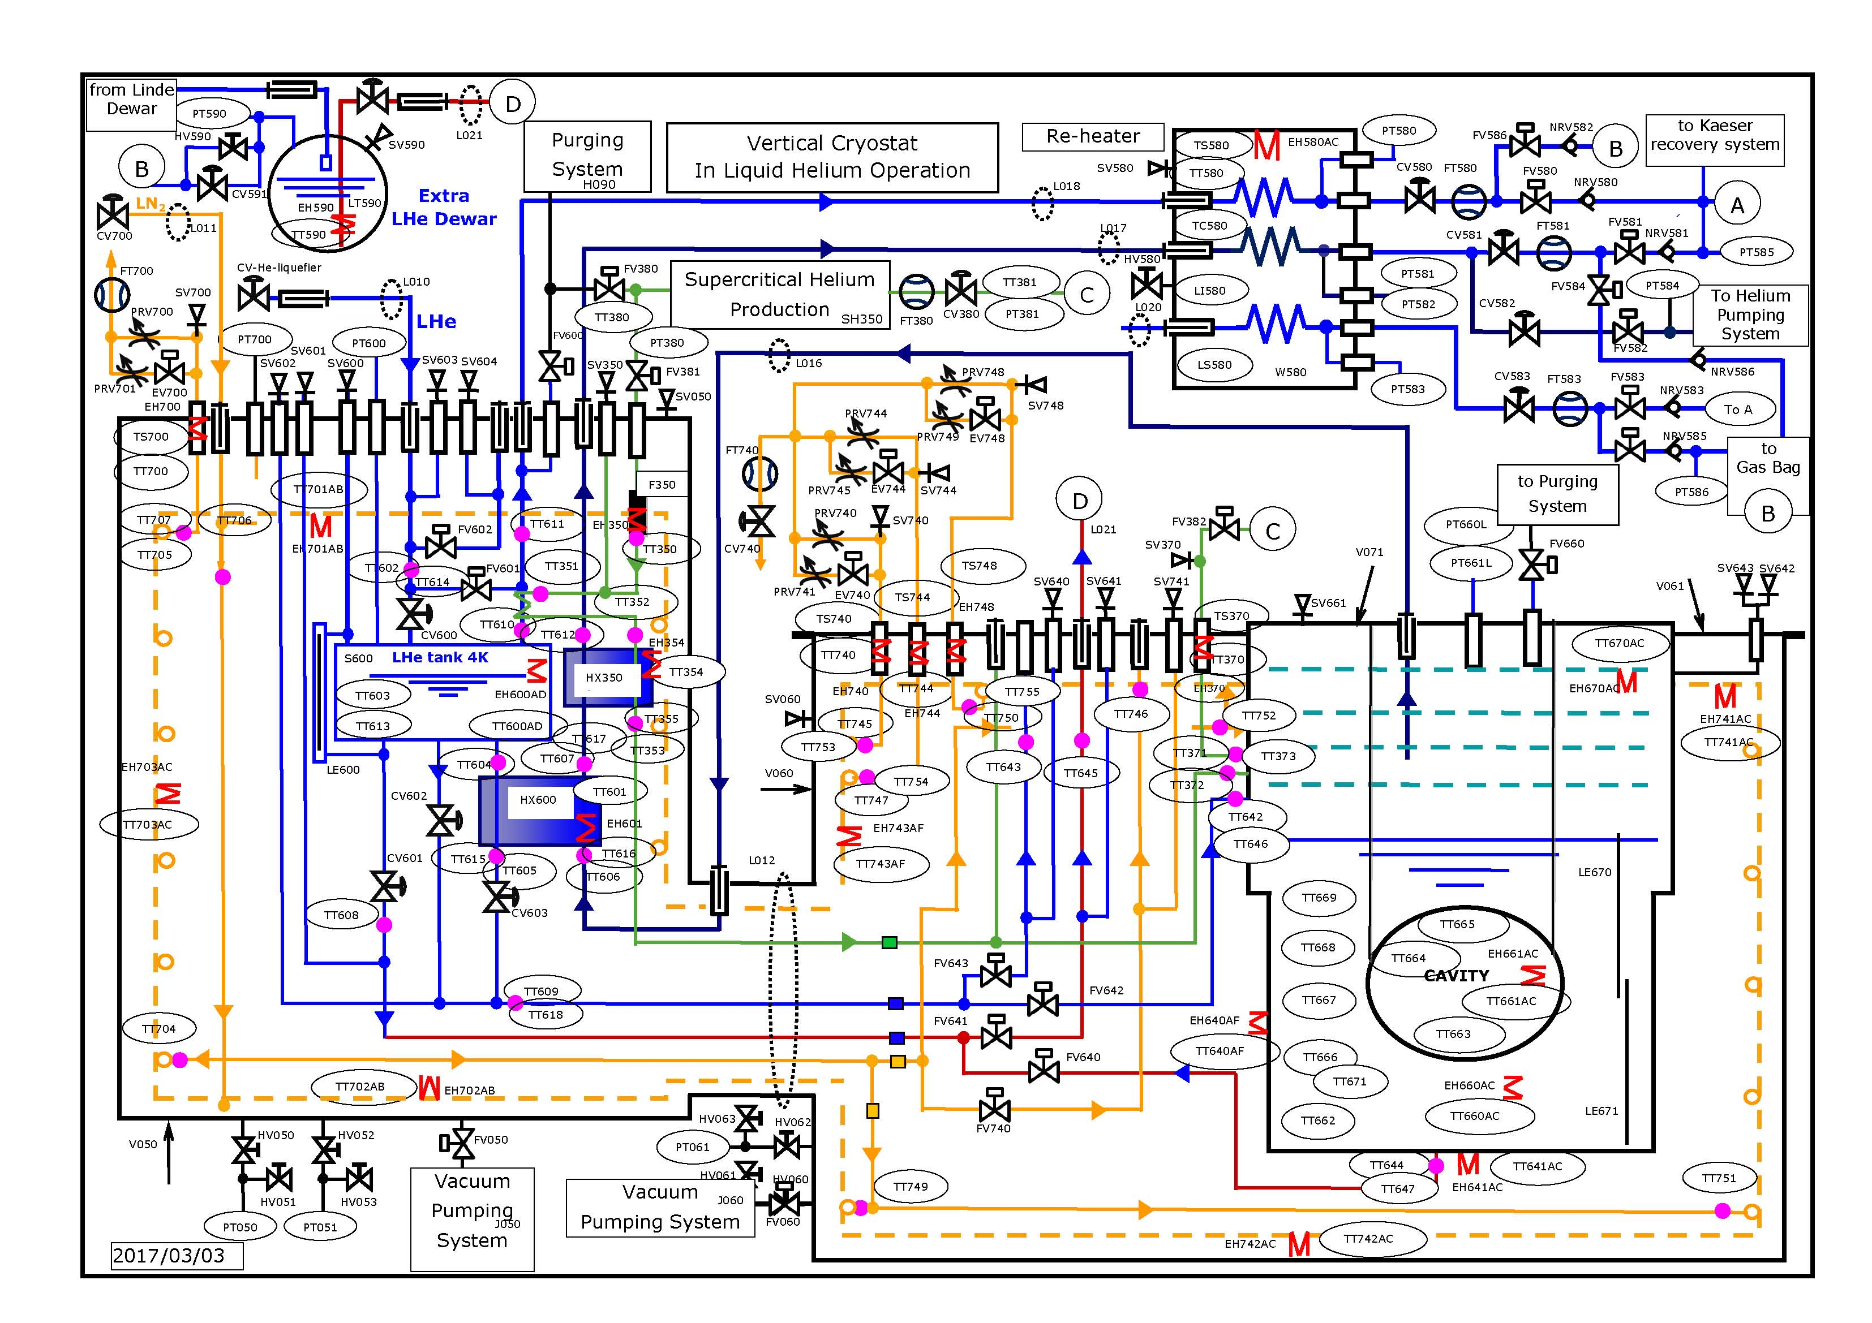Magnet mode

Start

Stop

CV601 closed

Close CV601, CV602, CV603

Close FV642, FV643

Stop

FV641 closed

Close FV602

Prepare to L021 connection

FV602 closed

No

Yes

“The cryogenic Line L021 is it connected to the cryostat?”

“Do you want to stop the emptying?“

No

Yes

TT645 OR TT590 < TT645setpoint

Isolate Valve Box tank

Open FV640, FV641

CV590 opens with a slope

Cool down

L021

LT590 > LT590setpoint

Stop

LI680 < LI680setpoint

CRYOSTAT EMPTY

“Do you want to stop the emptying or define a new level setpoint?“

DEWAR FULL

“Do you want to stop the emptying or define a new level setpoint?“

LI680 < LI680setpoint OR LT590 > LT590setpoint

New setpoint

Stop

New setpoint

Filling Stopped

Close FV641, FV680

CV583 regulated

PT681=PT681setpoint

CV581 opened

Pressurization

Cryostat

CV583 regulated

PT681=PT681setpoint

Close CV680, FV681

Open CV581

Open FV680

DEWAR FULL

“Have you defined the new level setpoint?“

Yes

CRYOSTAT EMPTY

“Have you defined the new level setpoint?“

Yes

Stop LHe transfer

Close FV640, CV590

FV641 opened

FV640, FV641 opened

CV590 regulated

PT590=PT590setpoint

Start LHe transfer

