**NUEN 647**

Assignment #6: Final Project

**Student**: Ramiro Freile

1. Introduction

For the Final Project, we study the solidification of lead in forced flow conditions. The governing equations are solved using a mesoscopic approach instead of a macroscopic approach, solving for the enthalpy and velocity fields using the Lattice Boltzmann Method (LBM). The inlet velocity, the wall temperature and the inlet temperature are sampled in space and for each one of these cases, the stationary solid profile formed along the pipe wall is obtained. Through Proper Orthogonal Decomposition (POD) and a non-intrusive Reduced Order Model (ROM) approach, we build a surrogate model to predict the solid profile as a function of the 3 uncertain parameters.

1. Methodology

In this work the double distribution thermal LBM is employed. By using the total enthalpy energy conservation form, the model can take into account phase change.

The macroscopic governing equations for a weakly compressible Newtonian fluid in this problem using the total enthalpy method, are:

where the volumetric force takes into account drag and hydrodynamic forces exerted by the solid on the fluid, similarly to a porous medium equation. The enthalpy is defined as

where is the liquid fraction and is the latent heat.

* 1. *LBM Advection-Diffusion Equation*

In the LBM framework we solve the advection diffusion equation in (3) by solving for the particle distribution function , given by:

where is the microscopic lattice velocity in direction , is the enthalpy relaxation time and . The equilibrium distribution function is defined as:

Where the weights and the lattice velocities are given by the standard D3Q7 velocity set. The enthalpy is then computed as the zeroth order moment of :

The temperature and the liquid fraction are then obtained as:

with as the solidus/liquidus temperature, as the solidus/liquidus enthalpy and as the solidus/liquidus specific heat. We can now define the thermophysical properties as a function of the liquid fraction:

In order to improve on numerical stability, the reference specific heat appearing in Eq (6) is given by

* 1. *LBM for the fluid flow*

To account for the evolving solid phase in the simulations, an immersed boundary method is employed, the Partially Saturated Method (PSM). The particle distribution function is described by

where the weighting function that depends on the liquid fraction is

The and are the fluid and solid collision operators, respectively

where is the solid velocity, which is equal to zero for our case. The equilibrium function is

and the relaxation time is related to the fluid viscosity

The lattice velocity set used for the fluid particle distribution function is the standard D3Q19 velocity set. Having solved for , the macroscopic quantities are then obtained taking the zeroth and first order moments

1. Simulation Parameters
   1. *Geometry and Boundary conditions*

In this work, the geometry used is a cylindrical pipe of radius 0.1 m and length 0.5 m. The geometry is discretized into regular hexahedrals of side 0.002 m resulting in a total number of 2.4 Million elements.

Regarding the boundary conditions of the problem, we impose velocity inlet and pressure outlet conditions. At the walls, a no-slip condition is imposed, using the Bouzidi bounce-back scheme to take into account the curved boundaries of the cylinder wall. For the enthalpy, a Dirichlet value and an outflow boundary is set at the inlet and outlet, respectively. At the pipe walls, an adiabatic boundary condition is imposed along the first and last 0.1 m of the pipe wall (please refer to the blue sections in Figure 1 ). Along the middle section (section in red in Figure 1) a Dirichlet value for the enthalpy is set.

Inlet

Outlet

Cooled section

Figure 1. Geometry of the problem

* 1. *Thermophysical properties and Lattice parameters*

The fluid simulated in this problem is molten lead. In table 1, a list of the thermophysical properties and the lattice parameters set in the simulations is specified

Table 1. Lattice parameters and lead thermophysical properties employed

|  |  |
| --- | --- |
|  | Value |
|  | 11000 |
|  | 2.22 |
|  | 16 |
|  | 138.8 |
|  | 23648.6 |
|  | 600.6 K |
|  | 0.51 |
|  | 1.22 |

where is the melting temperature of lead.

1. Constructing the Surrogate Model
   1. *Simulating Physics: Results*

The purpose of this subsection is to show an example of the simulation results for a better comprehension of the problem. The boundary conditions of the simulated case include an inlet velocity of which translates to a Reynolds number of around 1000, an inlet temperature of 680 K and a cooling wall temperature of 595 K. As the wall temperature is 5.6 K lower than the melting temperature of lead, a solid phase forms near the wall region. As the transient evolves, the fluid velocity increases in the increasingly narrower section of the pipe. The convective heat transfer of the fluid and the conductive heat transfer from the solid wall finally balance and the solid profile shape stabilizes. Figures 2, 3 and 4 show the final contours of the liquid fraction, velocity magnitude and temperature, respectively, in a 2D slice of the geometry in the direction of the cylinder axis.

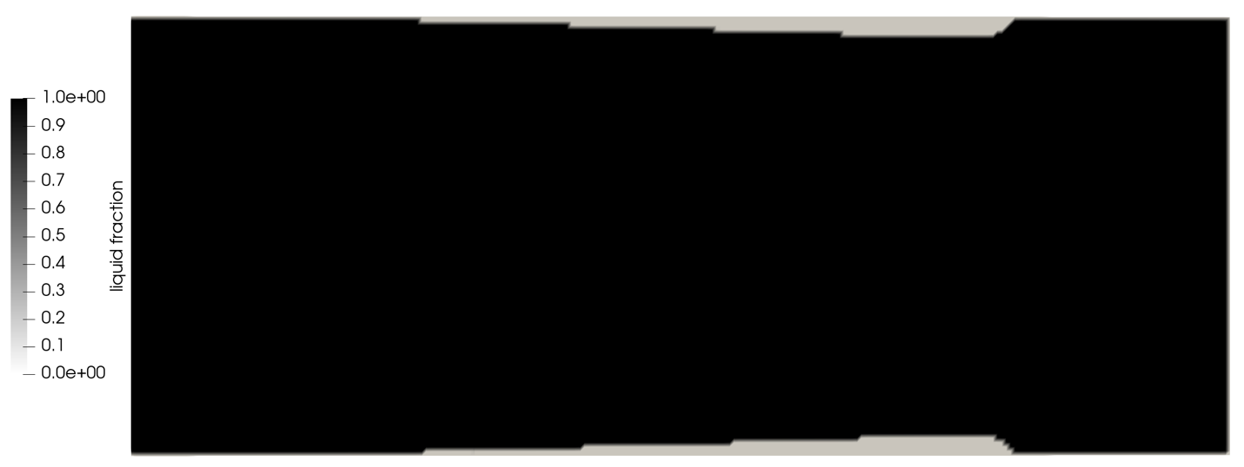

Figure 2. Liquid fraction contour

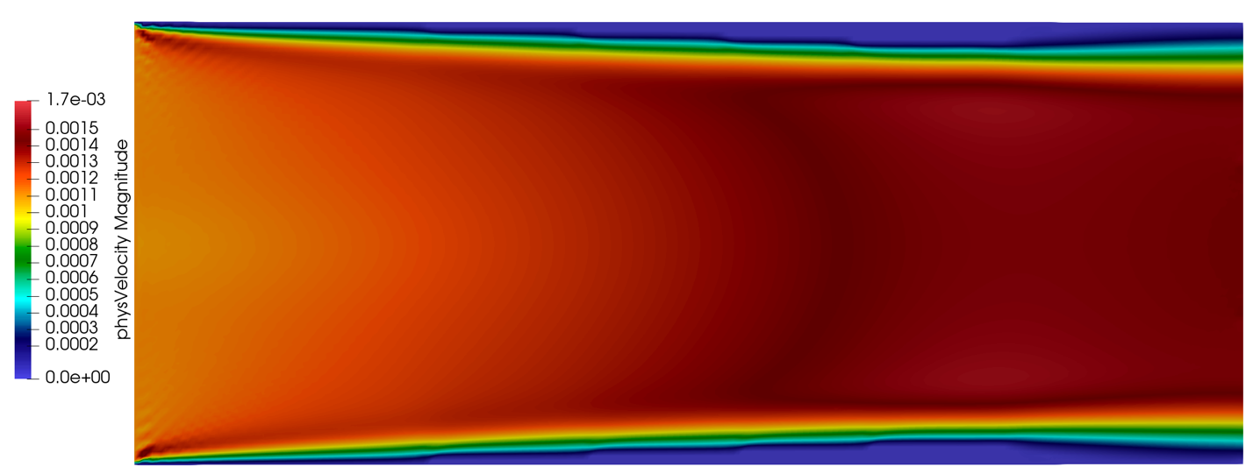

Figure 3. Velocity Magnitude contour

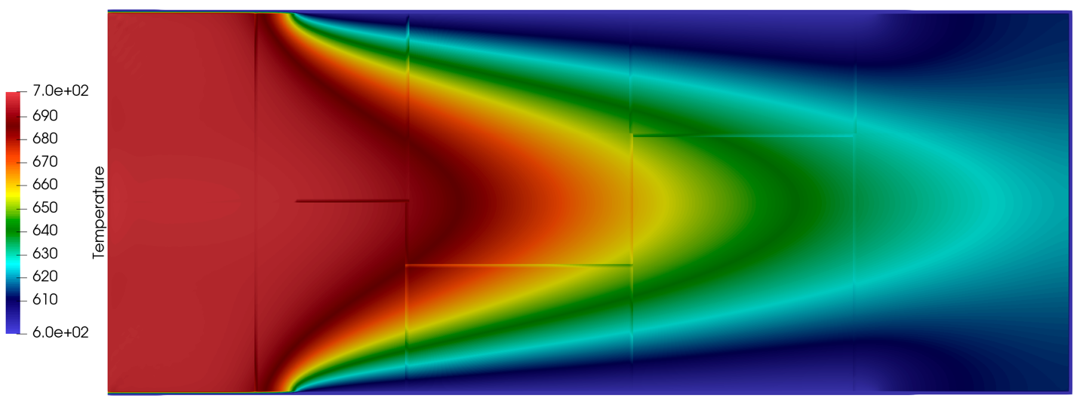

Figure 4. Temperature contour

* 1. *Definition of QoI*

The quantity of interest is the solid profile in the direction parallel to the axis of the cylinder. A python function is implemented to extract the maximum solid thickness at each x-coordinate. This solid thickness profile will be the output of our surrogate model.

* 1. *Simulation Parameter sampling*

The inlet velocity, the inlet temperature and the wall temperature are sampled in space using a Latin Hypercube sampling technique. Each three-dimensional vector sample is then defined as , where is the number of samples and with the following prescribed ranges

The velocity bounds impose a range of Reynolds numbers between 900 and 1100. Within this range, the flow is still in laminar flow range, which means we do not expect considerable velocity fluctuations. Thus, turbulence modeling is not necessary. The inlet temperature is within expected temperatures in a fast lead reactor.

A 3D plot of the sample points is shown in Figure 5.



Figure 5. Latin Hypercube Sampling of the uncertain inputs

* 1. *Surrogate Model Methodology*

Using the samples we create a total of 40 snapshots. This means that the LBM code takes each of the vector samples and runs parallelly with 40 cores. A python function reads the liquid fraction fields outputted by the LBM code and extracts the solid thickness profile from simulation ,where represents the number of axial coordinate points along the pipe axis. Next, we build our snapshot matrix , where each column is given by . The snapshots are then subdivided in a training set and a testing set, 30 and 10 snapshots respectively. As a consequence, the matrix is split into and .

The following step consists of performing Singular Value Decomposition (SVD) on the matrix, such that

where are the left-singular vectors that conform an orthogonal basis of the data matrix and is a diagonal matrix containing the singular values. By inspection of the eigenvalues magnitude decay, we truncate to obtain our reduced POD base vectors , where is an integer that represents the reduced number of modes we keep. This means that our surrogate model seeks the solution in the space of these reduced POD modes:

where is a column vector of coefficients that depend on the uncertain parameters.

The fitting of the coefficients is done via a non-intrusive approach. For this we propose a polynomial expression

where is one of the components of the vector of coefficients and are the multidimensional polynomial coefficients. Using Eq 22, we can obtain the exact . Next, after selecting the degree of the polynomial basis, we perform least squares to solve for

which is Eq 23 expressed in a matrix system form. We now have the ingredients necessary to build a surrogate model, expressed in Eq 22.

Next, we evaluate with the 10 testing uncertain parameters sample and obtain our model prediction. Finally, we compare our ROM predictions against the testing data and compute the relative mean squared error.

* 1. *ROM Results: Part 1*

Figure 6 shows the 30 data realizations that are used for training the surrogate model. The y-axis represents the stationary solid distance from the pipe wall and the x-axis is the distance along the pipe centerline.



Figure 6. Solid profiles for the 30 uncertain inputs

Figure 7 shows the normalized magnitude of the eigenvalues after performing SVD. The results depict a slow decay in the magnitude of the eigenvalues, which indicates that the information is well spread between all of the realizations. The desired behavior would be to have a fast decay in the first few modes assuring that our principal modes have a low dimension and also contain most of the information of our training data.



Figure 7. SVD normalized eigenvalues

Table 2 displays the energy percentage of the data kept as a function of the number of modes we select for the orthogonal basis. The energy percentage is defined as

In addition to the energy percentage, Table 2 depicts the relative error between the ROM solid profile prediction against the testing data. The ROM prediction is done by performing the matrix vector multiplication in Eq 22, where coefficient vector is obtained using a second order polynomial basis function in Eq 23. The computational cost of this matrix-vector multiplication is negligible compared to the full order model LBM simulations. The ROM prediction takes less than 1 second, whereas a full order simulation takes 3000 seconds.

Table 2. Energy % and relative error % for different number of modes

|  |  |  |
| --- | --- | --- |
| #Modes | Energy (%) | Error(%) |
| 3 | 80.92 | 8.36 |
| 5 | 84.4 | 8.62 |
| 10 | 90.0 | 8.80 |
| 15 | 94.1 | 8.88 |

For illustrative purposes, Figure 8 shows some of the test cases comparison. The most important conclusion of this Figure is the fact that using the principal modes of the data, the ROM has a high difficulty in predicting the length and height varying steps of the solid fraction results. This is explained by the zig-zag behavior observed in the ROM predictions. This observation is also in agreement to the slow eigenvalue decay we observe in the SVD decomposition in Figure 7.



Figure 8. ROM predictions versus testing data

* 1. *ROM Results: Part 2*

In this subsection the aim is to improve on the results of subsection 4.5. The conclusions of the last subsection give us evidence on the difficulty of predicting steps with the use of principal modes. As a result, we preprocess the training data in Figure 6 via applying a Gaussian filter to the data.



Figure 9. Gaussian Filtered training data compared to the raw data

Figure 10 shows the normalized magnitude of the eigenvalues after performing SVD on the preprocessed training data. This figure also includes the previous SVD study performed in the previous subsection. The results portray an enhanced decay in the magnitude of the eigenvalues when compared with the un-processed training data.



Figure 10. SVD normalized eigenvalues comparison between pre-processed and unprocessed data.

Table 3. Energy % and relative error % for different number of modes

|  |  |  |
| --- | --- | --- |
| #Modes | Energy (%) | Error(%) |
| 3 | 95.13 | 5.13 |
| 5 | 96.65 | 5.15 |
| 10 | 98.69 | 5.16 |
| 15 | 99.53 | 5.17 |

Table 3 shows an improvement on the relative error percentage with respect to Table 2. Analyzing the error results between the prediction and the testing data, we select the worst case in an attempt to further improve the predictive capabilities of our surrogate model. The worst case is defined as

The worst case is displayed in Figure 11.



Figure 11. Test case with the highest discrepancy between prediction and data

After identifying the worst test case, the testing data is added to the training set. The SVD process is repeated and the principal modes are obtained. With the new basis functions, the relative error is further improved to around 3%. The results are shown in Table 4.

Table 4. Energy % and relative error % for different number of modes

|  |  |  |
| --- | --- | --- |
| #Modes | Energy (%) | Error(%) |
| 3 | 95.00 | 3.54 |
| 5 | 96.59 | 3.56 |
| 10 | 98.69 | 3.56 |
| 15 | 99.53 | 3.58 |

The set of figures below depict the 10 test cases compared to the ROM predictions.



Figure 12. Comparison of the ROM predictions against the testing data.

1. Conclusions

This work demonstrates the feasibility of building a surrogate model through POD to predict the stationary solid profile of lead in a pipe in forced flow conditions. The computational cost is greatly reduced from the full order LBM model, less than a second against 3000 seconds.

Data with steps such as the one displayed in Figure 6 is proven to be hard to predict using POD. Gaussian filtering of the raw data has proven to improve the predictive error of the surrogate model, by dropping the error from 8.8% to 5.3%. A further improvement can be made by taking the worst test case and adding it to the training set. This action has enhanced the predicting capabilities of the ROM by 2%.

An important observation portrayed in Tables 2,3 and 4 is that the addition of modes to the orthogonal basis does not improve the prediction of the model, which is counterintuitive. This behavior could be explained by a poor least squares solve (see Eq 24) or by the fact that the vector of coefficients is not well represented by a multidimensional polynomial.