#draft 1.0x10-9001

#internal memo – do not release!

[0.0 – $victim_manual]

Welcome test subject $victim_count! You have been selected to take part in an exciting and worthwhile endeavor that will test your wits and mettle! This is Pokémon Purple, the revolutionary new spin on the way Pokémon are mistreated and abused. The following sections will instruct you on how to properly and sadistically take advantage of your Little Battle Machine™. Questions and concerns can be sent to the following address: [idgaf@ignoreduserrequests.ru](mailto:idgaf@ignoreduserrequests.ru).

[0.1 – Battle Stations! Interface™]

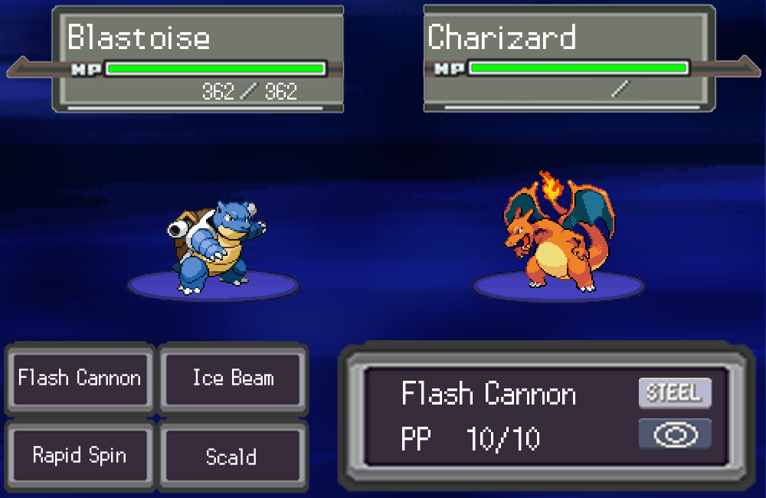

[1.0 – Beginning a New Sadistic Session]

$victim_count, it is time for you to begin your first battle against our specially trained Organic Intelligence™! Upon opening up the Pokémon Purple program, you are now greeted with several options, be sure to click on “New Game” to make your ~~test supervisors~~ friends extremely happy. You are now at the Pokémon selection screen, please click the Pokémon you would most like to see abused.

[2.0 – Procuring Victory through the Abuse of your Little Battle Machine™]

In the middle of a Pokémon battle, it may be necessary for you to give commands to your Pokémon of choice; should this occur, giving your Pokémon a command is fairly straightforward. From the Battle Stations! Interface™, take a gander at the lower left corner of the screen (figure 0.1), your retinas will encounter a grouping of four buttons. These are the current skills your Pokémon possesses; clicking on one will send that command via electronic carrier pigeon to your Pokémon. Rinse and repeat as needed to subdue your opponent’s Pokémon.

[3.0 – Deciding to Abuse Your Pokémon Rather than letting Your Opponent Abuse it for you]

Over the course of many battles you may realize that you have absolutely no skill, and that no matter how hard you try, opponents will abuse your Pokémon for you. Here at $test_center, we take a different tack. If you find yourself in a situation where you risk having your Pokémon abused at the hands of another, you have the option of resigning or “rage quitting”. The latter option is the preferred method of resigning a match, as it will abruptly and without warning close the session. The former option will, quite cowardly, as you if you would *really* like to end the session; using this method will earn you disapproval from your ~~test supervisors~~ friends and family. These options may be accessed by click on the red “X” at the top right of your session.