

|  |
| --- |
| LONDON CLIMBING CLUB |

Contents

1.1 Business background 3

1.2 Problems. Current Situation 3

1.3 the Benefits of implementing a database. Project Vision 3

2.1 Definitions & Acronyms 4

2.2 Logical Scheme 4

2.3 Objects 5

# 

# Business Description

## Business background

John Doe, who has always loved the mountains, became his main passion. He organized trips with his friends, where more and more people accompanied him. The love of nature became his profession and finally he became a famous mountaineer. The small club - which he had founded earlier - took on more and more members thanks to its reputation.

## Problems. Current Situation

Due to John Doe's reputation - and thanks to marketing activities - more and more people joined the club, but due to the increasing number of club members and hiking opportunities, the organization of community events and the increase in the number of employees, a simple excel spreadsheet is no longer enough for the efficient operation of the organization.

## the Benefits of implementing a database. Project Vision

With the help of the relational database, organized trips, locations, and the data of many customers can be easily managed, several employees can use it at the same time, so tours and community events can be organized simultaneously.

Since it is a large amount of data, it is necessary to delete redundant, repetitive data, which makes data manipulation easier and faster, such as querying data or inserting new data or modifying existing data.

# Model description

## Definitions & Acronyms

PK: Primary Key

FK: Foreign Key

ID: identification

PID: personal identification

Nr: number

Accom: Accomodation

Evcl: Event-Climber bridge table

Clcl: Climb-Climber bridge table

Mopr: Mountain-Program bridge table

Mocl: Mountain-Climb bridge table

Climber_ICE_Phone --> ICE: in case of emergency

## Logical Scheme

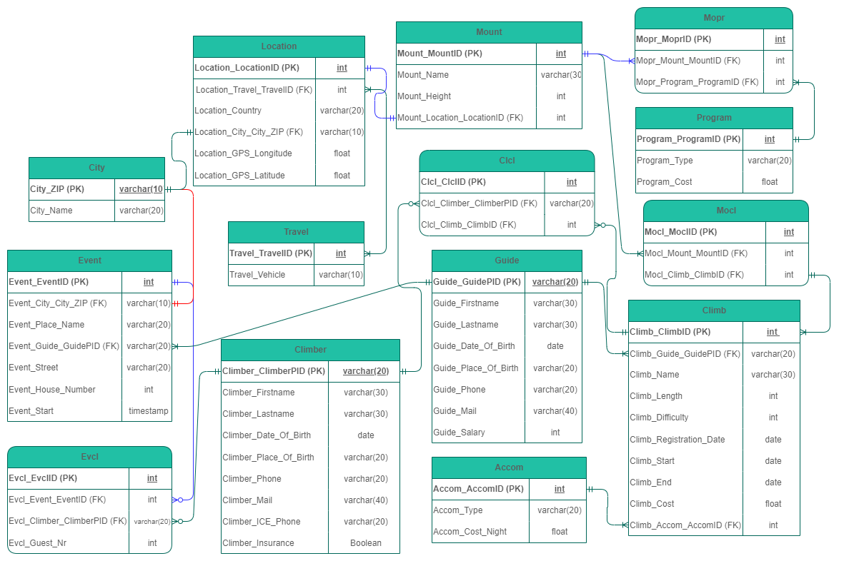

## Objects

Where it was possible, natural key is selected as Primary Key. Such tables are: Climber, Guide and City entities.

Several climbers can join one climb/tour, but one climber can also undertake several climbs/tours, so there is a many-to-many relationship between them, which are connected by a Clcl (ClimbClimber) junction table.

Similar to the relationship above, there is also a many-to-many relationship between the Climber and the social Event, because a Climber can go to several such Events, and several Climber can register for a social Event. The relationship between them was established by Evcl (EventClimber) I created it with a junction table.

There is also a many-to-many relationship between the Location of the climbs and the Programs organized on them, since several Programs can be organized on a Mount and its surroundings, but one type of Program can be carried out at several climbing Locations.

Only one person can be connected to a tour and the event organized in connection with it, who acts as a tour Guide and then as a contact of the event.

**Table Description**

Table Climb:

|  |  |  |  |
| --- | --- | --- | --- |
| Table Name | Field name | Field Description | Data Type |
| Climb | Climb_ClimbID | Generated ID of the climb, PK | Int |
| Climb_Guide_GuidePID | Personal Identity Number of Guide, FK | Varchar(20) |
| Climb_Name | The name of the tour | Varchar(30) |
| Climb_Lenght | The length of the tour in kilometers | Int |
| Climb_Difficulty | The difficulty of the tour on a scale of 1-10 | Int, Check |
| Climb_Registration_Date | The deadline for applying for the tour | Date |
| Climb_Start | The start date of the climb | Date |
| Climb_End | The end date of the climb | Date |
| Climb_Cost | The cost of climbing | Float |
| Climb_Accom_AccomID | Possible accommodations on the climbs, FK | Int |

|  |  |  |  |  |  |  |  |  |  |
| --- | --- | --- | --- | --- | --- | --- | --- | --- | --- |
| Climb_ClimbID | Climb_Guide_GuidePI | Climb_Name | Climb_Lenght | Climb_Difficulty | Climb_Registration_Date | Climb_Start | Climb_End | Climb_Cost | Climb_Accom_AccomID |
| 1 | FA856789432 | Everest_Summer_2023 | 256 | 7 | 1/5/2023 | 1/7/2023 | 7/7/2023 | 150 | 1 |

Table Climber:

|  |  |  |  |
| --- | --- | --- | --- |
| Table Name | Field name | Field Description | Data Type |
| Climber | Climber_ClimberPID | Personal identity number of climber, PK | Varchar(20) |
| Climber_Firstname | The firstname of the climber | Varchar(30) |
| Climber_Lastname | The lastname of the climber | Varchar(30) |
| Climber_Date_Of_Birth | Date of birth of the climber | Date |
| Climber_Place_Of_Birth | Place of birth of the climber | Varchar(20) |
| Climber_Phone | Phone number of the climber | Varchar(20) |
| Climber_Mail | Mail address of the climber | Varchar(40) |
| Climber_ICE_Phone | Contact phone of the climber in the case of emergency | Varchar(20) |
| Climber_Insurance | Climber has got insurancy or not | Boolean |

|  |  |  |  |  |  |  |  |  |
| --- | --- | --- | --- | --- | --- | --- | --- | --- |
| Climber_ClimberPID | Climber_Firstname | Climber_Lastname | Climber_Date_Of_Birth | Climber_Place_Of_Birth | Climber_Phone | Climber_Mail | Climber_ICE_Phone | Climber_Insurance |
| AC234545621 | Robert | Smith | 7/4/1985 | London | +44 20 8456 2816 | robert.smith@gmail.com | +44 20 8676 3922 | True |

Table Clcl:

|  |  |  |  |
| --- | --- | --- | --- |
| Table Name | Field name | Field Description | Data Type |
| Clcl | Clcl_ClclID | ID of the Clcl table, PK | Int |
| Clcl_Climber_Climber_PID | Personal identity number of climber, FK | Varchar(20) |
| Clcl_Climb_ClimbID | Generated ID of the climb, FK | Int |

|  |  |  |
| --- | --- | --- |
| Clcl_ClclID | Clcl_Climber_Climber_PID | Clcl_Climb_ClimbID |
| 1 | 5 | 3 |

Table Accom:

|  |  |  |  |
| --- | --- | --- | --- |
| Table Name | Field name | Field Description | Data Type |
| Accom | Accom_AccomID | ID of the Accom table, PK | Int |
| Accom_Type | Type of accomodation of the climb | Varchar(20) |
| Accom_Cost_Night | The cost of the climb per night | Float |

|  |  |  |
| --- | --- | --- |
| Accom_AccomID | Accom_Type | Accom_Cost_Night |
| 4 | hut | 40 |

Table Event:

|  |  |  |  |
| --- | --- | --- | --- |
| Table Name | Field name | Field Description | Data Type |
| Event | Event_EventID | ID of the Event table, PK | Int |
| Event_City_City_ZIP | The ZIP code of the social Event, FK | Varchar(10) |
| Event_Place_Name | The name of the place | Varchar(20) |
| Event_Guide_GuidePID | Identity number of the contact guide, FK | Varchar(20) |
| Event_Street | Street of the place’s location | Varchar(20) |
| Event_House_Number | House number of the place’s location | Int |
| Event_Start | Start date of the social event | Timestamp |

|  |  |  |  |  |  |  |
| --- | --- | --- | --- | --- | --- | --- |
| Event_EventID | Event_City_City_ZIP | Event_Place_Name | Event_Guide_GuidePID | Event_Street | Event_House_Number | Event_Start |
| 34 | W1K 2RX | The Audley Public House | FA856789432 | Mount Street | 41 | 5/9/2023 18:00:00 |

Table Evcl:

|  |  |  |  |
| --- | --- | --- | --- |
| Table Name | Field name | Field Description | Data Type |
| Evcl | Evcl_EvclID | ID of the Evcl table, PK | Int |
| Evcl_Event_EventID | ID of the Event table, FK | Int |
| Evcl_Climber_ClimberPID | Personal identity number of climber, FK | Varchar(20) |
| Evcl_Guest_Nr | The number of companions of the climber | Int |

|  |  |  |  |
| --- | --- | --- | --- |
| Evcl_EvclID | Evcl_Event_EventID | Evcl_Climber_ClimberPID | Evcl_Guest_Nr |
| 76 | 56 | AC234545621 | 2 |

Table Guide:

|  |  |  |  |
| --- | --- | --- | --- |
| Table Name | Field name | Field Description | Data Type |
| Guide | Guide_GuidePID | Personal identity number of guide, PK | Varchar(20) |
| Guide_Firstname | The firstname of the guide | Varchar(20) |
| Guide_Lastname | The lastname of the guide | Varchar(20) |
| Guide_Date_Of_Birth | Date of birth of the guide | Date |
| Guide_Place_Of_Birth | Place of birth of the guide | Varchar(20) |
| Guide_Phone | Phone number of the guide | Varchar(20) |
| Guide_Mail | Mail address of the guide | Varchar(20) |
| Guide_Salary | The amount of salary of the guide | Int |

|  |  |  |  |  |  |  |  |
| --- | --- | --- | --- | --- | --- | --- | --- |
| Guide_ GuidePID | Guide_Firstname | Guide_Lastname | Guide_Date_Of_Birth | Guide_Place_Of_Birth | Guide_Phone | Guide_Mail | Guide_Salary |
| FA856789432 | Henry | Tailor | 16/5/1974 | Oxford | +44 20 6336 1232 | henry.t@londonmountain.com | 3500 |

Table Mount:

|  |  |  |  |
| --- | --- | --- | --- |
| Table Name | Field name | Field Description | Data Type |
| Mount | Mount_MountID | ID of the Mount table, PK | Int |
| Mount_Name | Name of the mountain | Varchar(30) |
| Mount_Height | Height of the mountain | Int |
| Mount_Location_LocationID | Location of the mountain | Int |

|  |  |  |  |
| --- | --- | --- | --- |
| Mount_MountID | Mount_Name | Mount_Height | Mount_Location_LocationID |
| 3 | Scafell Pike | 978 | 6 |

Table Location:

|  |  |  |  |
| --- | --- | --- | --- |
| Table Name | Field name | Field Description | Data Type |
| Location | Location_LocationID | ID of the Location table, PK | Int |
| Location_Travel_TravelID | ID of the Travel table, PK | Int |
| Location_Country | Country where the mountain is located | Varchar(20) |
| Location_City_City_ZIP | The ZIP code of the location, FK | Varchar(10) |
| Location_GPS_Longitude | GPS coordinate - longitude | Float |
| Location_GPS_Latitude | GPS coordinate - latitude | Float |

|  |  |  |  |  |  |
| --- | --- | --- | --- | --- | --- |
| Location_LocationID | Location_Travel_TravelID | Location_Country | Location_City_City_ZIP | Location_GPS_Longitude | Location_GPS_Latitude |
| 6 | 5 | England | NULL | 54.45424 | - 3.2115 |

Table Travel:

|  |  |  |  |
| --- | --- | --- | --- |
| Table Name | Field name | Field Description | Data Type |
| Travel | Travel_TravelID | ID of the Travel table, PK | Int |
| Travel_Vehicle | Type of vehicle to reach the location | Varchar(10) |

|  |  |
| --- | --- |
| Travel_TravelID | Travel_Vehicle |
| 2 | train |

Table City:

|  |  |  |  |
| --- | --- | --- | --- |
| Table Name | Field name | Field Description | Data Type |
| City | City_ZIP | ZIP (Postal) code of the city, PK | Varchar(10) |
| City_Name | Name of the city | Varchar(20) |

|  |  |
| --- | --- |
| City_ZIP | City_name |
| W1T 1NG | London |

Table Program:

|  |  |  |  |
| --- | --- | --- | --- |
| Table Name | Field name | Field Description | Data Type |
| Program | Program_ProgramID | ID of the Program table, PK | Int |
| Program_Type | Type of the program | Varchar(20) |
| Program_Cost | Cost of the program | Float |

|  |  |  |
| --- | --- | --- |
| Program_ProgramID | Program_Type | Program_Cost |
| 2 | Skiing | 37.50 |

Table Mopr:

|  |  |  |  |
| --- | --- | --- | --- |
| Table Name | Field name | Field Description | Data Type |
| Mopr | Mopr_MoprID | ID of the Mopr table, PK | Int |
| Mopr_Mount_MountID | ID of the Mount table, FK | Int |
| Mopr_Program_ProgramID | ID of the Program table, FK | Int |

|  |  |  |
| --- | --- | --- |
| Mopr_MoprID | Mopr_Mount_MountID | Mopr_Program_ProgramID |
| 15 | 11 | 6 |

Table Mocl:

|  |  |  |  |
| --- | --- | --- | --- |
| Table Name | Field name | Field Description | Data Type |
| Mocl | Mocl_MoclID | ID of the Mocl table, PK | Int |
| Mocl_Mount_MountID | ID of the Mount table, FK | Int |
| Mocl_Climb_ClimbID | ID of the Climb table, FK | Int |

|  |  |  |
| --- | --- | --- |
| Mocl_MoclID | Mocl_Mount_MountID | Mocl_Climb_ClimbID |
| 23 | 15 | 3 |