**Title:** Graphical Time-to-event (TTE) model diagnostics and evaluation techniques: A tutorial

**Authors (final order TBD):** Giselle Brown (1), Jonathan French (2), Nidal Al-Huniti (3), Justin Wilkins(5), Benjamin Weber(1), Matthew M. Hutmacher (4), and the Model Evaluation Group of the International Society of Pharmacometrics (ISoP) Standards and Best Practices Committee.

**Affiliations:**

(1) Boehringer Ingelheim Pharmaceuticals, Inc., Connecticut, USA

(2) Metrum Research Group, LLC, Connecticut, USA

(3) Quantitative Clinical Pharmacology, AstraZeneca, Waltham, Massachusetts, USA

(4) Ann Arbor Pharmacometrics Group Inc, Michigan, USA

(5)

**Running title:** A Tutorial on Graphical Evaluation of Time-to-Event Models

**Corresponding author:**

**Giselle Brown,** 900 Ridgebury Road, Ridgefield,CT, giselle.brown@boehringer-ingelheim.com

**Key words:** Time to event analysis, Visual predictive check, Hazard, Survival analysis

**Word count:** --

**Figure count:** --

**Table count:** --

**Reference count:** --

## Introduction

* + *simulation and re-estimation based exercise was performed on a simplified case study based on a realistic frame work*
  + *the case study was simulated from a known scenario defined by a model (whose parameters are h0, f(u)~AUC, f(u)~gender)*
  + *define misspecification systematically (see table below)*
  + *We fit the true and misspecified models to the case study data*
  + *Clarify objectives*

*Notes from our last meeting:*

* + - *Manuscript objectives and summary* 
      * *Objective: provide an overview on diagnostics to evaluate for single TTE models*
      * *Summary: In the simulation and re-estimation exercise, the single TTE data was simulated from a known set of parameters. The parameters were then re-estimated from true and misspecified models (see table below). Plots were created and evaluated determine their diagnostics capabilities*

|  |  |  |  |
| --- | --- | --- | --- |
| *Scenario* | *Hazard function* | *Drug effect* | *Covariate effect* |
| *1* | *Weibull* | *Emax* | *Included* |
| *2* | *Weibull* | *Emax* | *Excluded♠* |
| *3* | *Weibull* | *Linear♠* | *Included* |
| *4* | *Weibull* | *Linear♠* | *Excluded♠* |
| *5* | *Exponential♠* | *Emax* | *Included* |
| *6* | *Exponential♠* | *Emax* | *Excluded♠* |
| *7* | *Exponential♠* | *Linear♠* | *Included* |
| *8* | *Exponential♠* | *Linear♠* | *Excluded♠* |
| *♠=Misspecified* | | | |

The tutorial is intended for individuals with limited experience in applying time-to-event models. Despite the focus on beginners, the tutorial can also serve as reference for more experienced users. Its objective is to provide an overview on available visual diagnostic for time-to-event analysis. SINGLE TTE vs. RTTE

This tutorial uses clinical trial simulation (i.e., simulation and re-estimation methods) to illustrate the application of visual diagnostics for time-to-event analyses. The number of hospitalizations in a phase two dose finding trial are simulated from a known parametric time-to-event model. The true (known) model and seven miss-specified models are then systematically fit to the data (TABLE X). A set of visual diagnostics was subsequently generated for all eight models. Overall, this tutorial attempts to provide a realistic application of time-to-event analyses in clinical drug development. However, some simplifications were made to allow focusing on the key aspects of visual diagnostics for TTE analyses (e.g., restricting the number of miss-specified hazard functions and covariates influencing the hazard).

## Case study

* + *Describe design of the case study* 
    - *Two goals/tasks in this section:*
* *First, describe the design of the trial as you would do it for a real trial*

*Second, describe how assumptions/procedures for the clinical trial simulation*

* + - *Goal: Tell the reader how the data was simulated (include distribution used, how censoring was simulated) while keeping the technical language to a minimum; move technical take and notation to the appendix*
  + *Describe the data. Use KM plots, exposure response box plots, demographic plots (table or box plots by dose)*

For this case study the desired effects of an investigational new drug on the incidence of hospitalization (i.e., the event of interest) were tested in a phase II dose finding study.

A total of 800 patients suffering from a cardiovascular disease were randomized into four parallel treatment groups (n = 200 per treatment group). The patients received ether a 0 (placebo) 1, 3 or 10 mg tablet once per day for 24 weeks. Hospitalizations were recorded on a weekly basis. During week five, sparse blood sampling was conducted once per patients so that individual level pharmacokinetic parameters could be obtained.

From previous studies, the investigational new drug is known to achieve pharmacokinetic steady state within 72h. Also, the drug’s apparent clearance (CL/F) was shown to be 1 L/h, distributed log-normally across subjects, with an approximate 30% coefficient of variation.

### Data Simulation and Assumptions

* The drug effect on the hazard was assumed to be driven by plasma exposure, explicitly AUC,0-tau,ss and gender.
* The higher the exposure the lower the risk of hospitalization. Males were assumed to be XXX.
* The placebo doses subjects are the reference group for this analysis (dose / AUC = 0 and gender = male). The onset half-life of the exposure effect is such that 90% of the effect is achieved by 5 months (20 weeks). Finally, we assume the censoring process will happen closer to 24 weeks then the start of the study.

Events were simulated according to the 2-parameter Weibull distribution, which describes event rates proportional to the power of time. The Weibull function (Equation 1) depends on two parameters, scale (λ) and shape (α). Five weeks was selected as the median time () to event for the reference group and the value for α = 3. The scale parameter (λ), calculated as , is 0.177. Emax model and linear models were selected describe the drug and covariate effects, respectively (Equation 2).

Censoring times were simulated using a Beta distribution scaled to 24 weeks with parameters 4 and 2. Given this censoring mechanism, about 1% of the censoring happens before the median of the survival distribution (5 weeks) and 10% happens after 21 weeks (illustrated in Figure 1A) and the resulting time to hospitalization is illustrated in Figure 1B.

The final case study data set consists of 800 subjects with a total of 734 events. Area under the curve at steady state (AUCss) was calculated as for each subject. The distributions of subject exposure, gender, and time to the first event are illustrated in Figure 1C. Table 2 summarizes the simulated patient characteristics.

Visualization of time-to-event data is usually done by creating a survival plot, which graphs the distribution of survival times for each person in a study. Survival plots can be stratified by areas of interest (i.e., dose group, gender, age group, etc.) in order to investigate the differences between groups. A nonparametric maximum likelihood estimator for survival, , developed by Kaplan and Meier (KM) was used to generate survival for the plot in Figure 1D. The KM estimator works as a left continuous decreasing step function where jumps occur at events Figure 1E shows the estimate survival probabilities versus days on treatment. From this plot we can see the time to hospitalization increases with increasing dose.

### Data Analysis

First, parameters were estimated for the true model and then systematically for each of the seven miss-specified models. Models were fitted to the data using the Laplacian method in NONMEM version 3.0. Post processing and graphical evaluation were perfomred using R Version 3.2.2, Perl-speaks-NONMEM (PsN) Version 4.6.0, Ggplot2 Version 2.1.0 and Xpose4 version 4.5.3.

### Graphical evaluation

The predictive check most commonly used for time-to-event data is a VPC based on the survival function. This predictive check compares the model-based predictive distribution for survival function with a non-parametric estimate of . The hazard-based VPC is similar in concept to the survival-based (KM) VPC, except that the focus of the VPC is at the level of the hazard function, not the survival function. The estimated hazard function,, based on the original data is then graphically compared to the predictive distribution for . The 90% prediction intervals of the simulated data were calculated across 1000 simulations from the model and overlaid with the corresponding observed data. In both VPCs the observed data is expected to fall within the 90% prediction interval of the simulated data.

While not frequently utilized in pharmacometric modeling of TTE data, residual-based diagnostics have a long history in the field of statistics. The primary difference between these residuals and the classical residuals from regression models is that residuals from TTE models are not always of the “Observed minus Expected” form. In this evaluation, we focus on two types of residuals: Deviance residuals and Cox-Snell residuals.

Deviance residuals are most useful for identifying outliers and assessing whether drug and covariate effects have been modeled using the (approximately) correct functional form. Deviance residuals are expected to be symmetrically distributed around zero. Cox-Snell residuals can be used to assess overall adequacy of the model. Under the assumption the model is correct, the Cox-Snell residuals are expected to follow a standard exponential distribution () [4]. Modifications to the Cox-Snell residual have been proposed to adjust for censoring and been used in pharmacometric literature [5]. These modifications account for the fact that the cumulative hazard for censored observations is smaller than it would be had the actual event time been observed.

## Results [GB]

* + *Mainly consists of plots with an objective description)*
  + *Organize section into 3 subsections – plots should be arranged in a grid*
  + *Factors: hazard function, drug effect, covariate effect to discuss with each set of diagnostics* 
    - *Residuals [generate 4 plots: Martingale, deviance, Cox Snell, modified Cox Snell and for each have unstratified, stratified by dose, stratified by gender]*
    - *Hazard based VPCs [Binned Hazard method 1, generate 3 plots: unstratified, stratified by dose, stratified by gender]*
    - *Survival based VPCs [Kaplan Meier plots, generate 3 plots: unstratified, stratified by dose, stratified by gender]*
  + *Appendix work*
    - *KMMC plots, should be mentioned in the discussion*
* Notes: Residual based diagnostics
  + Cox Snell / Modified Cox Snell have been tested to assess overall model fit. Under the assumption the model is correct; these residuals are expected to follow a standard exponential distribution (illustrated by a red line).
    - Easy to interpret. Plots generated from the models containing the exponential distribution yielded a skewed pattern. The departures from the line of identity indicate inadequacies with the distribution selected. Residual plots obtained from models containing a Weibull distribution produce a straighter line, indicting a more appropriate fit.
    - Powerful tool; Based on this diagnostic alone, the correct hazard model could be selected.
    - Models selected based on this diagnostic: scenarios 1 – 4
    - For detecting hazard misspecification, generating is diagnostic is more time efficient than simulation based methods
* Notes: Deviance residuals have been tested to assess whether drug effects and covariate effects have been modeled correctly. Deviance residuals are expected to be symmetrically distributed around zero (illustrated by a red horizontal zero line).
  + Continuous covariate: Easy to interpret. Able to detect the true drug effect, but not helpful in detecting hazard model or covariate model misspecification.
    - Models accounting for a linear drug effect relationship show a trend, which correspond to relatively large deviance residuals that are not well fit by the model.
    - Models selected based on this diagnostic: scenarios 1 ,2, 5, 6
    - Evaluation of this plot with (Modified) Cox-Snell residual, the correct hazard model and drug effect model could be selected.
      * Models selected based on both diagnostics: scenarios 1, 2
    - Generating this diagnostic is more time efficient than simulation based methods.
  + Categorical covariate: Difficult to interpret. All of the models produce plots where the reference line is very close to the median (and therefore also contained within the interquartile range).
  + Based on this diagnostic alone, it would be difficult to support the inclusion or exclusion of gender.
  + This diagnostic should be evaluated along with (Modified) Cox-Snell residual & Deviance residuals. Based on the diagnostic capabilities of these plots, we start with scenarios 1 and 2.
    - In scenario 1, where gender is included, no trend indicates the covariate is correctly handled.
    - In scenario 2, the skewed trend between males and females for models that exclude gender gives a hint that gender should be included in the model.
    - Limitation: In the example the red horizontal zero line is always included within the interquartile range, regardless of whether the model includes or excludes gender.

INCOMPLETE

* Hazard-based VPC
  + Unstratified: Easy to interpret. Able to clearly detect hazard misspecification and drug effect misspecification. Only scenarios 1 and 2 seem to
  + Stratified
    - By dose:
    - By gender:
* Survival-based VPC
  + Unstratified: Easy to interpret. Able to clearly detect hazard misspecification
  + Stratified
    - By dose:
    - By gender:

*Results organized by variable: hazard model, drug effect model, covariate model*

Table 4 provides an overview of the key scenarios tested during this analysis. In short, time to hospitalization was analyzed with a TTE model. Exponential and Weibull distributions were tested as structural models. Linear and Emax models were assessed to describe a drug effect and gender was evaluated as a covariate effect. Uncertainty in the estimates was acceptable with RSE < 30% for all parameters and parameter correlations were < 0.95. The final parameter estimates are provided in Table 5. Diagnostics plots were generated and results compared.

*Results.1. Evaluation the hazard function*

Cox Snell and modified Cox Snell residuals (Figures 2 and 3) obtained from the models containing the exponential distribution yielded a skewed pattern. The departures from the line of identity indicate inadequacies with the distribution selected. Residual plots obtained from models containing a Weibull distribution produce a straighter line, indicting a more appropriate fit.

Figures 4 and 5 show the survival-based and hazard-based VPCs computed for the case study. It is obvious from both VPCs, that models containing an exponential distribution do not describe the case example data. Deviations, like those observed within the hazard based VPC scenarios 3 and 4, warrant further investigation.

*Results.2 Evaluation of the drug effect*

Deviance residuals (Figure 6) were constructed to evaluate the functional form for AUCss.  Compared to the E-max model, the downward trend produced by the linear model is indicative of a model misspecification. The corresponding plots for the Emax model support the conclusion that the Emax relationship with AUCss describes the true drug effect.

Stratification of the survival and hazard based VPCs by dose (Figures 7A and 8A) show the linear model tends to predict the observed data poorly at later time points. The Emax model seems to appropriately capture the observed curve, suggesting a better fit overall than the linear model. The stratified survival-based VPC (Figure 7A) clearly shows the linear model over predicts the observed survival curve for the placebo group and slightly under predicts the 3 mg group, which suggests there might be some nonlinearity with respect to dose, and implies an inadequate fit. The stratified hazard-based VPC (Figure 8A) shows in the 3 mg dose group the linear model slightly under predicts the hazard at earlier time points and poorly describes the placebo and 10 mg dose groups. Figures 7B and 8B, stratified VPC for models using an exponential distribution, have the same diagnostic capability as an unstratified VPC (Figure 4 & 5, scenarios 5 – 8).

*Results.3. Evaluation of the covariate effect*

Gender was evaluated as a meaningful covariate on the hazard. In figures 9 – 11, models where gender was included (odd numbers scenarios) was compared with models excluding gender. When gender is included in the model, deviance residuals (Figure 9) are symmetrically distributed around zero, indicating the covariate has been modeled using the (approximately) correct functional form. In contrast, where gender was excluded, there is a skewed nature of the distribution. The survival-based VPC (Figure 10) and hazard-based VPC (Figure 11) show the models where gender is included describe the data better then when gender is excluded.

## Discussion [GB]

* + *Task: Outline some bullet points*
  + Hazard misspecification
    - Easily detectable using any of these methods
    - Note: it may be difficult to graphically determine the difference between the Weibull and Gompertz models, which both can be used to describe time varying hazards
    - The hazard based VPC might be very useful during early model development. Unstratified plots of the Weibull distribution (Figure 5, scenario 3 & 4) give a clear indication that these models do not describe the data at later time points. This could eliminate further investigation of models with a linear drug effect. The corresponding survival based VPC plots were not as clear.
  + Drug effect misspecification
    - Best detected my simulation based methods
    - Survival based VPCs
      * Easy to implement in R, xpose package
      * Stratifying by dose is crucial for detection
        + Unstratified plots of scenarios 1 – 4 indicate that the model adequately describes the data
        + Stratified plots of scenarios 1 – 4 show with a linear model the survival probability for the placebo and 10 mg dose groups is under predicted and the 3 mg dose group over predicted over the time course.
    - Hazard based VPCs
      * Not currently automated; code will need to be manually updated depending on the user’s needs
      * Stratifying by dose is helpful for detection.
      * If automated could be a nice complement to survival based VPC plots
  + Gender effect misspecification
    - One could argue for a time invariant covariate, such as gender, a graphical analysis stratified by covariate using any of the methods described is equally as informative as modeling with or without the covariate.
  + Diagnostic tools
    - Cox-Snell residuals are simple to make, these diagnostics are only sensitive to large departures from the correct model.
    - Work confirms omitting covariates or including incorrect functional form for a covariate effects are not well-detected by these diagnostics [4].
    - It is difficult to select between the models based upon these residuals.
    - KMMC – Figures 12 and 13
      * Probably not appropriate here because we don’t have continuous or time varying covariates
      * *Notes: that for continuous and time-varying covariates, in contrast to the baseline categorical covariate discussed in this example, a more sophisticated approach to model evaluation is needed. One straightforward tool is the KMMC VPC [PAGE poster Hooker & Karlsson 2012].*
      * *For assessing the appropriateness of including continuous and time-varying covariates, simple stratification is not sufficient. A modified KM VPC, dubbed the Kaplan-Meier Mean Covariate (KMMC) plot, has been proposed to overcome this problem [cite]: at every inflection point in a KM survival curve, the mean of a given covariate across all the subjects remaining in the study is calculated. This “running mean” may be expected to increase or decrease over the course of the study if it is influential. Simulating numerous times from a given model and comparing the observed running mean with its predicted distribution provides a useful assessment of the covariate’s value in the model. Cite [Hooker A & Karlsson MO (2012). The Kaplan-Meier Mean Covariate plot (KMMC): a new diagnostic for covariates in time-to-event models. PAGE 21 (2012) Abstr 2564 [www.page-meeting.org/?abstract=2564]*
    - Deviance residuals
      * Because Deviance residuals are transformations of the “observed minus expected” number of cumulative events, observations with large Deviance residuals are not well fitted by the model, similar to residuals from traditional regression models. Consequently, Deviance residuals can be used to identify outlier observations. Similarly, plotting the deviance residuals against covariates, can be used to assess whether there is evidence for misspecification of the functional form of a covariate model but not the underlying hazard or drug effect model.

|  |  |  |
| --- | --- | --- |
| **Diagnostic** | **Pros** | **Usefulness demonstrated in** |
| Survival based VPC1 | Easy to interpret, implemented in software, straightforward | TTE analysis **P**  RTTE analysis |
| Kaplan Meier Mean Covariate VPC1 | Easy to interpret, implemented in software, straightforward | TTE analysis **P**  RTTE analysis |
| Hazard based VPC2 | Sensitive | TTE analysis **P** |
| Deviance residuals3 | More sensitive than other residual-based diagnostics | TTE analysis **P** |
| Cox-Snell residuals4 | Easy to interpret, robust | TTE analysis **P** |
| **P** = present publication *Plan to add other publications*  How to implement: 1 PsN documentation, VPC section 5 & Xpose documentation *kaplan.plot()* ; 2 Supplementary material, section BH1 & Huh and Hutmacher, 2016 (doi: 10.1007/s10928-015-9454-9); 3 Supplementary material, section DEVRES; 4 Supplementary material, section CSRES | | |

* + Recommendations table. The idea here to give pros and a list of references (your thoughts? would it be useful or is it overkill?)
  + Describe a detailed Data simulation (Maybe for the appendix) – still working out this idea

## Tables

### Table 1: True Values

|  |  |
| --- | --- |
| **Parameter** | **True value** |
|  |  |
| Shape | 3 |
| Scale | 0. 177 |
| E max | 0.063 |
| E50 | 7.39 |
| θGENDER | 2 |
| 1 , where weeks is the median survival time for the reference hazard of the Weibull distribution | | |

### Table 2: Simulated patient characteristics

|  |  |  |  |  |  |
| --- | --- | --- | --- | --- | --- |
| Simulated patient characteristics | | | | | |
| Treatment arm | Placebo | 1 mg | 3 mg | 10 mg | **Total** |
| n | 200 | 200 | 200 | 200 | 800 |
| Gender: Male | 106 | 101 | 91 | 108 | 406 |
| Gender: Female | 94 | 99 | 109 | 92 | 394 |
| n, adverse events | 197 | 194 | 180 | 163 | 734 |
| AUCss, mean  (range) | 0 mg⋅hr/L  (NA) | 1.01 mg⋅hr/L  (0.47 – 2.20) | 3.20 mg⋅hr/L  (1.45 – 8.35) | 10.62 mg⋅hr/L  (4.50 – 25.67) | 3.71 mg⋅hr/L  (0 – 25.67) |

|  |
| --- |
|  |

### Table 3: Key scenarios

|  |  |  |  |  |  |  |  |  |
| --- | --- | --- | --- | --- | --- | --- | --- | --- |
| Scenario | Hazard function | Drug effect | Covariate effect | OFV | Δ OFV | n, parameters | AIC | Δ AIC♣ |
| 1 | Weibull | Emax | Included | 3461.39 | ---- | 5 | 3471.39 | --- |
| 2 | Weibull | Emax | Excluded♠ | 3536.46 | + 75.07♦ | 4 | 3544.46 | + 73.07 |
| 3 | Weibull | Linear♠ | Included | 3591.21 | ---- | 4 | 3599.21 | + 127.82 |
| 4 | Weibull | Linear♠ | Excluded♠ | 3641.4 | + 50.19♦ | 3 | 3647.40 | + 176.01 |
| 5 | Exponential♠ | Emax | Included | 4360.74 | ---- | 4 | 4368.74 | + 897.35 |
| 6 | Exponential♠ | Emax | Excluded♠ | 4375.12 | + 14.38♦ | 3 | 4381.12 | + 909.73 |
| 7 | Exponential♠ | Linear♠ | Included | 4377.24 | ---- | 3 | 4383.24 | + 911.85 |
| 8 | Exponential♠ | Linear♠ | Excluded♠ | 4389.45 | + 12.21♦ | 2 | 4393.45 | + 922.06 |
| ♠=Misspecified ; ♦= change in OFV as compared to the preceding scenario; ♣ = change in AIC as compared to scenario 1 | | | | | | | | |

### Table 4: Final parameter estimates

|  |  |  |  |  |  |
| --- | --- | --- | --- | --- | --- |
| Scenario | Lambda (%RSE) | Gamma (%RSE) | Emax (%RSE) | θgender (%RSE) | EC50 (%RSE) |
| 1 | 0.172526 (2.49) | 3.0792 (2.86) | -2.62873 (5.64) | 0.659553 (10.9) | 1.71503 (17.7) |
| 2 | 0.188286 (2.48) | 2.92451 (2.91) | -2.53238 (6.38) | NA | 1.95034 (20.6) |
|  | | | | |  |
| Scenario | Lambda (%RSE) | Gamma (%RSE) | θAUC (%RSE) | θgender (%RSE) |
| 3 | 0.141607 (2.31) | 2.77476 (2.78) | -0.15368 (7.33) | 0.53017 (14.3) |
| 4 | 0.155109 (1.93) | 2.69197 (2.84) | -0.15072 (7.41) | NA |
|  | | | | |
| Scenario | Lambda (%RSE) | Emax (%RSE) | θgender (%RSE) | EC50 (%RSE) |
| 5 | 0.183195 (3.14) | -1.08699 (8.43) | 0.280871 (12) | 2.51839 (24.7) |
| 6 | 0.206994 (2.84) | -1.11486 (9.55) | NA | 2.8877 (27.7) |
|  | | | |  | |
| Scenario | Lambda (%RSE) | θAUC (%RSE) | θgender (%RSE) |
| 7 | 0.151581 (3.04) | -0.06807 (8.36) | 0.257723 (13.7) |
| 8 | 0.171995 (2.31) | -0.06885 (8.38) | NA |

## Figures

### Figure 1A: Censoring distribution

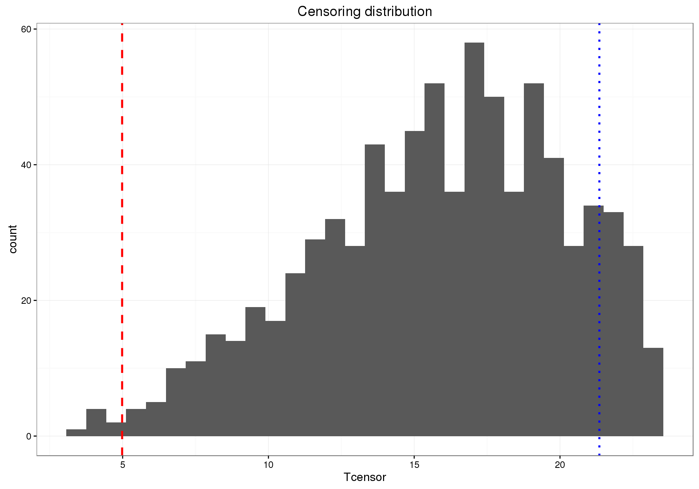

Figure 1A: Time to event distribution. The dashed red line represents the median of the survival distribution. The dotted blue line represents week 21.

### Figure1B. Time to hospitalization distribution

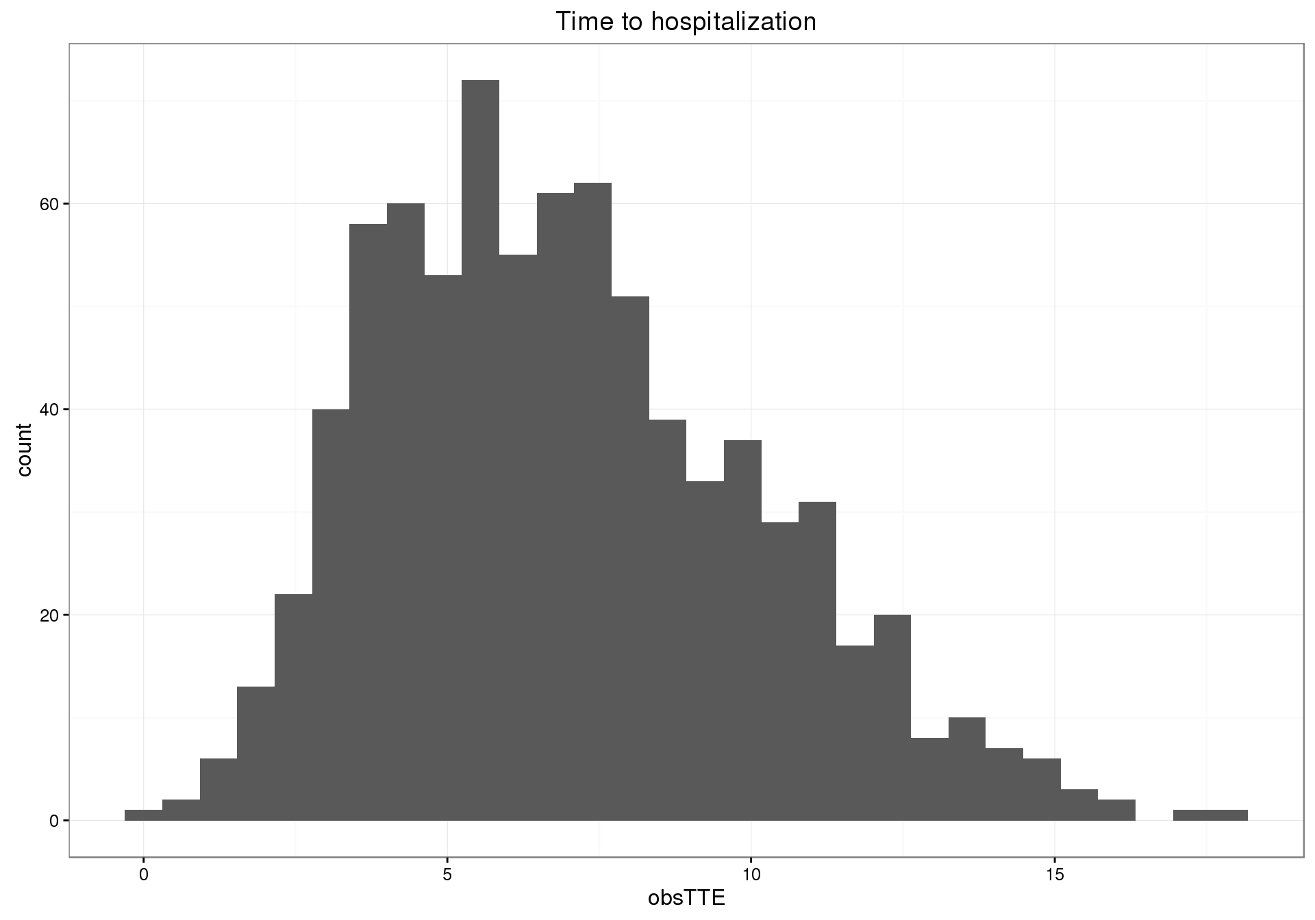

### Figure 1C: Simulated patient distributions: Exposure & gender

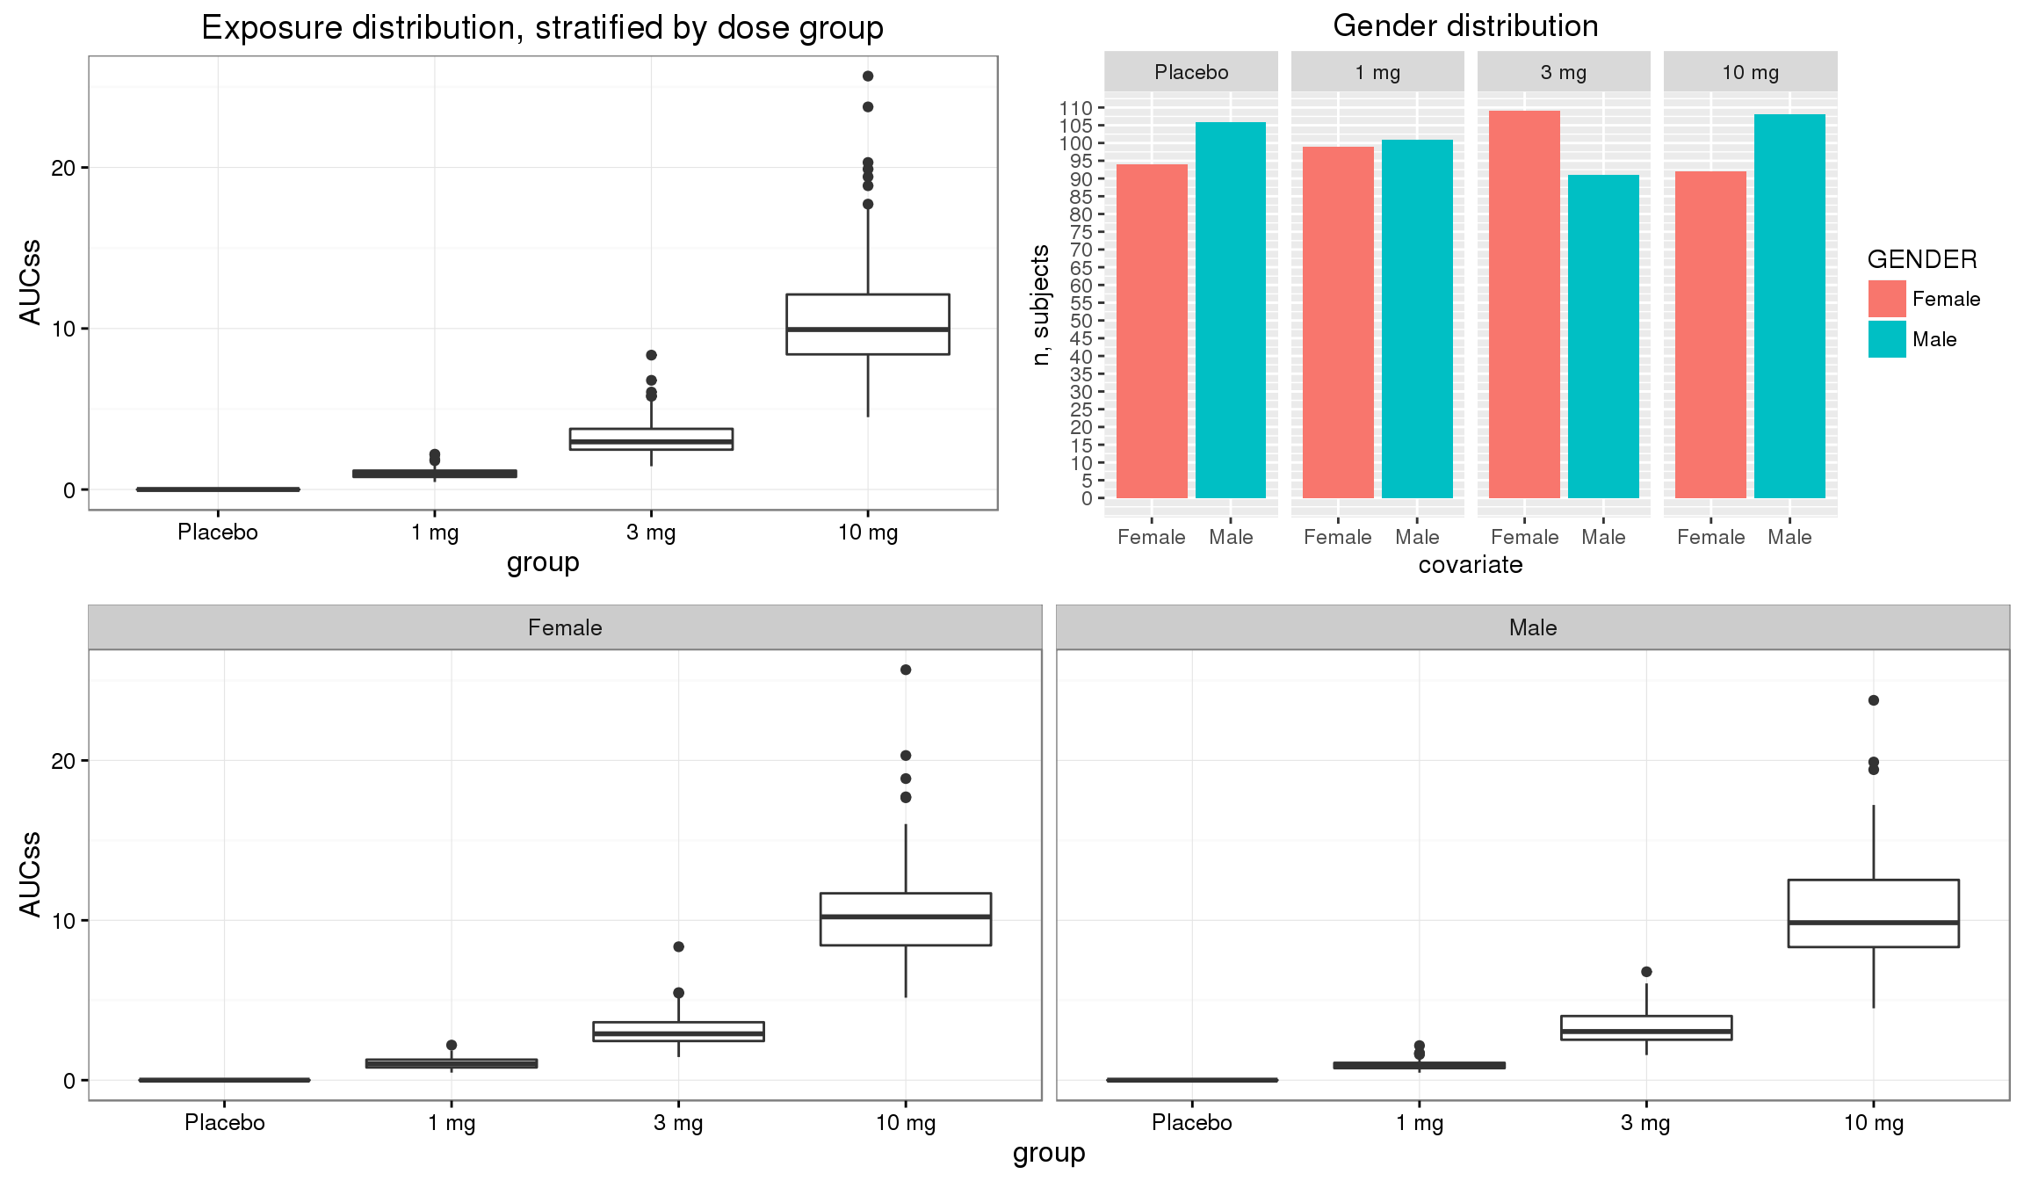

Figure 1C: Exposure and gender distributions. In each boxplot, the horizontal line represents the median, the box represents the interquartile range (IQR), the whiskers illustrate the data falling within 1.5 x IQR, and the dots represent outliers falling outside of 1.5 x IQR.

### Figure 1D: Survival curves (stratified by dose)

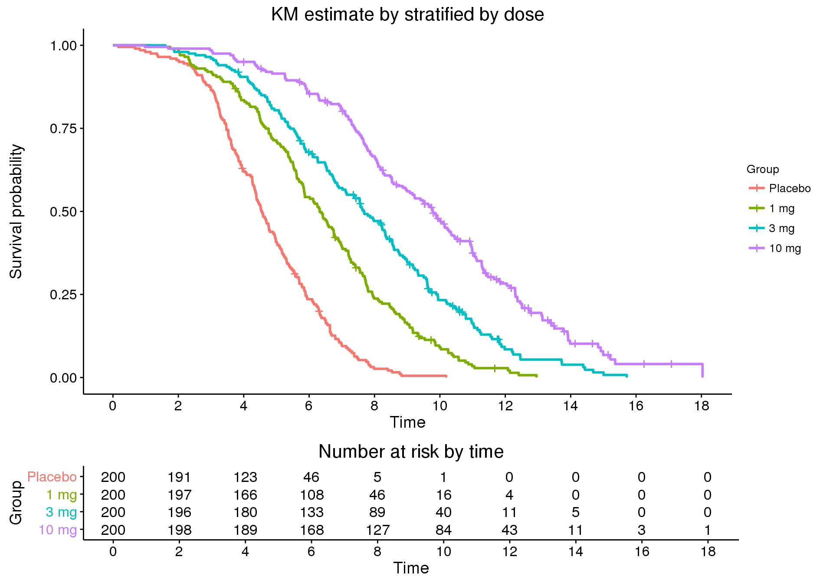

### Figure 1E: Survival Curves (stratified by gender)

### Figure 2: Cox Snell residuals (unstratified)

|  |  |  |  |  |
| --- | --- | --- | --- | --- |
| Weibull distribution | Scenario 1  \\eu\data\bib\de_as_prophet\PMx_Playground\gBrown\PostDoc_project_ISoP\CASE_STUDY\IMAGES\Run1_Diagnostics\cox_snell_diag-1.png | Scenario 2 | Scenario 3 | Scenario 4 |
| Exponential distribution ♠ | Scenario 5 | Scenario 6 | Scenario 7 | Scenario 8 |

### Figure 3: Modified Cox Snell residuals (unstratified)

|  |  |  |  |  |
| --- | --- | --- | --- | --- |
| Weibull distribution | Scenario 1 | Scenario 2 | Scenario 3 | Scenario 4 |
| Exponential distribution ♠ | Scenario 5 | Scenario 6 | Scenario 7 | Scenario 8 |

|  |  |  |  |  |
| --- | --- | --- | --- | --- |
| Survival based VPC | | | | |
| Weibull distribution | Scenario 1 | Scenario 2 | Scenario 3 | Scenario 4 |
| Exponential distribution ♠ | Scenario 5 | Scenario 6 | Scenario 7 | Scenario 8 |

### Figure 4: Survival-based VPC (unstratified)

|  |  |  |  |  |
| --- | --- | --- | --- | --- |
| Hazard based VPC | | | | |
| Weibull distribution | Scenario 1 | Scenario 2 | Scenario 3 | Scenario 4 |
| Exponential distribution ♠ | Scenario 5 | Scenario 6 | Scenario 7 | Scenario 8 |

### Figure 5: Hazard-based VPC (unstratified)

### Figure 6: Deviance residuals (unstratified)

|  |  |  |  |  |
| --- | --- | --- | --- | --- |
|  | E-max model | | Linear model♠ | |
| Weibull distribution | Scenario 1 | Scenario 2 | Scenario 3 | Scenario 4 |
| Exponential distribution ♠ | Scenario 5 | Scenario 6 | Scenario 7 | Scenario 8 |

### Figure 7A: Survival-based VPC (stratified by dose, Weibull distribution)

|  |  |  |
| --- | --- | --- |
| E-max Model | Scenario 1 | Scenario 2 |
| Linear Model♠ | Scenario 3 | Scenario 4 |

### Figure 7B: Survival-based VPC (stratified by dose, exponential distribution)

|  |  |  |
| --- | --- | --- |
| E-max Model | Scenario 5 | Scenario 6 |
| Linear Model♠ | Scenario 7 | Scenario 8 |

### Figure 8A: Hazard-based VPC (stratified by dose, Weibull distribution)

|  |  |  |
| --- | --- | --- |
| E-max Model | Scenario 1 | Scenario 2 |
| Linear Model♠ | Scenario 3 | Scenario 4 |

### Figure 8B: Hazard-based VPC (stratified by dose, exponential distribution)

|  |  |  |
| --- | --- | --- |
| E-max Model | Scenario 5 | Scenario 6 |
| Linear Model♠ | Scenario 7 | Scenario 8 |

### Figure 9A: Deviance residuals (stratified by gender, Weibull distribution)

|  |  |  |
| --- | --- | --- |
|  | Gender Included | Gender Excluded♠ |
| E-max model | Scenario 1 | Scenario 2 |
| Linear model♠ | Scenario 3 | Scenario 4 |

### Figure 9B: Deviance residuals (stratified by gender, exponential distribution)

|  |  |  |
| --- | --- | --- |
|  | Gender Included | Gender Excluded♠ |
| E-max model | Scenario 5 | Scenario 6 |
| Linear model♠ | Scenario 7 | Scenario 8 |

### Figure 10A: Survival-based VPC (stratified by gender, Weibull distribution)

|  |  |  |
| --- | --- | --- |
|  | Gender Included | Gender Excluded♠ |
| E-max model | Scenario 1 | Scenario 2 |
| Linear model♠ | Scenario 3 | Scenario 4 |

### Figure 10B: Survival-based VPC (stratified by gender, exponential distribution)

|  |  |  |
| --- | --- | --- |
|  | E-max model | Linear model♠ |
| E-max model | Scenario 5 | Scenario 6 |
| Linear model♠ | Scenario 7 | Scenario 8 |

### Figure 11A: Hazard-based VPC (stratified by gender, Weibull distribution)

|  |  |  |
| --- | --- | --- |
|  | Gender Included | Gender Excluded♠ |
| E-max model | Scenario 1 | Scenario 2 |
| Linear model♠ | Scenario 3 | Scenario 4 |

### Figure 11B: Hazard-based VPC (stratified by gender, exponential distribution)

|  |  |  |
| --- | --- | --- |
|  | Gender Included | Gender Excluded♠ |
| E-max model | Scenario 5 | Scenario 6 |
| Linear model♠ | Scenario 7 | Scenario 8 |

### Figure 12: Kaplan Meier Mean Covariate (KMMC) plot, AUCss

|  |  |  |  |  |
| --- | --- | --- | --- | --- |
|  | E-max model | | Linear model♠ | |
| Weibull distribution | Scenario 1 | Scenario 2 | Scenario 3 | Scenario 4 |
| Exponential distribution ♠ | Scenario 5 | Scenario 6 | Scenario 7 | Scenario 8 |

### Figure 13: Kaplan Meier Mean Covariate (KMMC) plot, gender

|  |  |  |  |  |
| --- | --- | --- | --- | --- |
|  | E-max model | | Linear model♠ | |
| Weibull distribution | Scenario 1 | Scenario 2 | Scenario 3 | Scenario 4 |
| Exponential distribution ♠ | Scenario 5 | Scenario 6 | Scenario 7 | Scenario 8 |

# Bibliography

|  |  |
| --- | --- |
| [1] | E. L. Kaplan and P. Meier, "Nonparametric estimation from incomplete observations," *Journal of the American statistical association,* vol. 53, pp. 457-481, 1958. |
| [2] | J. T. Rich, J. G. Neely, R. C. Paniello, C. C. J. Voelker, B. Nussenbaum and E. W. Wang, "A practical guide to understanding Kaplan-Meier curves," *Otolaryngology-Head and Neck Surgery,* vol. 143, pp. 331-336, 2010. |
| [3] | M. A. T. S. O. Karlsson and N. I. C. K. Holford, "A tutorial on visual predictive checks," in *Annual Meeting of the Population Approach Group in Europe*, 2008. |
| [4] | D. Collett, Modelling survival data in medical research, CRC press, 2015. |
| [5] | C. Hu and M. E. Sale, "A joint model for nonlinear longitudinal data with informative dropout," *Journal of Pharmacokinetics and Pharmacodynamics,* vol. 30, pp. 83-103, 2003. |
| [6] | A. C. H. M. O. K. Martin Bergstrand, "Visual Predictive Checks for Censored and Categorical data," in *Methodology- Model evaluation*, 2009. |
| [7] | E. L. Plan, G. Ma, M. Någård, J. Jensen and M. O. Karlsson, "Transient lower esophageal sphincter relaxation pharmacokinetic-pharmacodynamic modeling: count model and repeated time-to-event model," *Journal of Pharmacology and Experimental Therapeutics,* vol. 339, pp. 878-885, 2011. |
| [8] | N. Holford, "The visual predictive check—superiority to standard diagnostic (Rorschach) Plots. 2005," in *Abstract*, 2005. |
| [9] | P. K. Andersen, O. Borgan, R. D. Gill and N. Keiding, Statistical models based on counting processes, Springer Science & Business Media, 2012. |
| [10] | R. V. Juul, S. Rasmussen, M. Kreilgaard, L. L. Christrup, U. S. H. Simonsson and T. M. Lund, "Repeated time-to-event analysis of consecutive analgesic events in postoperative pain," *The Journal of the American Society of Anesthesiologists,* vol. 123, pp. 1411-1419, 2015. |
| [11] | F. Harrell, Regression modeling strategies: with applications to linear models, logistic and ordinal regression, and survival analysis, Springer, 2015. |
| [12] | W. B. Nelson, Recurrent events data analysis for product repairs, disease recurrences, and other applications, SIAM, 2003. |
| [13] | A. Gelman, X.-L. Meng and H. Stern, "Posterior predictive assessment of model fitness via realized discrepancies," *Statistica sinica,* pp. 733-760, 1996. |
| [14] | K. E. Karlsson, E. L. Plan and M. O. Karlsson, "Performance of three estimation methods in repeated time-to-event modeling," *The AAPS journal,* vol. 13, pp. 83-91, 2011. |
| [15] | K. E. Karlsson, E. L. Plan and M. O. Karlsson, "Performance of three estimation methods in repeated time-to-event modeling," *The AAPS journal,* vol. 13, pp. 83-91, 2011. |
| [16] | S. L. Beal, L. B. Sheiner, A. J. Boeckmann and R. J. Bauer, "NONMEM 7.3. 0 Users Guides," *ICON Development Solutions, Hanover,* 1989. |
| [17] | T.-H.-T. Nguyen, M.-S. Mouksassi, N. Holford, N. Al-Huniti, I. Freedman, A. C. Hooker, J. John, M. O. Karlsson, D. R. Mould, J. J. Pérez Ruixo and others, "Model evaluation of continuous data pharmacometric models: Metrics and graphics," *CPT: Pharmacometrics \& Systems Pharmacology,* 2016. |
| [18] | T. M. Therneau, P. M. Grambsch and T. R. Fleming, "Martingale-based residuals for survival models," *Biometrika,* pp. 147-160, 1990. |
| [19] | M. I. D. EFPIA, S. F. Marshall, R. Burghaus, V. Cosson, S. Y. Cheung, M. Chenel, O. Dellapasqua, N. Frey, B. Hamrén, L. Harnisch and others, "Good Practices in Model-Informed Drug Discovery and Development: Practice, Application, and Documentation.," *CPT: pharmacometrics \& systems pharmacology,* vol. 5, p. 93, 2016. |
| [20] | Y. Yano, S. L. Beal and L. B. Sheiner, "Evaluating pharmacokinetic/pharmacodynamic models using the posterior predictive check," *Journal of pharmacokinetics and pharmacodynamics,* vol. 28, pp. 171-192, 2001. |
| [21] | J. Crowley and M. Hu, "Covariance analysis of heart transplant survival data," *Journal of the American Statistical Association,* vol. 72, pp. 27-36, 1977. |
| [22] | D. R. Mould and R. N. Upton, "Basic concepts in population modeling, simulation, and model-based drug development," *CPT: pharmacometrics \& systems pharmacology,* vol. 1, pp. 1-14, 2012. |
| [23] | N. Holford, "A time to event tutorial for pharmacometricians," *CPT: pharmacometrics \& systems pharmacology,* vol. 2, pp. 1-8, 2013. |
| [24] | R. C. Team, "R A Language and Environment for Statistical Computing," 2015. |
| [25] | J. Nyberg, "Simulating large time-to-event trials in NONMEM," in *Page 23*, 2014. |
| [26] | O. Aalen, "Nonparametric inference in connection with multiple decrement models," *Scandinavian Journal of Statistics,* pp. 15-27, 1976. |
| [27] | W. Nelson, "Theory and applications of hazard plotting for censored failure data," *Technometrics,* vol. 14, pp. 945-966, 1972. |
| [28] | J. D. Kalbfleisch and R. L. Prentice, The statistical analysis of failure time data, vol. 360, John Wiley & Sons, 2011. |
| [29] | J. P. Klein and M. L. Moeschberger, Survival analysis: techniques for censored and truncated data, Springer Science & Business Media, 2005. |
| [30] | B. W. Turnbull, "The empirical distribution function with arbitrarily grouped, censored and truncated data," *Journal of the Royal Statistical Society. Series B (Methodological),* pp. 290-295, 1976. |
| [31] | M. Hutmacher, "Visual Predictive Checks for the Evaluation of the Hazard Function in Time-to-Event Analyses," in *Page 22*, 2013. |
| [32] | Y. Huh and M. M. Hutmacher, "Application of a hazard-based visual predictive check to evaluate parametric hazard models," *Journal of pharmacokinetics and pharmacodynamics,* vol. 43, pp. 57-71, 2016. |
| [33] | L. Lindbom, P. Pihlgren and N. Jonsson, "PsN-Toolkit—a collection of computer intensive statistical methods for non-linear mixed effect modeling using NONMEM," *Computer methods and programs in biomedicine,* vol. 79, pp. 241-257, 2005. |
| [34] | L. Lindbom, J. Ribbing and E. N. Jonsson, "Perl-speaks-NONMEM (PsN)—a Perl module for NONMEM related programming," *Computer methods and programs in biomedicine,* vol. 75, pp. 85-94, 2004. |
| [35] | E. N. Jonsson and M. O. Karlsson, "Xpose--an S-PLUS based population pharmacokinetic/pharmacodynamic model building aid for NONMEM," *Computer Methods and Programs in Biomedicine,* vol. 58, pp. 51-64, 1999. |
| [36] | R. Y. C. Liu and J. Van Ryzin, "A histogram estimator of the hazard rate with censored data," *The Annals of Statistics,* pp. 592-605, 1985. |
| [37] | S. M. Snapinn, Q. I. Jiang and B. Iglewicz, "Illustrating the impact of a time-varying covariate with an extended Kaplan-Meier estimator," *The American Statistician,* vol. 59, pp. 301-307, 2005. |
| [38] | J. Stare, M. Pohar and R. Henderson, "Goodness of fit of relative survival models," *Statistics in medicine,* vol. 24, pp. 3911-3925, 2005. |

Supplemental material

## Code

### A1. Data set generation:

library(survival)

library(survminer)

library(ggplot2)

library(dplyr)

## Set seed:

set.seed(4321)

set.seed(160516)

doses = c(0,1,3,10)

nPerGroup = 200

nGroups = length(doses)

nTotal = nPerGroup \* nGroups

# Define parameters for Weibull distribution

med0 = 10

alpha = 3

lambda = 1/med0 \* log(2)^(1/alpha)

gamma = 2 # E50

hrAt10 = 4 # hazard ratio

theta3 = log(hrAt10)\*(gamma+10)/10 # Effect at 10 mg dose is a HR of 4 (at steady-state)

theta4 = log(2)

theta = c(theta3,theta4)

params=list(lambda=lambda, alpha=alpha,theta=theta, gamma=gamma)

# Define parameters for CL distribution and binar covariate

TVCL = 1

CVCL = 0.3

probX = 0.5

# Set-up design and simulate exposure, random time-to-event on survival scale,

# and random censoring time.

data = data.frame(ID = rep(1:nTotal),

dose = rep(doses, each=nPerGroup),

CL = TVCL \* exp(rnorm(nTotal,0,CVCL)),

x = rbinom(nTotal,size=1,prob=probX),

Utte = runif(nTotal),

Tcensor = 24 \* rbeta(nTotal,shape1 = 4, shape2 = 2))

data = mutate(data,

AUCss = dose/CL,

group = factor(dose, levels=doses,

labels=c('Placebo', paste(doses[-1],'mg')))

)

# Define Weibull-like hazard function

hazWeib = function(t,AUC,x,params) {

h0 = with(params, alpha \* lambda^alpha \* t^(alpha-1))

h = with(params, h0 \* exp((theta[1]\*AUC/(gamma+AUC)) + theta[2]\*x))

return(h)

}

# Define function for simulating time-to-event data based on inverting

# the survival curve

simFun = function(t, AUC,x,U,params, hazFun) {

cumHaz = integrate(hazFun, lower=0, upper=t, AUC=AUC, x=x, params=params)$value

return(cumHaz + log(U))

}

# Simulate true time-to-event data

data$TTE = sapply(1:nTotal, function(i) {

uniroot(simFun, interval=c(0,100),

AUC=data$AUCss[i], x=data$x[i], U=data$Utte[i],

params=params, hazFun=hazWeib)$root

})

# Generate censoring indicator and observed time-to-event variable

data$censored = data$TTE > data$Tcensor

data$obsTTE = ifelse(data$censored==TRUE, data$Tcensor, data$TTE)

|  |  |  |  |  |  |  |  |  |  |  |
| --- | --- | --- | --- | --- | --- | --- | --- | --- | --- | --- |
| ID | dose | CL | x | Utte | Tcensor | AUCss | group | TTE | censored | obsTTE |
| 1 | 0 | 0.87269 | 1 | 0.999953 | 21.81751 | 0 | Placebo | 0.323065 | FALSE | 0.323065 |
| 2 | 0 | 0.91376 | 0 | 0.477246 | 10.55336 | 0 | Placebo | 10.21914 | FALSE | 10.21914 |
| 3 | 0 | 0.935994 | 0 | 0.838839 | 11.03604 | 0 | Placebo | 6.329148 | FALSE | 6.329148 |
| 4 | 0 | 0.859372 | 1 | 0.299589 | 16.55062 | 0 | Placebo | 9.544467 | FALSE | 9.544467 |
| 5 | 0 | 1.057393 | 0 | 0.321969 | 11.09386 | 0 | Placebo | 11.78075 | TRUE | 11.09386 |
| 6 | 0 | 1.039022 | 0 | 0.28498 | 18.88289 | 0 | Placebo | 12.18929 | FALSE | 12.18929 |
| 7 | 0 | 1.028737 | 1 | 0.369168 | 20.02185 | 0 | Placebo | 8.957937 | FALSE | 8.957937 |
| 8 | 0 | 1.28899 | 1 | 0.179124 | 3.953886 | 0 | Placebo | 10.74477 | TRUE | 3.953886 |
| 9 | 0 | 0.839258 | 0 | 0.87933 | 22.33247 | 0 | Placebo | 5.703371 | FALSE | 5.703371 |
| 10 | 0 | 0.986373 | 0 | 0.422987 | 6.504723 | 0 | Placebo | 10.74717 | TRUE | 6.504723 |

### A2. Example NM code for final model

;Sim\_start : add to simulation model

;$SIZES NO=500 LIM6=500

;Sim\_end

$PROB 1 Weibull + Emax + with covariate

$INPUT ID DOSE CLI X1 TIME DV MDV

; DV event = 1, DV censored = 0

$DATA ../../data/derived/SimulatedData\_weibull\_nm.csv IGNORE=@

$SUBROUTINE ADVAN13 TOL=6

$MODEL

COMP=(CHAZ)

$PK

; exposure

AUCSS = 0

IF (DOSE.GT.0) AUCSS = DOSE / CLI

; parameters

DLTA = EXP(THETA(1))

LAMBDA = EXP(THETA(2) + ETA(1))

XEFF = THETA(3)

EMAX = THETA(4)

E50 = EXP(THETA(5))

;BETA = EXP(THETA(6))

; initial conditions

A\_0(1) = 0

$DES

HAZ0 = DLTA \* LAMBDA \* (LAMBDA\*T)\*\*(DLTA-1)

EXPOSURE = AUCSS ; \* (1 - EXP(-BETA\*T))

DEFF = EMAX \* EXPOSURE / (E50 + EXPOSURE)

HAZ = HAZ0 \* EXP(DEFF + XEFF \* X1)

DADT(1) = HAZ

$ERROR

CUMHAZ = A(1)

SURV = EXP(-CUMHAZ)

HAZ0NOW = DLTA \* LAMBDA \* (LAMBDA\*TIME)\*\*(DLTA-1)

EXPOSNOW = AUCSS ; \* (1 - EXP(-BETA\*TIME))

DEFFNOW = EMAX \* EXPOSNOW / (E50 + EXPOSNOW)

LNHAZNOW = LOG(HAZ0NOW) + DEFFNOW + XEFF\*X1

HAZNOW = EXP(LNHAZNOW)

; likelihood = SURV (if censored)

; likelihood = SURV\*HAZNOW (if event)

IF (DV.EQ.1) THEN

LIKE = SURV \* HAZNOW

ELSE

LIKE = SURV

ENDIF

Y = -2 \* LOG(LIKE)

; Martingale residual: rM = (1-CENSOR) + log(SURV)

MARTRES = (DV) - CUMHAZ

; deviance residual = sign(rM) \* SQRT(-2\*(rM + (1-CENS)\*log(-log(SURV))))

SIGNRM = 1

IF (MARTRES < 0) SIGNRM = -1

IF (MDV.EQ.1) THEN

DEVRES = 0

ELSE

DEVRES = SIGNRM \* SQRT(-2 \* (MARTRES + (DV)\*LOG(CUMHAZ)))

ENDIF

; Simulation for model evaluation

IF (ICALL.EQ.4) THEN

CALL RANDOM (2,R)

DV=0

RTTE = 0

IF(TIME.EQ.24.0) RTTE=1

IF(R.GE.SUR) THEN

DV=1

RTTE = 1

ENDIF

ENDIF

$THETA

(1.1) ; LOG(DELTA)

(-2.42) ; log(lambda)

(0.7) ; additive effect of x1 on log hazard

(1.7) ; emax

(0.7 ) ; log(e50)

;(-0.7) ; log(beta)

$OMEGA 0 FIX

;Sim\_start : add/remove for simulation

$ESTIMATION MAXEVAL=9999 -2LL PRINT=5 NOABORT METHOD=1 MSFO=./1.msf

$COV PRINT=E

;$SIMULATION (5988566) (39978 UNIFORM) ONLYSIM NOPREDICTION SUB=1000

;Sim\_end

$TABLE FILE=./1.tab ONEHEADER

ID DOSE AUCSS X1 TIME DV MDV PRED CUMHAZ SURV HAZNOW MARTRES DEVRES

NOAPPEND NOPRINT

$TABLE ID TIME SUR HAZNOW DOSE EVID NOAPPEND NOPRINT ONEHEADER FILE=sdtab1

$TABLE ID AUCSS NOAPPEND NOPRINT ONEHEADER FILE=patab1

$TABLE ID X1 NOAPPEND NOPRINT ONEHEADER FILE=catab1

### A3. R code for Cox Snell and modified Cox Snell residuals

library(survival)

tab <- read.table(file=1.tab, header=TRUE, skip=1,as.is=TRUE)

NMtable <- tab[tab$EVID==0,] # only events, note for events DV=1, for censored DV = 0

NMtable$CSRES <- -log(NMtable$SUR) # Cox Snell residual

NMtable$MCSRES <- -log(NMtable$SUR) + 1-NMtable$DV # or + log(2)-NMtable$DV # modified Cox Snell residual

fit = survfit(Surv(RES,DV)~1,data=NMtable) # RES = CSRES or MCSRES

cs.plot = ggplot(data=NULL,

aes(x=cs.fit$time, y=-log(cs.fit$surv))) + geom\_abline(intercept=0,slope=1,col='red') +

geom\_point() + theme\_bw() + ggtitle(run.prob) + # facet\_wrap(~label, scales="fixed", ncol=2)

labs(x = 'Cox-Snell residual', y='-S(residual)') + lims(x=c(0,ceiling(max(cs.fit$time))),

y=c(0,ceiling(max(cs.fit$time))))

print(cs.plot)

# Other Examples

The time grid method for simulating events using the same model as that used for estimation is illustrated in Figure HAZARD BASED VPC. This shows the Kaplan-Meier survivor function obtained from the original data set and the 95% confidence interval for curves simulated using the time grid method.

### **Supplementary Table X**.

A time grid is shown for simulation of bleeding events associated with warfarin treatment. The time grid covers 1 year period. Events are generated at 1 day intervals. The DVID variable is used to simulate observations of drug concentration (DVID=1, biomarker influencing the hazard (DVID=2) and whether or not an event occurred in the 1 day interval (DVID=3).

|  |  |  |  |  |  |  |  |  |  |  |
| --- | --- | --- | --- | --- | --- | --- | --- | --- | --- | --- |
| #ID | TIME | TRT | AMT | RATE | ADDL | II | WT | DVID | DV | MDV |
| 1 | 0 | 1 | 5 | -2 | 364 | 1 | 70 | 0 | . | 1 |
| 1 | 0 | 1 | . | . | . | . | 70 | 1 | . | 1 |
| 1 | 0 | 1 | . | . | . | . | 70 | 2 | . | 1 |
| 1 | 0 | 1 | . | . | . | . | 70 | 3 | . | 1 |
| 1 | 1 | 1 | . | . | . | . | 70 | 1 | . | 1 |
| 1 | 1 | 1 | . | . | . | . | 70 | 2 | . | 1 |
| 1 | 1 | 1 | . | . | . | . | 70 | 3 | . | 1 |

$SIZES NO=1200 LIM6=1200 ; NO AND LIM6 MUST BE >=MAX NUMBER OF OBSERVATIONS RECS/SUBJECT

$PROB SIMULATE TIME TO EVENT

$DATA ..\data.csv

$INPUT ID TIME TRT AMT RATE ADDL II WT DVID DV MDV REP

$SIM (20091202) (20091203 UNIFORM) (20091204 UNIFORM)

(20091218 UNIFORM) (20091220 UNIFORM) ONLYSIM NSUB=1

;O'REILLY RA, AGGELER PM. STUDIES ON COUMARIN ANTICOAGULANT DRUGS.

;INITIATION OF WARFARIN THERAPY WITHOUT A LOADING DOSE.

;CIRCULATION. 1968;38:169-77.

;O'REILLY RA, AGGELER PM, LEONG LS. STUDIES OF THE COUMARIN ANTICOAGULANT DRUGS:

;THE PHARMACODYNAMICS OF WARFARIN IN MAN.

;J CLIN INVEST. 1963;42(10):1542-51.

;HOLFORD NHG. THE VISUAL PREDICTIVE CHECK – SUPERIORITY TO STANDARD DIAGNOSTIC

;(RORSCHACH) PLOTS

;[WWW.PAGE-MEETING.ORG/?ABSTRACT=738]. PAGE. 2005;14

;EVENT HAZARD

$THETA

0.1 ; POP\_HBASE 1/Y BASELINE HAZARD (MAJOR HAEMORRHAGE)

0.2 ; POP\_HDROP 1/Y BASELINE HAZARD (DROPOUT)

0 FIX ; POP\_BTATRT HAZARD RATIO INCREASE PER 1 MG/D WARFARIN (0.4)

0 FIX ; POP\_BTAPCA HAZARD RATIO INCREASE WITH 100% DECREASE IN PCA (2.0)

0.5 ; POP\_BTAINR HAZARD RATIO INCREASE WITH INR (0.5)

;WARFARIN PKPD

$THETA

(0.01,0.128,1) ; POP\_CL L/H/70KG

(0.01,8.11,20) ; POP\_V L/70KG

(0.01,1.46,24) ; POP\_TABS H

(0.,0.998,24) ; POP\_LAG H

(0.01,96.3,200) ; POP\_PCA0

-1. FIX ; POP\_EMAX

(0.01,1.24,10) ; POP\_C50 MG/L

(0.01,12.9,100) ; POP\_TEQ H

$OMEGA

0.0645 ; PPV\_CL

0.0183 ; PPV\_V

0.619 ; PPV\_TABS

0.278 ; PPV\_LAG

0.001 ; PPV\_PCA0

0 FIX ; PPV\_EMAX

0.191 ; PPV\_C50

0.0116 ; PPV\_TEQ

0.01 ; PPV\_HBASE

$SIGMA

0.00693 ; RUV\_CV

0.0818 ; RUV\_SD MG/L

16. ; RUV\_PCA

$THETA

70 ; TBWKG\_STD KG

$OMEGA

0.01 ; PPV\_TBWKG

$SUBR ADVAN6 TOL=3

$MODEL

COMP=CENTRAL

COMP=PCA

COMP=HAZEVT

COMP=HAZDRP

$PK

IF (NEWIND.LE.1) THEN

LN2=LOG(2)

HASEVT=0 ; NOT HAD EVENT

HASDRP=0 ; NOT DROPPED OUT

SEVTZ=1 ; SURVIVOR FUNCTION AT TIME=0

DOSE=0

ENDIF

IF (ICALL.EQ.4) THEN

IF (NEWIND.LE.1) THEN ; FIRST RECORD

CALL RANDOM(2,R)

UEVT=R ; UNIFORM RANDOM NUMBER FOR EVENT

CALL RANDOM(3,R)

UTRT=R ; UNIFORM RANDOM NUMBER FOR TREATMENT

CALL RANDOM(4,R)

UDRP=R ; UNIFORM RANDOM NUMBER FOR DROPOUT

IF (UTRT.LT.0.25) THEN ; PLACEBO

RATE=0

ADDL=0

II=0

SF1=0

STRT=0

ELSE

IF (UTRT.LT.0.5) THEN ; DOSE 1

SF1=2.5

STRT=1

ELSE

IF (UTRT.LT.0.75) THEN ; DOSE 2

SF1=5

STRT=2

ELSE

SF1=10

STRT=4

ENDIF

ENDIF

ENDIF

STBWKG=TBWKG\_STD\*EXP(PPV\_TBWKG) ; SIMULATED WEIGHT

ENDIF

DOSE=1\*SF1 ; MG

TBWKG=STBWKG

TRT=STRT

ENDIF

F1=DOSE

FSZV=TBWKG/TBWKG\_STD

FSZCL=FSZV\*\*0.75

CL=FSZCL\*POP\_CL\*EXP(PPV\_CL)\*24 ; L/H -> L/D

V=FSZV\*POP\_V\*EXP(PPV\_V)

TABS=POP\_TABS\*EXP(PPV\_TABS)/24 ; H -> D

TLAG=POP\_LAG\*EXP(PPV\_LAG)/24 ; H -> D

PCA0=POP\_PCA0\*EXP(PPV\_PCA0)

EMAX=POP\_EMAX\*EXP(PPV\_EMAX)

C50=POP\_C50\*EXP(PPV\_C50)

TEQ=POP\_TEQ\*EXP(PPV\_TEQ)/24 ; H -> D

HBASE=POP\_HBASE\*EXP(PPV\_HBASE)/365 ; 1/Y -> 1/D

HDROP=POP\_HDROP/365 ; 1/Y -> 1/D

BTATRT=POP\_BTATRT

BTAPCA=POP\_BTAPCA

BTAINR=POP\_BTAINR

D1=TABS

ALAG1=TLAG

S1=V

A\_0(2)=PCA0

KPCA=LN2/TEQ

RPCA=PCA0\*KPCA

$DES

DCP=A(1)/V

DPCA=A(2)

DINR=PCA0/DPCA

PD=1+EMAX\*DCP/(C50+DCP)

DADT(1)=- CL\*DCP ; WARFARIN CONC

DADT(2)=RPCA\*PD - KPCA\*DPCA ; TURNOVER FOR PCA

DADT(3)=HBASE \* EXP(BTATRT\*TRT + BTAINR\*DINR + BTAPCA\*(1-DPCA/PCA0))

DADT(4)=HDROP

$ERROR

CP=A(1)/V

PCA=A(2)

CUMEVT=A(3)

CUMDRP=A(4)

; PROB OF NOT HAVING EVENT UP TO THIS TIME

SEVTT=EXP(-CUMEVT) ; SURVIVOR FUNCTION (T)

; PROB OF NOT HAVING DROPPED OUT TO THIS TIME

SDRPT=EXP(-CUMDRP) ; SURVIVOR FUNCTION (T)

IF (DVID.LE.1) THEN

F\_FLAG=0

Y=CP\*(1+RUV\_CV) + RUV\_SD

ENDIF

IF (DVID.EQ.2) THEN

F\_FLAG=0

Y=PCA + RUV\_PCA

ENDIF

IF (DVID.EQ.3.AND.DV.EQ.0) THEN ; CENSORED EVENT

F\_FLAG=1

Y=SEVTT ; SURVIVOR FUNCTION

ENDIF

IF (DVID.EQ.3.AND.DV.EQ.1) THEN ; EVENT IN INTERVAL

F\_FLAG=1

Y=SEVTZ - SEVTT ; LIKELIHOOD OF EVENT IN INTERVAL

ENDIF

IF (ICALL.EQ.4) THEN

IF (DVID.EQ.3.AND.HASDRP.EQ.0.AND.SDRPT.LT.UDRP) THEN

HASDRP=1

DVX=0 ; CENSORED EVENT

DVIX=3

MDVX=0

ELSE

IF (HASDRP.EQ.0.AND.HASEVT.EQ.0) THEN

IF (DVID.EQ.3) THEN ; CHECK FOR EVENT

IF (SEVTT.LT.UEVT) THEN ; EVENT

HASEVT=1

DVX=1

DVIX=3

MDVX=0

ELSE ; DUMMY EVENT RECORD

DVX=0

DVIX=3

MDVX=1

ENDIF

ELSE ; LAST RECORD (DEFAULT FOR CENSORING) OR OTHER EVID (DOSE, OBS)

IF (DVID.EQ.4) THEN ; LAST RECORD

DVX=0 ; CENSORED EVENT

DVIX=3

MDVX=0

ELSE ; DOSE OR CONC OR PCA

IF (DVID.EQ.0) THEN ; DOSE

DVX=0

MDVX=1

ELSE ; OBSERVATION

DVX=Y

MDVX=0

ENDIF

DVIX=DVID

ENDIF

ENDIF

ELSE ; AFTER DROPOUT OR AFTER EVENT SO CONVERT TO MISSING

DVX=0

DVIX=DVID

MDVX=1

ENDIF

ENDIF

ENDIF

IF (DVID.EQ.3) THEN ; START NEW EVENT INTERVAL

SEVTZ=SEVTT ; SURVIVOR FUNCTION AT START OF NEW INTERVAL

ELSE ; SAVE RECURSIVE RANDOM VARIABLE (ONLY WORKS WITH NM6 OR LATER)

SEVTZ=SEVTZ

ENDIF

INR=PCA0/PCA

$TABLE ID TIME TRT AMT RATE ADDL II TBWKG DVIX DVX MDVX REP

CP PCA INR CL V TABS TLAG F1 PCA0 EMAX C50 TEQ

NOAPPEND ONEHEADER NOPRINT FILE=warf\_inr\_sim\_org.fit