Xavier Cadot

3/11/18

CS 6363.003

**Project 1: Library Database Quick Start Guide**

This document is quick guide for your average librarian trying to use this library Database Guide. This GUI was created to make it an easy process on checking out and returning books.

This GUI and guide is divided into 4 Parts:

1. Search Tab
2. Borrowers Tab
3. Fines Tab
4. Return Tab

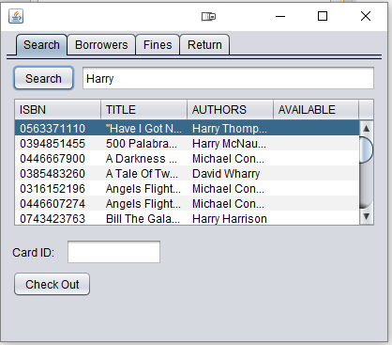**1. Search Tab:**

The Search tab allows you to search and check out a book.

Search Features:

* Search by ISBN

(Parts of an ISBN will show all ISBN containing that part)

* Search Title or list parts of the title in the search bar.
* Search by Author
* The books will show up the in the table below
* Books that are checked out will be labeled as “OUT” in the availability column
* The whole database of books will show up in the table if the search box is kept blank

Card ID Features:

* Able to enter a card ID
* Check the database and only allows for cards ID that exist
* A pop up window will come up if a wrong id is chosen

Check out Feature

* A user is can click a row on the table to choose a book.
* Once a book and a correct card id is chosen, then the user can click and check out a book.
* A pop up error window will come up if the card id has more than 3 books and when the user tries to check out a book that is not available.
* The checkout button is disable until a book is chosen on the table.

**2. Borrower Tab**

The Borrower tab allows you to create new borrowers

* 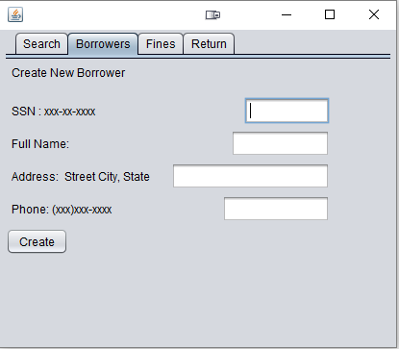It shows you the correct format to enter each field.
* Be careful to follow the format so that all the data looks the same
* The program will the check the database to see if the SSN you input already exist. A pop up error window will appear if it does.

**3. The Fines Tab**

The Fines Tab sum up all the fines of someone who has overdue books.

* 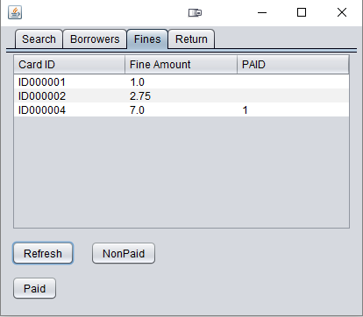The Refresh button fills the table with the sum of fines that correlate with that persons card ID. It will also list wither they have paid the fine or not.
* A null value means that the fine is not paid yet and a one value indicates that its paid.
* The non paid button refreshes the list, but excludes those that already paid the fine.
* Once the payment is received, then the user can click on the row of the paid user and hit the paid button.
* An error window will occur if someone tries to pay for a fine but hasn’t return one of the books yet.

**4. Return Tab**

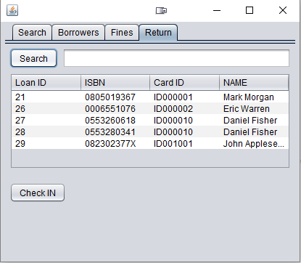The return tab to return books

Search Table Feature:

* Searches database of book loans
* Search by ISBN
* Search by card ID
* Search by Borrower name

Check IN Feature:

* Check in books that are click on in the table.