**Mock ups of Plagiarism Detection System:**

1. **Login page:**

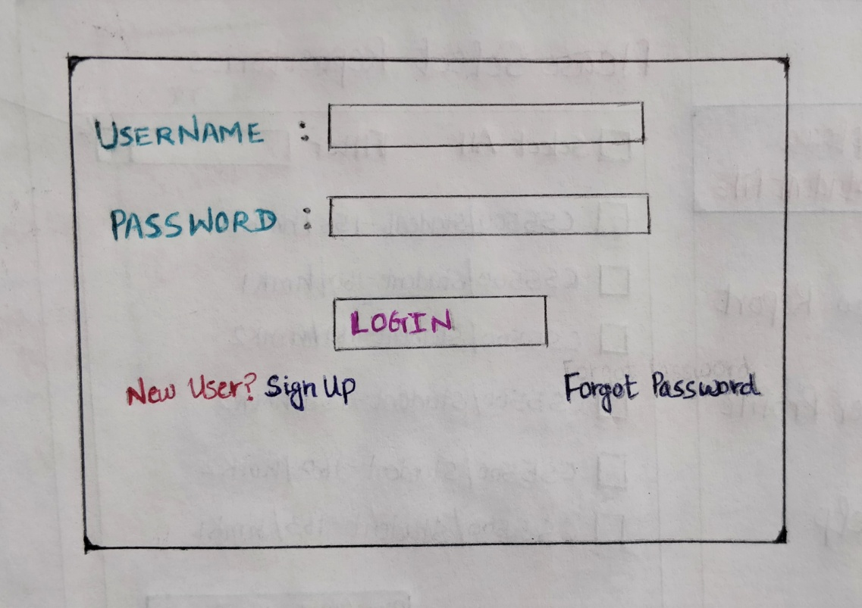

1. **Student Code Upload:**

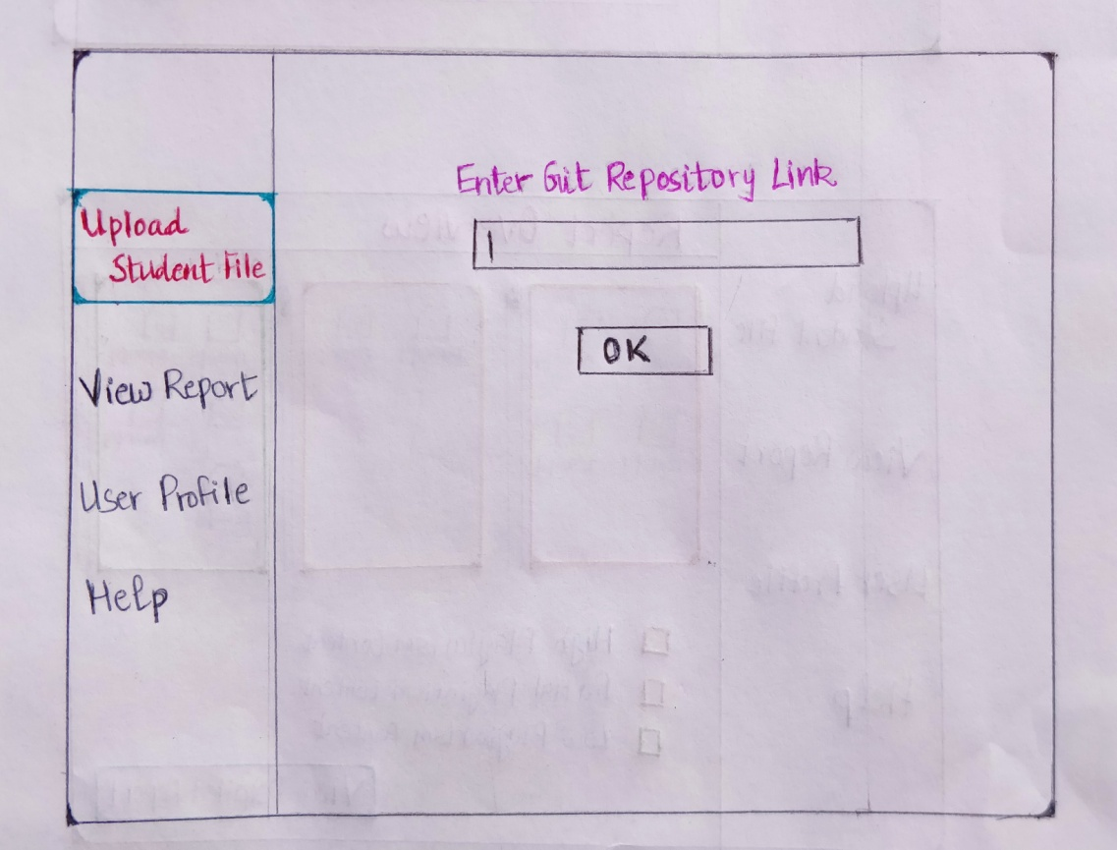

**Select Repository Page:**

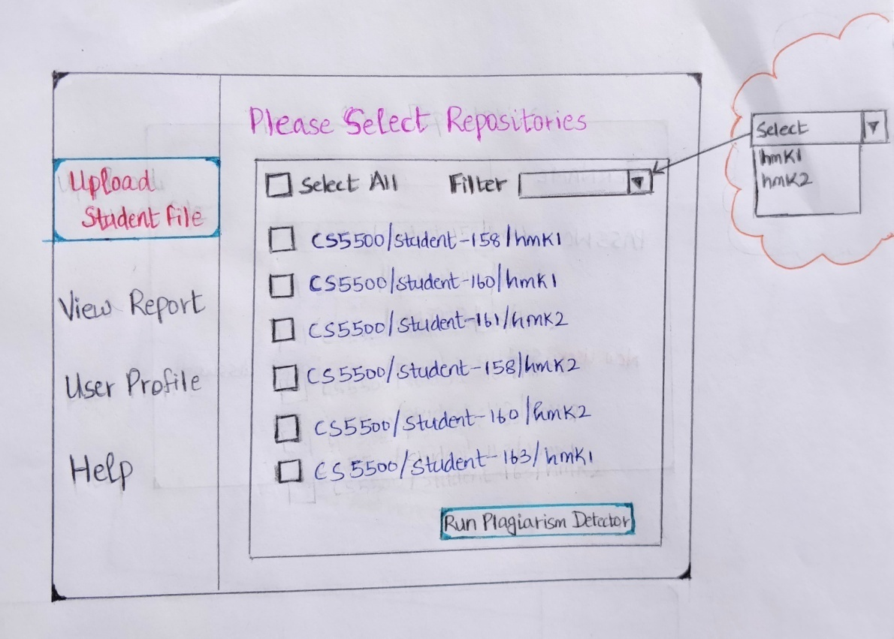

**Plagiarism Detector Running..:**

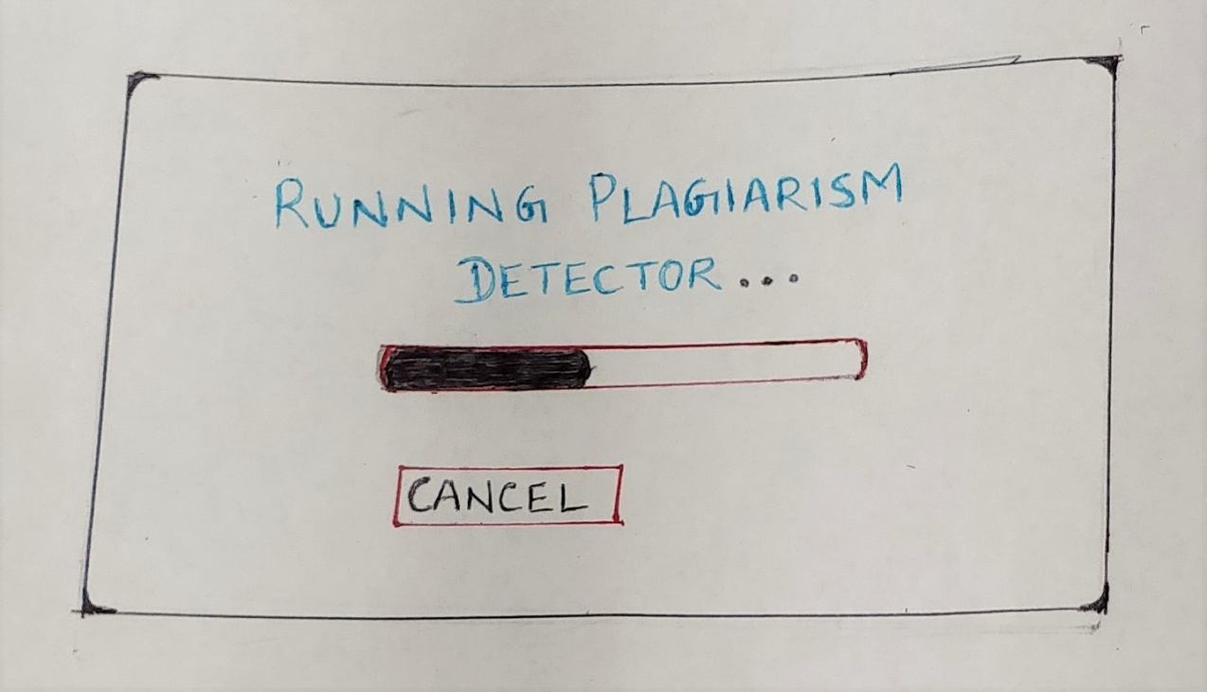

**Report Overview Page:**

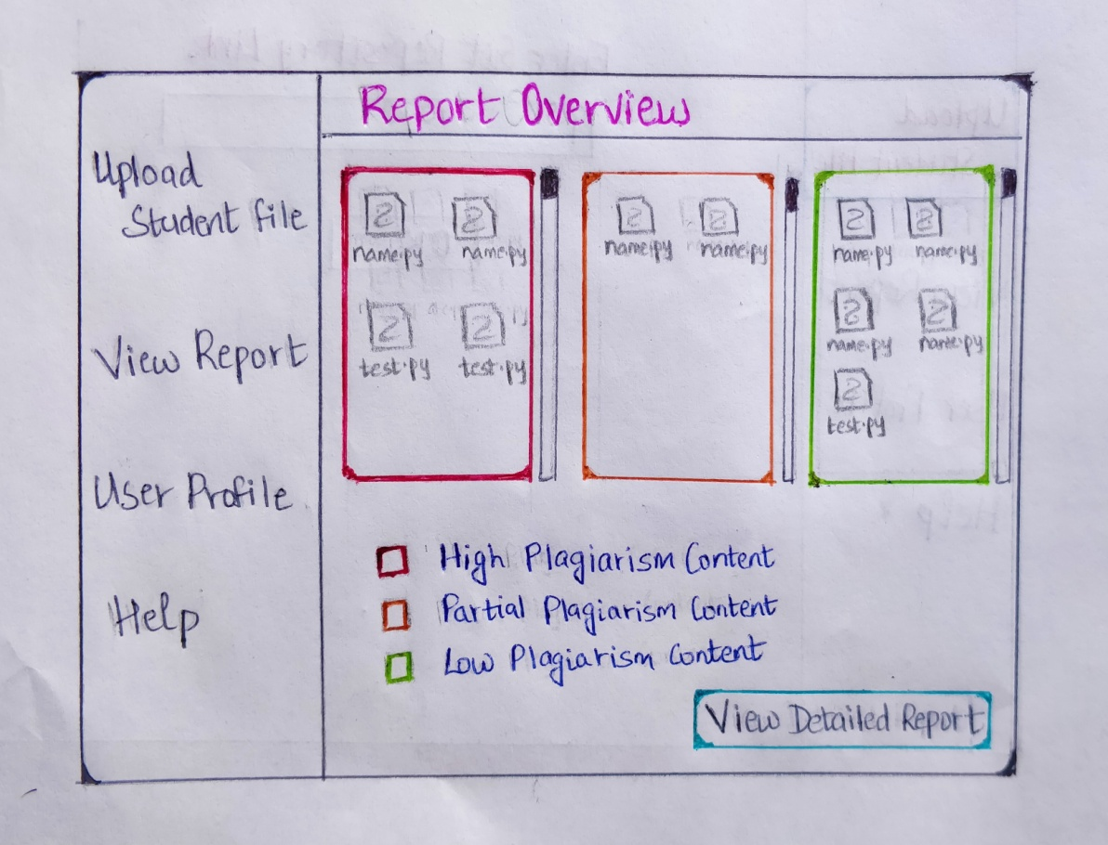

**View Report Page:**

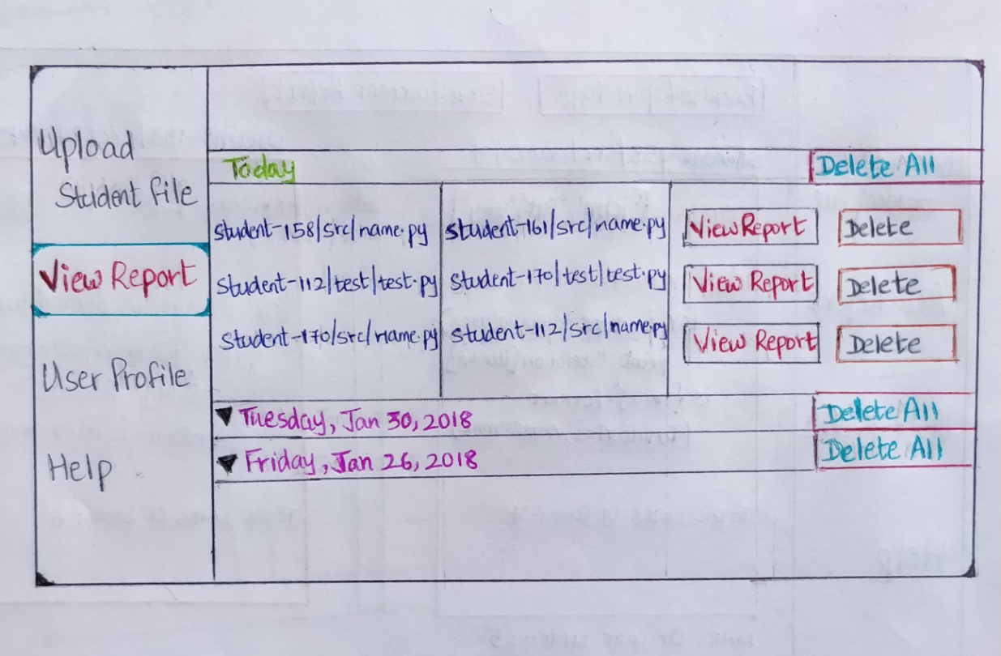

**Detailed Report Page:**

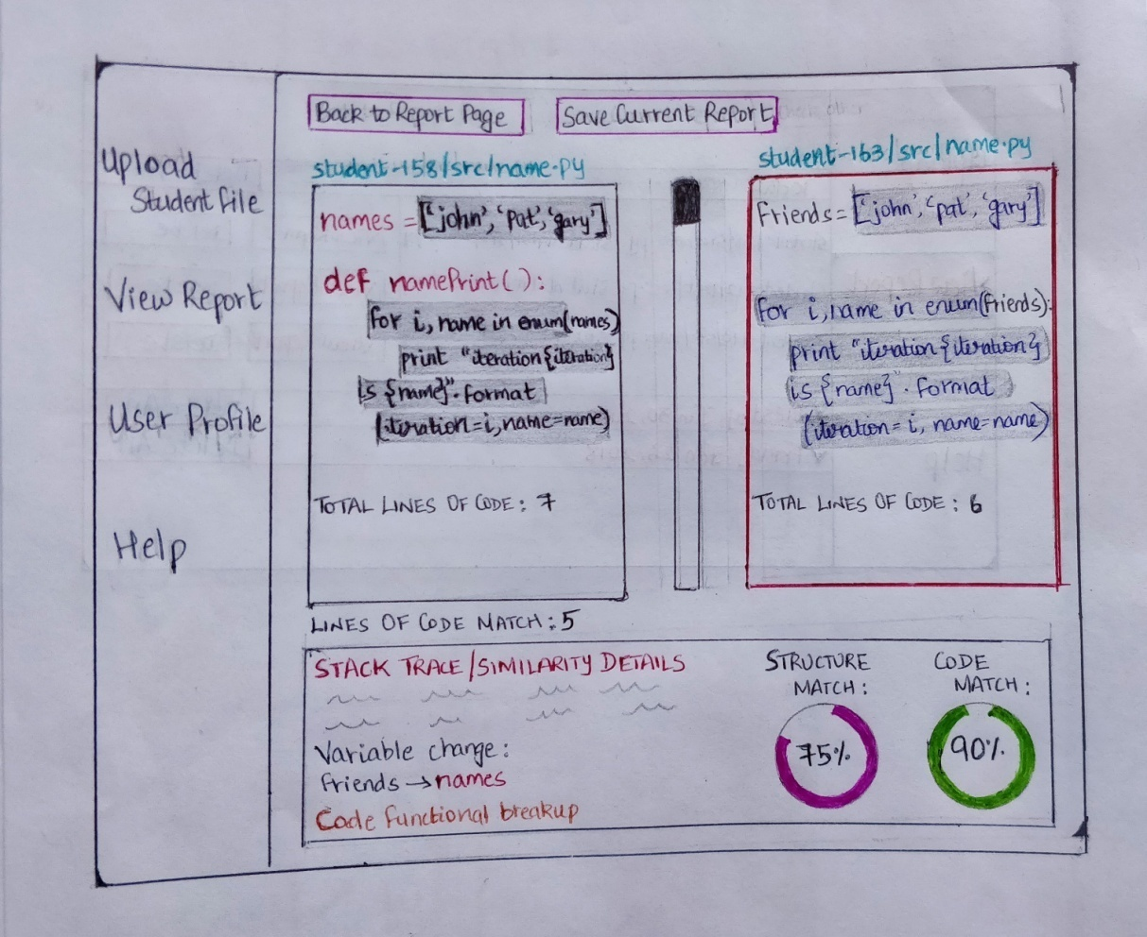

**User creation by Admin:**

