[**Kernel (image processing) - Wikipedia**](https://en.wikipedia.org/wiki/Kernel_(image_processing))

**Blur effect in MATLAB**

img = imread(‘barbara_gray.bmp’);

matrix = [1,1,1;1,1,1;1,1,1];

out_img = conv2(matrix, img) / 9;

out_img = uint8(out_img);

figure,imshow(img);

figure,imshow(out_img);

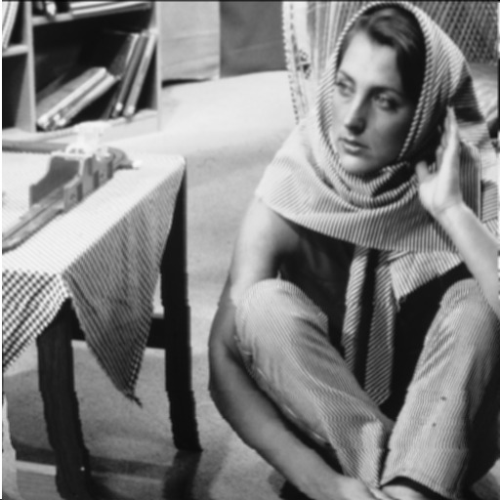

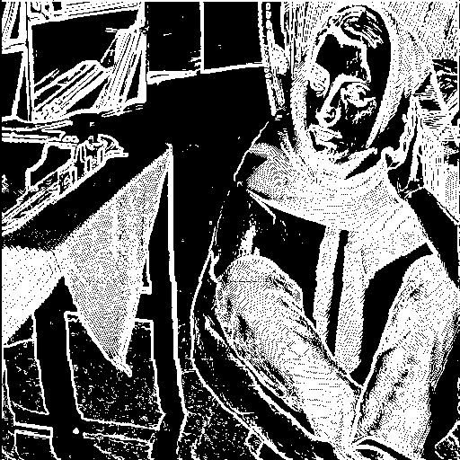

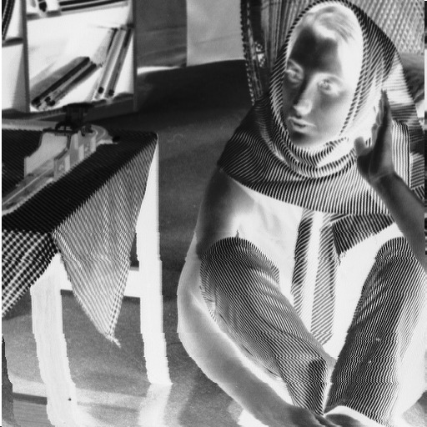

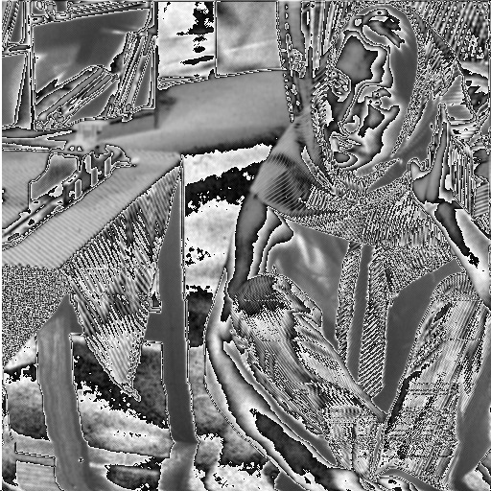

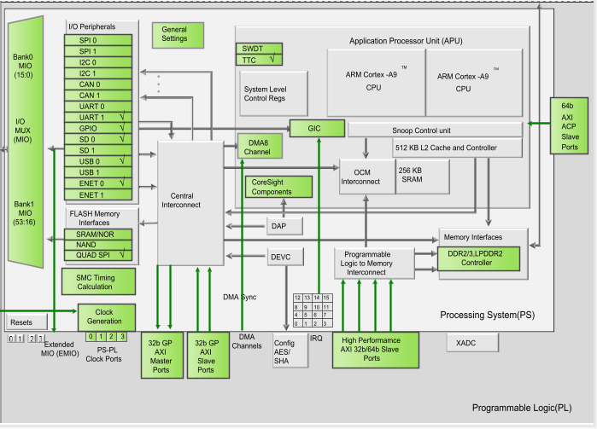

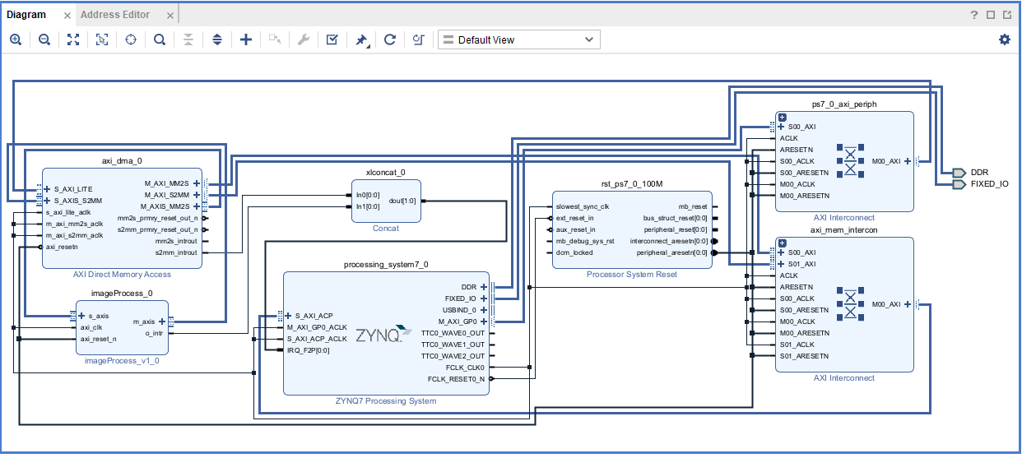

[Saudi Arabia: A Saudi prince beats a traffic policeman in Medina for stopping his car | Watch (msn.com)](https://www.msn.com/en-xl/news/other/saudi-arabia-a-saudi-prince-beats-a-traffic-policeman-in-medina-for-stopping-his-car/vi-BB1mYzVw?ocid=msedgntp&pc=U531&cvid=80b507b690664338beaf2040455b923a&ei=71)