Human Resource Development for AI Drug Discovery-opportunity for Hardware-Software-Biology-Chemistry

**Summary**

Recent technological advances in Computational Science and deep learning have opened up new avenues of research in drug discovery. However, lack of skilled resources and infrastructure (compute power) has always posed a challenge in initiating and successfully running such projects. The purpose of this proposal is to start a pilot project involving highly qualified students / researchers / teachers at Top Universities, to develop a High-Performance Computing platform for Computational Science specifically, AI Drug discovery (multi-billion market). The project will be initially funded by US organizations and Technocrats in the Silicon Valley. The length of the project is five years, and main goals of the project are: to develop awareness about the potential of AI based drug discovery, train personnel, at the same time layout the foundation for developing hardware and software for Computational Science (training in Computer Architecture, Hardware, Software, Chemistry, and Biology).

We are starting this initiative for the sake of God and Only God can make it successful.

# Introduction:

Recent advancement in Drug discovery using high speed computers, and artificial intelligence could help scientists develop better medicines faster—and thus improve millions of people’s lives. At present there is no treatment for many diseases, because it takes more than ten years to discover and develop a drug. Using high speed computers and AI, we might be able to develop drugs in less than few years (COVID-19 is an example Ref.1). This will be life-changing for many human beings and a very noble pursuit. We are at the pinnacle of time where we can participate in this pursuit through training of work force and developing new technologies. This type of work requires highly skilled personals and high-end six-figure average salaries are common (Ref. 2 & 3). The market is expected to grow to $50B in few years (Ref. 4) and there is a good opportunity to tap this market if we start now.

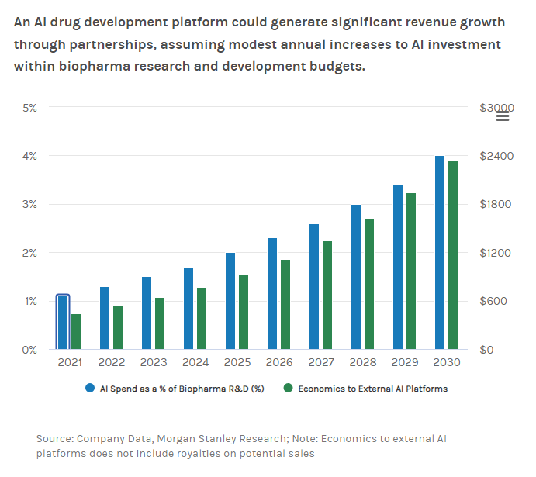

The process of drug discovery using computers is compute-intensive job and requires supercomputers. DE Shaw Research has developed three generations of Supercomputers (Anton-1, Anton-2, & Anton-3) for drug discovery and one of the pioneers in this field (Ref. 5). Similarly, Riken Japan has also developed a Supercomputer for Computational science (Ref. 6). In recent years Graphcore (Ref. 7) developed a solution using AI. All these solutions are very expensive and out of the reach of common people.

Folding@home (FAH or F@h) is an open-source distributed computing project aimed to help scientists develop new therapeutics for a variety of diseases by the means of simulating protein dynamics. Due to open-source a number of research labs are involved in running and enhancing F@h.

We can see that open-source computing is very useful in helping humanity, similarly the RISC-V Instruction Set Architecture (ISA) has also changed the computer architecture development (Ref. 9). Maintaining supercomputers is very expensive and consumes a large amount of electric power. Tesla has unveiled its latest version of its Dojo supercomputer using RISC-V like architecture Dojo is Tesla’s own custom supercomputer platform built from the ground up for AI machine learning. Dojo requires so much power that it managed to trip the grid in Palo Alto. (Ref. 10).

F@H can run on Nvidia graphics cards, which also consumes large amount of power, and not very attractive for earning Folding Coins (FLDC) tokens (Ref. 12). Therefore, we decided to propose an optimized open-source Hardware ASIC for F@H, which can perform domain specific computations more efficiently as compared to Nvidia Graphics cards. Our solution can work independently using WiFi or USB connectivity , or with IoT processors / boards, such as the Raspberry PI, ESP32, etc. and act

like an AI or Computation Science acceleration engine.

Proposed Hardware Accelerator Block Diagram

We are inspired from FLDC white paper, "What about the ASICs? You might be thinking: Why should I get involved if someone is just going to build a specialized machine or environment to do all of the folding and earn all of the FLDC tokens? That is a great question, and the answer is simple: money. In order for an ASIC to contribute folding power to earn FLDC, one would either have to get a hold of the Anton supercomputer23, which is an ASIC specifically designed for protein folding, or perhaps an Amazon EC20 instance. Both are so expensive that the possibility of earning a profit would be out the window. However, if the unimaginable did happen and a consumer grade ASIC was created for protein folding simulations, it would simply mean much more computing power would be devoted to our ultimate goal of finding a cure. Like Bitcoin, in which ASIC miners have helped drive security up

for the blockchain, ASIC Folder's would help drive up computing speed which is also a good thing for the research."

# Project Highlights:

The length of the project is five years, it is an inter-disciplinary (Multi-university) project and main goals of the project are:

1. To develop awareness about the potential of AI based drug discovery
2. To train personnel in the field of AI based drug discovery
3. To layout the foundation for developing hardware and software for Computational Science (training in Computer Architecture, Hardware, Software, Chemistry, and Biology).

The main beneficiaries of the project are:

1. Pharmaceutical sciences researchers with the domain knowledge but they don’t know how to use the latest compute-intensive tools that are used for drug discovery, and how to work in a drug discovery lab for designing a drug.
2. Software Engineering researchers will learn how to work in multi-disciplinary environment, use specialized software packages for biological sciences, and optimize software for a particular hardware architecture (hardware-software co-design).
3. Hardware Engineering students who want to learn computer arithmetic / architecture and the latest tools of the trade for designing accelerator circuits for making application domain-specific computing go faster.

At the end of five-year program, we would like to achieve following two milestones:

1. Train at least 25 researchers who can then train 2500 students
2. Develop the hardware-software architecture on paper/simulator to perform high performance computing.

Please join our team!

# Eligibility:

1. Good communication skills
2. Highly motivated, must be willing to spend at least 20hrs/week and attend meetings on zoom.
3. Perform Independent research
4. Pass the interview and test
5. The program will be started only if we have at least 4 qualified participants.

# Contact:

Dr. Aamir Farooqui **email**: aamirf@hotmail.com

# References:

1. <https://www.sciencedirect.com/science/article/pii/S2666651020300012>
2. <https://www.deshawresearch.com/current-opportunities.html>
3. <https://www.r-ccs.riken.jp/en/about/recruit/>
4. <https://www.morganstanley.com/ideas/ai-drug-discovery>
5. <https://www.deshawresearch.com/>
6. <https://www.r-ccs.riken.jp/en/>
7. <https://www.graphcore.ai/healthcare>
8. <https://foldingathome.org/?lng=en>
9. <https://en.wikipedia.org/wiki/RISC-V>
10. <https://www.tomshardware.com/news/tesla-d1-ai-chip>
11. [https://foldingcoin.net/#:~:text=WHAT%20IS%20FOLDINGCOIN%3F,and%20many%20other%20viral%20diseases.](_blank)
12. [Tesla’s AI supercomputer tripped the power grid (artificialintelligence-news.com)](_blank)