**Methodology of FrenziTech IoT Device**

**Explanation of Pin Utilization of ESP32 ucontroller**

ESP32 DevKitC-V4 has total of 38 pins. It has x3 GND pins for ground, x1 5V for 5volts power source, x1 3V3 pin for 3.3 volts power source and an EN pin for enable purpose. We can use them multiple times but it is better to provide external power source to power sensors and actuators. Therefore excluding 6 above pins there are a total of 32 GPIO pins.

|  |  |  |  |  |  |  |  |  |  |  |  |  |  |  |  |  |  |  |
| --- | --- | --- | --- | --- | --- | --- | --- | --- | --- | --- | --- | --- | --- | --- | --- | --- | --- | --- |
| **5V** | **D0/G07** | **D1/G08** | **G15** | **G02** | **G00** | **G04** | **G16** | **G17** | **G05** | **G18** | **G19** | **GND** | **G21** | **RxD** | **TxD** | **G22** | **G23** | **GND** |
| **ESP32 DevKitC – V4** | | | | | | | | | | | | | | | | | | |
| **CLK/G06** | **CMD/G11** | **D3/G10** | **D2/G09** | **G13** | **GND** | **G12** | **G14** | **G27** | **G26** | **G25** | **G33** | **G32** | **G35** | **G34** | **VN/G39** | **VP/G36** | **EN** | **3V3** |

Table 1: 5V, 3V3 in **RED**, GND in **BLACK** and EN in **GREEN**

x6 GPIOs excluding 3V3 and GND pins are being used from a uController ESP32 to LoRa Ra02 for communication purpose. These pins are ***G02***->DIO0, ***G14***->RES, ***G05***->NSS, ***G18***->SCK, ***G23***->MOSI and ***G19***->MISO from ESP32 -> LoRa Ra02 device. Excluding these 6 pins now 26 GPIOs are left.

|  |  |  |  |  |  |  |  |  |  |  |  |  |  |  |  |  |  |  |
| --- | --- | --- | --- | --- | --- | --- | --- | --- | --- | --- | --- | --- | --- | --- | --- | --- | --- | --- |
| **5V** | **D0/G07** | **D1/G08** | **G15** | **G02** | **G00** | **G04** | **G16** | **G17** | **G05** | **G18** | **G19** | **GND** | **G21** | **RxD** | **TxD** | **G22** | **G23** | **GND** |
| **ESP32 DevKitC – V4** | | | | | | | | | | | | | | | | | | |
| **CLK/G06** | **CMD/G11** | **D3/G10** | **D2/G09** | **G13** | **GND** | **G12** | **G14** | **G27** | **G26** | **G25** | **G33** | **G32** | **G35** | **G34** | **VN/G39** | **VP/G36** | **EN** | **3V3** |

Table 2: G02, G14, G05, G18, G19 G23 in **BLUE** connected to LoRa

***VP/G36 and VN/G39*** are digital pins and have no capability of PWM function therefore using these x2 pins as digital IN.

|  |  |  |  |  |  |  |  |  |  |  |  |  |  |  |  |  |  |  |
| --- | --- | --- | --- | --- | --- | --- | --- | --- | --- | --- | --- | --- | --- | --- | --- | --- | --- | --- |
| **5V** | **D0/G07** | **D1/G08** | **G15** | **G02** | **G00** | **G04** | **G16** | **G17** | **G05** | **G18** | **G19** | **GND** | **G21** | **RxD** | **TxD** | **G22** | **G23** | **GND** |
| **ESP32 DevKitC – V4** | | | | | | | | | | | | | | | | | | |
| **CLK/G06** | **CMD/G11** | **D3/G10** | **D2/G09** | **G13** | **GND** | **G12** | **G14** | **G27** | **G26** | **G25** | **G33** | **G32** | **G35** | **G34** | **VN/G39** | **VP/G36** | **EN** | **3V3** |

Table 3: G35 and G34, in **GREEN** connected for Digital IN pins.

There are x16 ADC pins which can be used as an analog to digital converter, only few analog pins are required therefore using x6 GPIOs for analog IN function to measure 0-3.3 volt signals, therefore utilizing ***G34 (ADC1_6), G35(ADC1_7), G32(ADC1_4), G33(ADC1_5) , G25(ADC1_8) and G26(ADC2_9)*** GPIO pins.

|  |  |  |  |  |  |  |  |  |  |  |  |  |  |  |  |  |  |  |
| --- | --- | --- | --- | --- | --- | --- | --- | --- | --- | --- | --- | --- | --- | --- | --- | --- | --- | --- |
| **5V** | **D0/G07** | **D1/G08** | **G15** | **G02** | **G00** | **G04** | **G16** | **G17** | **G05** | **G18** | **G19** | **GND** | **G21** | **RxD** | **TxD** | **G22** | **G23** | **GND** |
| **ESP32 DevKitC – V4** | | | | | | | | | | | | | | | | | | |
| **CLK/G06** | **CMD/G11** | **D3/G10** | **D2/G09** | **G13** | **GND** | **G12** | **G14** | **G27** | **G26** | **G25** | **G33** | **G32** | **G35** | **G34** | **VN/G39** | **VP/G36** | **EN** | **3V3** |

Table 4: G34, G35, G32, G33, G25 and G26 in **PURPLE** connected for Analog IN pins.

In field we also need to control the actuators therefor using ***G27, G12, G13, G15, G22 and G21*** x6GPIOs for this purpose. These pins also have a PWM generation capability therefore we can control the actuators output voltages from 0 to 255.

|  |  |  |  |  |  |  |  |  |  |  |  |  |  |  |  |  |  |  |
| --- | --- | --- | --- | --- | --- | --- | --- | --- | --- | --- | --- | --- | --- | --- | --- | --- | --- | --- |
| **5V** | **D0/G07** | **D1/G08** | **G15** | **G02** | **G00** | **G04** | **G16** | **G17** | **G05** | **G18** | **G19** | **GND** | **G21** | **RxD** | **TxD** | **G22** | **G23** | **GND** |
| **ESP32 DevKitC – V4** | | | | | | | | | | | | | | | | | | |
| **CLK/G06** | **CMD/G11** | **D3/G10** | **D2/G09** | **G13** | **GND** | **G12** | **G14** | **G27** | **G26** | **G25** | **G33** | **G32** | **G35** | **G34** | **VN/G39** | **VP/G36** | **EN** | **3V3** |

Table 4: G27, G12, G13, G15, G22 and G21 in **Orange** connected for Digital OUT pins.

There are x3 serial ports. Two of them port 0 and port 2 can be used without reinitialization whereas port 1 needs reinitialization. Port 0 is ***Rx/TxD***, Port 2 is ***G16/G17*** and Port 1 that needs reinitialization is ***G0/G04***. Port 2 is used for RS232 communication whereas Port 1 is used for RS485 communication and Port 0 is used for programming purpose.

|  |  |  |  |  |  |  |  |  |  |  |  |  |  |  |  |  |  |  |
| --- | --- | --- | --- | --- | --- | --- | --- | --- | --- | --- | --- | --- | --- | --- | --- | --- | --- | --- |
| **5V** | **D0/G07** | **D1/G08** | **G15** | **G02** | **G00** | **G04** | **G16** | **G17** | **G05** | **G18** | **G19** | **GND** | **G21** | **RxD** | **TxD** | **G22** | **G23** | **GND** |
| **ESP32 DevKitC – V4** | | | | | | | | | | | | | | | | | | |
| **CLK/G06** | **CMD/G11** | **D3/G10** | **D2/G09** | **G13** | **GND** | **G12** | **G14** | **G27** | **G26** | **G25** | **G33** | **G32** | **G35** | **G34** | **VN/G39** | **VP/G36** | **EN** | **3V3** |

Table 5: RxD, TxD, G16, G17, G00 and G04 in **Gray** connected for serial communication purposes.

X6 pins are left out which will be used further developing the code. Issue regarding not utilizing them now is that they are connected to memory.

**Vertical Table of Pin Utilization Diagram**

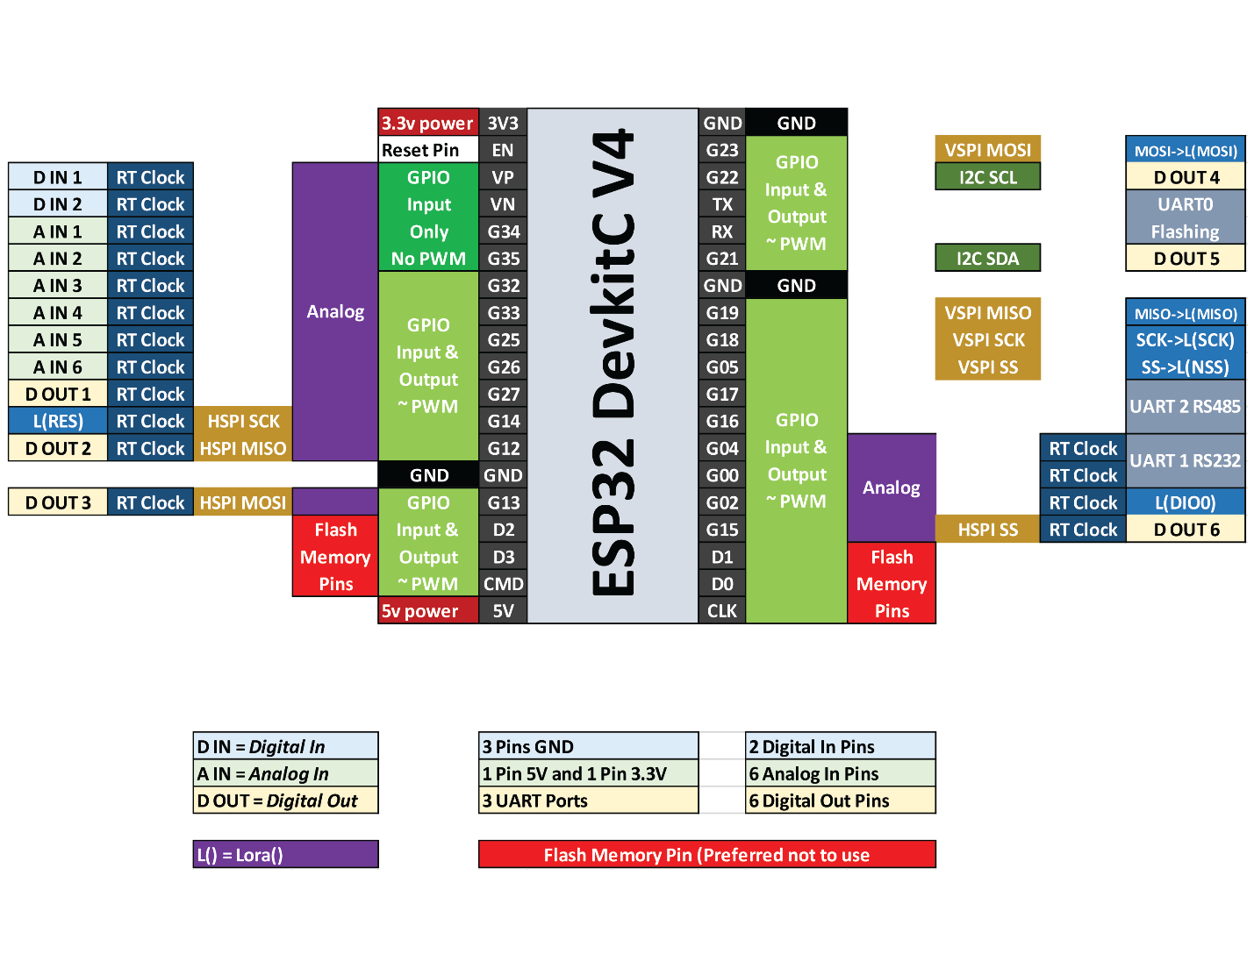

**MAIN BOARD SPEC**

|  |  |  |
| --- | --- | --- |
| INPUT AC VOLTAGE | 110-240V AC |  |
| INPUT DC VOLTAGE | 5V OR SOLAR |  |
| BATTERY BACKUP | 18305 LI-ION |  |
| CONNECTIONS | WIFI, LORA, BT, LTE |  |
| INTERNAL VOLTAGES | 3.3V, 5V, 12V, 18V, 24V? |  |
| DIGITAL IOS | 4-RELAYS 5V – 12 - 24V | EXTENDED TO 256 |
|  | 4-SOLENOIDS |  |
|  | RS232, I2C, SPI, RS485 |  |
| ANALOG IN | 6 – BAT IN VOLT, BOARD TEMP, MOTOR CURRENT, 4-20mA, 5V IN, 3.3V |  |
| SENSE | TEMP, MOISTURE, SALINITY, CURRENT, WELL DEPTH |  |

**Explanation of Block Diagram**

Suppose there are multiple RTUs and a single MCU. These multiple RTUs are communicating to MCU through LoRa Ra02 using an SPI communication utilizing 6 GPIO pins (G02, G14, G05, G18 and G19).

RTU and MCU has x2 digital IN pins (G36 and G39), x6 analog IN pins (G34, G35, G32, G33, G25 and G26) and x6 digital OUT pins (G27, G12, G13, G15, G22 and G21). There are x3 serial ports, of which port 2 is used for RS232 communication whereas Port 1 is used for RS485 communication and Port 0 is used for programming purpose.

The only difference between RTU and MCU is that MCU is continuously utilizing its port 2 communicating with 4G LTE device. Through this device the data is being published and subscribed to and from the MQTT cloud.

Right now MQTT cloud is an online server created on <https://mqtthq.com/>. But we will create our own offline MQTT server later.

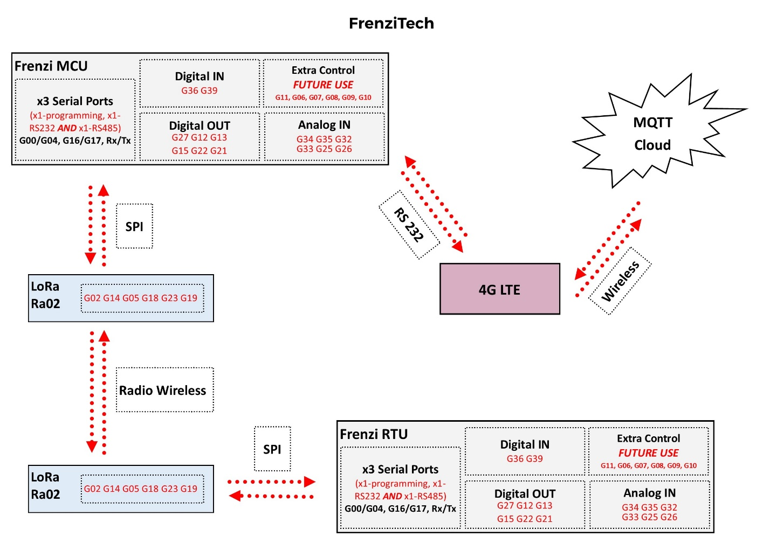

Figure 1: Block Diagram of an IoT device system

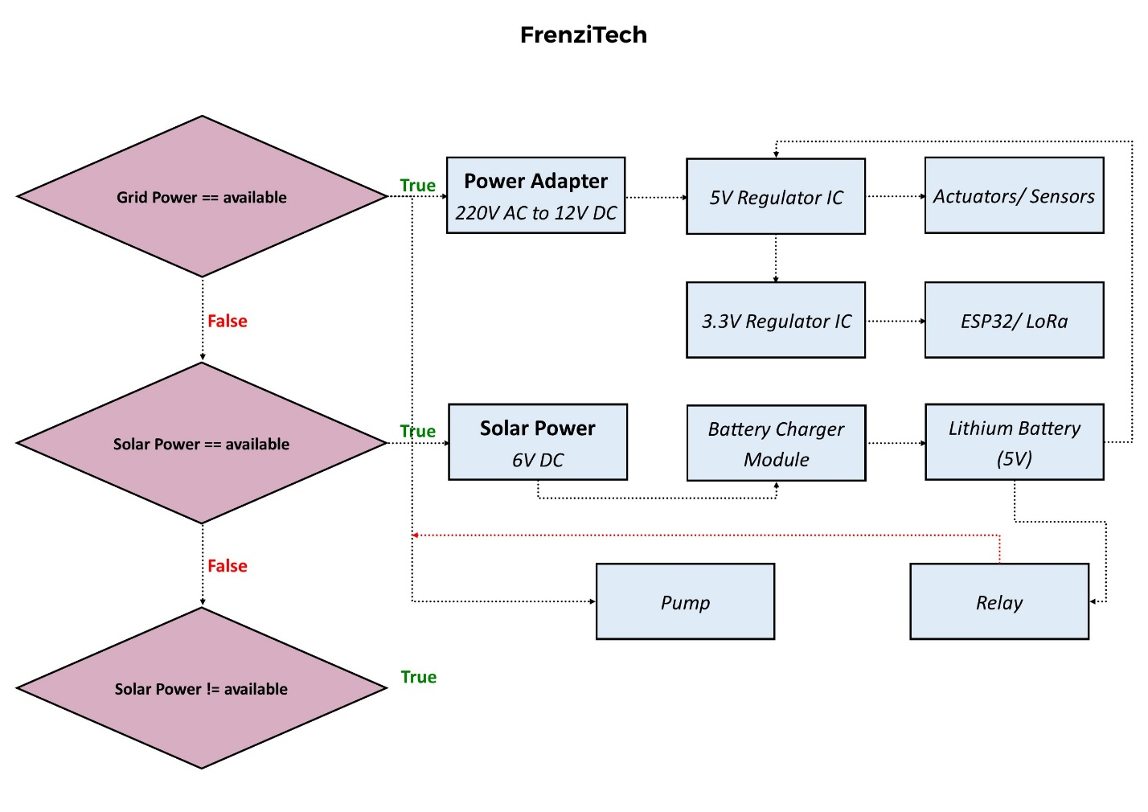

Figure 2: Block diagram for powering the IoT device system

**Explanation of Power System**

The system can be powered on from grid power, solar power and from lithium 5V battery. If actuators are a high voltage devices such as motors and pumps then we will be needing 220v to power them. A relay will be used to control them from ESP32.

Most of the systems are going to be powered from solar panels source. This solar power source is going to be charged in to 5V battery using battery charger. Then from 5V battery actuators and sensors can be powered on. A 3.3V regulator (LM3940) converts 5V to 3.3V to power the ESP32 and LoRa.