***Name*** *– Syed Najam*

***Document Name*** *– Conclusion of Wind Machine Design*

***Document Version*** *– 2nd Update on 14 March 2023*

*(The information in the document is not fixed and will get updates. (In process))*

**WIND**

.

**WIND INFORMATION**

MSN Live Weather Online Simulation (Free)

Can get wind speed at any point (past record and future predictions also available)

Annual Karachi average is approx. 10 mil/hr.

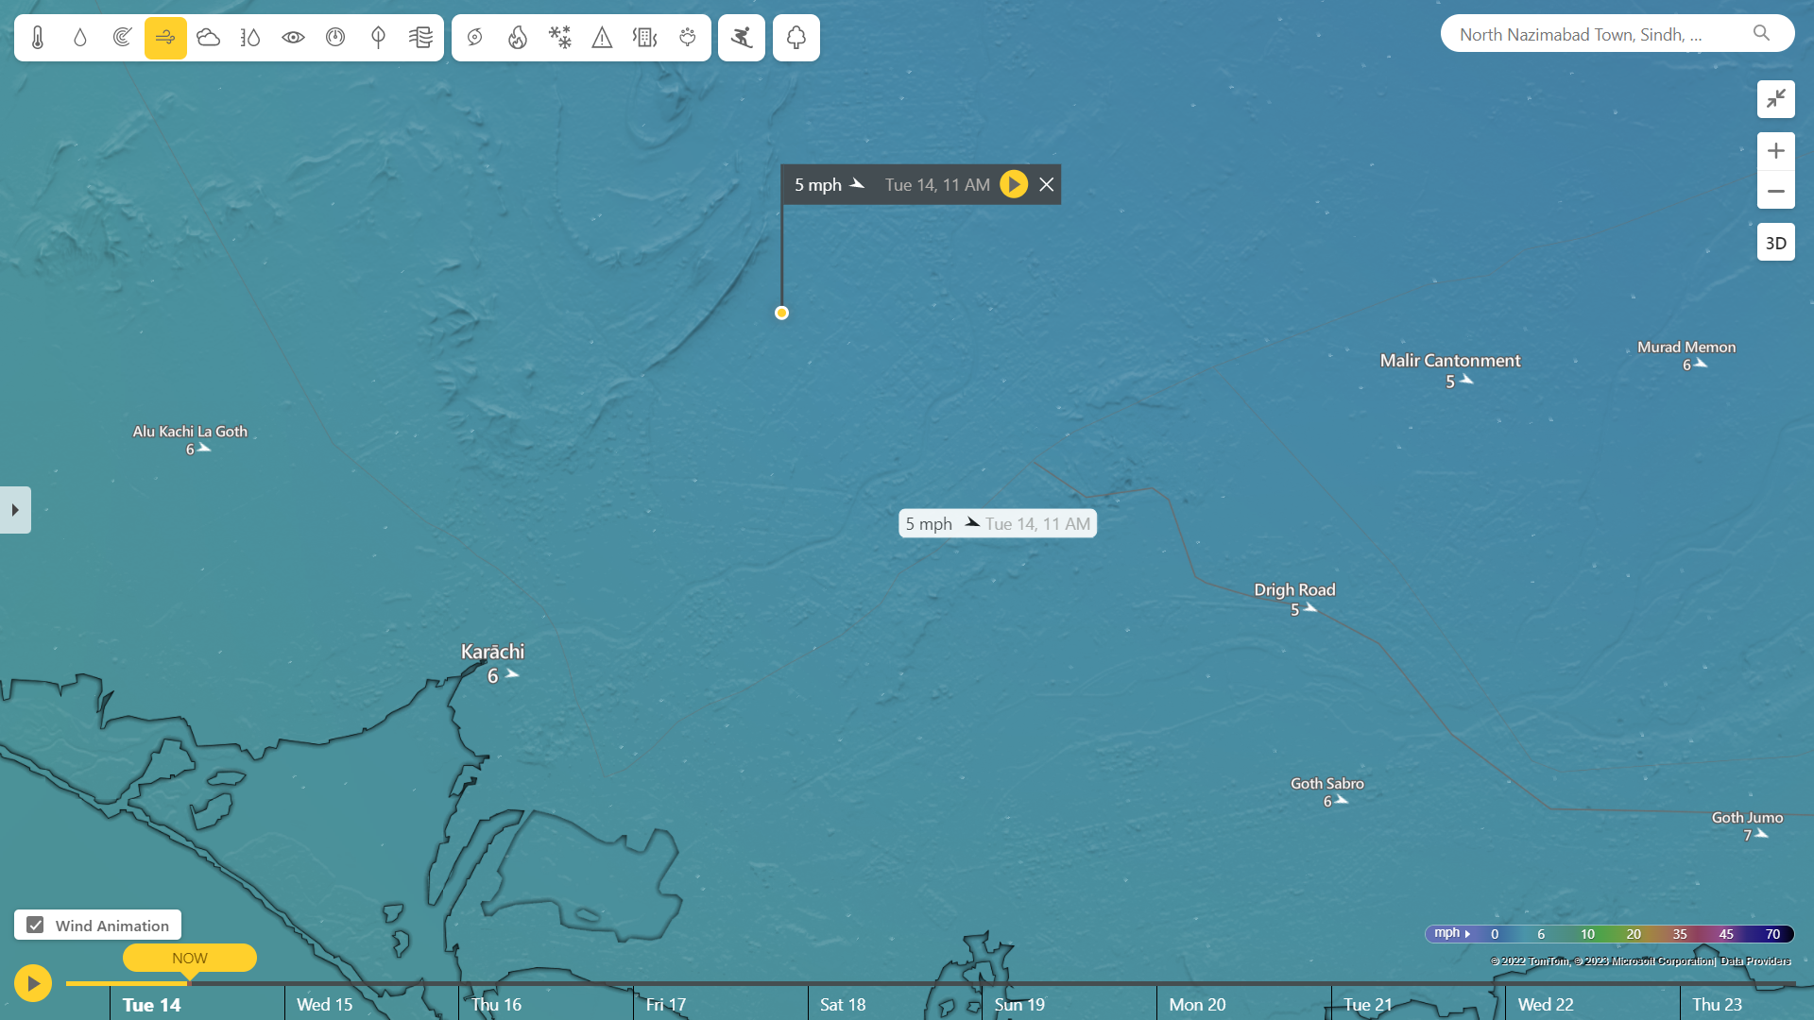

[www.msn.com/en-us/weather/forecast/](http://www.msn.com/en-us/weather/forecast/)

**WIND POWER CALCULATION**

Wind Power = [ (0.5) x (Swept Area) x (Air Density) x (Velocity)^3 x (Generator Efficiency) x (Gear Box Efficiency) x (Betz Limit) ]

.

.

.

**BLADES**

.

Blade Material will be PVC

Blade Cord = [ 5.6 x (radius at tip)^2 ] / [ (no. of blades) x (lift coefficient) x (radius at point) x (tip speed ratio) ]

<https://sear.unisq.edu.au/8546/1/Kirsch_2009_MainProject_.pdf> , (Following for blade designing idea)

.

.

**SHAFT**

[ (Maximum Shear stress) / (Radius of the shaft)

= (Twisting Moment or Torque) / (Polar moment of inertia)

= Modulus of rigidity for the shaft material) x (Angle of twist in radians on a length) / (Length of the shaft) ]

.

As we will be knowing the torque (required) so we will find the radius and length. Remaining parameters will be knows as we select the material.

.

.

**GEAR**

.

**Target**

To increase the speed at driven shaft attached with dynamo / alternator which is driven by driving shaft gear attached with the mechanical rotational source.

**Gear Calculation**

[ (RPM of A) x (Teeths of A) = (RPM of B) x (Teeths of B) ] ; A-Driving & B-Driven

[ Gear Ratio = (Teeth of B) / (Teeth of A) ]

[ Output Speed = (Speed of driving gear) / (Gear Ratio) ]

[ Output Torque = (Torque of driving gear) – (Output Speed) ]

Will be calculated according to the requirements

(For an idea) Generally,

1 HP needed for 50-70 A less friction dynamo, where thumb rule says 1 HP needed for every 25A at 12 V.

.

.

**BELT & WHEEL**

.

Can simulate / visualize our calculations on <https://www.blocklayer.com/pulley-belteng> (Free)

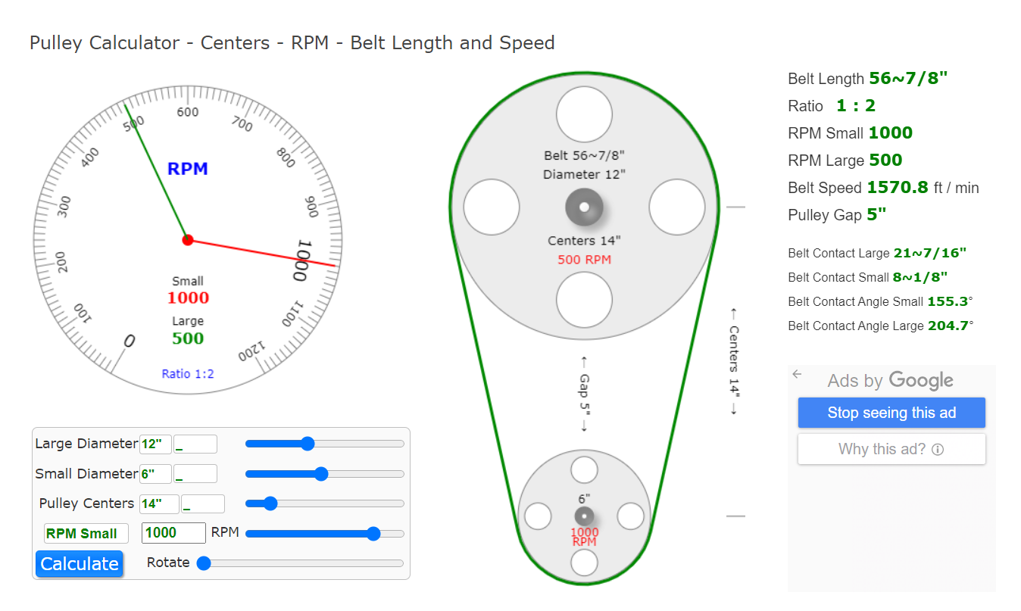

.

[ Belt Speed = (pi)/2 x (diameter of the pulley) x (RPM)/(60) ]

[ Belt Torque = (Force) x (driven pulley radius) / (efficiency of system) ]

Our target will be to keep the dynamo shaft rotating within suitable RPMs range. So the diameters and length will be calculated accordingly.

Keeping in view that larger diameter of driving pulley will cause interruption in rotor swept area of wind blades.

.

.

**DYNAMO / ALTERNATOR**

**CALCULATIONS**

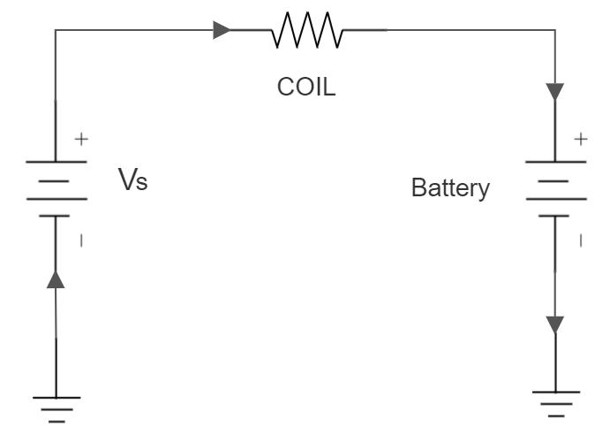

[ Voltage across coil resistance = Vs – Battery Volts ]

[ Current into battery = (V across R) / (Coil R) ]

[ Power into battery = (V across R) x (Current into battery) ]

[ Power lost = (V across R)^2 / (Coil R) ]

Efficiency of Genset = [ (power into battery) / (power into battery) x (power lost) ]

**PRIORITIES**

* Less Startup Requirements
* Less Starting / Running / Cogging Torque Requirements
* Less running RPM Requirements
* Approx. 500W output at 7 mil/hr.

**OPTIONS**

* 1300 CC Car Alternators / Dynamo.
  + High power output
  + Needs High RPM for their rated output voltages.
  + Have carbon brushes and slip rings as regulator control the field excitation through DC circuit.
  + Diode Trio, rectifier, regulator already attached.
* Coreless Axial Flux Permanent Magnet Generator.
  + Coreless.
  + Freedom from hysteresis losses and iron losses.
  + Having permanent magnet.
  + Brushless structure
  + Need to add rectifier and regulator externally.
  + Can operate in low RPMs range.
* Low RPM Permanent Magnet Alternator.
  + Less cogging torque needed.
  + Easy startup condition
  + Gearless, direct drive
  + Permeant magnet
  + Generally Starting torque of 0.5 – 0.6 Nm required.
  + Brushless structure.
  + Need external rectifier and regulator.
* HUB MOTOR
  + (conclusion in process)
* WASHING MACHINE MOTOR
  + (conclusion in process)
  + Better than car alternator in providing electrical power output with respect to the car alternator.

.

.

.

**BATTERY**

.

Will be connected through multi stage external voltage regulator, as to maintain the concept of battery charging condition, the voltages coming from wind machine output should be greater than battery voltages.

Battery Selection will be according to its acceptance percentage of current in relation with dynamo / alternator maximum possible output.

(for an idea) Generally,

Standard Flooded Battery accepts 25-35% of it’s AH from Charging Source.

GEL Battery accepts 30-40% of it’s AH from Charging Source.

AGM Battery accepts 50-60% of it’s AH from Charging Source.

.

.

**USEFULL LINKS**

.

Blade Design <https://sear.unisq.edu.au/8546/1/Kirsch_2009_MainProject_.pdf>

Power Calculations <https://www.ijsrp.org/research_paper_feb2012/ijsrp-feb-2012-06.pdf>

Efficiency <https://onlinelibrary.wiley.com/doi/pdf/10.1002/eej.20426>

Torque <https://extrudesign.com/torsional-stress-torsional-shear-stress/>

Wind Analysis <https://www.researchgate.net/publication/336959575_Techno_-_Economic_assessment_of_wind_power_potential_of_Hawke's_Bay_using_Weibull_parameter_A_review>

ALTERNATOR AS WIND TURBINE <https://icrepq.com/PONENCIAS/4.288.FERNANDEZ.pdf>

<https://mev.lipi.go.id/mev/article/view/14>

<https://www.sciencedirect.com/science/article/pii/S2213138816301680>

CAR ALTERNATOR INSIDE <https://exxotest.com/wp-content/uploads/2018/03/GU_DT-M008_EN.pdf>

WASHING MACHINE MOTOR VS CAR ALTERNATOR <https://www.sciencedirect.com/science/article/pii/S2452321620304911>

HONDA CAR ALTERNATORS LISTS AND DATA SHEETS

<https://www.dahkee.com/en/product/DK_Alternator-31100-PFB-004.html>

<https://www.parts-honda.uk/honda-cars/CITY/2006/V/ENGINE/ALTERNATOR-MITSUBISHI-/19SELKD1/E__0610/1/8139>

TOYOTA CAR ALTERNATORS LISTS ONLY

<https://www.dahkee.com/en/product/DK_Alternator-169.html>

TOYOTA ALTERNATOR BUILD MANUAL (To be Downloaded)

<https://www.scribd.com/document/259216586/Toyota-Alternator-Build-Manual-1-4-3pdf-pdf#>