***Name*** *– Syed Najam*

***Document Name*** *– Conclusion of Wind Machine Design*

***Document Version*** *– 2nd Update on 14 March 2023*

*(The information in the document is not fixed and will get updates. (In process))*

**WIND**

.

**WIND INFORMATION**

MSN Live Weather Online Simulation (Free)

Can get wind speed at any point (past record and future predictions also available)

Annual Karachi average is approx. 10 mil/hr.

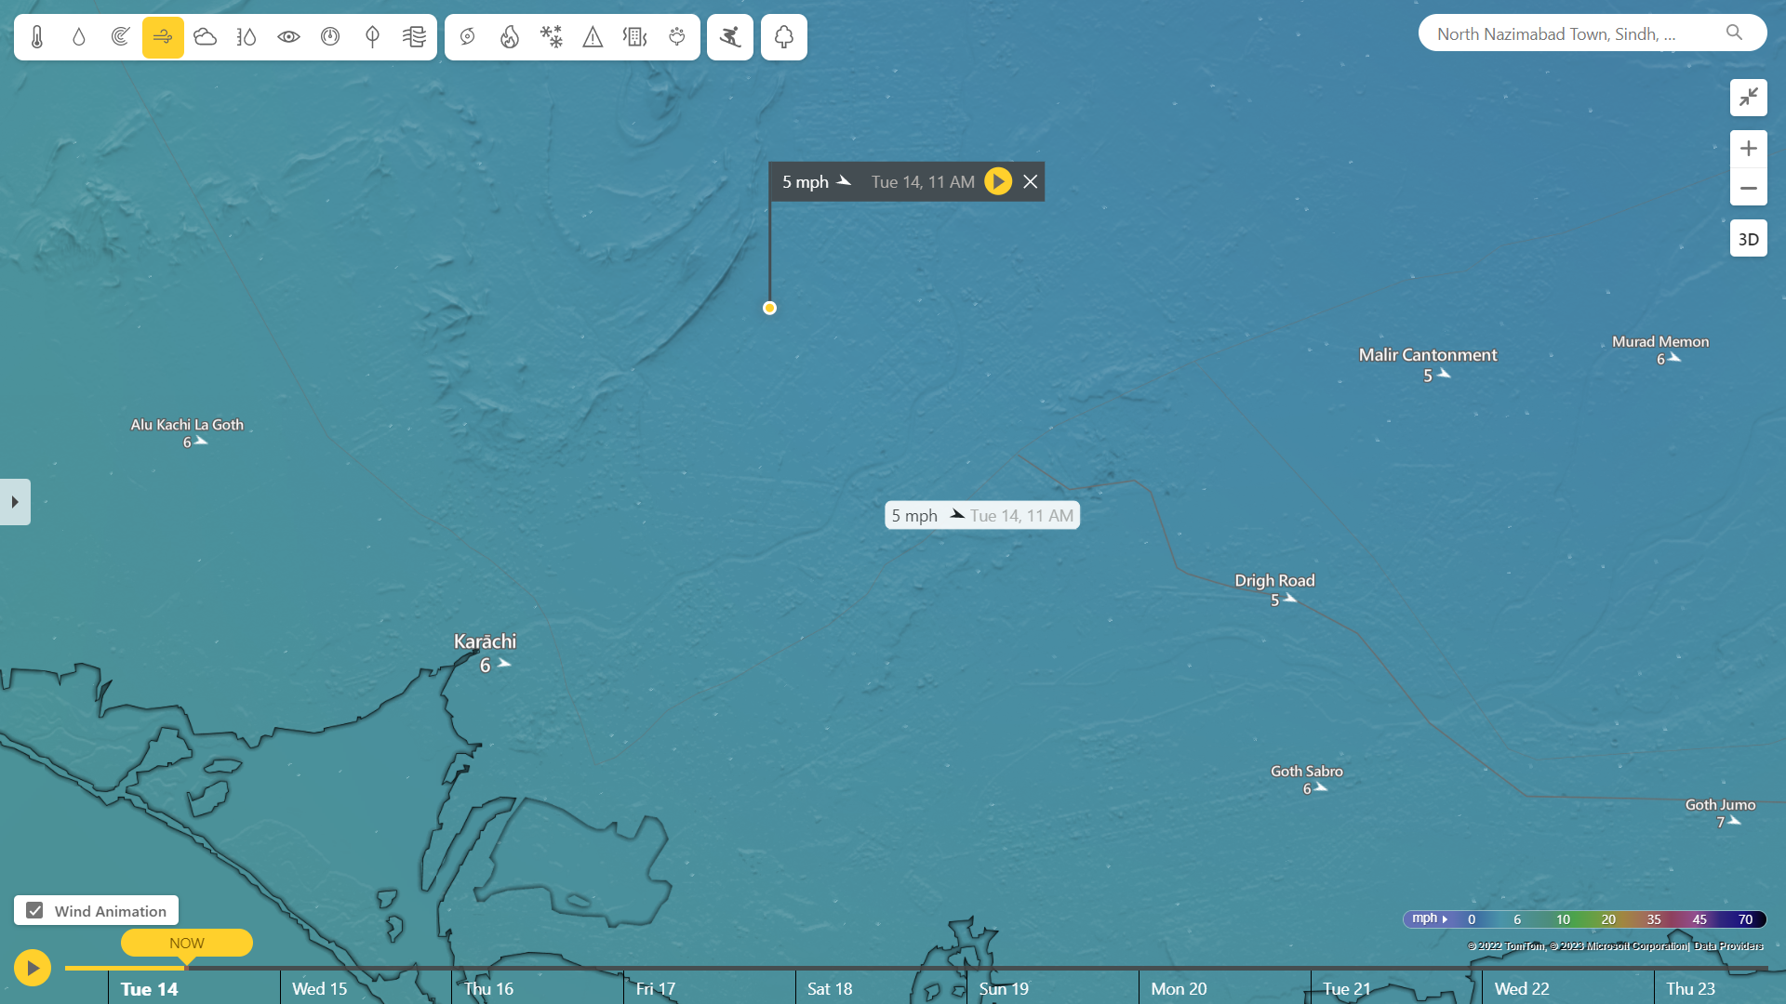

[www.msn.com/en-us/weather/forecast/](http://www.msn.com/en-us/weather/forecast/)

**WIND POWER CALCULATION**

Wind Power = [ (0.5) x (Swept Area) x (Air Density) x (Velocity)^3 x (Generator Efficiency) x (Gear Box Efficiency) x (Betz Limit) ]

.

.

.

**BLADES**

.

Blade Material will be PVC

Blade Cord = [ 5.6 x (radius at tip)^2 ] / [ (no. of blades) x (lift coefficient) x (radius at point) x (tip speed ratio) ]

<https://sear.unisq.edu.au/8546/1/Kirsch_2009_MainProject_.pdf> , (Following for blade designing idea)

.

.

**SHAFT**

[ (Maximum Shear stress) / (Radius of the shaft)

= (Twisting Moment or Torque) / (Polar moment of inertia)

= Modulus of rigidity for the shaft material) x (Angle of twist in radians on a length) / (Length of the shaft) ]

.

As we will be knowing the torque (required) so we will find the radius and length. Remaining parameters will be knows as we select the material.

.

.

**GEAR**

.

**Target**

To increase the speed at driven shaft attached with dynamo / alternator which is driven by driving shaft gear attached with the mechanical rotational source.

**Gear Calculation**

[ (RPM of A) x (Teeths of A) = (RPM of B) x (Teeths of B) ] ; A-Driving & B-Driven

[ Gear Ratio = (Teeth of B) / (Teeth of A) ]

[ Output Speed = (Speed of driving gear) / (Gear Ratio) ]

[ Output Torque = (Torque of driving gear) – (Output Speed) ]

Will be calculated according to the requirements

(For an idea) Generally,

1 HP needed for 50-70 A less friction dynamo, where thumb rule says 1 HP needed for every 25A at 12 V.

.

.

**BELT & WHEEL**

.

Can simulate / visualize our calculations on <https://www.blocklayer.com/pulley-belteng> (Free)

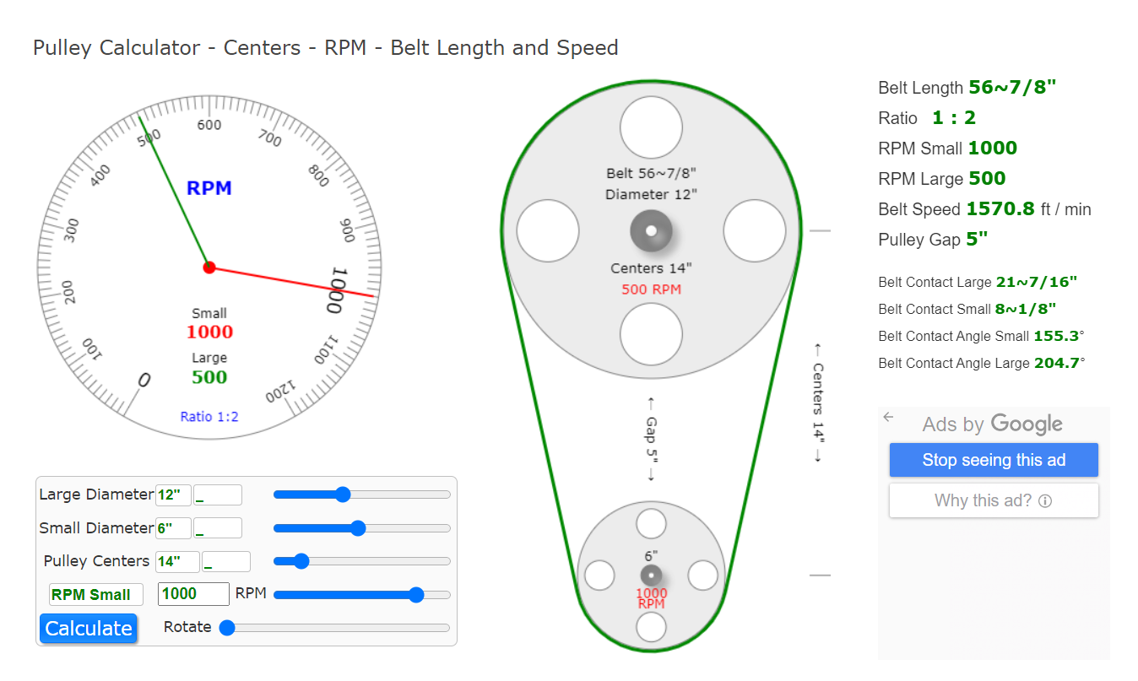

.

[ Belt Speed = (pi)/2 x (diameter of the pulley) x (RPM)/(60) ]

[ Belt Torque = (Force) x (driven pulley radius) / (efficiency of system) ]

Our target will be to keep the dynamo shaft rotating within suitable RPMs range. So the diameters and length will be calculated accordingly.

Keeping in view that larger diameter of driving pulley will cause interruption in rotor swept area of wind blades.

… final output will be equals to the combine efforts by HAWT and VAWT and their combine torque will provide the low rpm output to the dynamo connected with the first shaft and this will rotate along the y and x axis both therefore we have to develop the timeline of toque requirement and output speed calculations of other dynamos connected on the same pulley and belts respectively.

.

**DYNAMO / ALTERNATOR**

**CALCULATIONS**

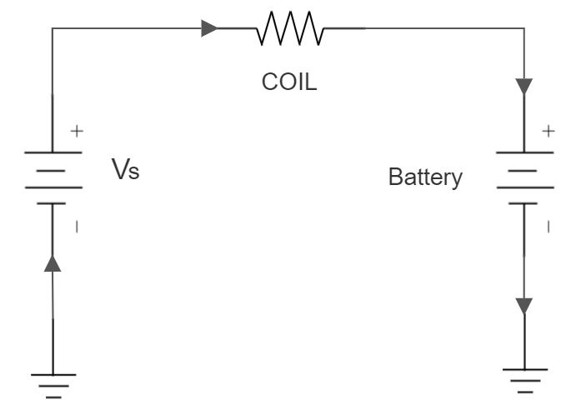

[ Voltage across coil resistance = Vs – Battery Volts ]

[ Current into battery = (V across R) / (Coil R) ]

[ Power into battery = (V across R) x (Current into battery) ]

[ Power lost = (V across R)^2 / (Coil R) ]

Efficiency of Genset = [ (power into battery) / (power into battery) x (power lost) ]

**PRIORITIES**

* Less Startup Requirements
* Less Starting / Running / Cogging Torque Requirements
* Less running RPM Requirements
* Approx. 500W output at 7 mil/hr.

**OPTIONS**

* 1300 CC Car Alternators / Dynamo.
  + High power output
  + Needs High RPM for their rated output voltages.
  + Have carbon brushes and slip rings as regulator control the field excitation through DC circuit.
  + Diode Trio, rectifier, regulator already attached.
* Coreless Axial Flux Permanent Magnet Generator.
  + Coreless.
  + Freedom from hysteresis losses and iron losses.
  + Having permanent magnet.
  + Brushless structure
  + Need to add rectifier and regulator externally.
  + Can operate in low RPMs range.
* Low RPM Permanent Magnet Alternator.
  + Less cogging torque needed.
  + Easy startup condition
  + Gearless, direct drive
  + Permeant magnet
  + Generally Starting torque of 0.5 – 0.6 Nm required.
  + Brushless structure.
  + Need external rectifier and regulator.
* HUB MOTOR
  + (conclusion in process)
* WASHING MACHINE MOTOR
  + (conclusion in process)
  + Better than car alternator in providing electrical power output with respect to the car alternator.

.

.

.

**BATTERY**

.

Will be connected through multi stage external voltage regulator, as to maintain the concept of battery charging condition, the voltages coming from wind machine output should be greater than battery voltages.

Battery Selection will be according to its acceptance percentage of current in relation with dynamo / alternator maximum possible output.

(for an idea) Generally,

Standard Flooded Battery accepts 25-35% of it’s AH from Charging Source.

GEL Battery accepts 30-40% of it’s AH from Charging Source.

AGM Battery accepts 50-60% of it’s AH from Charging Source.

.

.

**HYBRID TURBINE**

**3D Model**

First Design Completed.

**Blades**

Blades will be of aluminum alloy. Light weight, low cost respectively, mechanically good.

4 Blades 90 degree apart from each other.

Cutting of sheets for Savonius will be C shaped and for Darrieus will be V shaped.

Gear ratio will be around 1:10-15.

Swept area will be = pi * Dia * Height

Rotor area will be = 2 * Radius * Length

Design target converge incoming wind to some higher velocity which is to be strike on the concave side of savonius. While guide mechanism at convex side to limit the flow. This all to increase positive torque and lesser drag.

**Simulation**

We are having 5 different options for simulation

Q Blade (haven’t got the crack version)

Ansys Fluent (crack has been founded), will use dynamic mesh.

Converge (crack has been founded)

MATLAB Simulink Mask Editor (available)

Solid Works Wizard fluid flow (available)

**Radius Modification**

Rotor radius effect on output

We are having two options in our common shaft hybrid system.

Savonius Bucket radius can be fixed while Darrieus keeps varied.

OR

Darrieus rotor radius can be fixed while Savonius bucket radius keep varied,

Whereas the target will be to maintain the ratio of radius between both turbines.

(completed in rough … will be documented here shortly)

**Calculations**

We can evaluate the performance of our hybrid wind machine by torque coefficient and coefficient of power.

The Tip Speed Ratio relates to average available wind power and rotor diameter.

We can have Ratio = tip speed or peripheral velocity / wind speed = angular velocity * rotor radius / wind speed

Coefficient of torque = Actual torque by rotor / Theoretical torque = 4 * Actual Torque by rotor / Air Density * Swept area * rotor diameter * ( wind velocity )^3

Also = coefficient of power / tip speed ratio

The Force on rotor shaft will be = T = ( radius of brake drum + radius of rope (shaft connected) ) * gravitational acceleration

So the coefficient of power will be = maximum power obtained from the spring / total power available from incoming wind = Max power obtained / (0.5) * air density * rotor swept area * wind velocity^3.

Power of turbine will be = Calculated torque * angular velocity of rotor

**MIX Turbine Clutch mechanism**

(completed in rough … will be documented here shortly)

**Twisting Blades Modification**

Our target is to modify the design parameters to get best field characteristics of rotor so we can enhance power coefficient and self-starting capability of our hybrid machine

By modifying twist angle of the blade along x and y axis both. And overlap ratio and endplates size ratio. By this we will be able to get the aerodynamic performance of the twisted savonius turbine. Toque variation power thrust, static torque coefficient will be enhanced in comparison with the conventional turbine.

45 degree twisting angles

Zero overlapping ratio

Endplate size ration of approx. 1.1

(Modelling in process… will be completed in the simulation software)

**USEFULL LINKS**

.

Blade Design <https://sear.unisq.edu.au/8546/1/Kirsch_2009_MainProject_.pdf>

Power Calculations <https://www.ijsrp.org/research_paper_feb2012/ijsrp-feb-2012-06.pdf>

Efficiency <https://onlinelibrary.wiley.com/doi/pdf/10.1002/eej.20426>

Torque <https://extrudesign.com/torsional-stress-torsional-shear-stress/>

Wind Analysis <https://www.researchgate.net/publication/336959575_Techno_-_Economic_assessment_of_wind_power_potential_of_Hawke's_Bay_using_Weibull_parameter_A_review>

ALTERNATOR AS WIND TURBINE <https://icrepq.com/PONENCIAS/4.288.FERNANDEZ.pdf>

<https://mev.lipi.go.id/mev/article/view/14>

<https://www.sciencedirect.com/science/article/pii/S2213138816301680>

CAR ALTERNATOR INSIDE <https://exxotest.com/wp-content/uploads/2018/03/GU_DT-M008_EN.pdf>

WASHING MACHINE MOTOR VS CAR ALTERNATOR <https://www.sciencedirect.com/science/article/pii/S2452321620304911>

HONDA CAR ALTERNATORS LISTS AND DATA SHEETS

<https://www.dahkee.com/en/product/DK_Alternator-31100-PFB-004.html>

<https://www.parts-honda.uk/honda-cars/CITY/2006/V/ENGINE/ALTERNATOR-MITSUBISHI-/19SELKD1/E__0610/1/8139>

TOYOTA CAR ALTERNATORS LISTS ONLY

<https://www.dahkee.com/en/product/DK_Alternator-169.html>

TOYOTA ALTERNATOR BUILD MANUAL (To be Downloaded)

[https://www.scribd.com/document/259216586/Toyota-Alternator-Build-Manual-1-4-3pdf-pdf#](https://www.scribd.com/document/259216586/Toyota-Alternator-Build-Manual-1-4-3pdf-pdf)

Hybrid Turbine

<https://www.sciencedirect.com/science/article/pii/S0196890420302119>

<https://tj.uettaxila.edu.pk/older-issues/2016/No4/12.%20Common%20Vertical%20Axis%20Savonius-Darrieus%20Wind%20Turbines%20for%20Low%20Wind%20Speed%20Highway%20Applications.pdf>

<https://www.hindawi.com/journals/ijrm/2018/3568542/>

<https://iopscience.iop.org/article/10.1088/1757-899X/217/1/012020/pdf>