Title: Solar Air Purification System (SAPS)
Summary:
The researchers suggest the Solar Air Purification System (SAPS) as a response to the pressing threat posed by climate change. This creative idea addresses the negative consequences of air pollution globally by using sustainable solar energy to power cutting-edge air filtration technology. In order to combat climate change and promote environmental health, SAPS offers a cost-effective and sustainable solution that combines solar panels with effective air filtration modules. Communities everywhere gain from this system, but especially those who are most at risk from bad air quality. With its self-sufficient functioning and low upkeep needs, SAPS is a viable approach to lessen the effects of climate change and build a more sustainable, healthy future for everybody.

Background and Problem:

Rising temperatures, harsh weather, and worsening air quality are all signs of climate change, which is a serious threat to our world. The escalation of air pollution is one of the most important effects of climate change, having a negative influence on ecosystems, human health, and economy. The fundamental issue that traditional air filtration techniques seek to address is made worse by their frequent reliance on energy-intensive procedures driven by fossil fuels. Thus, there is an immediate need for creative and long-lasting ways to reduce air pollution and lessen the effects of climate change.

Using innovative air filtration technology and renewable solar energy, the Solar Air filtration System (SAPS) aims to address this pressing issue. SAPS eliminates carbon emissions associated with conventional air purification systems and lessens dependency on fossil fuels by using solar panels to gather sunlight and turn it into power. The air purification system incorporates effective modules that employ filtration and purification methods to eliminate air pollutants, including particulate matter, volatile organic compounds, and greenhouse gases.

Furthermore, vulnerable groups such as children, the elderly, and those with respiratory disorders are disproportionately affected by the negative consequences of air pollution. These populations frequently suffer the most from bad air quality, with greater incidences of cardiovascular disease, respiratory ailments, and early mortality. Therefore, SAPS not only tackles the problem of air pollution from an environmental standpoint but also advances social justice by enhancing the quality of the air in marginalized groups.

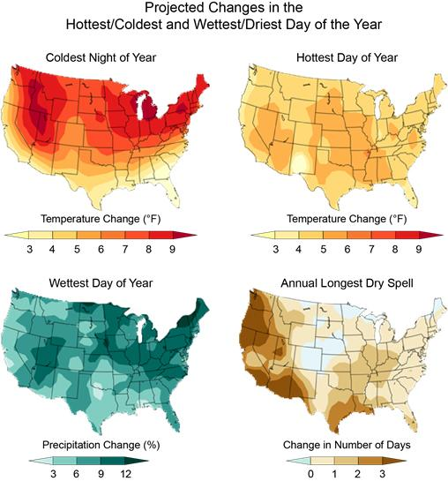
Climate Impacts on Human Health | Climate Change Impacts | US EPA (chicago.gov)
Projected changes in several climate variables for 2046-2065 with respect to the 1981-2000 average for the RCP6.0 scenario. These include the coldest night of the year (top left) and the hottest day of the year (top right). By the middle of this century, the coldest night of the year is projected to warm by 6°F to 10°F over most of the country, with slightly smaller changes in the south. The warmest day of the year is projected to be 4°F to 6°F warmer in most areas. Also shown are projections of the wettest day of the year (bottom left) and the annual longest consecutive dry day spell (bottom right). Extreme precipitation is projected to increase, with an average change of 5% to 15% in the precipitation falling on the wettest day of the year. The length of the annual longest dry spell is projected to increase in most areas, but these changes are small: less than two days in most areas.

Fighting air pollution and lessening the effects of climate change are two new strategies that SAPS offers. SAPS provides a sustainable way to build a more resilient and healthy future for all by utilizing solar energy and modern day air purification technologies.

Beneficiaries:

The communities impacted by air pollution and climate change across the world are among the beneficiaries of SAPS. Cleaner air and better environmental conditions are especially beneficial for vulnerable groups, such children, the elderly, and people with respiratory disorders.

Proposed solution:
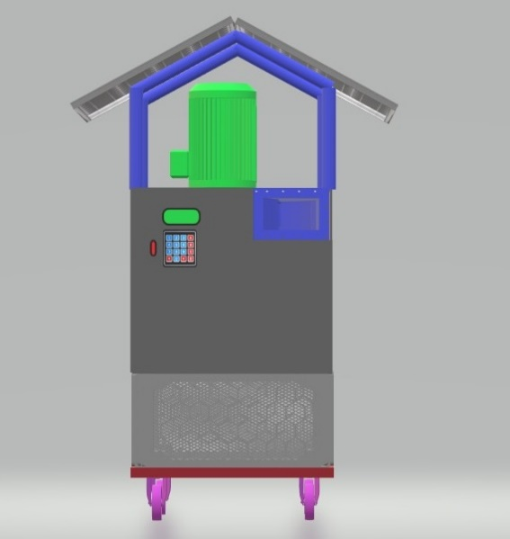
The innovative Solar Air Purification System (SAPS) offers a cutting-edge response to the urgent problems caused by air pollution and climate change. SAPS offers a sustainable and effective way to clean the air and counteract the negative impacts of pollution by utilizing the sun's plentiful and renewable energy.

To provide clean, breathing air, SAPS is made up of a number of essential parts that operate in unison. Modern filtration and purification technologies are integrated into its core advanced air purification modules. Particulate matter, volatile organic compounds (VOCs), nitrogen oxides (NOx), sulfur dioxide (SO2), and carbon monoxide (CO) are just a few of the many air pollutants that these modules are intended to target.

The fundamental component of SAPS is its use of solar energy to fuel its operations. Solar cells in solar panels, which are usually mounted on rooftops or in open spaces with lots of sunshine, absorb solar radiation and transform it into electrical energy. The air purification process within the system is then powered by this electricity, doing away with the requirement for fossil fuels or grid electricity. This not only makes SAPS eco-friendly, but it also guarantees that the system runs with low carbon emissions, which helps with the mitigation of climate change in general.

Apart from being powered exclusively by solar energy, SAPS is outfitted with sophisticated sensors and monitoring apparatuses that consistently evaluate air quality metrics in real-time. These sensors track pollution levels and give useful information to help the air purification modules operate at their best. SAPS makes sure that it removes pollutants as efficiently and effectively as possible by dynamically modifying purification parameters in response to the state of the air.

Because of its adaptability, SAPS can be used in a variety of contexts and environments. SAPS can be customized to meet the specific needs of every site, whether it is put in an indoor environment with inadequate ventilation, an industrial site producing pollutants, or an urban region with a lot of traffic. Scalability is another benefit of its modular architecture, which permits customization according to the target area's particular requirements and size.

The Solar Air Purification System (SAPS) offers a technologically sophisticated, economically viable, and environmentally sustainable response to the worldwide problems of air pollution and climate change. SAPS provides a way forward for communities all over the world to have cleaner, healthier environments by using the sun's power to purify the air.

Methods/Details:

The Solar Air Purification System runs on its own, continuously checking the quality of the air and modifying the purification settings as necessary. Urban regions, industrial sites, and indoor environments are just a few of the situations where the system can be implemented. According to a cost-analysis, SAPS provides considerable long-term savings over conventional air purification techniques while requiring little upkeep and without requiring fossil fuels. Further reducing the effects of climate change is SAPS's contribution to carbon reduction initiatives.

References:

