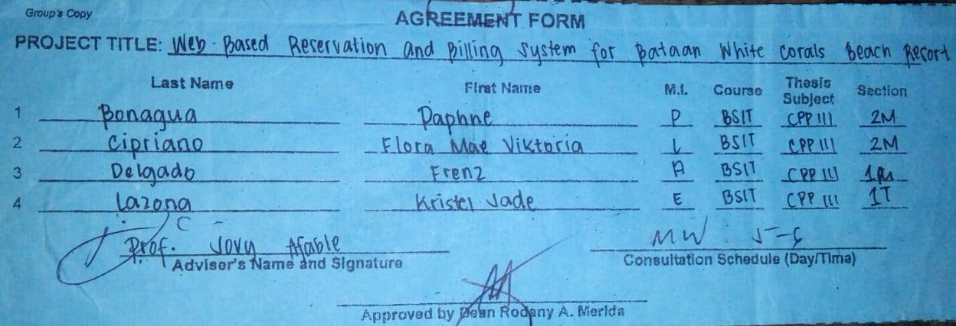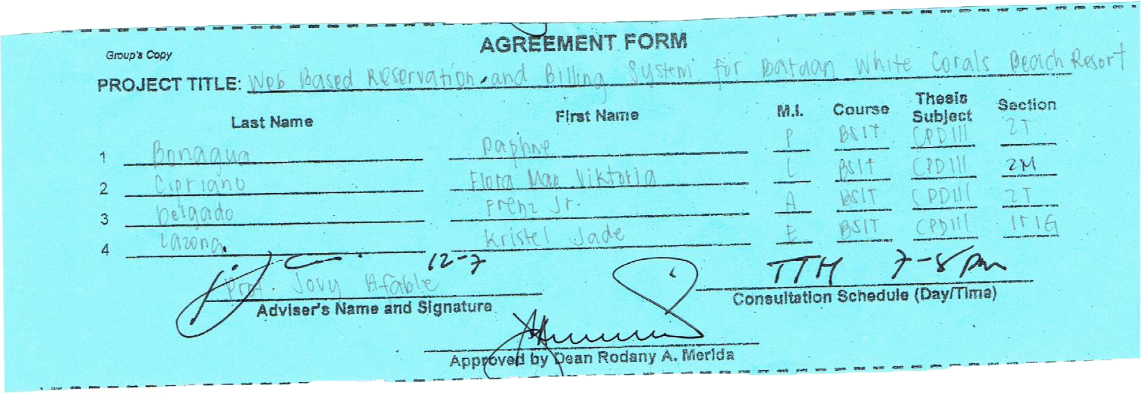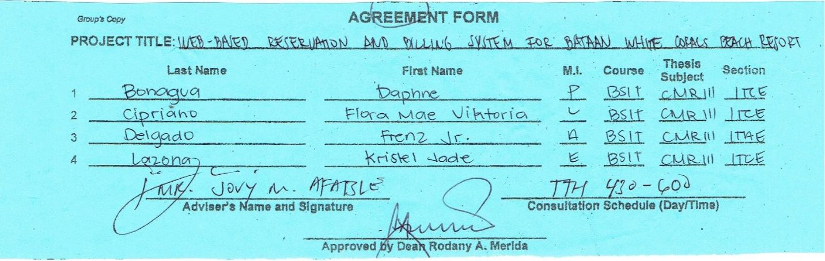­­

CPD 111 (Capstone Project Development)

CPP 111 (Capstone Project Planning)

CMR 111 (Methods of Research for I.T)