daphne puche bonagua

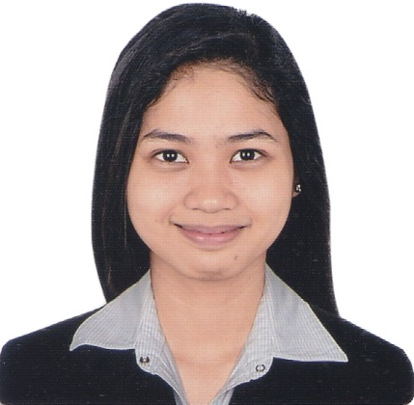

Permanent: 121 Evangelista St. Santolan, Pasig City

Email Address: bonaguadaphne026@gmail.com

EDUCATION

1. **Tertiary Level**  BS Information Technology University of the East Manila 2015-2019
2. **Secondary Level** Sto. Tomas de Villanueva Parochial School

Evangelista St. Santolan, Pasig City

2011-2015

1. **Primary Level**

Sto. Tomas de Villanueva Parochial School School

Evangelista St. Santolan, Pasig City

2005-2011

SEMINARS ATTENDED

* **Fears in Job Interviews: How to Overcome It**, On-the-Job Training Office, University of the East – Manila
* **Labor Education for Graduating Student, Guidance and Counseling Office**, University of the East – Manila
* **Introduction to Programming using HTML and CSS**, Microsoft Technology Associate, University of the East – Manila
* **Battery Exam Tutorial for I.T.** , Computer Students Society (COMSSO)
* **Tech Tutor 10 The Digital Generation**, Jerry Liao’s Power Tips, Megatrade Hall 2, SM Megamall, Mandaluyong City

SKILLS AND INTERESTS

Knowledgeable in Microsoft Office Application and Adobe Photoshop, Basic knowledge in C++, Java, C# and HTML5, Creativity, Time Management

Badminton, Music, Photography, Travelling.

PERSONAL INFORMATION

DATE OF BIRTH: Sept. 17, 1998

AGE: 20 years old

PLACE OF BIRTH: Pasig

NATIONALITY: Filipino

SEX: Female

CIVIL STATUS: Single

HEIGHT: 5’0

WEIGHT: 43.1kg

RELIGION: Roman Catholic

LANGUAGE: Filipino

& English