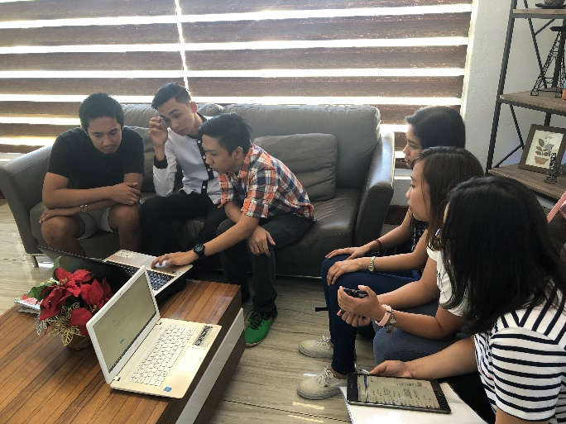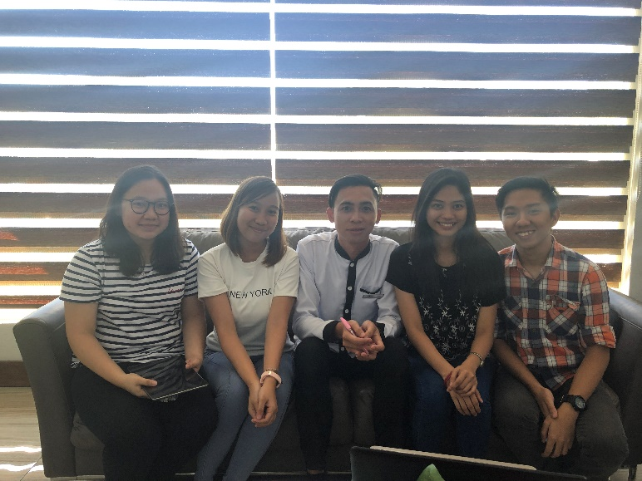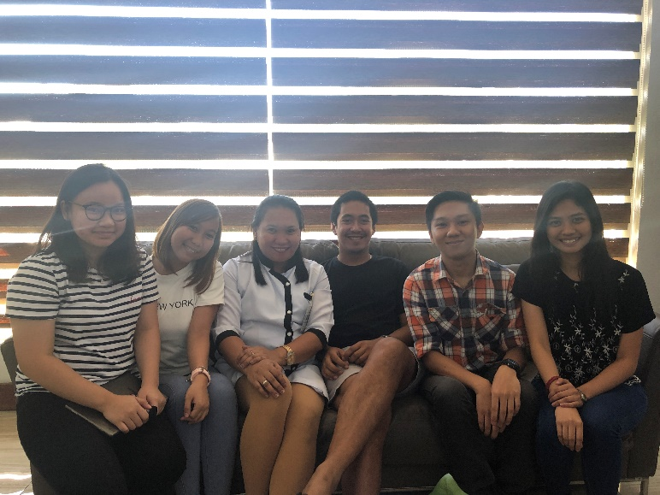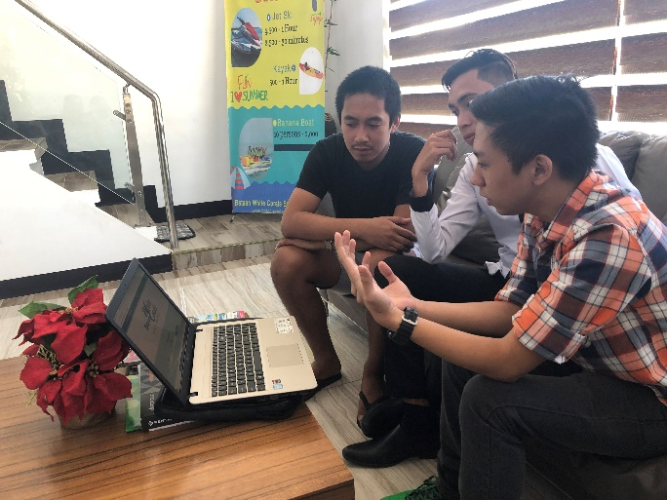

With General Manager Mr. Joroni Paul Simbulan and the receptionist.

Introducing the system and user training to the BWC’s General Manager Mr. Joroni Paul Simbulan and Sales Account Manager Mr. Noel Fulgar.

With Mr. Noel “SAM” Fulgar, the resort’s Sales Account Manager.

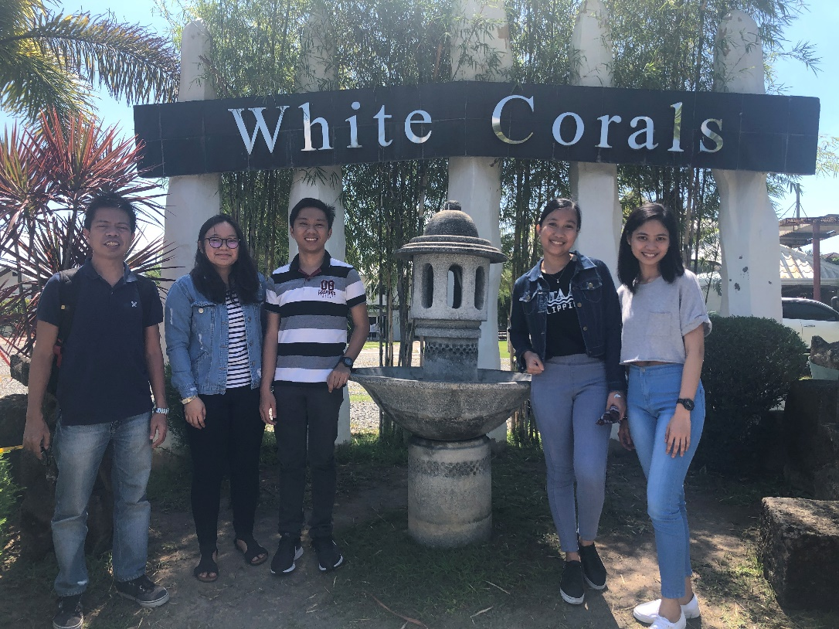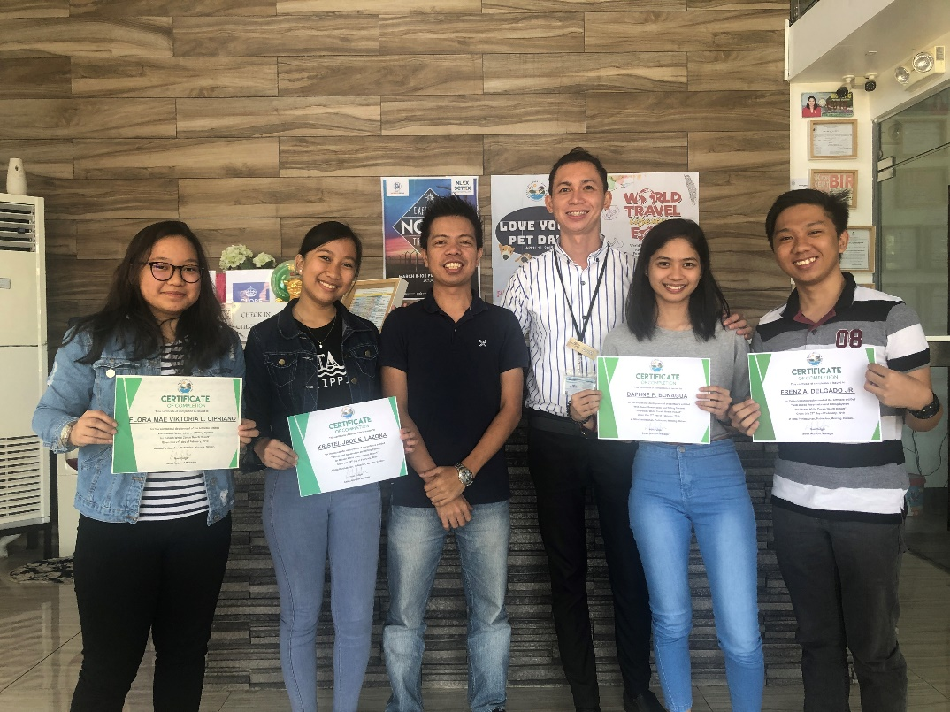

Deployment visit our Adviser, Prof. Jovy M. Afalble held on February 27, 2019.

From left to right: Prof. Jovy M. Afable, Ms. Flora Mae Viktoria L. Cipriano,

Mr. Frenz A. Delgado Jr., Ms. Kristel Jade E. Lazona, Ms. Daphne P. Bonagua