DIPLOMA THESIS
Documentation

Author(s) | Michael Friesenhengst  Florian Weinzerl
Form  Academic year | 5AHWII  2016/17
Topic | EPIC (Electronic Programmable Intelligent Calculator)
Co-operation partners

Assignment of tasks | EPIC is an advanced pen-operated tablet-calculator. EPIC can perform complex calculations, create graphs and solve equations. It’s main purpose is to replace hand-written and computer-aided notes, this makes an ideal combination of both systems in one portable device. The entire system is stored on a replaceable SD-card, this makes easy software-updates and resets possible. The long-lasting battery guarantees a continuous workflow without interceptions.

Realisation | - completed hardware  - created case  - installed system-software  - implemented GUI in Java  - programming of mathematics-system finished  - finished GUI-design  - combining and testing of all components  - final marketing-measures

Results | A fully functional tablet-pc where calculations, notes, sketches, etc. can be created.

Illustrative graph, photo  (incl. explanation) | 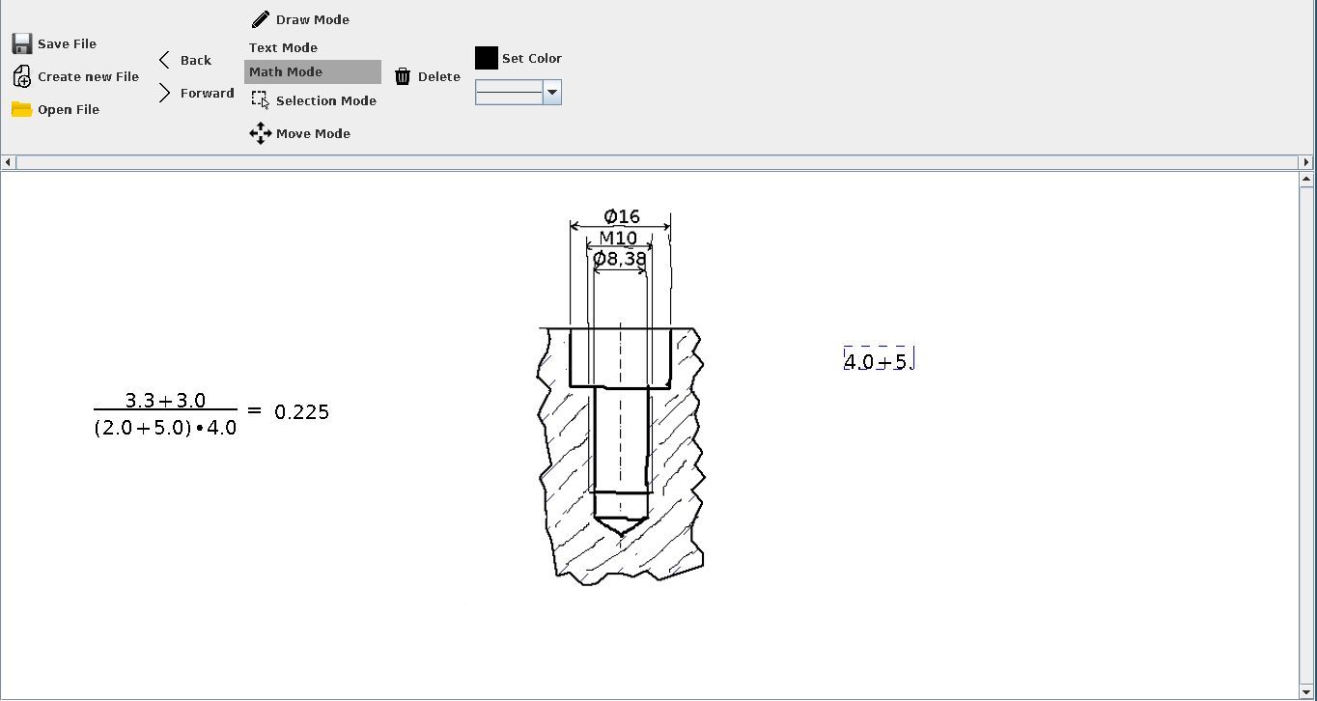

Participation in competitions
Awards

Accessibility of  diploma thesis | https://www.github.com/frequem/EPIC

Approval  (date / signature) | Examiner | Head of College / Department

