**COMMUNITIES CREATION DOCUMENTATION**

**CREATING CONTENT TYPES FOR COMMUNITIES**

Modules : For organic group : organic group, entity api module

For tagging : mltag and porter stemmer module

1. Create a content type for community

* Steps : Go to Structure >> create content type and name it as “Community”

Go to “Organic groups” tab >> select ‘group' option

* Go to Community >> Manage Fields >> Label = “Image” , Field Type = “Image” , Widget = “Image” and Save >> Save setting >> Max Image Resolution = 300 x 300 , Min Image Resolution = 200 x 200, select “Enable Alt field”, Preview Image Style = bootstyle and Save settings

1. Create an article content type for community

* Steps:
  + Go to Structure >> create content type and name it as “Community Article”
  + Go to Publishing Options >> select “Promoted to front page” , “Sticky at top of list”, “Create new revision”, “Enable moderation of revisions”
  + Go to “Organic groups” tab >> select “Group content” option
* Go to Community Article >> Manage Fields >> Label = “Image” , Field Type = “Image” , Widget = “Image” and Save >> Save setting >> Max Image Resolution = 300 x 300 , Min Image Resolution = 200 x 200, select “Enable Alt field”, Preview Image Style = bootstyle and Save settings
* Go to Community Article >> Manage Fields >> Add new field = “Tags” , Field Type = “Term Reference” , Widget = “Autocomplete term widget (tagging)”

Go to Manage Display >> Change “Tags” field from “Hidden” to “Visible”

Go to Manage Fields >> Edit >> “Tags field settings” and select Number of Values = “Unlimited”

**GROUP SPECIFIC ROLES**

Steps : Go to Configuration >> OG Roles Overview >> Edit group type “Node-Community” >> add 3 roles “Community author”, “Community Editor”, “Community Reviewer”

**GROUP PERMISSIONS**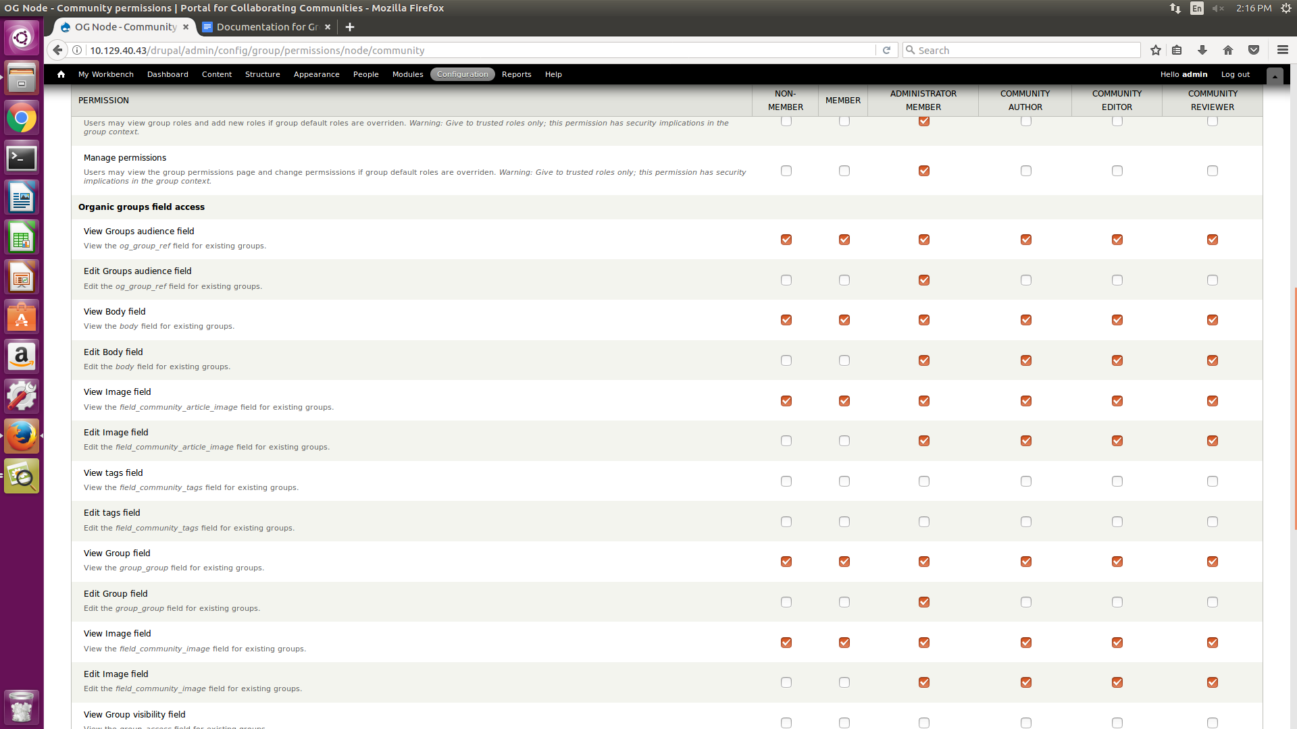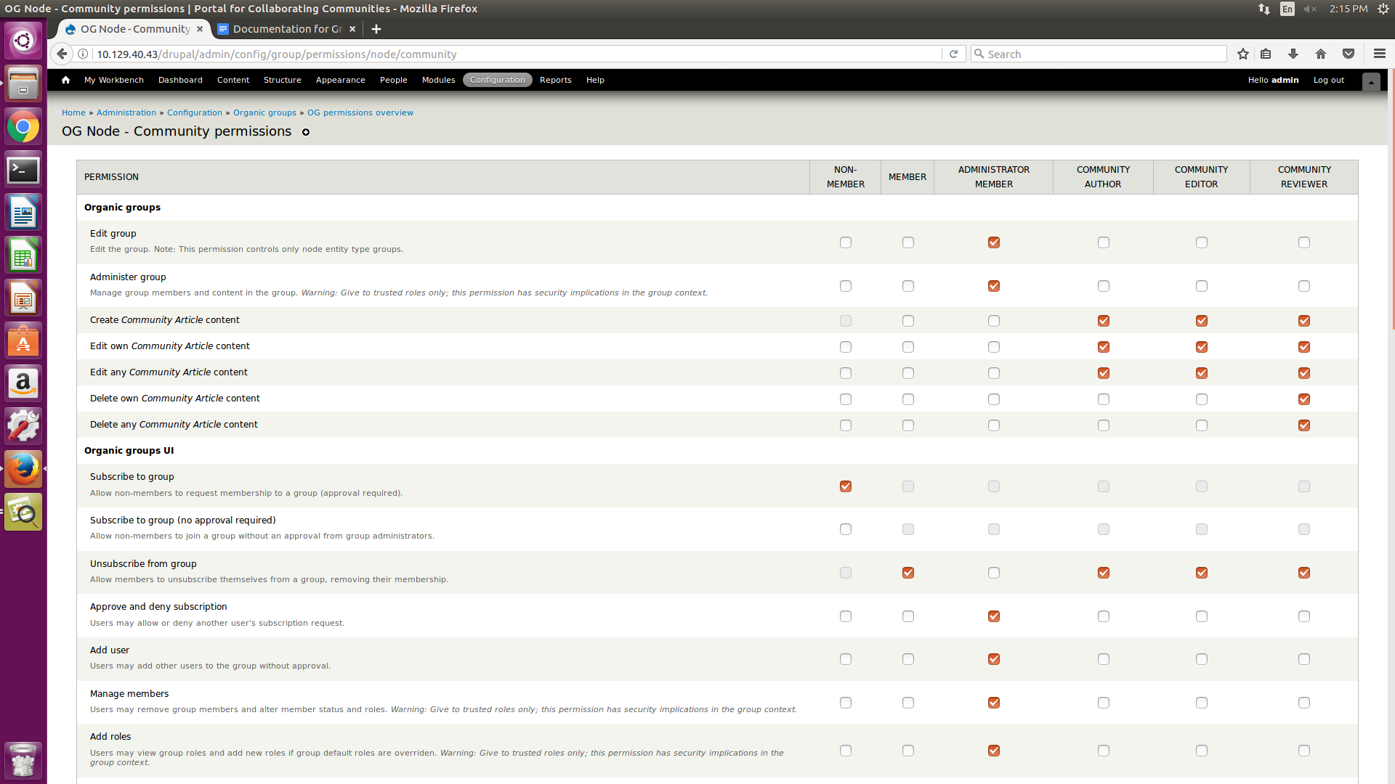

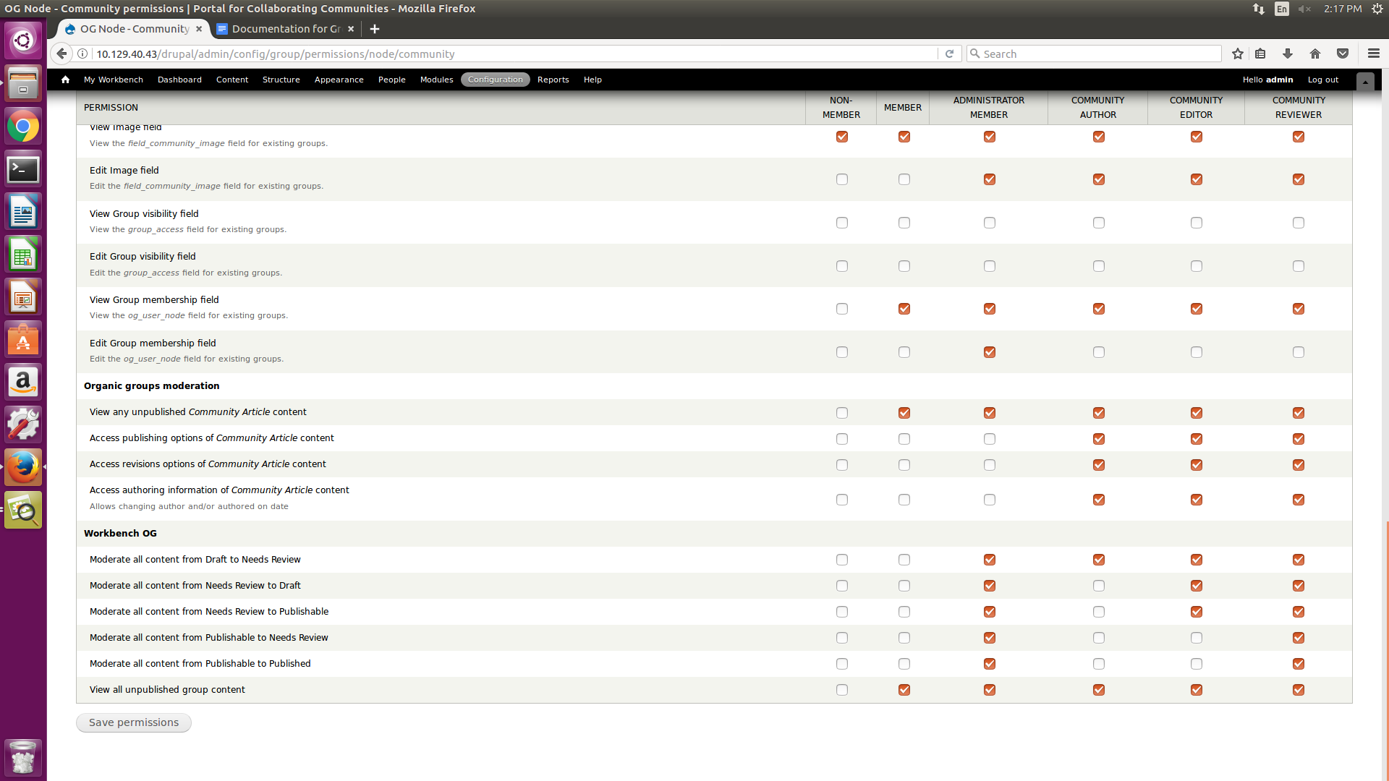

**PEOPLE >> PERMISSIONS**

|  |  |  |  |  |  |  |  |
| --- | --- | --- | --- | --- | --- | --- | --- |
|  | **anonymous user** | **authenticated user** | **administrator** | **user** | **author** | **editor** | **reviewer** |
| ***Community article*: Create new content** |  | ✓ | ✓ | ✓ | ✓ | ✓ | ✓ |
| ***Community article*: Edit own content** |  | ✓ | ✓ | ✓ | ✓ | ✓ | ✓ |
| ***Community article*: Edit any content** |  |  | ✓ |  |  | ✓ | ✓ |
| ***Community article*: Delete own content** |  | ✓ | ✓ | ✓ | ✓ | ✓ | ✓ |
| ***Community article*: Delete any content** |  |  | ✓ |  |  |  | ✓ |
| ***Community* : Create new content** |  |  | ✓ |  |  |  |  |
| ***Community* : Edit own content** |  |  | ✓ |  |  |  |  |
| ***Community* : Edit any content** |  |  | ✓ |  |  |  |  |
| ***Community* : Delete own content** |  |  | ✓ |  |  |  |  |
| ***Community*: Delete any content** |  |  | ✓ |  |  |  |  |

**ORGANIC GROUP VIEWS**

Modules : chaos tools, views

1. Creating a view page for the members of a particular community

Steps: Go to views >> og members >> edit >> title = “Recent Members of %1”

***To become a member of any community:***

Login as an anonymous user and click on “Request group membership” option

The membership request can be approved by ‘community admin’ by going to that particular community >> select ‘group’ tab >> people >> change status from pending to active

***Assigning role by default to the creator the group:***

Go to OG settings >> select “administrator member” from “Group Manager Default Roles”

**ALLOW GROUP MEMBER TO POST CONTENT**

Steps : Go to People >> Permissions and give the “Community Article” permissions according to user need.

**ORGANIC GROUPS LAYOUT**

Module : Panels, page manager

Enable panels, page manager and view content panes module

**Configure panels and page manager settings**

1. Go to structure >> Pages >> Enable page_manager node view option and edit
2. Add a new variant and select both selection rules and contexts option and create variant
3. Select “OG: Node is an OG group” option
4. Under relationship Select “OG group from node” and add the relation (check this!!!!!! )
5. Under relationship Select “Book Parent" and add the relation (check this!! )
6. Choose the Flexible Builder Layout >> Continue
7. Select "Disable Drupal blocks/regions” option (if sidebars are needed do not disable this)
8. Hit create variant

**Creating Panels for Communities**

1. Go to Content >> click “Show layout designer”
2. Click on “Row” and select “Add Region to Right” and name it “Right”
3. In the “Center” Region select “Add Content” and add the following fields:

* Go to “Node” >> Select “Field: Image (field_community_image)” >> continue >> Link image to “Content”
* Go to “Node” >> Select “Node content” >> select “Full Content” from Build mode >> finish
* Go to “View Panes” >> “OG : Content” >> Finish
* In the “Right” Region select “Add Content” and add the following fields:
* Go to “Node" >> Select “Field: Group (group_group)” >> Override title = “Group Membership” ,Change h2 to h3, Select a formatter = “OG subscribe link” >> Field name = “Group Membership” >>Finish
* Go to “Menu” >> Select Navigation >> Override Title = “Create Content” , change h2 to h3 >> Finish
* Go to “Views” >> Select OG User Groups >> Continue >> Override Title = %title , change h2 to h3 >> Finish
* Go to “View Panes” >> Select “OG members” >> Finish

**GIVING ACCESS PERMISSIONS TO COMMUNITIES**

Module : **Organic groups access control**

Steps :

1. Install og access control and enable it
2. Go to Configuration >> OG field settings >> Bundle = “Community” , Fields = “Group Visibility” >> Add field
3. Go to Content type >> Edit Community >> Manage Fields >> Add “Group Visibility” field