**Software Functional Specification**

**for**

**System for Collaborating Communities**

Version 1.0 approved

IIT Bombay

10 April, 2017

**Brief Status Report**

The portal is being developed using Drupal 7 as the base. Various modules in Drupal have been identified and investigated thoroughly. The component for content creation, editing, and publishing has been achieved through the workbench module. The workflow for content publishing has been integrated with the main workbench module in Drupal. At present, the support for 16 major Indian languages have been tested. 'Reputation points' is another Drupal module used in the system. The reputation system scores the user, based on the work done in the system. Integration of the module, 'Reputation Points' with the module, 'Workbench' is yet to be achieved. The 'Reputation Points' module is purely configurable, and can be achieved based on the system model. Content versioning is one of the core modules in the system and will be integrated with other components.

**Software used for implementing The System**:

|  |  |  |
| --- | --- | --- |
| **Software Type** | **Name** | **Version** |
| Operating System | Ubantu 16.04 | Kernel 4.x |
| Server | Apache | 2.0 |
| Database | MySql | 14.14 |
| Language | Php | 5.x |
| Platform | Drupal | 7.x |
| VCS | Git | 2.x |
| Command Line module | Drush | 7.x |

Sample Source Code for Submodule implemented the system:

**1.Introduction**

The portal on 'Collaborative Communities' involves efforts from the users in creating, editing, and publishing the content, before making it live. The overall goal of this subproject is to allow communities to form, grow, and nurture. The communities will be responsible for creating, editing, and publishing OERs in the form of audios, videos, images, texts, manuscripts, books, and such other digital artifacts. Five major components of the system which are being developed are: a) Content Publishing, b) Localization support for Indian Languages, c) User Reputation Component, d) Content Versioning, and e) Event Logging.

We highlight all the five major components below:

**2. Content Publishing**

The users work together on the same task, either synchronously or in frequent asynchronous interaction. The dynamic publishing of content is promoted through document sharing, collaboration, and process automation features. The following user roles have been defined in the system:

**2.1. User Roles**

Table 1: User Roles and their definitions

|  |  |
| --- | --- |
| **Term** | **Definition** |
| Administrator | An authenticated user, who is given specific permissions for managing and controlling the system. He will be able to see all the communities available in the system and the interaction between the entities of each communities in the system. |
| Anonymous User | Anonymous user can view content and read discussions about it. |
| Basic User | An authenticated user, who can comment on any content and rate it. By doing this he takes part in the reputation gaining process. |
| Author | An authenticated user, who creates new content and makes change to any content in the community. |
| Editor | An authenticated user of the system, who reviews the content created by the author, makes more changes, or rejects it. He sends a request to the reviewer for publishing it. |
| Reviewer | An authenticated user of the system, who publishes, deletes, or revises any content. |
| Content Manager | An authenticated user who manages different content types. |
| Content Supervisor | An authenticated user who manages the activity of the site at a higher level, i.e. create new roles if needed, blocking/unblocking of users, etc.. |

**2.2. Content Publishing System Workflow**

The workflow defines the states of a node, from its 'Create' state to its finally 'Publish' state. The roles that take part in the workflow, are authenticated users of the system. These users can create, update, or delete a content based on the permissions provided to them.

Given below is a description of the workflow, and its entities required for creating an efficient workflow in the system.

**Transition States:** The workflow requires sets of transition for maintaining the state of a content in the system. From its state of 'Create'to 'Publish', a content goes through a number of states, until it gets published.

Table 2: Transition States

|  |  |
| --- | --- |
| **States** | **Description** |
| Create | This state indicates creation of a content |
| Draft | This state saves the content in draft mode. |
| Request Review | Changing the state to Request Review, sends a request to the editor for reviewing. |
| Publishable | Changing the state to Publishable, sends a request to the reviewer for publishing the content. |
| Publish | It publishes the content. This state is set by the reviewer. |

Table 3: Transitions based on Permissions

|  |  |  |  |
| --- | --- | --- | --- |
| **Initial State** | **New State** | **Permission given to** | **Description** |
| Create | Draft | Author, Editor, Reviewer | Saves content to draft mode |
| Create | Request Review | Author | Requests the reviewer to review the content |
| Request Review | Publishable | Editor | Changes the state to publishable mode |
| Request Review | Draft | Editor | This state is set if the content is not found suitable enough for publishing |
| Publishable | Request review | Reviewer | Editor is requested to make more changes to it. |
| Publishable | Publish | Reviewer | Publishes a content |

**Transition State Diagram with respect to users in the system:**

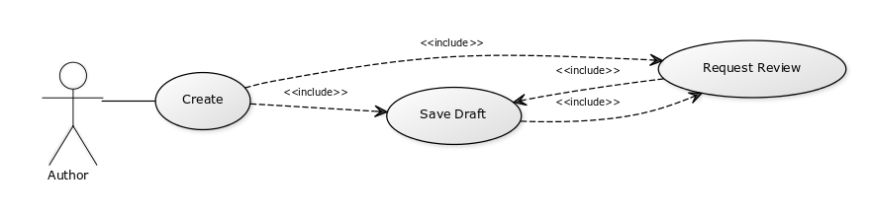

Fig 1: Transition state diagram for Author

Fig 2: Transition state diagram for Editor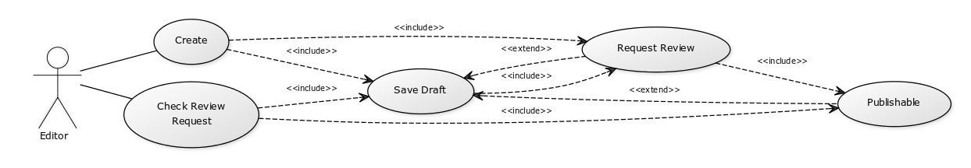

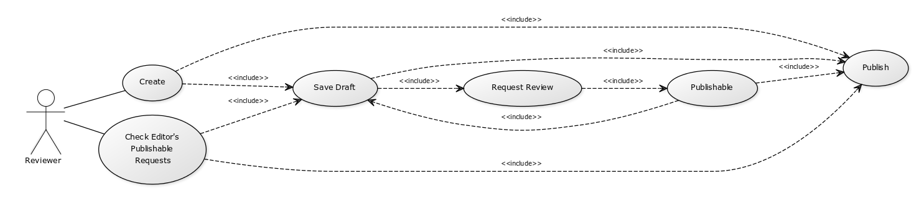

Fig 3: Transition state diagram for Reviewer

**2.3. Permissions of Various Users based on Workflow**

The users of the system (i.e. editors, reviewers, administrator, etc.) need to be registered and requires authentication for contributing to the system. The system stores (a) personal information of users securely and (b) activity logs, which involve different activities and content contributions in the system. The system creates a new revision, when a user makes a change to a content. This is handled by the version control module of the system.

Table 4: Permissions

|  |  |  |  |  |  |  |  |
| --- | --- | --- | --- | --- | --- | --- | --- |
| **Permissions** | **Roles** | | | | | | |
| **Anonymous User** | **User** | **Author** | **Editor** | **Reviewer** | **Content Manager** | **Content Supervisor** |
| Create new content |  |  | Y | Y | Y | Y | Y |
| Save Content as draft |  |  | Y | Y | Y | Y | Y |
| Edit own unpublish content |  |  | Y | Y | Y | Y | Y |
| Edit any unpublish content |  |  |  | Y | Y | Y | Y |
| Publish any content |  |  |  |  | Y | Y | Y |
| Edit any published content |  |  | Y | Y | Y | Y | Y |
| Edit own published content |  |  | Y | Y | Y | Y | Y |
| View revision of content |  |  | Y | Y | Y | Y | Y |
| Publish new revision |  |  |  |  | Y | Y | Y |
| View comments | Y | Y | Y | Y | Y | Y | Y |
| Post Comments |  | Y | Y | Y | Y | Y | Y |
| Edit own comments |  | Y | Y | Y | Y | Y | Y |
| Delete any Content |  |  |  |  | Y | Y | Y |
| Delete any revision |  |  |  |  | Y | Y | Y |
| Create new content type and forms |  |  |  |  |  | Y | Y |
| Edit content type and forms |  |  |  |  |  | Y | Y |
| Assign new roles to users |  |  |  |  |  |  | Y |
| Rate a content |  | Y | Y | Y | Y | Y | Y |
| View rating on contents | Y | Y | Y | Y | Y | Y | Y |
| Translate contents |  |  | Y | Y | Y | Y | Y |
| Manage site reports/issues |  |  |  |  |  |  | Y |
| View/Update own profiles |  |  | Y | Y | Y | Y | Y |
| Block/Unblock accounts |  |  |  |  |  |  | Y |
| View/Update global Site Settings |  |  |  |  |  |  | Y |
| Assign content type with roles |  |  |  |  |  |  | Y |

**Note**: A blank cell in the table given above, denotes that the user does not have the permission mentioned.

**3. Localization Support for Indian Languages**

The system provides authoring and publishing multilingual content, in the form of sub-domains. It provides translation of both, its interfaces and its content.

## **Interface Translation :**

Translating the interface, translates the miscellaneous text strings used all over the site (like the label used on Submit button, etc.). These are the elements which are available in core part of the system. The System is able to provide everyone with translated values for all these elements in various languages.

## **Content Translation:**

The system allows users to select a specific language for creating a content. It allows users to translate any published content and store that translated version in the form of revision in the system. User can select any of the sub domains for viewing its respective translation for any content.

The list of modules needed, for localizing the system in Drupal are:

* Locale (included in core)
* Entity Translation
* Title (to translate the node titles)
* Entity (required by Title)
* Internationalization (i18n)
* Variable (required by many of the translation modules)
* Localization Update
* Language Icons

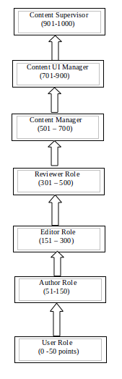

4. User Reputation Component

The system allows user to earn reputation, by performing activities based on certain rules integrated in the system. As user performs certain activities in the system, he/she earns points and gains new role and reputation. After achieving the required number of points, he/she is promoted to the new role (as described in the stages of reputation).

## **4.1. Stages of Reputation :**

The Figure 4, illustrates the reputation mechanism for allocating scores. List of roles described in the system are User, Author, Editor, Reviewer, Content Manager, Content UI Manager, and Content Supervisor.

**4.2. Rules for earning points:**

1. 1) Initial points for all users roles:

* A user has 0 points when he/she logs into the system for the very first time.
* A privileged user can award points to a new user.

1. 2) A new user will be able to earn points by either commenting on an article, blog, etc., or by rating an article posted by another user. As a new user to the system, he/she is not privileged enough to be assigned an “author” role or someone who can create new articles or blogs. He/she will only be earning points through commenting or rating other articles.

1. 3) A system administrator or a privileged user can set targets for achieving new roles in the system. For example, 50 points are required for gaining Author role, 100 points for Editor, or 200 points for Reviewer role, etc.. The targets based on points are modifiable and can be set to new targets as required.
2. 4) When a user achieves the required points for a role, the system automatically awards him points, and processes transition of his role to a new role in the system. For example, if a new user achieves the target for an Author role, the system awards him the role, and he will be privileged enough to create articles, blogs, etc..
3. 5) A user will earn points only when his/her content is published.

**4.3. Rules for Deducting points:**

A user loses points when his/her:

1. comment is deleted.
2. content is deleted by a privileged user.
3. request for publishing a content is rejected by a privileged user.
4. reputation falls below the present role, and the user is demoted
5. The user will loose points if he/she deletes a comment posted by someone else in his/her article.

**5. Content Versioning**

Drupal creates a new revision every time a node is updated. All revisions are maintained in the system in the form of logs. By default, it allows any authenticated user to publish any of the revisions maintained. Workflow mechanism described in one of the previous section, has a tight integration mechanism to the roles of the users. Thus, only preliveged users are able to revert a submission to any previous revisions. Fined grained control has been achieved by installing a Diff module. This module allows the user to see the differences between any two revisions.

**5. Event Logging**

The System will keep track of all the events including content creation logs and user clicking events in the system.