Supplementary Material: Appendices
When Coverage Is Not a Signal: Designing Reliability Monitoring for Cardinality Estimation Under Drift — Appendices A–G (GitHub supplementary material)

A Experimental Protocol and Evidence Ledger
The static stats workload covers 8 tables and 43 columns with 622-dimensional features. LightGBM uses 300 trees, 63 leaves, and a learning rate of 0.06; initial training and calibration use 20,000 and 3,000 labels. Unless stated otherwise, 95% CIs use 10,000 split or seed bootstrap resamples, and per-window trajectories are pointwise intervals. q50/q90/q99 are quantiles of the truncated q-error, GMQ is their geometric mean, and pp denotes percentage points.
Table 6 summarizes the configuration of every experiment. Throughout we use the score |log(1+y) − log(1+ŷ)| and its inverse transform. Each experiment fixes its training targets, sample splits, and comparison budget in advance, and the point predictor is fixed before calibration. Static experiments, 80-window replays, the real 30-window maintenance run, and the plan-utility audit record their calibration, monitoring, and update operations separately. Per-query logs retain predictor version, observed feedback, interval, threshold, and label role, and coverage, length, point error, and cost are verified independently. SQL times reflect real execution on the corresponding controlled snapshot.
The data-level correlation experiment regenerates data and recomputes cardinalities, using exact batch counting as a speedup; a small-scale control matches the original per-query CPU counts exactly. Zero counts are retained after drift. The original query generator selects queries with no-drift cardinality of at least 8 and at most half the table size, preserving its intended study population; this design is not interpreted as covering all possible SQL. The execution-feedback pool retains its real zero results.
Table 6: Main experimental configurations. Unless annotated otherwise, slashes denote training, calibration, and threshold-validation labels in order; val/test/audit mark validation, test, and audit respectively. Repetitions are counted in splits or seeds.
Experiment | Label configuration | Repetitions
Static mechanism | init: 20,000 / 3000 | 50
 | follow-up: 500 / 500
Width matching | init: 20,000 / 3000 / 2000 val | 10
 | follow-up: 4000 test
Fixed predictor | init: 20,000 / 3000 / 5000 val | 30/DB
 | follow-up: 5000 neg / 10,000 pos
Cross-DB correlation | init: 20,000 / 3000 | 20/DB
 | follow-up: 500 / 500
Cross-DB workload/schema | init: 1500 / 300; up to 20,000 / 3000 | 20/DB
 | follow-up: 200 / 200
PRICE | init: 2000 / 500 | 10/case
 | follow-up: 500 / 500; 2000 audit
80-window maintenance | init: 4000 / 1000 / 2000 val | 10/DB
 | follow-up: 200 / 200 / 400 val
Real 30-window | init: 400 / 200 / 200 val | 5
 | follow-up: 40 / 80 / 80 val
Identity and data alignment.
Cross-database and continuous replays deduplicate by SQL identity: whitespace is collapsed, trailing semicolons are removed, and a whole group is excluded when one identity carries conflicting labels. Cross-database pools retain 50,000 / 46,672 / 49,999 / 49,773 unique queries for stats / imdb / ergastf1 / genome, which are then split into label roles. The static query cache forms its query population from records whose original truth and base-model estimate are both positive; the execution-feedback population retains zero responses as actually recorded. The 45 duplicate identity groups with conflicting labels in imdb are excluded from the original alignment pool. Base-model predictions are checked against the original row index, features, and labels; overlap with the native PRICE checkpoint's pretraining data is not certified by this interface experiment. Roles within an experiment never overlap on the same split, and repeated queries across splits are not accumulated as independent samples.

B Coverage Proof and Metrics for Unified Intervals
With the predictor fixed, the calibration scores s₁,…,sₙ and the new score sₙ₊₁ are exchangeable. Ties are broken by an independent random ordering, so the rank of the new score is uniform on 1,…,n+1. When k ≤ n, the non-strict coverage event gives
$$\text{Pr}(s_{n+1}>q)≤\frac{n+1-k}{n+1}≤α.$$
When k > n, q = +∞ and the interval covers the entire non-negative response space. Because log(1+y) is monotone, coverage in score space is equivalent to coverage of the back-transformed interval. This is a marginal probability statement; it does not replace post-drift empirical auditing, time-uniform guarantees, or coverage for arbitrary subgroups.
Coverage always uses the raw y. Conventional q-error truncates truth and prediction to at least 1 only in its own definition; coverage never uses that truncation. Width is uniformly W: the feedback-sampling and plan-utility audits report the median length within each audit, and other width results report means. Aggregation across splits is stated separately; GMQ is the geometric mean of per-query q-error.

C Degradation Under Drift
This appendix isolates the phenomenon that motivates the design. On a fixed query population, a controlled correlation shift changes only the ground truth of multi-column filter queries, while features and the predictor are held fixed. The frozen predictor's geometric-mean q-error (GMQ) rises from 2.36 to 5.11 and its audited coverage falls from 90.1% to 63.4% (Figure 10). The waterfall bars show the coverage drop, the black line is GMQ, and the error bars are 95% split-bootstrap CIs; the numbers on the bars give the coverage change between adjacent levels in percentage points, and the x-axis is the correlation drift level. Past reliability therefore cannot stand in for post-drift validity, which is why the main text monitors coverage against version-matched intervals (Section 4.2).
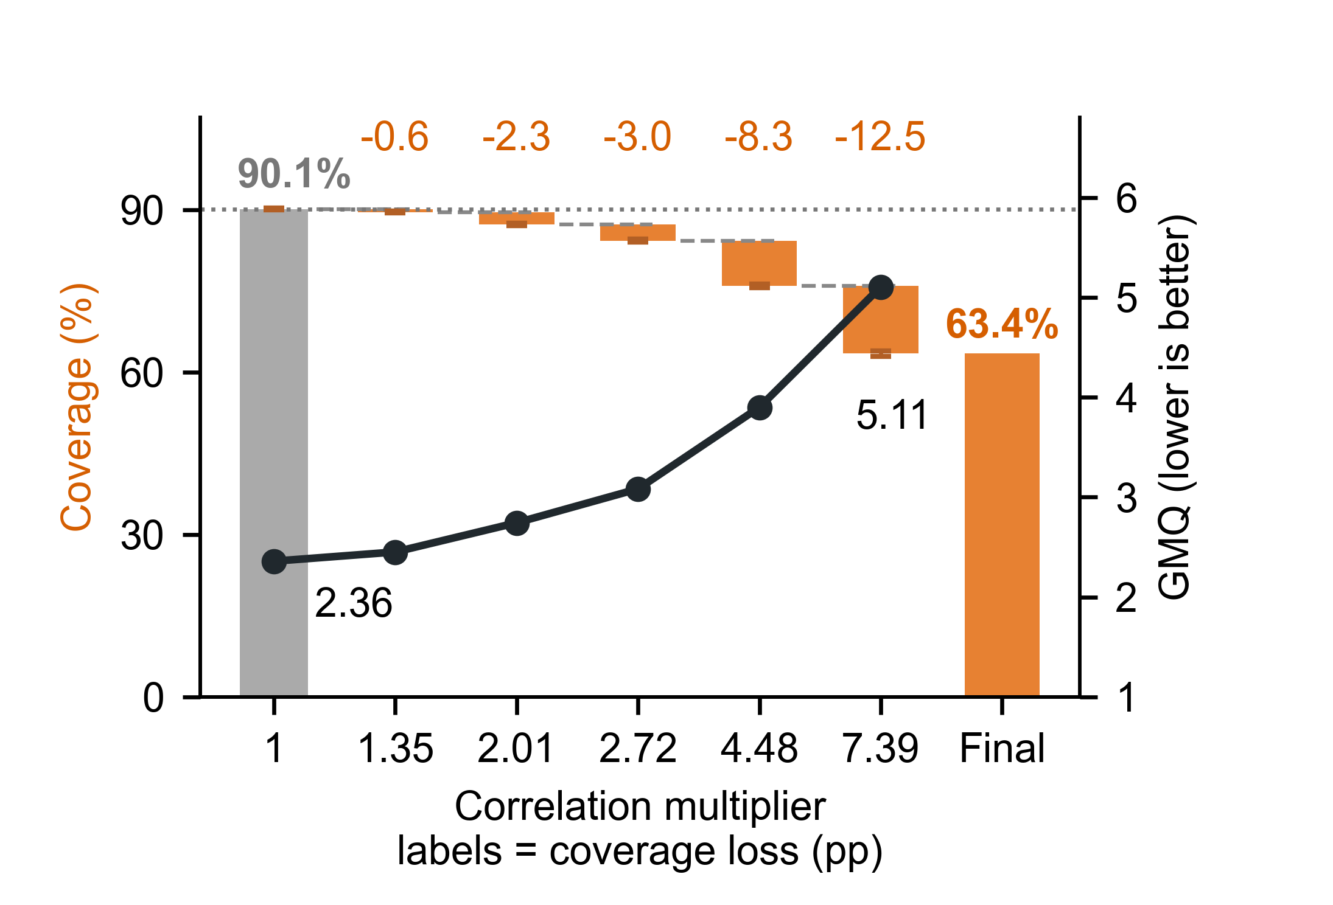
Figure 10: Frozen coverage and point error under a controlled correlation shift, 50 splits. Waterfall bars are the coverage drop; the black line is GMQ; error bars are 95% split-bootstrap CIs; labels on the bars give the coverage change between adjacent levels (pp).

D Complete Readings of the Mechanism Experiments
Figure 11 supplements the nominal-coverage sweep, and Figure 12 reports the zero-result subgroup audit under the unified score.
The frozen state of the self-test experiment calibrates and self-tests on the old calibration set, while the other three arms calibrate and self-test on their own drift calibration blocks. All arms share audit identities that never participate in updates. Table 7 reports the four readings jointly. Width matching reads only the independent validation set, and the final test never takes part in choosing the calibration level. Thresholds in the fixed-predictor sweep use strict exceedance, so the realized false alarms in Table 8 cannot be replaced by the common target.
Table 7: Self-test, independent audit, mean W, and q50 over 50 splits. Coverage is in percent; bracketed ranges are 95% split CIs.
State | Self-test | Audit and CI | $$W$$ | q50
Frozen | 90.03 | 66.0 | 8.12 | 4.64
Recalibration | 90.20 | 90.1 | 29.51 | 4.64
Repaired | 90.20 | 90.0 | 39.59 | 2.88
Catastrophic error | 90.20 | 90.1 | 1253.75 | 97.74

Table 8: Fixed-predictor sweep at the 4.48× shift, mean over 30 splits per database. Detection is the alarm fraction over 100-label positive windows; non-detection is the fraction of ten eight-window sequences, formed from the first 80 positive windows, that never alarm. Delay starts at 0 in the first drift window and is recorded as 8 when no alarm occurs.
Target % | $$W$$ | False alarm % | Detection % | Delay | Missed %
imdb
99 | 254.95 | 5.13 | 5.83 | 6.17 | 63.3
95 | 19.43 | 4.67 | 49.33 | 1.08 | 1.0
90 | 7.61 | 7.60 | 92.87 | 0.07 | 0.0
80 | 3.20 | 7.60 | 99.97 | 0.00 | 0.0
70 | 1.84 | 8.87 | 99.93 | 0.00 | 0.0
stats
99 | 110.24 | 5.47 | 13.33 | 4.73 | 35.0
95 | 15.44 | 7.60 | 81.80 | 0.20 | 0.0
90 | 7.54 | 8.07 | 99.10 | 0.02 | 0.0
80 | 3.69 | 7.73 | 100.00 | 0.00 | 0.0
70 | 2.32 | 6.67 | 99.97 | 0.00 | 0.0

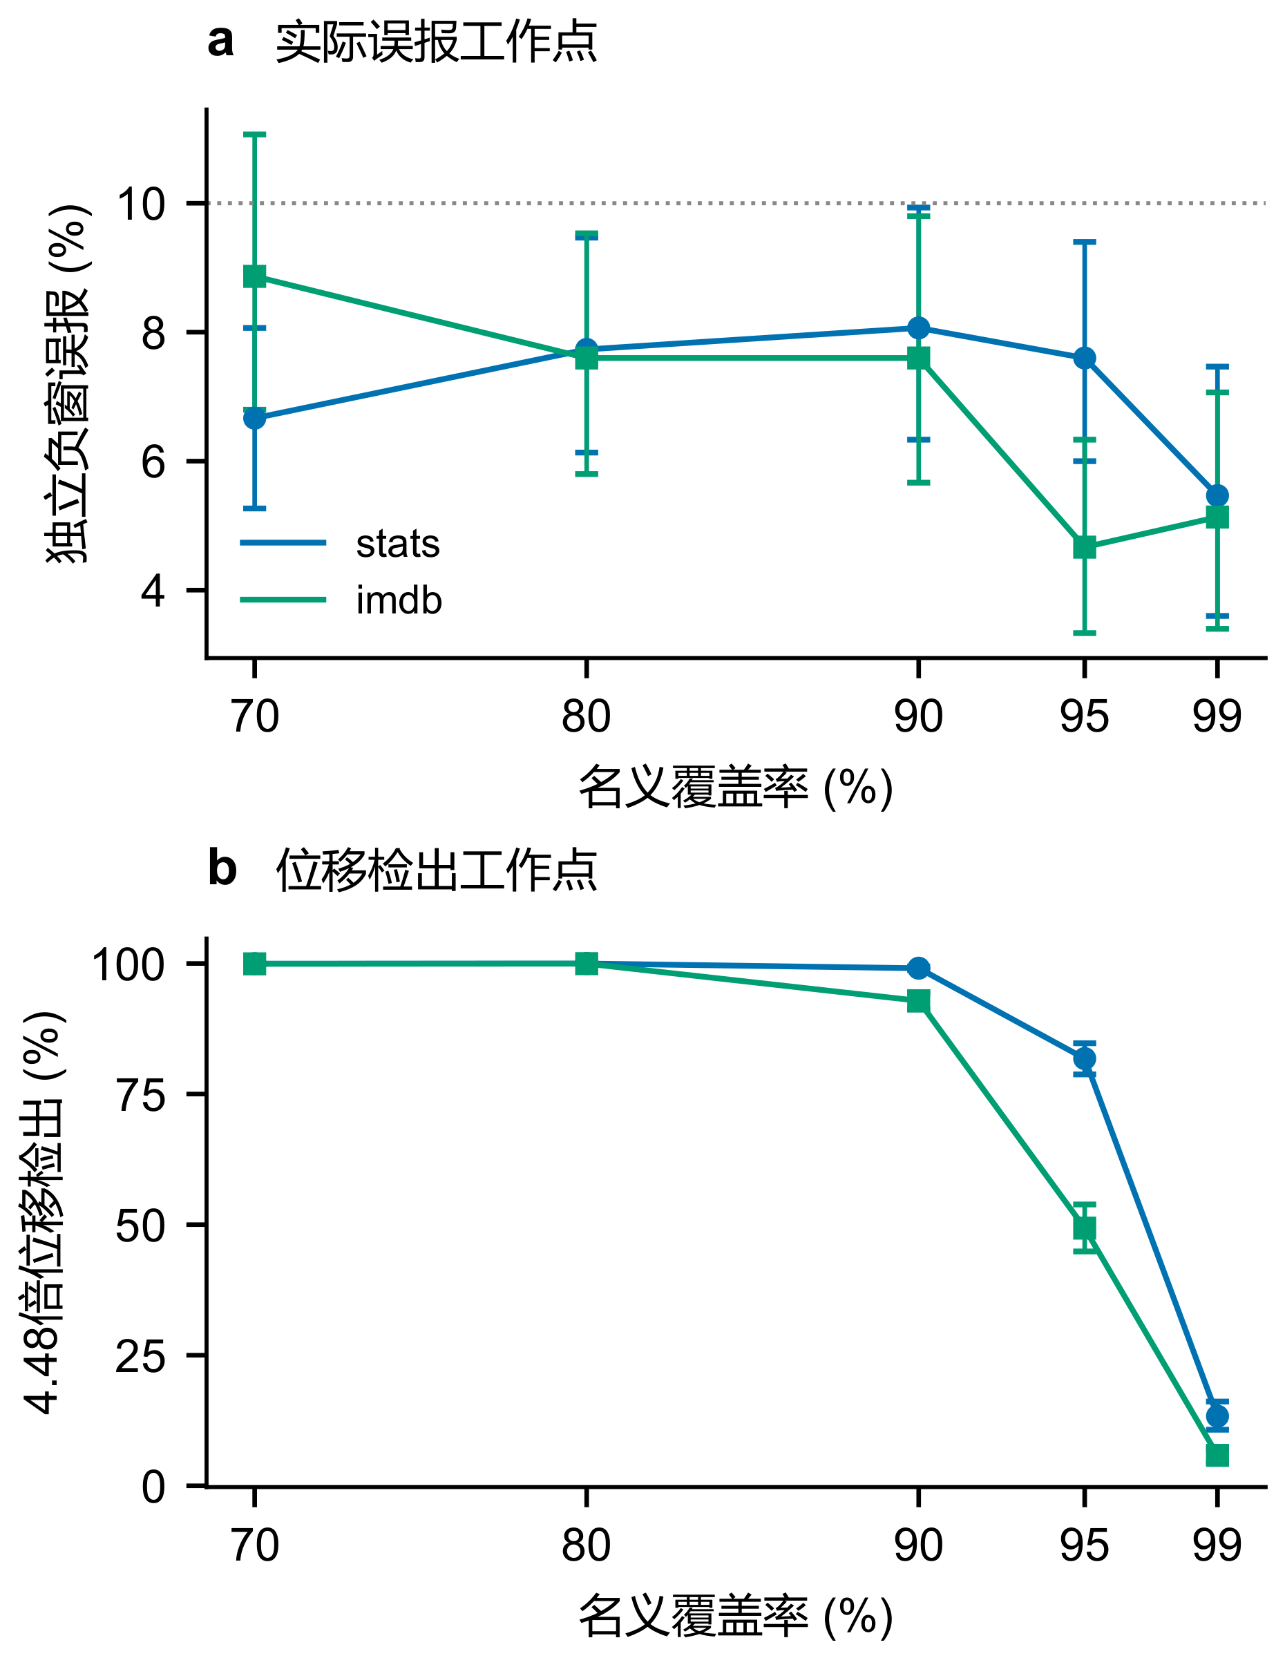
Figure 11: Nominal-coverage sweep of the fixed predictor: 30 splits per database, means with 95% split CIs. The two panels show independent negative-window false alarms and detection at the 4.48× shift. Thresholds use validation windows only; realized false alarms are measured separately.

D.1 Feedback Budget and Zero-Result Subgroups
Budgets are 30/60/90/120, split evenly among monitoring, center updating, and calibration; a budget is skipped when a role pool is exhausted. Three valid pools, 30 splits, and the available state/policy/budget combinations give 5,550 comparisons. The original imdb766 pool is excluded by the pre-specified alignment check because its array lengths disagree. Table 9 lists every budget and exploration ratio for the deleted-old-data pool.

Table 9: Complete budget sweep for the deleted-old-data pool. Length is the median of the per-split audit median W; other quality metrics are split means.
Labels | Exploration % | Overall coverage % | Median W | Zero coverage % | Valid splits
30 | 00 | 74.9 | 30.8 | 13.0 | 30
30 | 05 | 74.9 | 30.8 | 13.0 | 30
30 | 10 | 75.1 | 34.7 | 14.7 | 30
30 | 20 | 81.0 | 207.3 | 23.3 | 30
30 | 100 | 90.9 | 37603.1 | 60.3 | 30
60 | 00 | 79.0 | 68.2 | 13.8 | 30
60 | 05 | 79.6 | 113.1 | 17.0 | 30
60 | 10 | 79.4 | 80.2 | 16.3 | 30
60 | 20 | 81.3 | 166.2 | 20.0 | 30
60 | 100 | 90.9 | 4138.5 | 48.1 | 30
90 | 00 | 80.4 | 164.9 | 14.3 | 30
90 | 05 | 81.6 | 216.1 | 16.9 | 30
90 | 10 | 82.7 | 276.1 | 18.9 | 30
90 | 20 | 83.0 | 369.8 | 19.9 | 30
90 | 100 | 90.3 | 4069.0 | 45.9 | 30
120 | 00 | 85.9 | 425.7 | 25.4 | 30
120 | 05 | 86.1 | 425.5 | 26.8 | 30
120 | 10 | 86.3 | 703.3 | 28.6 | 30
120 | 20 | 85.3 | 504.0 | 26.5 | 30
120 | 100 | 89.9 | 2162.6 | 41.9 | 30

Subgroup summaries use only splits that contain zero results; the effective denominators and missingness flags for other states are carried over from the source results.
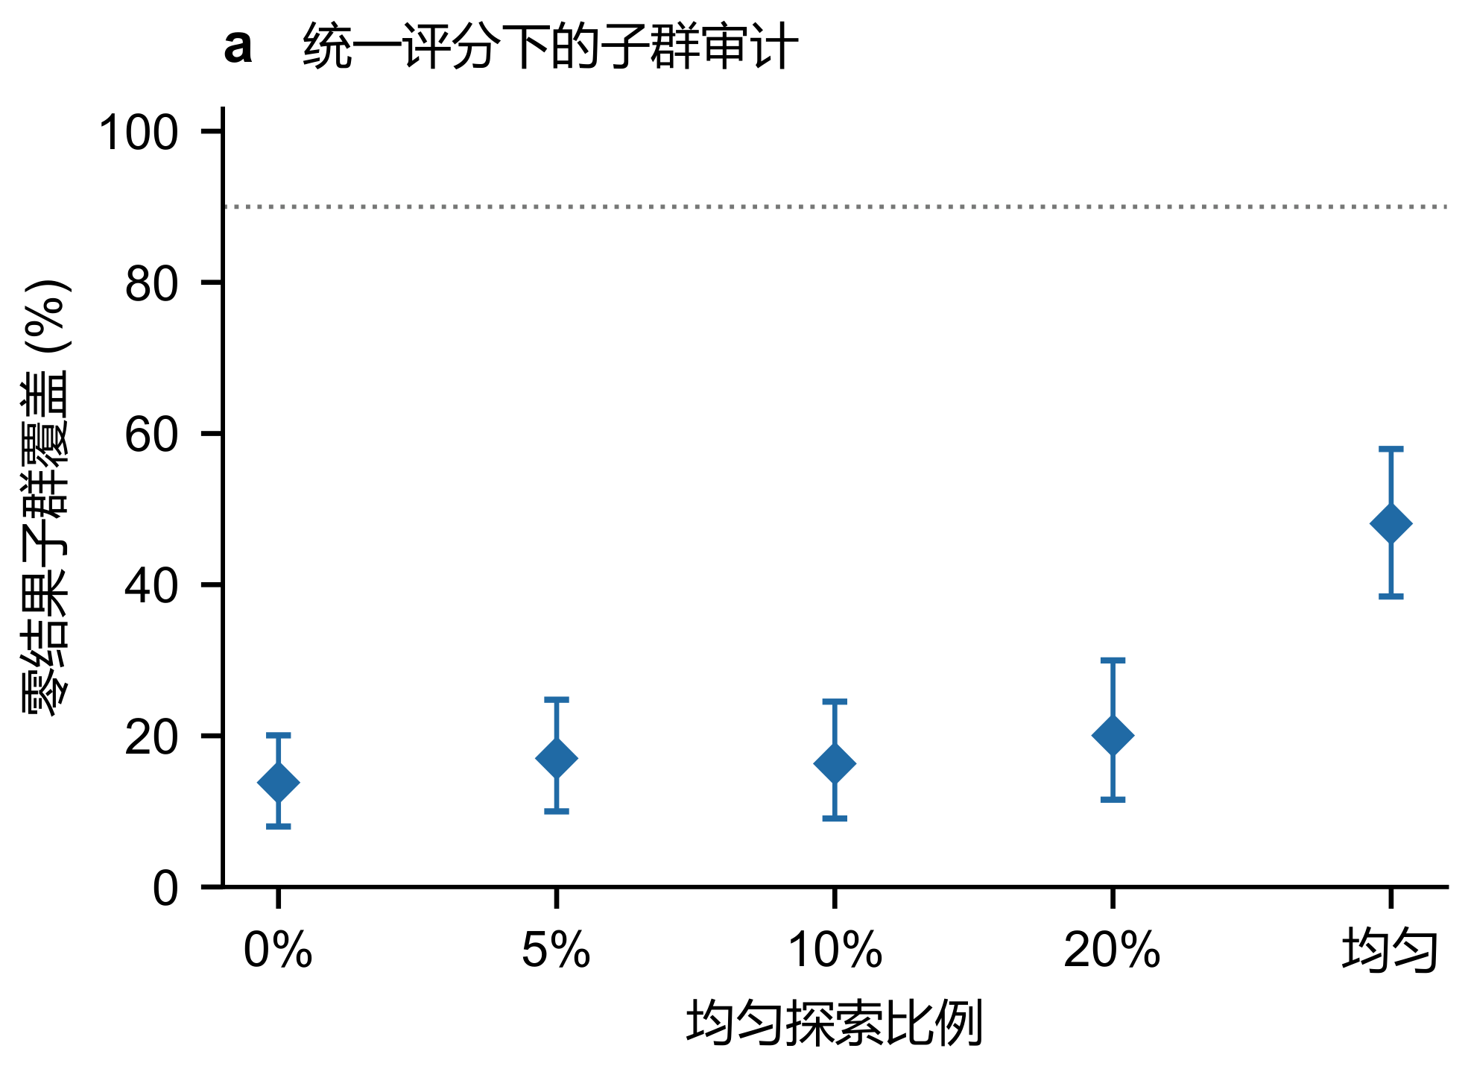
Figure 12: Zero-result subgroup audit under the unified score: deleted-old-data pool, 60 labels, 30 splits per policy. Means with 95% split CIs; the dashed line is the 90% population target; all queries use the same interval definition.

E Cross-Environment Results and Native Adaptation
Table 12 gives the paired error ratios and confidence intervals for the two repair arms.
The cross-database correlation shift changes only the truth of multi-column filters; the workload moves from simple to complex queries by table count; and the schema control selects existing table combinations unseen in initial training. Frozen and repaired states share the same final audit subset in every condition, and source logs retain each role's identity. Mean normalized length, typical error, and tail error are in Table 10.
Table 10: Full joint quality across databases, means over 20 splits. Frozen and repaired states share the corresponding audit identities.
State | Coverage % | $$W$$ | q50 | q90
stats / correlation
Frozen | 63.2 | 7.53 | 4.70 | 27.29
Repaired | 90.3 | 30.04 | 2.66 | 27.80
stats / workload
Frozen | 52.8 | 6.65 | 6.14 | 240.15
Repaired | 89.3 | 74.33 | 4.48 | 75.91
stats / schema
Frozen | 66.4 | 5.17 | 2.83 | 65.81
Repaired | 90.1 | 64.97 | 3.73 | 56.93
imdb / correlation
Frozen | 69.0 | 7.55 | 3.28 | 25.00
Repaired | 89.8 | 19.06 | 2.02 | 19.31
imdb / workload
Frozen | 29.4 | 7.14 | 27.50 | 910.65
Repaired | 91.0 | 139.61 | 5.32 | 104.93
imdb / schema
Frozen | 61.6 | 4.38 | 2.88 | 32.02
Repaired | 90.5 | 48.02 | 2.74 | 43.43
ergastf1 / correlation
Frozen | 56.8 | 6.70 | 5.62 | 26.51
Repaired | 89.9 | 19.21 | 2.32 | 18.79
ergastf1 / workload
Frozen | 50.4 | 5.37 | 5.57 | 251.46
Repaired | 90.6 | 58.79 | 4.04 | 54.43
ergastf1 / schema
Frozen | 71.5 | 4.43 | 2.31 | 17.04
Repaired | 90.1 | 38.97 | 3.08 | 34.56
genome / correlation
Frozen | 14.0 | 2.53 | 7.30 | 14.35
Repaired | 90.0 | 15.28 | 2.19 | 15.23
genome / workload
Frozen | 59.0 | 5.94 | 4.60 | 40.61
Repaired | 89.1 | 28.43 | 3.42 | 29.90
genome / schema
Frozen | 81.7 | 2.33 | 1.39 | 4.20
Repaired | 89.7 | 22.12 | 2.67 | 21.85
Native PRICE configuration and evidence.
Table 11 lists the full joint quality of native adaptation, residual repair, and recalibration. All settings share 2,000 initial training labels on the target database and 500 independent calibration labels; the new budget is 1,000, and the main comparison uses 500 training plus 500 calibration. PRICE uses Adam with learning rate 2.85×10⁻⁵, weight decay 5×10⁻⁵, batch size 128, 30 epochs, and gradient clipping at 1; the audit selects neither epochs nor hyperparameters. Real training outputs, repair-calibration predictions, and independent audit predictions are all retained. The repaired predictor fixes its interval on independent calibration labels and then compares coverage, width, and point error on the shared audit queries.
Table 11: Unified interval quality for native adaptation and the recalibration reference, 10 splits per setting. Recalibration uses 500 new labels; the two main repair arms use 1,000 each.
Method | Coverage % | $$W$$ | q50 | q90
imdb / correlation
PRICE | 90.0 | 19.33 | 2.51 | 19.21
Recalibration | 89.8 | 47.18 | 3.23 | 48.51
Residual repair | 89.6 | 20.45 | 2.14 | 22.15
imdb / workload
PRICE | 90.0 | 41.00 | 3.12 | 39.39
Recalibration | 89.7 | 44.26 | 3.04 | 47.58
Residual repair | 90.0 | 39.84 | 3.05 | 40.21
stats / correlation
PRICE | 90.7 | 26.91 | 3.14 | 23.68
Recalibration | 89.8 | 48.89 | 4.93 | 50.34
Residual repair | 89.9 | 28.51 | 2.75 | 29.46
stats / workload
PRICE | 90.2 | 34.96 | 3.11 | 32.62
Recalibration | 90.1 | 53.53 | 3.04 | 50.69
Residual repair | 90.1 | 44.30 | 3.46 | 41.75
Table 12: Paired geometric-mean error ratios of residual versus PRICE with 95% split-bootstrap CIs, on the same 10 paired splits as the main text.
Metric | Paired ratio and CI
stats / correlation
q50 | 0.876 [0.840, 0.914]
q90 | 1.257 [1.122, 1.398]
stats / workload
q50 | 1.114 [1.067, 1.147]
q90 | 1.283 [1.167, 1.412]
imdb / correlation
q50 | 0.853 [0.808, 0.896]
q90 | 1.154 [1.043, 1.275]
imdb / workload
q50 | 0.982 [0.934, 1.029]
q90 | 1.031 [0.911, 1.154]

F Full Protocol and Results for Continuous Maintenance
Continued per-database tables are Tables 13, 14, and 15.
The 80-window inputs—training, calibration, threshold validation, independent negative windows, traffic, and repair pools—are pre-split by SQL identity with capacities 4,000, 1,000, 2,000, 2,000, 5,600, and 8,000. Seeds are 120–129; initialization fits deterministically in a single thread. Monitoring, every repair candidate, and the audit never overlap, and unused candidates do not count as spend. Policies are compared within a seed and then resampled over seeds; per-window CIs are pointwise.
Tables 13, 14, and 15 retain all stable, gradual, and recurring trajectories and separate the gains and spend of current coverage, current residual, periodic, and random updates. False-alarm spend in the stable replay and the competitiveness of periodic updates under gradual drift together bound the conclusions of the main text.

Table 13: Full continuous-maintenance comparison: stable. Coverage is the mean with 95% seed CI; other metrics are seed means of trajectory-pooled values; labels are actual online spend.
Policy | Coverage % and CI | $$W$$ | q50 | q90 | q99 | Labels
stats
No update | 90.3 | 14.00 | 1.99 | 13.54 | 309.80 | 1600
Initial reference | 89.9 | 13.76 | 1.99 | 13.59 | 304.33 | 6480
Current coverage | 89.9 | 13.89 | 1.98 | 13.56 | 308.31 | 6240
Current residual | 90.0 | 14.23 | 1.99 | 13.47 | 315.01 | 5360
Periodic | 90.0 | 14.29 | 1.98 | 13.42 | 304.87 | 9600
Random | 90.3 | 14.56 | 1.99 | 13.51 | 315.03 | 9600
imdb
No update | 90.3 | 11.63 | 1.67 | 11.26 | 512.75 | 1600
Initial reference | 90.3 | 12.65 | 1.67 | 11.00 | 564.03 | 7440
Current coverage | 90.2 | 12.25 | 1.67 | 11.13 | 542.97 | 6960
Current residual | 90.8 | 13.36 | 1.67 | 11.17 | 533.45 | 4480
Periodic | 90.2 | 12.45 | 1.67 | 11.15 | 558.65 | 9600
Random | 90.3 | 12.38 | 1.66 | 11.08 | 547.55 | 9600

Table 13: Full continuous-maintenance comparison: stable. Coverage is the mean with 95% seed CI; other metrics are seed means of trajectory-pooled values; labels are actual online spend. (continued)
Policy | Coverage % and CI | $$W$$ | q50 | q90 | q99 | Labels
ergastf1
No update | 89.8 | 10.93 | 1.88 | 11.01 | 173.52 | 1600
Initial reference | 90.1 | 11.82 | 1.88 | 11.03 | 175.58 | 7760
Current coverage | 90.1 | 11.64 | 1.87 | 10.99 | 176.45 | 6720
Current residual | 89.9 | 11.33 | 1.87 | 11.03 | 175.98 | 6640
Periodic | 90.0 | 11.53 | 1.88 | 11.06 | 180.43 | 9600
Random | 90.1 | 11.76 | 1.88 | 11.07 | 177.26 | 9600
genome
No update | 90.4 | 5.03 | 1.43 | 5.01 | 32.59 | 1600
Initial reference | 89.8 | 4.88 | 1.43 | 5.01 | 32.90 | 6320
Current coverage | 90.2 | 4.99 | 1.43 | 5.01 | 32.97 | 5040
Current residual | 90.2 | 4.95 | 1.43 | 4.99 | 32.85 | 5520
Periodic | 89.9 | 4.92 | 1.43 | 5.02 | 32.61 | 9600
Random | 89.7 | 4.83 | 1.43 | 5.01 | 32.81 | 9600

Table 14: Full continuous-maintenance comparison: gradual. Coverage is the mean with 95% seed CI; other metrics are seed means of trajectory-pooled values; labels are actual online spend.
Policy | Coverage % and CI | $$W$$ | q50 | q90 | q99 | Labels
stats
No update | 85.3 | 14.00 | 2.52 | 22.16 | 407.04 | 1600
Initial reference | 87.8 | 13.94 | 2.18 | 17.25 | 463.38 | 9520
Current coverage | 89.4 | 14.04 | 2.08 | 14.57 | 355.17 | 6960
Current residual | 89.3 | 14.03 | 2.08 | 14.43 | 332.46 | 6400
Periodic | 89.2 | 14.29 | 2.05 | 14.94 | 392.98 | 9600
Random | 89.5 | 14.59 | 2.09 | 15.04 | 384.72 | 9600
imdb
No update | 85.6 | 11.63 | 1.94 | 18.75 | 484.62 | 1600
Initial reference | 87.9 | 12.86 | 1.78 | 15.19 | 857.50 | 9600
Current coverage | 89.3 | 12.44 | 1.74 | 12.59 | 609.77 | 8480
Current residual | 89.3 | 12.43 | 1.76 | 12.94 | 564.29 | 6640
Periodic | 89.4 | 12.52 | 1.71 | 12.53 | 608.16 | 9600
Random | 89.2 | 12.43 | 1.72 | 12.73 | 659.87 | 9600

Table 14: Full continuous-maintenance comparison: gradual. Coverage is the mean with 95% seed CI; other metrics are seed means of trajectory-pooled values; labels are actual online spend. (continued)
Policy | Coverage % and CI | $$W$$ | q50 | q90 | q99 | Labels
ergastf1
No update | 83.3 | 10.93 | 2.48 | 19.28 | 238.43 | 1600
Initial reference | 86.3 | 11.13 | 2.11 | 15.26 | 298.84 | 9600
Current coverage | 88.9 | 11.49 | 1.98 | 12.31 | 184.16 | 8400
Current residual | 89.2 | 11.51 | 1.95 | 11.93 | 180.46 | 8640
Periodic | 88.7 | 11.55 | 1.97 | 12.78 | 210.79 | 9600
Random | 88.6 | 11.76 | 2.01 | 12.98 | 214.62 | 9600
genome
No update | 70.9 | 5.03 | 2.40 | 11.36 | 56.98 | 1600
Initial reference | 79.2 | 5.06 | 1.71 | 8.91 | 59.28 | 9600
Current coverage | 88.2 | 4.91 | 1.55 | 5.65 | 33.07 | 7520
Current residual | 88.5 | 4.91 | 1.54 | 5.60 | 32.87 | 7920
Periodic | 86.2 | 4.94 | 1.55 | 6.88 | 38.51 | 9600
Random | 84.7 | 4.83 | 1.63 | 7.00 | 41.02 | 9600

Table 15: Full continuous-maintenance comparison: recurring drift. Coverage is the mean with 95% seed CI; other metrics are seed means of trajectory-pooled values; labels are actual online spend.
Policy | Coverage % and CI | $$W$$ | q50 | q90 | q99 | Labels
stats
No update | 84.2 | 14.00 | 2.50 | 23.95 | 422.98 | 1600
Initial reference | 85.1 | 13.95 | 2.34 | 21.21 | 552.57 | 9600
Current coverage | 88.5 | 14.08 | 2.11 | 16.21 | 402.01 | 8800
Current residual | 88.7 | 14.46 | 2.07 | 15.82 | 361.23 | 8480
Periodic | 86.2 | 14.29 | 2.30 | 20.22 | 504.18 | 9600
Random | 86.5 | 14.59 | 2.33 | 20.57 | 484.41 | 9600
imdb
No update | 84.5 | 11.63 | 1.92 | 20.64 | 552.40 | 1600
Initial reference | 86.5 | 12.39 | 1.84 | 17.24 | 1006.62 | 9600
Current coverage | 89.0 | 12.47 | 1.73 | 13.21 | 649.65 | 9120
Current residual | 88.5 | 11.87 | 1.73 | 13.23 | 607.84 | 8160
Periodic | 86.4 | 12.45 | 1.83 | 16.84 | 762.37 | 9600
Random | 86.4 | 12.40 | 1.84 | 16.95 | 780.13 | 9600

Table 15: Full continuous-maintenance comparison: recurring drift. Coverage is the mean with 95% seed CI; other metrics are seed means of trajectory-pooled values; labels are actual online spend. (continued)
Policy | Coverage % and CI | $$W$$ | q50 | q90 | q99 | Labels
ergastf1
No update | 81.9 | 10.93 | 2.47 | 21.26 | 260.54 | 1600
Initial reference | 83.2 | 11.19 | 2.42 | 19.88 | 423.09 | 9600
Current coverage | 87.1 | 11.12 | 2.04 | 14.37 | 228.64 | 9040
Current residual | 88.1 | 11.54 | 1.97 | 13.29 | 225.04 | 9120
Periodic | 84.5 | 11.55 | 2.26 | 18.25 | 304.34 | 9600
Random | 84.1 | 11.76 | 2.30 | 19.39 | 290.38 | 9600
genome
No update | 66.7 | 5.03 | 2.26 | 12.86 | 63.17 | 1600
Initial reference | 70.8 | 5.02 | 2.02 | 11.10 | 81.24 | 9600
Current coverage | 86.8 | 5.01 | 1.48 | 6.54 | 39.43 | 8160
Current residual | 87.0 | 4.96 | 1.48 | 6.47 | 40.06 | 7920
Periodic | 73.5 | 4.94 | 1.88 | 10.77 | 62.96 | 9600
Random | 71.1 | 4.84 | 2.00 | 11.00 | 67.85 | 9600

Table 16: Full quality on the real 30-window run, five query-role splits per condition; repeated measurements on the same snapshot are not an independent database population.
Policy | Coverage % and CI | $$W$$ | q50 | q90 | q99 | Labels
Correlation
Periodic | 91.2 | 5.34 | 1.37 | 4.75 | 23.78 | 1150
No update | 91.2 | 5.55 | 1.37 | 4.46 | 22.34 | 150
Current coverage | 90.8 | 5.51 | 1.37 | 4.58 | 22.17 | 630
Initial reference | 91.3 | 5.94 | 1.38 | 4.46 | 21.79 | 510
Current residual | 91.5 | 6.40 | 1.37 | 4.39 | 23.41 | 630
Random | 91.6 | 5.47 | 1.38 | 4.57 | 22.52 | 1150
Combined
Random | 88.7 | 5.64 | 1.30 | 4.88 | 57.13 | 1150
Initial reference | 90.8 | 6.81 | 1.29 | 4.91 | 57.36 | 1150
Current residual | 91.6 | 8.02 | 1.29 | 4.93 | 57.03 | 670
No update | 83.7 | 2.59 | 1.30 | 4.88 | 54.42 | 150
Current coverage | 92.7 | 8.81 | 1.30 | 5.05 | 56.32 | 830
Periodic | 88.9 | 6.28 | 1.29 | 5.15 | 56.82 | 1150

Table 16 lists quality and spend for every policy on the real 30-window run. Eligibility on the real replay is determined by SQL structure: old estimates plus the two explicit aliases and an equality join. The 800 initial labels are acquired once per split and shared: the physical ledger counts them once, while per-policy cold-start cost tables count them separately. The original 60-policy replay took 2,451.75 s of serial wall-clock time, with 247.33 s for initialization SQL, 583.75 s and 1,178.00 s for monitoring and repair, and 406.32 s and 21.25 s for independent auditing and COUNT verification; input loading, initial model fitting, and maintenance core computation took 0.255 / 2.332 / 0.418 s, and the remaining 12.09 s covers joins, partitioning, audit metrics, and evidence writing. The two ledger conventions are explained separately and are never double-counted into the physical total.

G Plan-Utility Audit Protocol

The feedback experiment permutes filter columns in PostgreSQL 16.6, preserving the marginal value multiset, join keys, and old statistics. Each condition has 8 windows with 20 monitoring queries per window; the snapshot switches at window 3, and the joint condition also switches query shape. The first alarm triggers a global center repair using 500 training plus 500 calibration labels, effective in the next window, at most once per condition. All 2,320 monitoring and repair labels come from row counts of the two-table subplan read from a single execution of the full three-table plan, and are verified by an independent COUNT.
Each condition additionally has 100 independent audit SQL queries. In the correlation control, frozen/repaired coverage is 94%/91%, median W is 2.77/4.07, and q50 is 1.15/1.26; under joint change the values are 76%/95%, 1.32/4.94, and 1.34/1.38.
Plan selection and timing.
Each two-table CE query gains a join with users; the two-table Hash subplan and the join order are fixed, and the outer candidates are Hash, Merge, and Nested Loop. Cardinalities are injected through Rows hints, five equally spaced scenarios are taken in log(1+c) space within the interval and added to the point prediction, and the planning row-count floor is 1. Requested and achieved cardinalities must agree within 5% relative error; across scenarios, a candidate must keep the same operators, indexes, join conditions, and ordering. For estimated cost C(p,c), candidate set P, and scenario set S, the selection rules are
$$\begin{matrix}p_{point} & =\text{arg}\underset{p∈P}{\text{min}}C(p,\hat{y}), \\ p_{int} & =\text{arg}\underset{p∈P}{\text{min}}\underset{c∈S}{\text{max}}\frac{C(p,c)}{\underset{p'∈P}{\text{min}}C(p',c)}.\end{matrix}$$
Before timing, structural verification drops 37 of 799 items and keeps 762; runtimes are never read. For each item, the 3 candidates run serially 3 times in random order, and 6,858 of 7,191 raw records are valid timings, none hitting the 5-second cap. Each candidate takes its median runtime; when both rules pick the same plan they share the timing. The fastest candidate is used only for post-hoc regret evaluation. CIs are within-state 10,000-query paired bootstraps; denominators differ across states, so between-state differences are not estimated as population causal repair gains.
Subgroup evaluation.
Zero-result and correlation-sensitive subgroups are defined in advance, and their valid query counts and cross-split aggregation are recorded separately. Population coverage does not imply subgroup coverage.

H Plan-Utility Audit: Full Results and Figure 13
This section supplies the plan-utility results and Figure 13 removed from the main text in the 20261021 version. The protocol, label budget, and timing verification are in Appendix G; what follows are the downstream selection changes and runtime ratio from real execution.
Figure 13 reports the real-execution comparison after candidate verification: (a) the fraction of queries whose plan changes, and (b) the geometric-mean runtime ratio T_point/T_interval with 95% CIs from 10,000 query-paired bootstrap resamples. In the repaired joint-change state, 6 of 46 valid queries change their choice, and the geometric mean T_point/T_interval = 0.980 (95% query-paired CI [0.958, 0.998]), so the interval rule is about 2% slower. The other 40 queries pick the same plan under both rules and share the timing, so the entire 2% gap comes from the 6 changed queries. After repair, intervals are about 3.7x as wide as when frozen, and the scenario span widens accordingly. On about 13% of queries the interval rule switches to plans that guard against the worst case, and these plans bring no runtime gain in actual execution.
Restored coverage makes intervals trustworthy again, but trustworthy intervals do not automatically yield faster plans. Plan gains depend on the candidate set and on whether worst cases actually occur in the workload. The value we establish is therefore checkable reliability maintenance with measured cost; plan gains must be tested separately for the relevant candidates and workloads. Because the valid query sets differ across states, we do not compare states with one another.
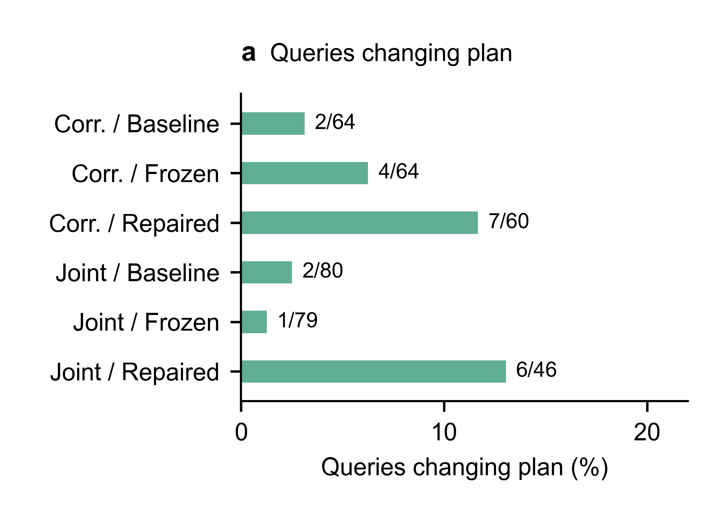
Figure 13: Plan-utility audit after fixed-candidate verification. (a) Fraction of queries whose plan changes, labeled as changed/valid queries. (b) Geometric-mean runtime ratio with 95% query-paired bootstrap CIs; positive values mean the interval rule is faster. Each candidate runs serially three times in random order and we take the median; valid query sets differ across states.

