

GEL Dataset Cost Proposal

For North Thames Genomic Medicine Centre

Prepared by: Hildegard Franke, freshEHR Clinical Informatics Ltd.

Date: 28-Aug-2016

# Introduction

The purpose of this document is to present our delivery and cost proposal for the GEL Rare Diseases Dataset.

This document should be read in conjunction with our earlier modelling proposal which is embedded below for reference purposes.



# Scope

This is a summary of the proposed scope for the Rare Diseases Dataset:

1. A total of 90 archetypes are required:
   1. New simple archetypes 37 (41%)
   2. New complex archetypes 7 (8%)
   3. Simple modifications to existing archetypes 19 (21%)
   4. Complex modifications to existing archetypes 1 (1%)
   5. Existing archetypes 26 (29%)
2. These will be compiled into 15 templates.

We will also include the Prostate Cancer Dataset, and there will be no additional cost associated with this.

We have estimated a total of 23 days for modelling, plus 7 days for further analysis, reviews and clarifications.

# Delivery schedule

We propose the following delivery schedule:

|  |  |  |  |
| --- | --- | --- | --- |
| Phase | Content | Duration | % Cost |
| Exploratory | * Clinical Genetics/ Family Pedigree * Imaging (subset) * Laboratory tests (subset) * Performance measures * Prostate cancer dataset | 1 month | 30% |
| End of Month 2 drop | TBC | 1 month | 10% |
| End of Month 3 drop | TBC | 1 month | 10% |
| End of Month 4 drop | TBC | 1 month | 10% |
| End of Month 5 drop | TBC | 1 month | 10% |
| Final drop | TBC | 1 month | 30% |

We will attempt to finish the project earlier if at all possible, and if this is achieved the payment for the final drop will amount to the remaining balance, e.g. finishing 2 months early would result in the 50% balance being payable at the end of Month 4.

# Cost Schedule

Total project cost = 30 days @ £695 + VAT **£20,850 + VAT**

Exploratory Phase cost = 30% of total cost **£6,255 + VAT**

Month drop cost = 10% of total cost **£2,085 + VAT**

End of project balance = 30% of total cost [1] **£6,255 + VAT**

**Assuming a project start date of 01-Oct-2016, the timeline below illustrates both the delivery and the cost schedule.**

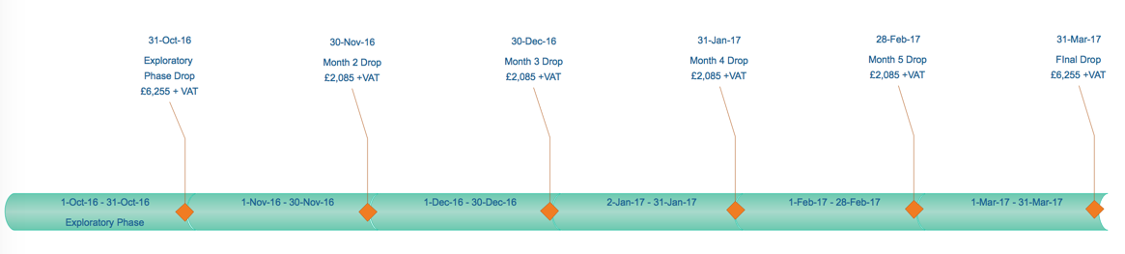

1. Please note that this final balance may increase if the project is completed early.