# Mobility

## Sugarman Master CNA

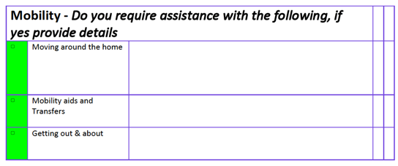

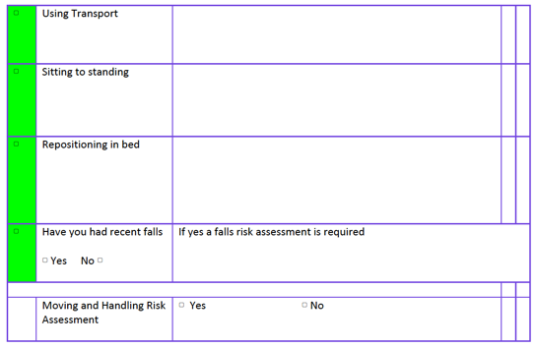

## Nightingale-Hammerson: Pre-admission assessment

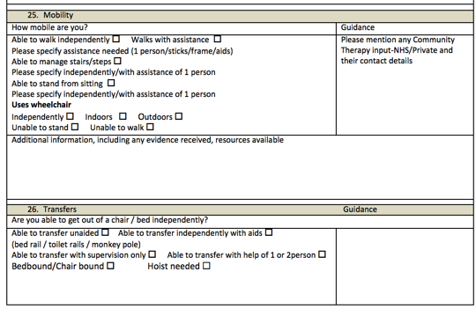

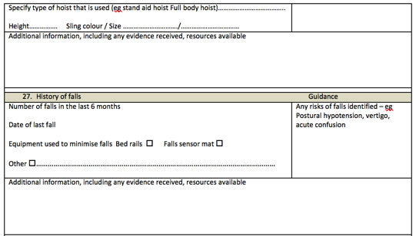

## Nightingale Hammerson: Health and Wellbeing care plan

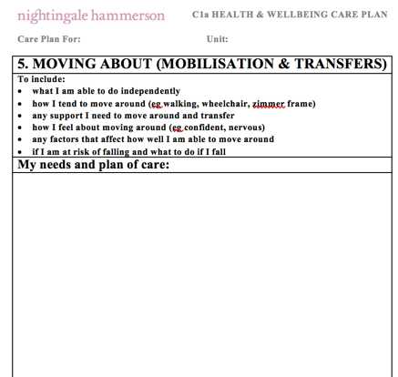

# Nutrition / Diet

## Sugarman Master CNA

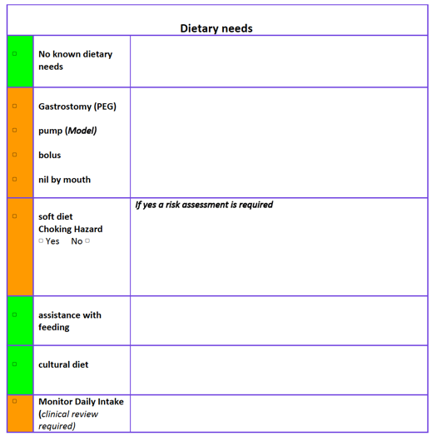

## Nightingale-Hammerson: Pre-admission assessment

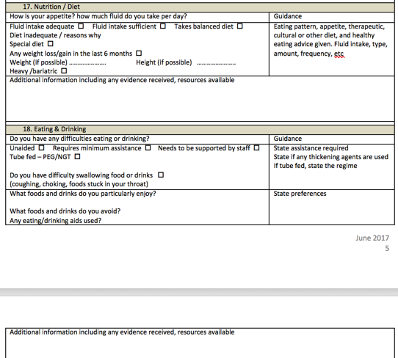

## Nightingale-Hammerson: Health and Wellbeing care plan

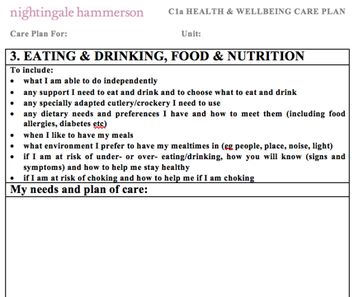

# Breathing

## Sugarman: Master CAN

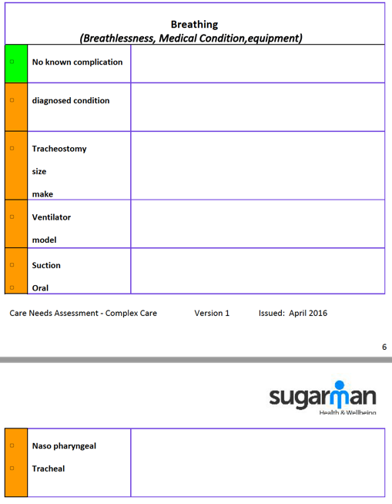

## Nightingale-Hammerson: Pre-admission assessment

