**🎬 Task: Movie Wishlist App — Extended Edition**

**🕐 Duration: ~1 hour**

**👨‍🏫 Level: Intermediate**

**🧠 Concepts Reinforced:**

✅ Functional Components  
✅ Props  
✅ useState, useEffect  
✅ Conditional Rendering  
✅ List Rendering with .map  
✅ filter, reduce for stats  
✅ Event Handling  
✅ **Form Handling** with validation (regex for name & year)  
✅ **CRUD operations** (Create, Read, Delete)  
✅ **React Context** for global state (like favorites)  
✅ **React Router** (e.g., Home, Favorites)

**🧩 App Overview:**

Build a **Movie Wishlist App** where users can:

1. ➕ Add movies via a form
2. ✅ Mark them as watched
3. ❌ Delete movies
4. 🔍 View stats (total, watched, by genre)
5. ❤️ Add to **Favorites** (stored via Context)
6. 🌐 Navigate using **React Router** (/, /favorites, /stats)

**📑 App Structure**

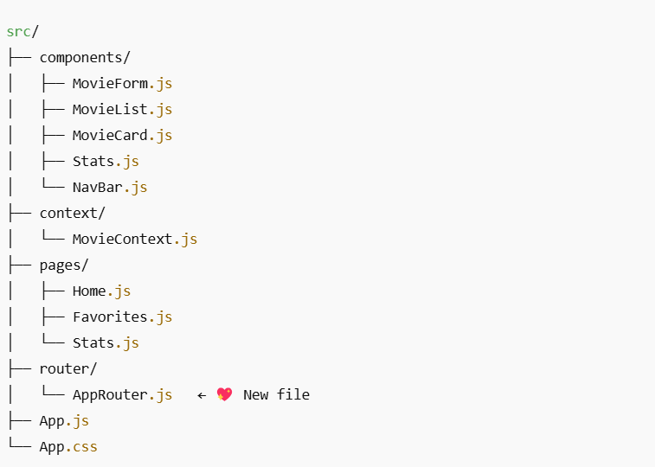

**✨ Feature Breakdown**

**1. Form with Validation**

Use useState for form input + regex:

// Validate: movie name (letters only), year (4 digits)

const nameRegex = /^[A-Za-z\s]{2,}$/;

const yearRegex = /^\d{4}$/;

**2. Wishlist (CRUD)**

* Add new movie (C)
* Display all (R)
* Delete movie (D)
* Optional: Edit (U)

**3. Movie Card**

Props-driven card component with:

* Toggle watched
* Add/remove from favorites

**4. Stats Page**

Use filter & reduce to show:

* Total movies
* Watched count
* Count by genre

**5. Favorites (Context + Route)**

Use React Context to manage global favorite list. Show them in /favorites.

**6. React Router**

Set up basic routes:

<Route path="/" element={<Home />} />

<Route path="/favorites" element={<Favorites />} />

<Route path="/stats" element={<Stats />} />

**🪄 Styling & Animation (Bonus)**

Use your upgraded elegant CSS baby 💅

* Hover effects on cards
* Smooth form slide-in
* Card fade-in on render
* Responsive layout

**✅ Evaluation Criteria:**

|  |  |
| --- | --- |
| Area | Expectations |
| Component Design | Split by responsibility |
| State Management | useState, useEffect, Context |
| Reusability | Clean, prop-driven components |
| Validation | Proper regex checks for form |
| Logic | Correct use of map, filter, reduce |
| Routing | Smooth navigation |
| Styling | Modern, animated, responsive |

**Sample UI:**

