If flash is blank or update software from V1.XXXX to V2.XXX to V3.XXX), need to use this tools to upgrade not only application firmware, but also bootloader.
V2 bootloader：
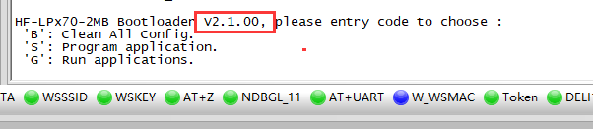
V3 bootloader
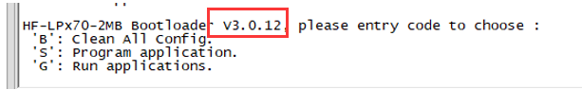
- GPIO8（HF-LPT270的PIN7），connect GPIO8 to VCC and reset. tools baud rate set to 921600
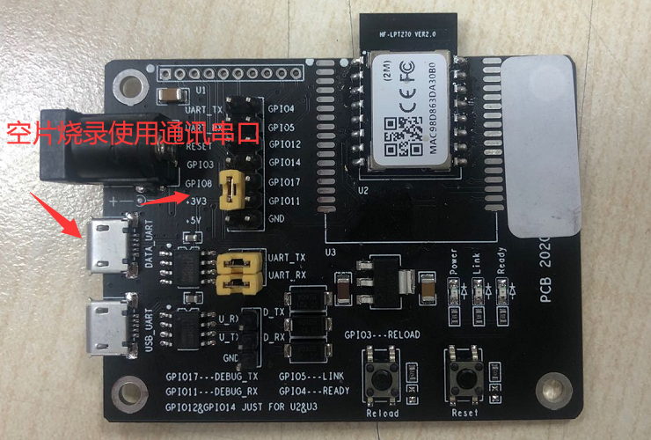
- run 【BLDevCube.exe】 tools.
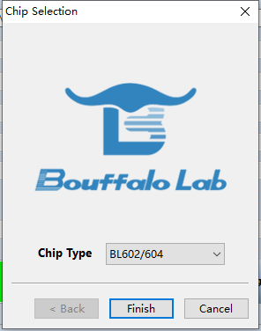
Partition Table choose：partition_cfg_HF_2M_V2.0.01.toml
Boot2Bin choose：bootloader_HF_2M_V3.0.12.bin
Firmware bin choose：LPT270_HFV3.00.13_2MB_20220330.bin
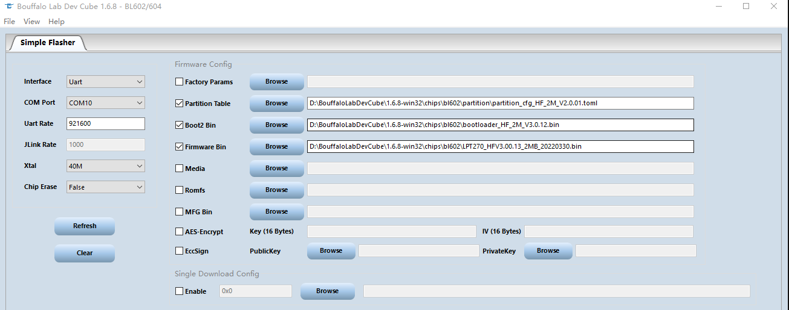
Click 【Open UART】 and then click 【Create & Download】 to download,
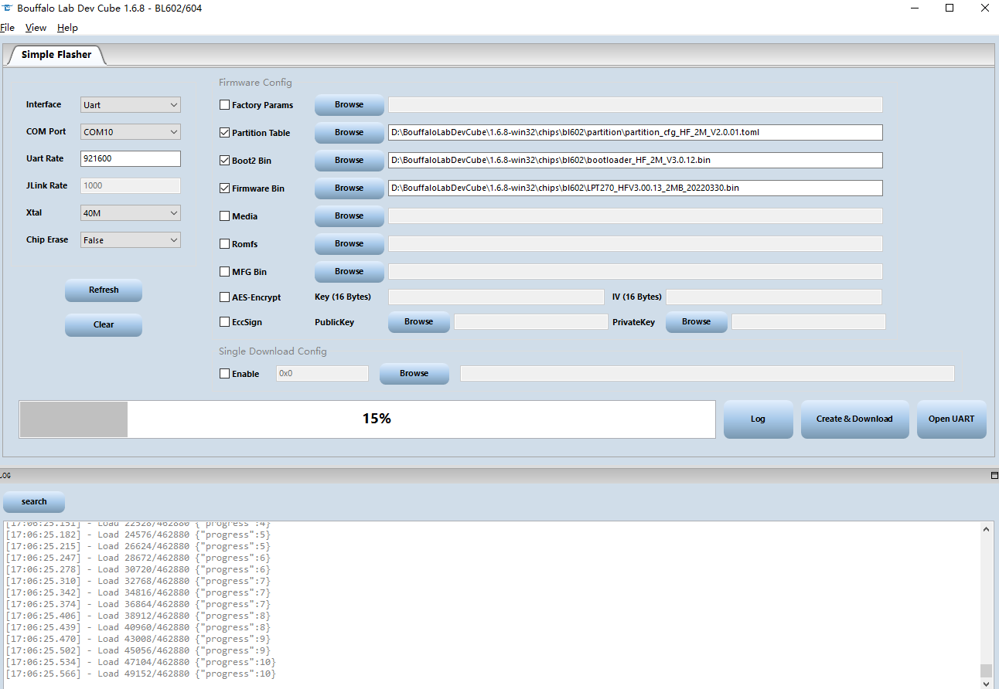
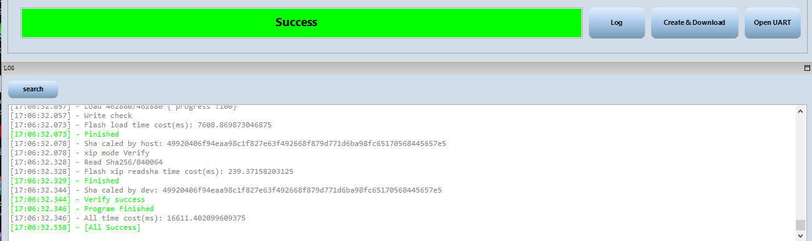
if download fails, reset module and retry.
Remove jumper connection of GPIO8 to VCC and reset to make module working normally after program successfully.
If indicate shakehand fail, this means program handshake fail, check communication UART, and GPIO8 is High voltage.
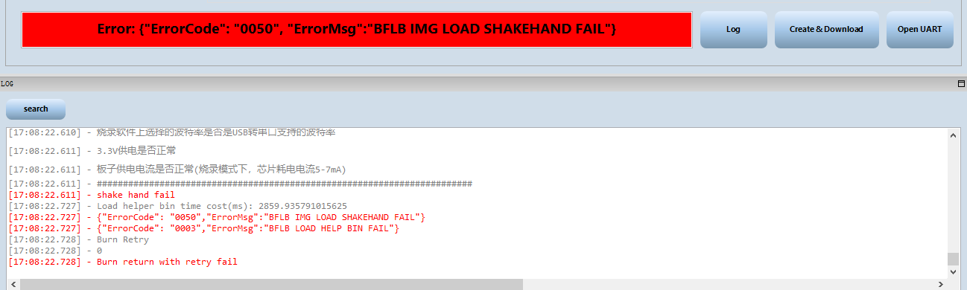
After program successfully, first to check MAC address(upgrade V1.XXX to V2.XXX to remove the previous MAC address), if MAC address is ACCF23FF8888, we consider the MAC is illegal, and most function won’t work. Contact us to get the key of modify MAC(provide MAC address to us ,key is unique with MAC),

or use the following example MAC for test usage.
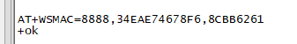
AT+WSMAC=8888,34EAE74678F6,8CBB6261
AT+WSMAC=8888,34EAE769AAD7,CF8D3E45
AT+WSMAC=8888,34EAE769AAA9,BE61D86F
AT+WSMAC=8888,34EAE769AAD6,5D4CB058

flash read method：
1、choose MCU
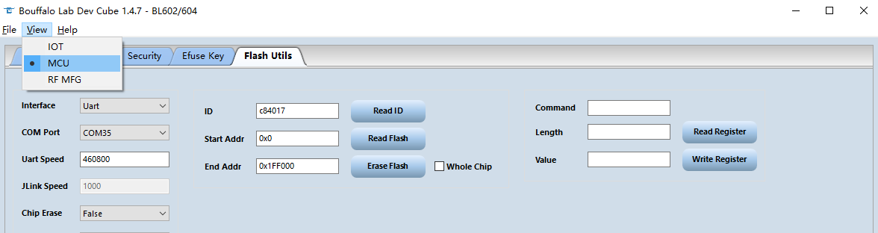
2、GPIO8 connect to VCC and reset，baud rate set to 460800，click 【Read ID】 for test
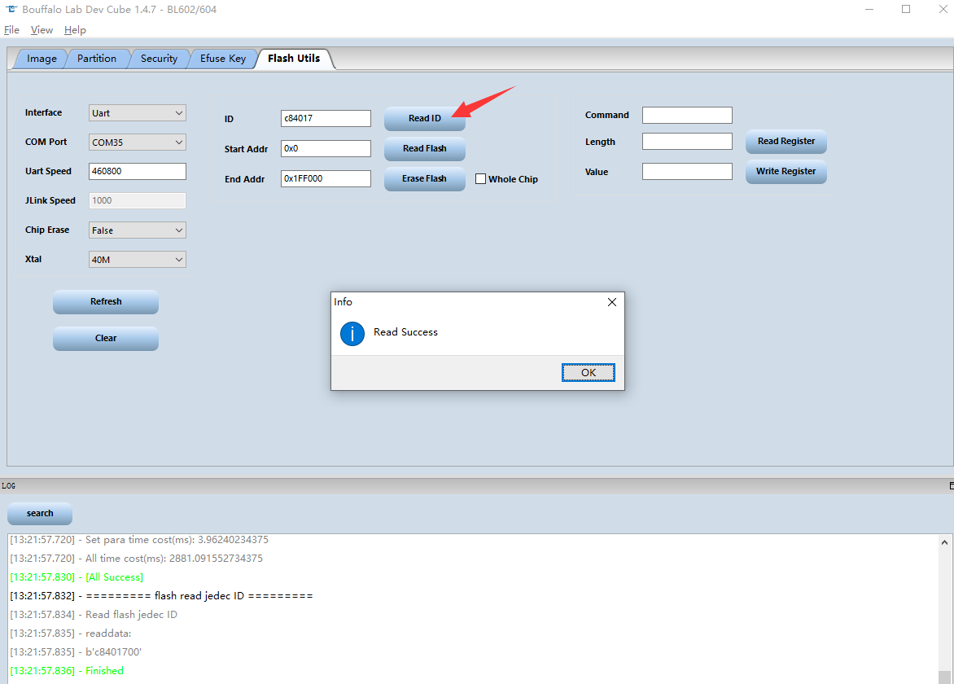
3、reset module, and fill in the Start and End Addr, then click【Read Flash】，the read file will be saved in tools directory. If got fail when in read process, change baud rate to 230400.
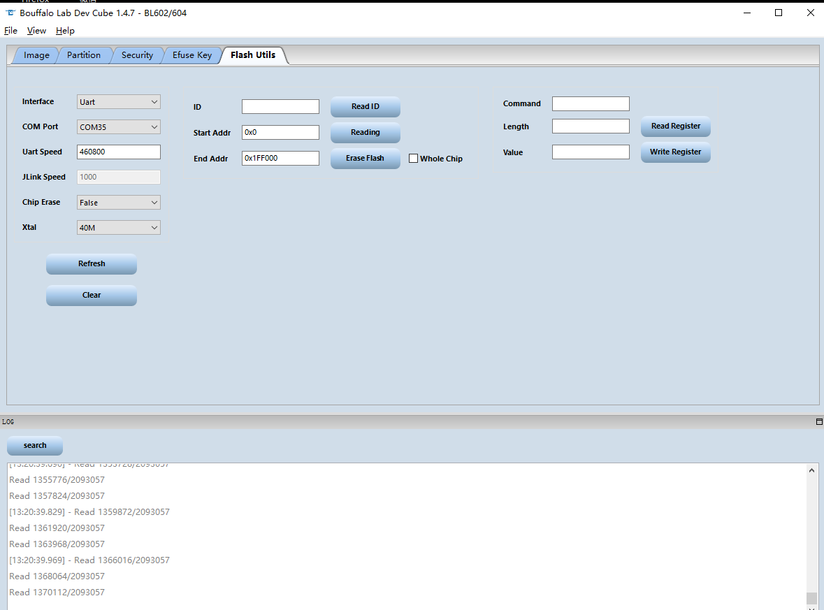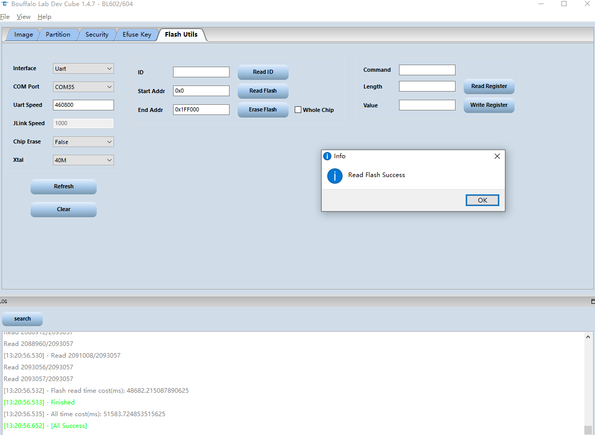

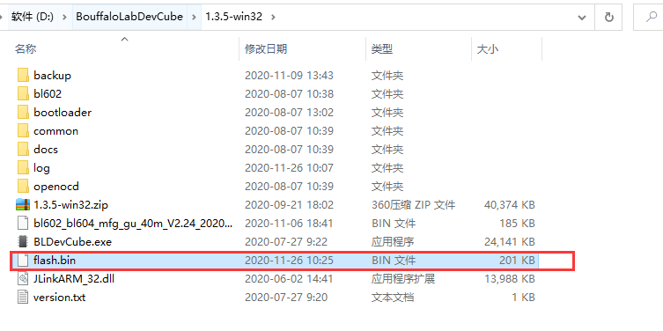
LPX70 2MB partition
