Name:_____________________________

Lecture Section: _____________________

CMPEN 352W/ CMPET 355 (Please circle your course name.)

H/W-4 (30 points)

Due: Monday, Mar. 13 before class

1. Let’s perform equality comparison between two numbers A=A1A0 and B=B1B0. Each has two bits.

(2 points) 1.1. What is the logic gate that allows to perform equality comparison between numbers?

XOR

(2 points) 1.2. Fill in the following truth table for the circuit shown in Fig 1.

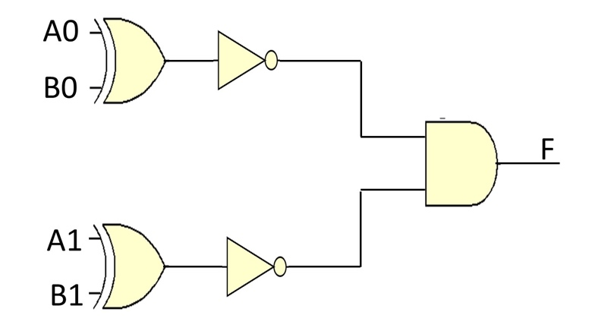

Fig. 1. A simple circuit to perform equality comparison

|  |  |  |  |  |
| --- | --- | --- | --- | --- |
| B1 | B0 | A1 | A0 | F |
| 0 | 0 | 0 | 0 |  |
| 0 | 0 | 0 | 1 |  |
| 1 | 0 | 1 | 0 |  |
| 0 | 0 | 1 | 1 |  |
| 1 | 0 | 1 | 1 |  |
| 1 | 1 | 1 | 1 |  |

(2 points) 1.3. What is the value of F when A=B?

(3 points) 1.4. Modify the circuit of Fig 1 to include an OR gate instead of the AND gate. The two circuits should perform the exact same task.

(6 points) 1.5. Write assembly code to implement the circuit shown in Fig 1 or the modified circuit you obtained in the previous question. The inputs and outputs should be as follows:

• A is stored at location 10H

• B is stored at location 20H

• Result F is stored at location 30H

(15 points) 2. Let’s build a digital safety system shown in the exam. The system has a predefined password combination. The size of the password is one byte. The predefined combination is denoted as P=P7...P0. The other combination is entered by the user and denoted by C=C7...C0. The requirements for this project are given as follows:

1. The predefined combination is stored in a file register addressed at 0x000. This combination is P=0xLM, where L is the month of your birth, M is the first digit in the day of your birth. (implementation: 5 points)
2. The input combination is entered through port C, i.e., RC7-RC0, and then, stored in a file register addressed at 0x010. (implementation: 5 points)
3. The output is an LED connected to one of the pins of port B, i.e., RB0. The LED turns on when the two combinations are equal. (implementation: 5 points)

Write assembly code to implement the system.