Low-Level Computer Vision with MATLAB

Name: Jinlai Ning Student ID:1917340

3.1.1

Box masks are generated by fspecial(‘average’). Argument-shape in conv2 is ‘same’ to ensure that all results are the same size with the original picture.

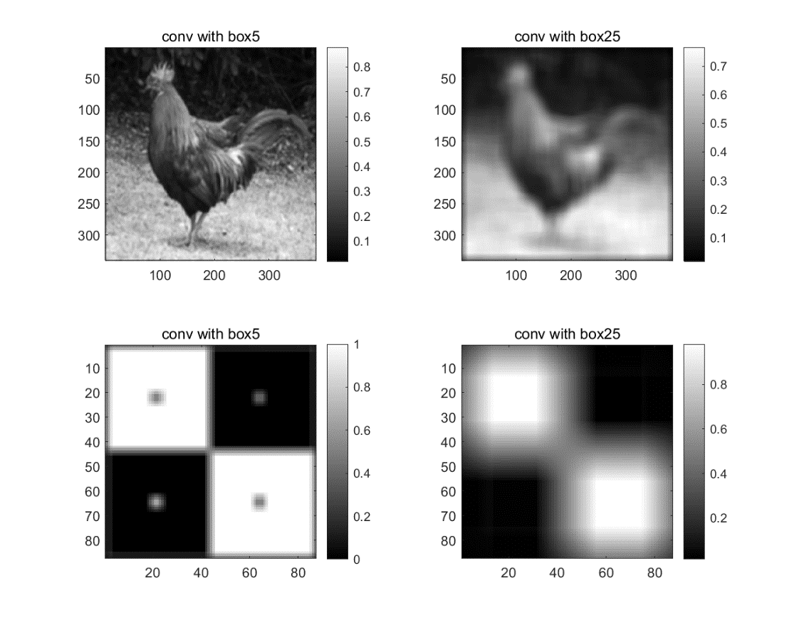

Both rooster and boxes are blurred after being convolved with box masks as box masks use average value with neighbor pixel to replace the original value of each pixel. However, it is clear that picture becomes more blurred convolved with large mask (25×25) than the small one (5×5). It not only can be intuitively seen but also can be proved from the fact that four little squares in boxes are still there in subplot223 but disappear in subplot224. It is because the bigger the size of mask is, more neighbor pixels are involved into average calculation, which will cause more blurred.

3.2.1

Gaussian masks are generated by fspecial(‘gaussian’). In fspecial, argument-hsize is 6 times bigger than argument-sigma to ensure the mask size is sufficient to accurately represent the Gaussian. Argument-shape in conv2 is ‘same’ to ensure that all results are the same size with the original picture.

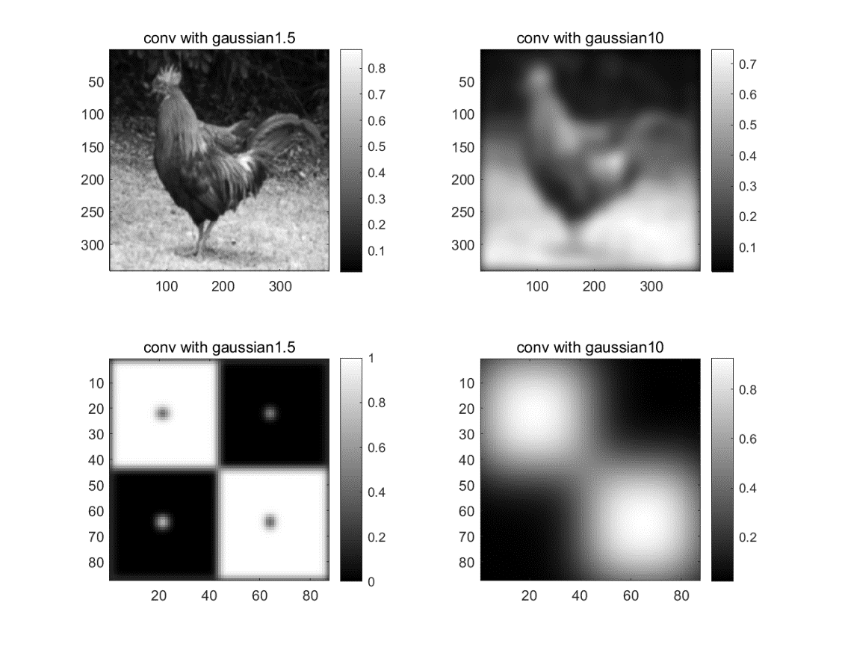

Both rooster and boxes are blurred after being convolved with gaussian masks as gaussian masks use gaussian function to calculate weighted average of pixel value with neighbor pixel. Additionally, picture becomes more blurred convolved with mask of large standard deviations (10) than the small one (1.5). It not only can be intuitively seen but also can be proved from the fact that four little squares in boxes are still there in subplot223 but disappear in subplot224. It is because that larger standard deviation means neighbor pixel has relatively bigger weight, which means neighbor influents more during calculation.

Comparing with the Q3.1.1, the edges detected in the results are more blurred. This is because that when using gaussian masks, the average is weighted by normal distribution, which means from centre, closer pixels have more influence on results.

4.1.1

Difference masks can detect the intensity discontinuous. In this problem, subplot311 is *y=sin(x)*, the original function, where x from 0 to 2*pi. Convolving with 1st difference mask, subplot312 is *-=-cos(x)*. Convolving with 2nd difference mask, subplot313 is . As ‘valid’ is used in conv2, the size of list is one element smaller than the upper one from top to bottom.

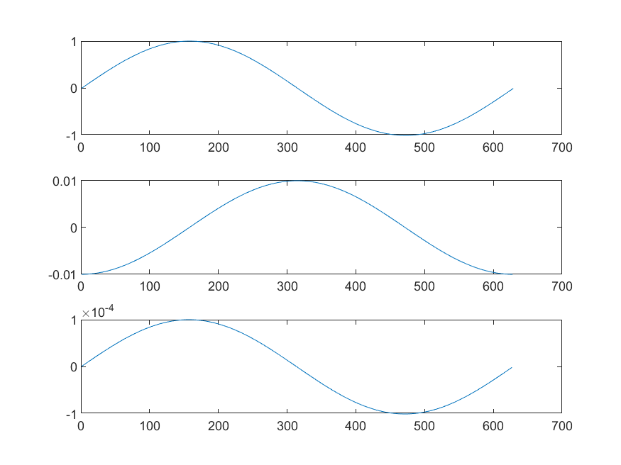

4.2.1

The main different is that the absolute value of pixel is smaller in the first image than the second one. It is because that Laplacian mask 1 has smaller magnitude than Laplacian mask 2. As a result, the calculation results at each pixel is smaller in the first image so the final colorbar range is smaller than the other one as well.

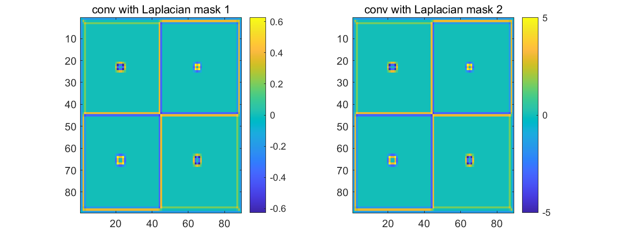

5.1.1

At the locations of large intensity discontinuities, convolved image has relatively high absolute value, which is shown as dark red (max value=0.0796) and dark blue (min value=-0.0796). There are two colors because there are two kinds of edges, which are black2white and white2black. In the first convolved image, only vertical edges can be detected while the second mask detect horizonal edges only.

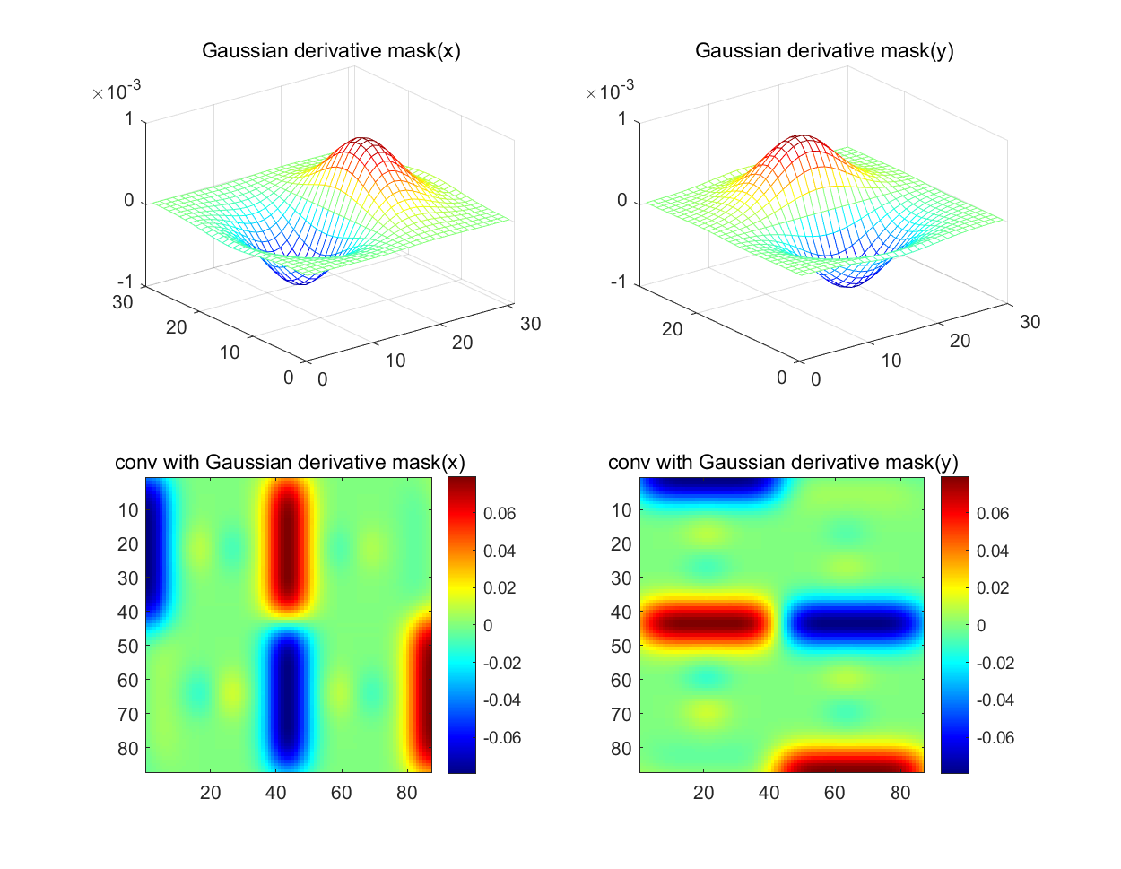

5.1.2

At the locations of large intensity discontinuities, convolved image has relatively high absolute value, which is shown as dark red (max value=0.2666) and dark blue (min value=-0.2666) in image. There are two colors because there are two kinds of edges, which are black2white and white2black. In the first convolved image, only vertical edges can be detected while the second mask detect horizonal edges only. Comparing with the gaussian masks which have high standard deviation (5), this mask with low standard deviation (1.5) can detect short edge better and have higher absolute value at the intensity discontinuities.

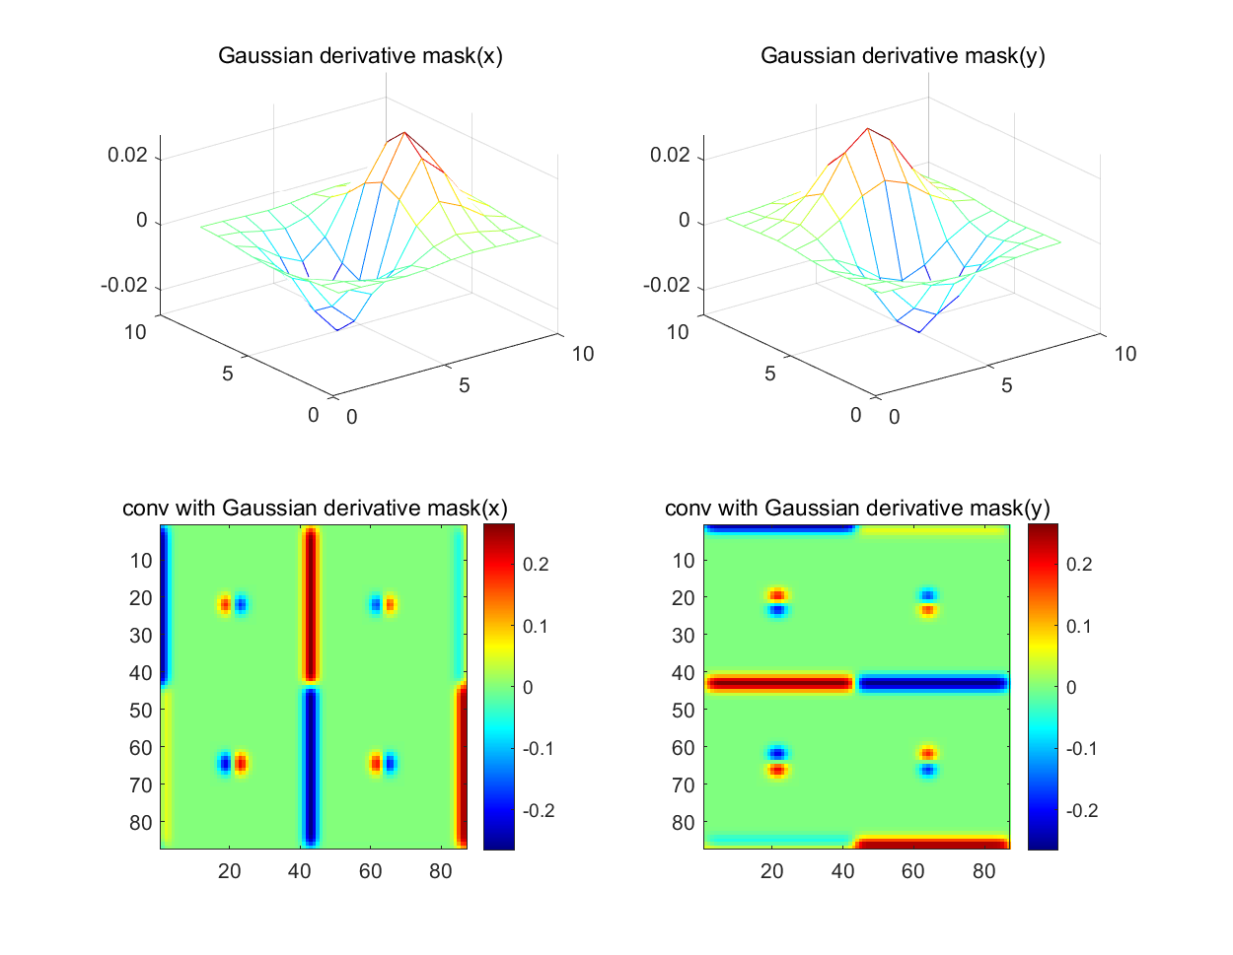

5.1.3

Following image is the combination of horizontal and vertical edge detection.

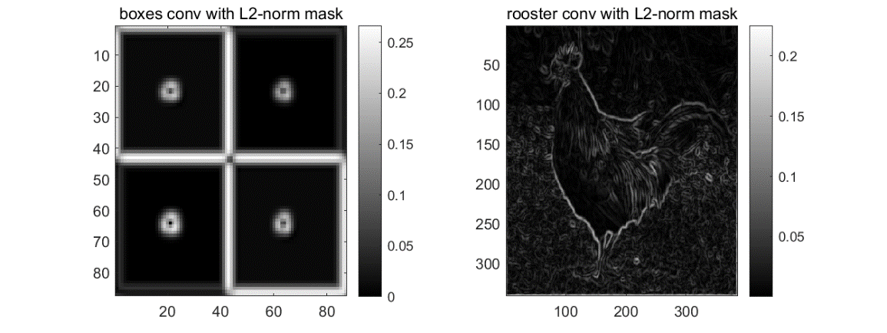

5.2.1

At the locations of large intensity discontinuities, the pixel value of convolved image is almost 0. Near the locations of large intensity discontinuities, the absolute value of convolved image is relatively high, which is shown in dark red and dark blue. There are two colors because of different relative locations to edges. This result is because the LoG masks detect 2nd derivative, which is supposed to detect the edges with positive value, negative value and zero crossing point.

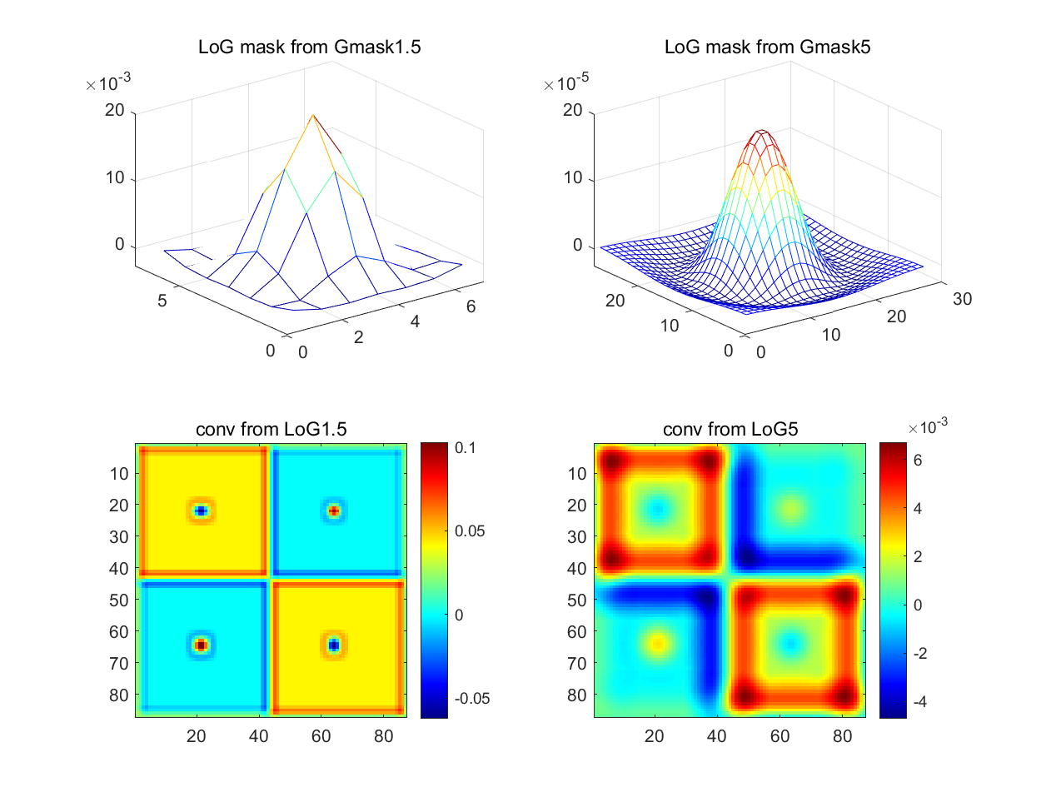

5.2.2

If the standard deviation is changed to be smaller, there will be several effects. Firstly, the overall value of picture would decrease. Secondly, edges would be a little clearer while more details in continuous area tend to disappear. Thirdly, area near edges which are detected becomes bigger and more obvious. Fourthly, image seems more blurred.

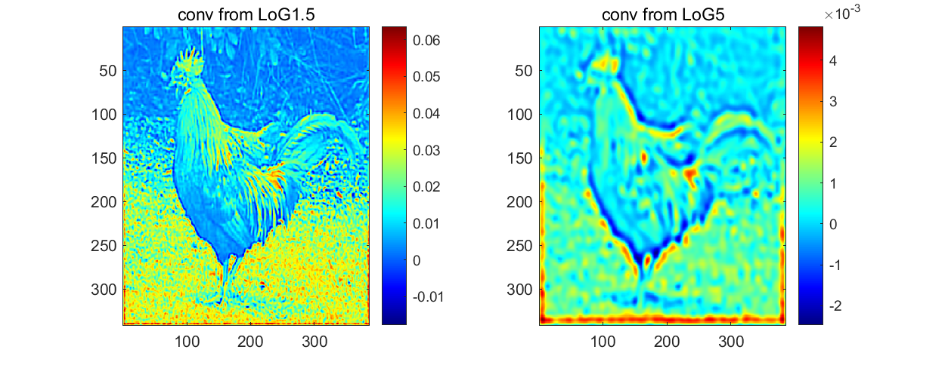

5.3.1

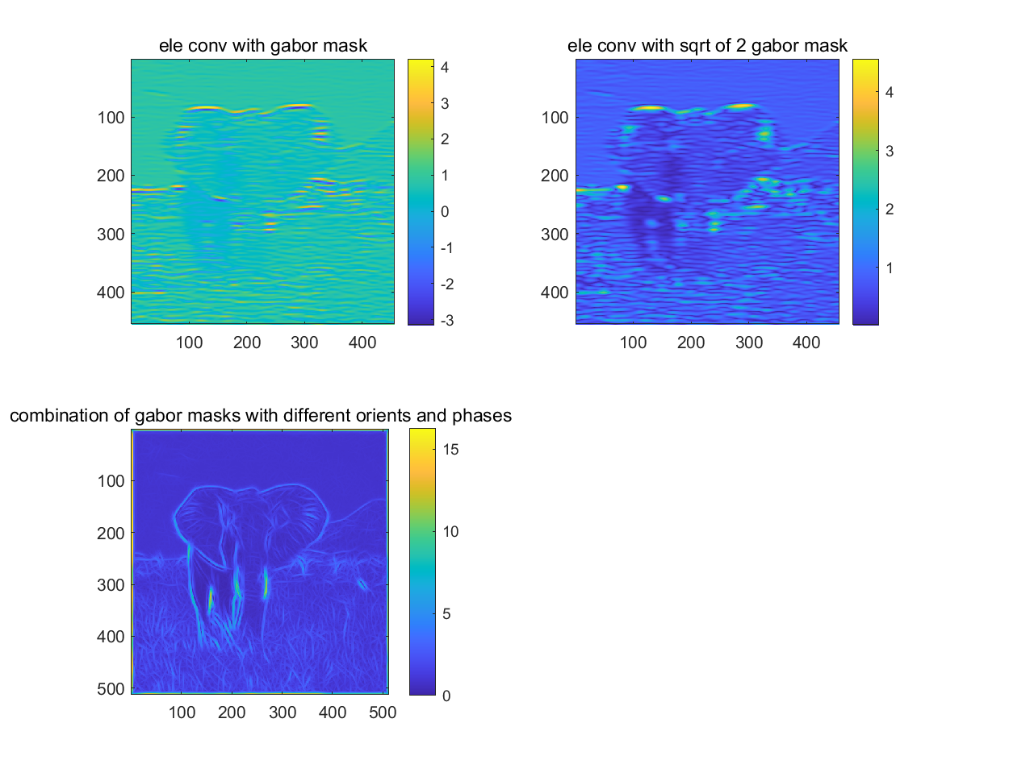

6.1.1

The correlation coefficient (corr) is inversely proportional to the number of shifted pixels. At the beginning, without shifting any pixel, the corr is 1. When the number of shifted pixels increase to 30, the corr decrease to about 0.7 (rooster) and 0.1 (woods) respectively. The corr value in woods drop faster because the size of woods is smaller, which means same number of pixels is relatively more in woods than in rooster.

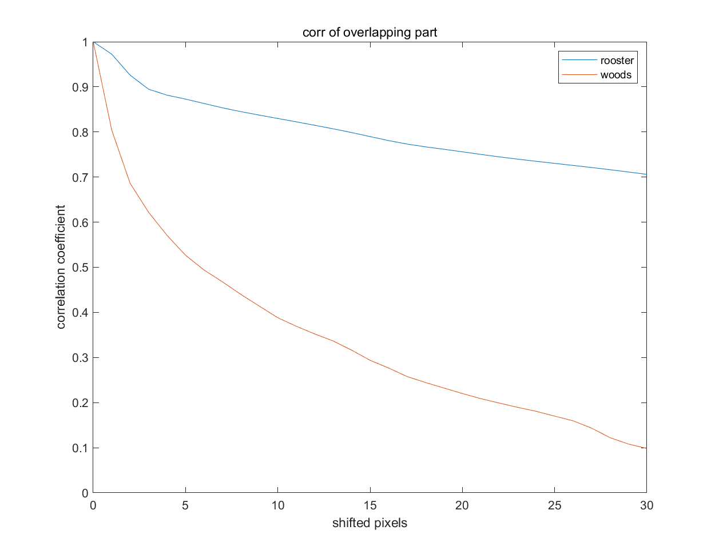

The pixel is shifted towards the direction where x increases. To ensure the two image parts are as large as possible, I use the size(img,1)-31 as the length of x in comparing image part.

6.2.1

The correlation coefficient (corr) decrease faster convolved with the DoG mask generating from the subtracting of gaussian masks with smaller standard deviation. In the left image (generating from Gaussian2-Gaussian6), after about 10 pixels shifting, corr drops under 0.1. The number in the right image (generating from Gaussian0.5-Gaussian4) is about only 5. The difference exists because two gaussian mask with smaller standard deviation will generate DoG with small standard deviation, which means it can detect edges more clearly. In other words, small standard deviation can reduce redundancy better. Therefore, corr decreases faster in right image.

Comparing with the Q6.1.1, this result has some difference as well. On the one hand, seeing from the singer image, after reducing redundancy by DoG mask, the corr drops faster. On the other hand, when it comes to the comparison between rooster and woods, there has less difference than the former one. It is because that when the edges are detected, shifted image would have little similar part with the original image. Therefore, the influence of how much percentage of shifted pixels in the image is reduced.

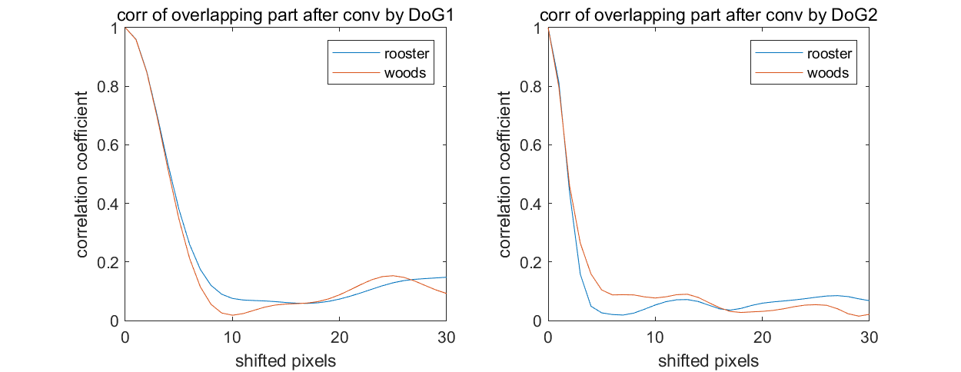

The pixel is shifted towards the direction where x increases. To ensure the two image parts are as large as possible, I use the size(img,1)-31 as the length of x in comparing image part.

7.1.1

In color-on channel, image is convolved with Gaussian-2 mask and in color-off channel, it is convolved with the additive inverse of Gaussian-3 mask. In the rest color channel, the image just keeps the same. When operating the yellow channel, the convolved image channel is given to both red channel and green channel.

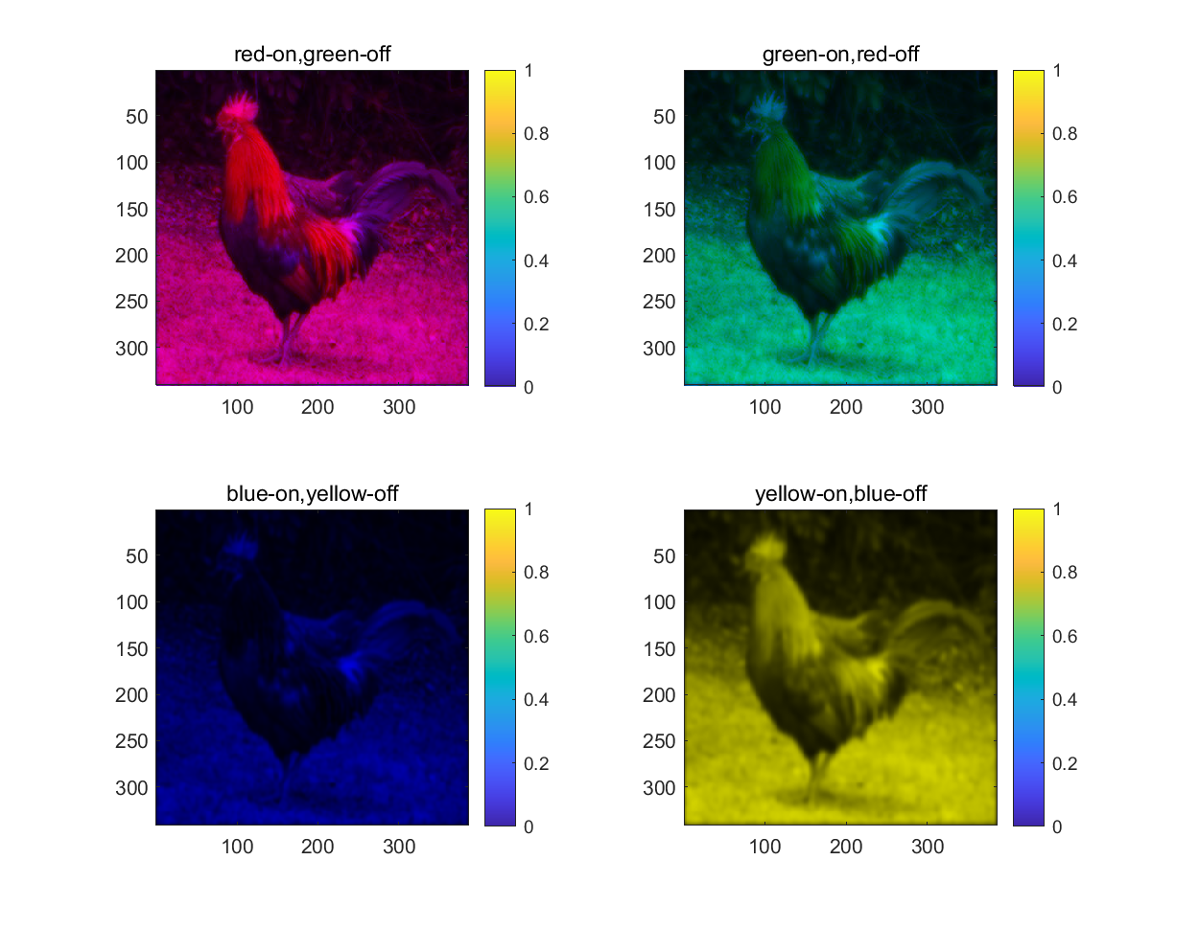

8.1.1

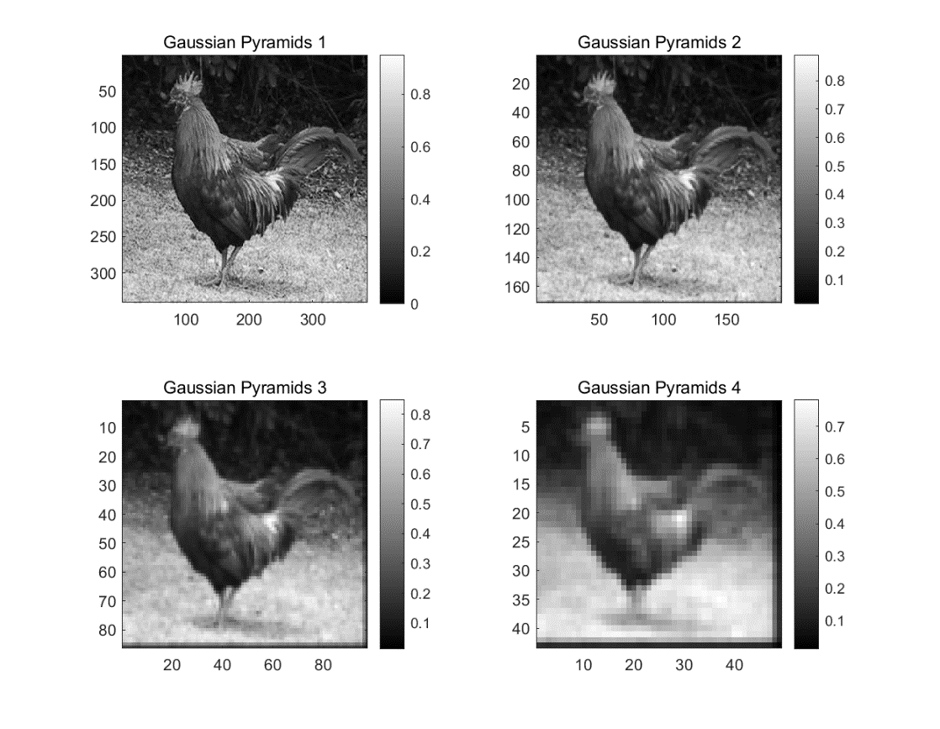

8.2.1

Comparing with the Q8.1.1, this result generates image which mainly contains intensity discontinuous information.

