Concordant mtDNA heteroplasmy between trophectoderm and inner cell mass validates blastocyst-stage PGT-mt for m.14487T>C
Supplementary Table S1 Primer sequences for m.14487T>C to couple PGT-A and PGT-mt
Forward | GCCATCGCTGTAGTATATCCAAA
Reverse | GGTCGGGTGTGTTATTATTCTGA

Supplementary Figure S1 PGT-A plots

embryo 1, TE biopsy
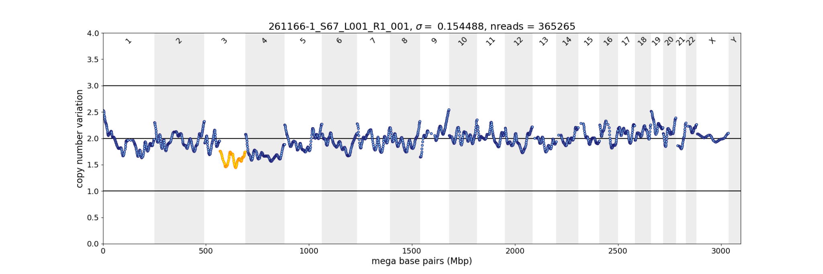
embryo 1, TE rest

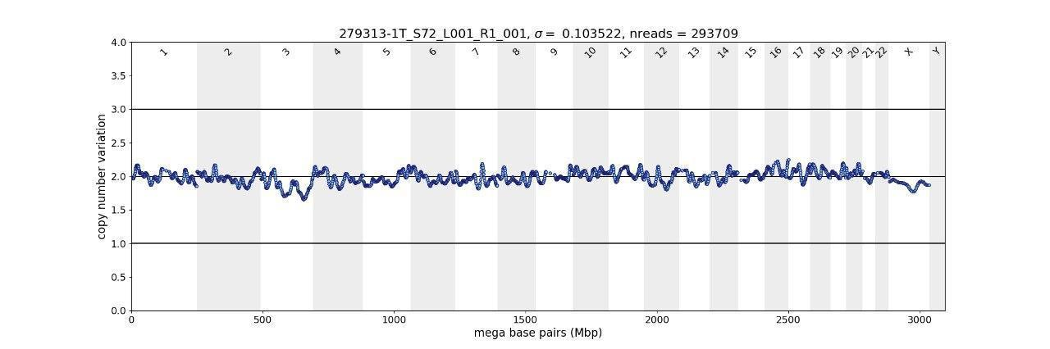

embryo 1, ICM

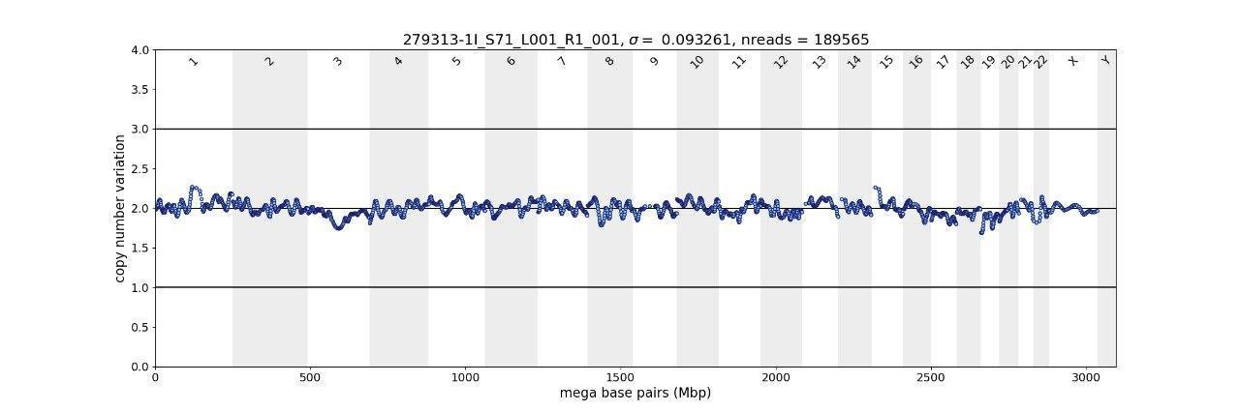

embryo 1, extra cells left under ZP

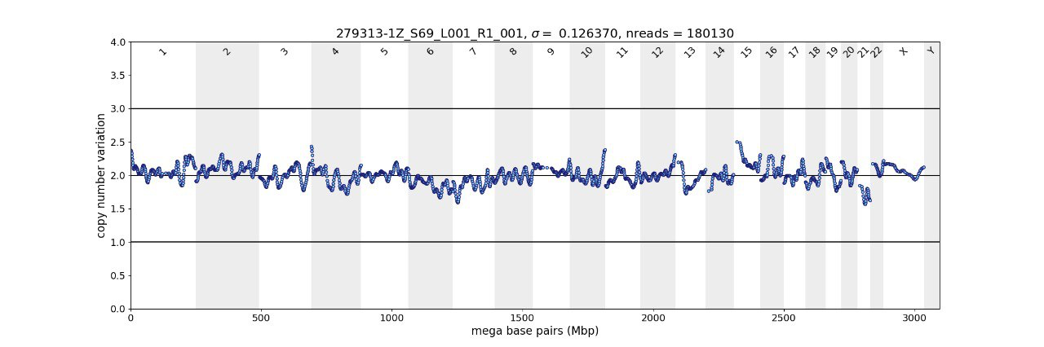

embryo 2, TE biopsy

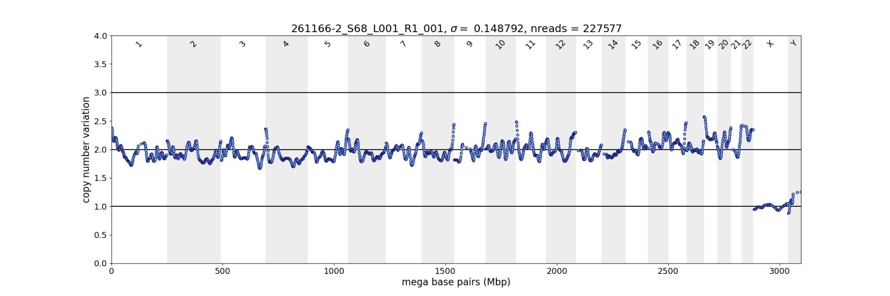

embryo 2, TE rest

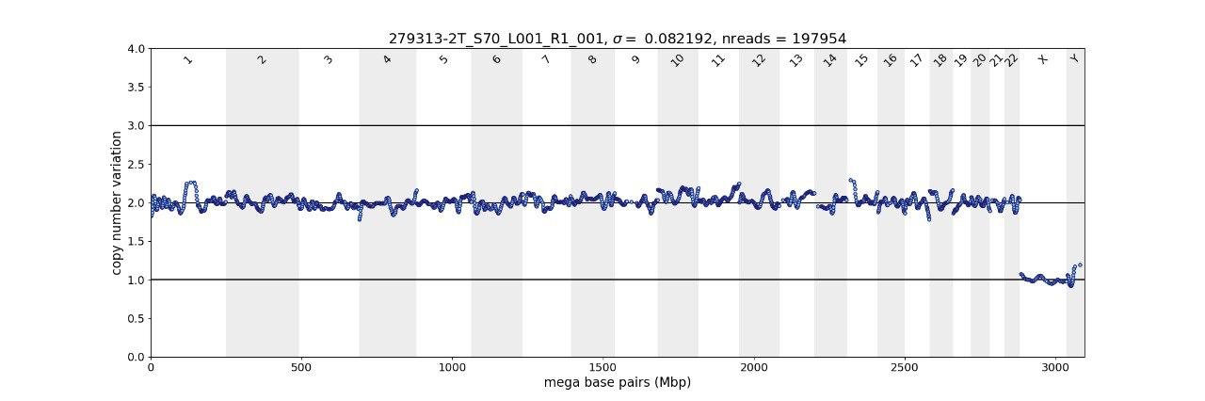

embryo 2, ICM

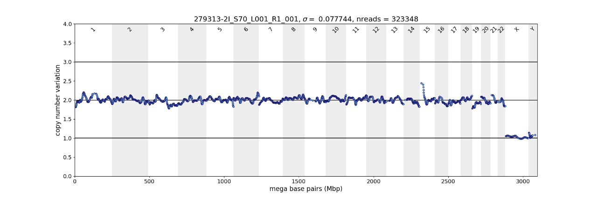

embryo 2, extra cells left under ZP

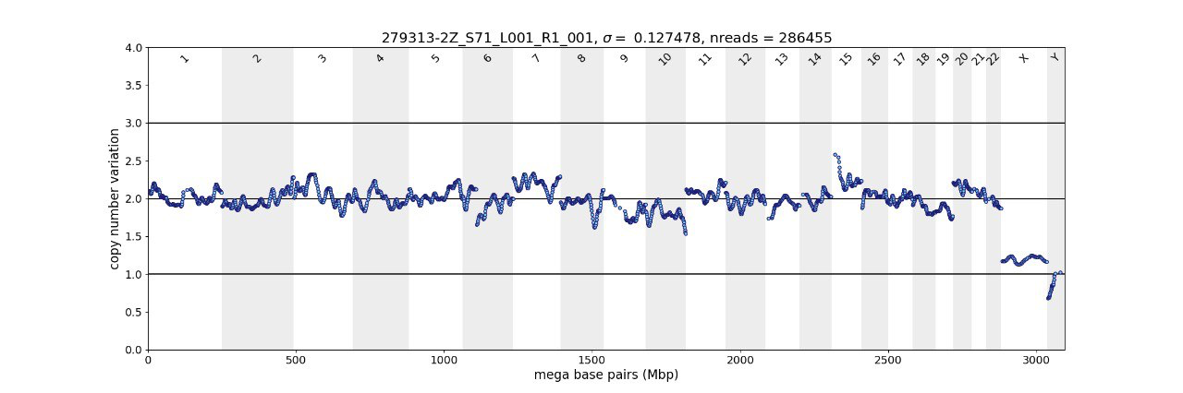

embryo 3, TE biopsy

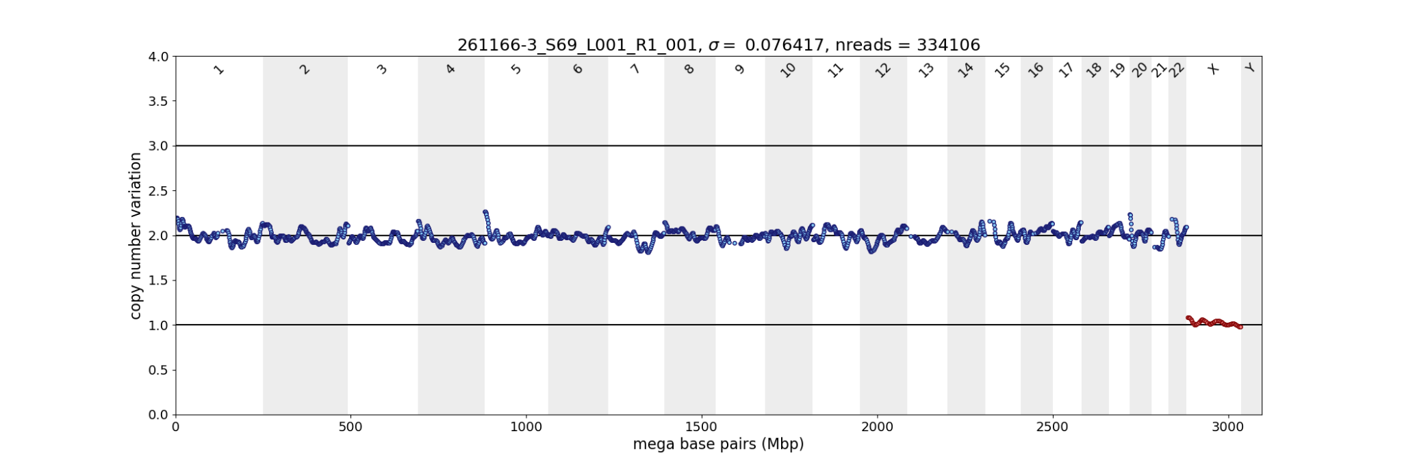
embryo 3, TE rest + ICM

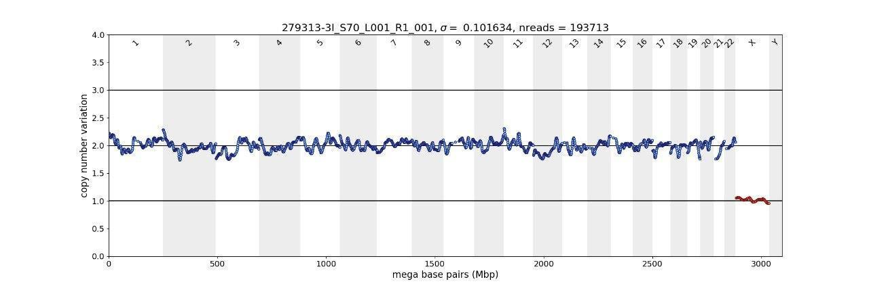

embryo 3, extra cells left under ZP

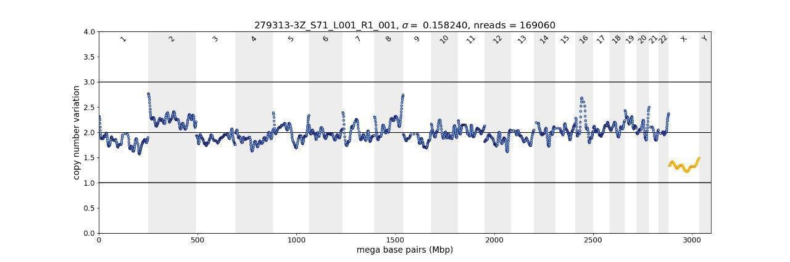

embryo 4, TE biopsy

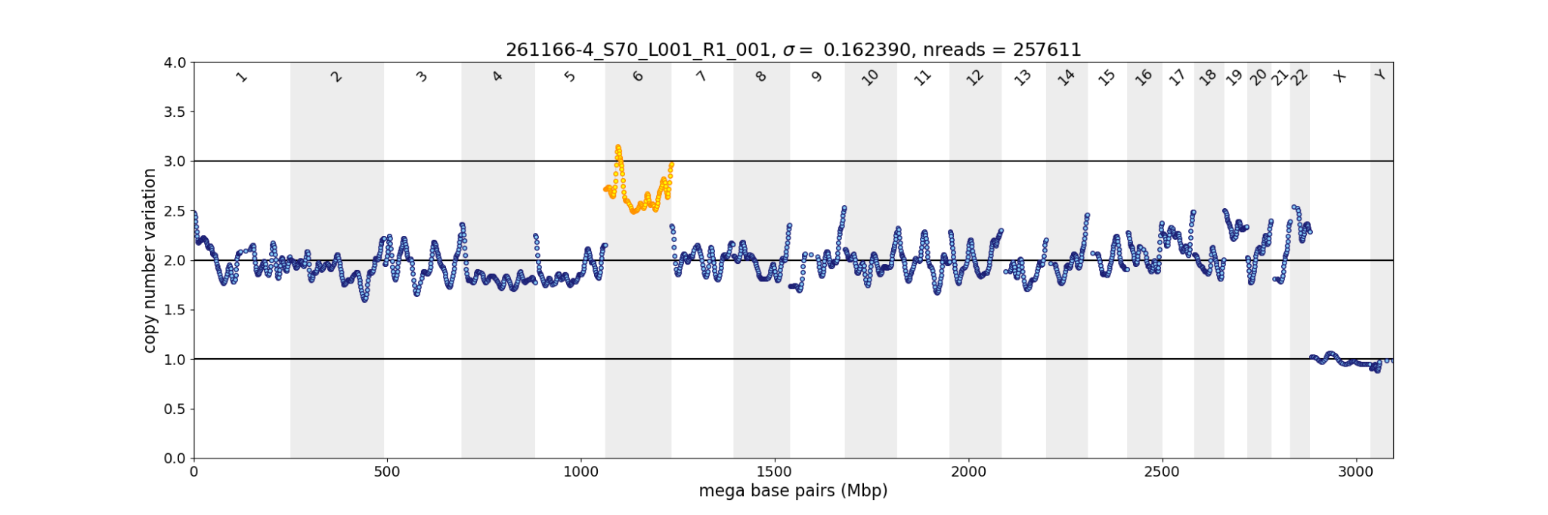

embryo 4, TE rest + ICM

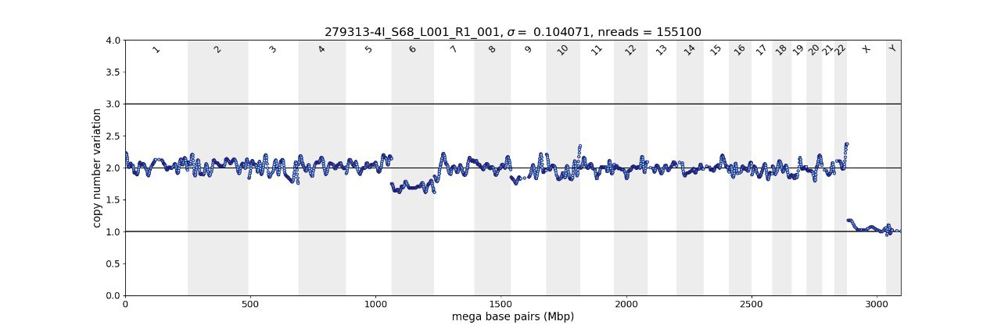

embryo 4, extra cells left under ZP

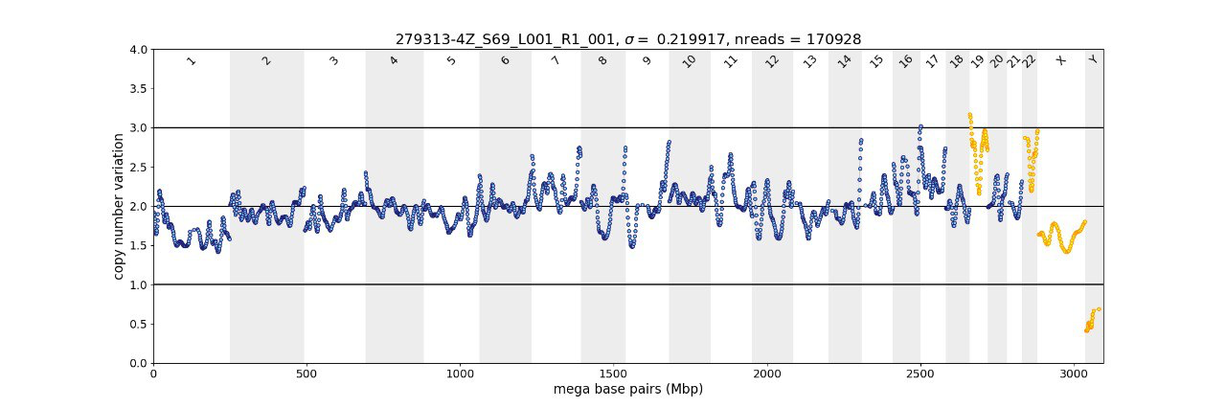

embryo 5, TE biopsy

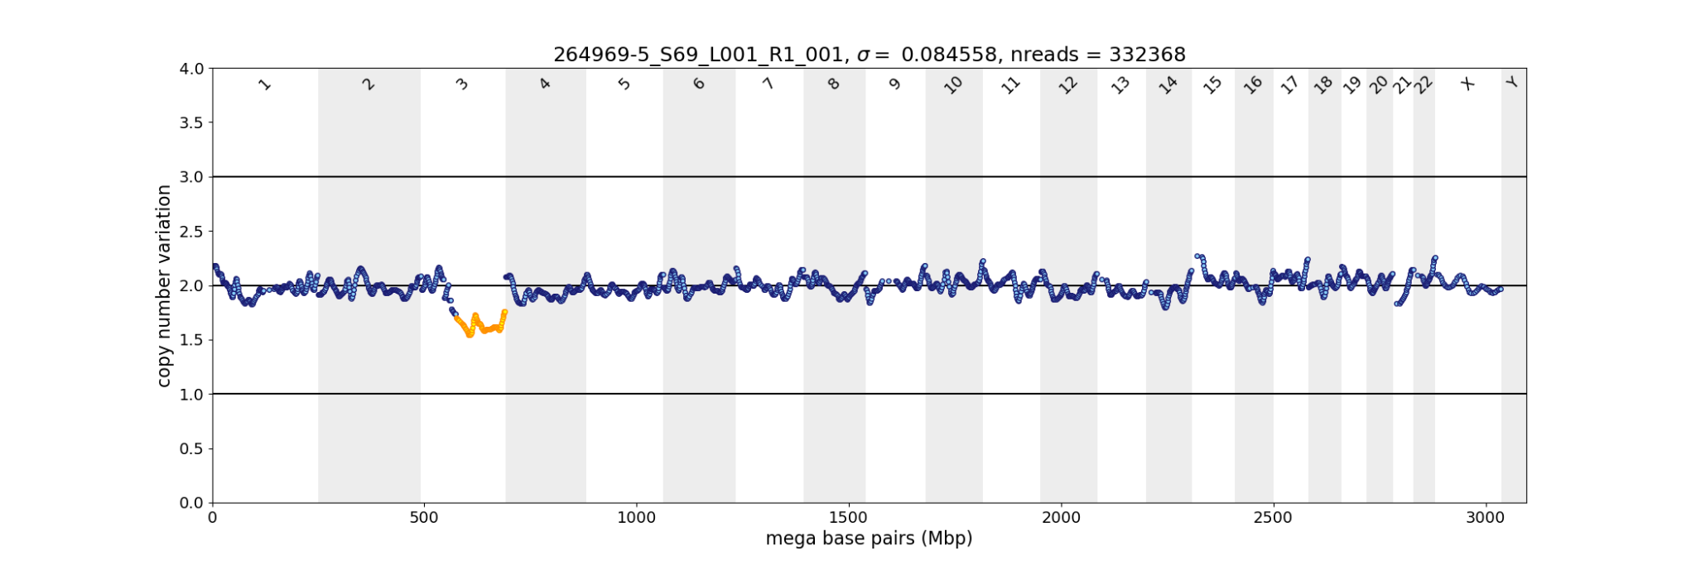

embryo 5, TE rest

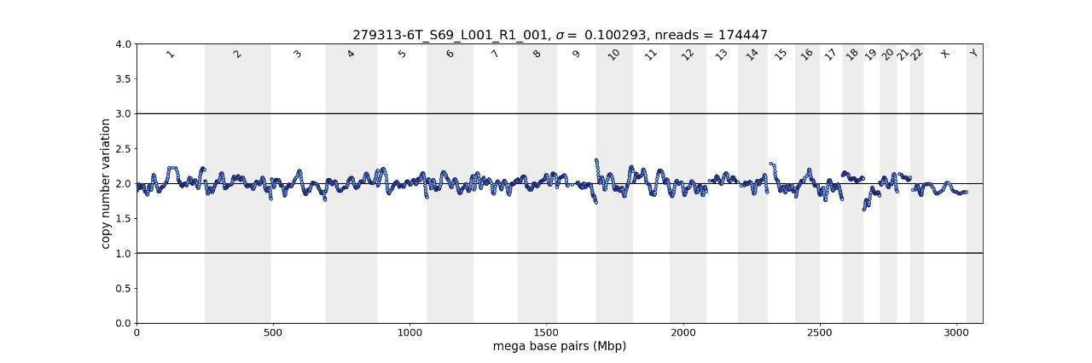

embryo 5, ICM

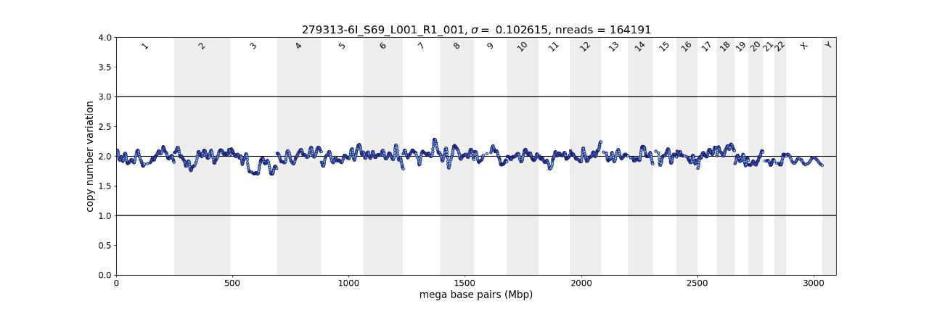

embryo 5, extra cells left under ZP

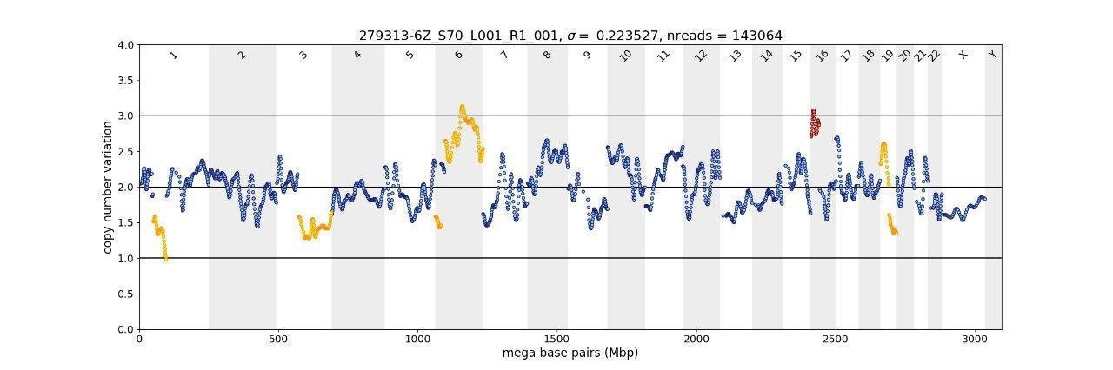

embryo 6, TE biopsy

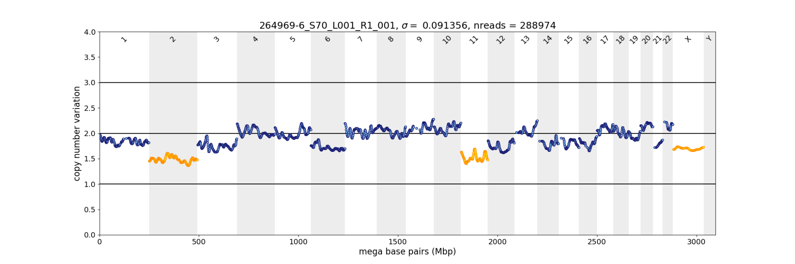

embryo 6, TE rest

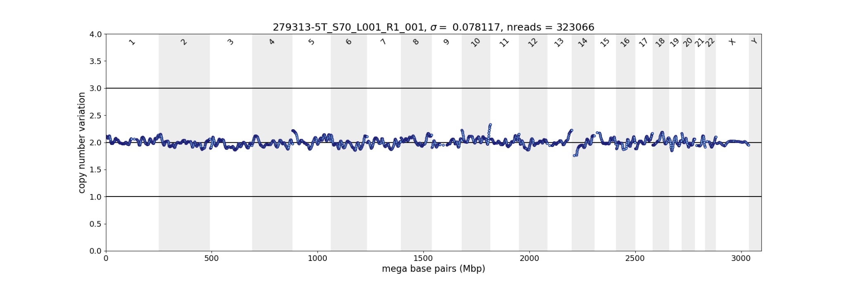

embryo 6, ICM

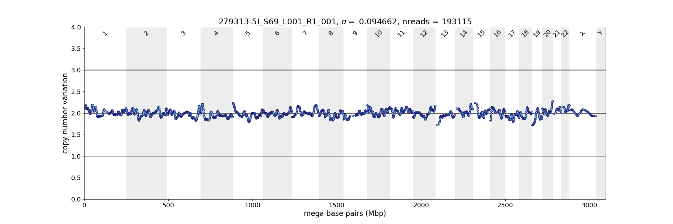

embryo 6, extra cells left under ZP

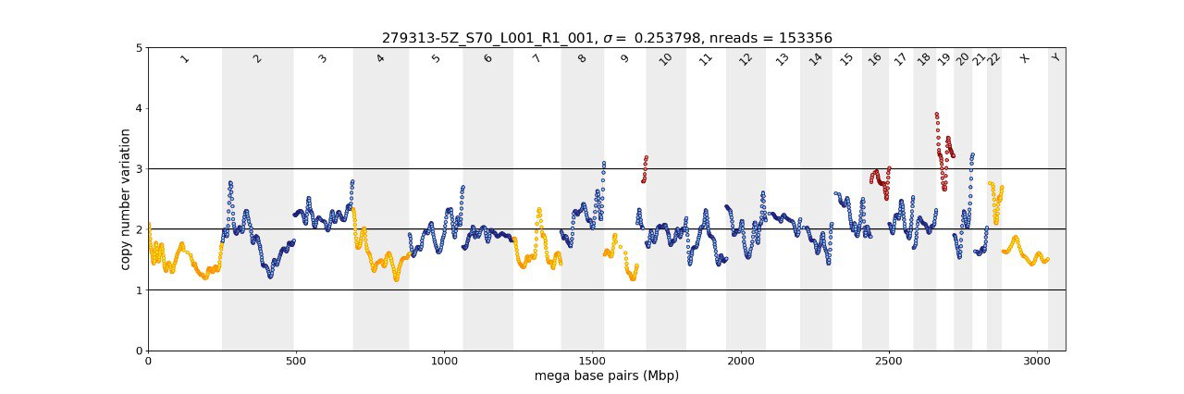

Supplementary Figure S2 Embryo parts for tubing (1-st photo – right after dissection (where applicable); 2-nd photo – 30—60 min later, at tubing). TE, TE remaining after biopsy, dissected from the embryo (within the TE, to exclude contamination with ICM cells); ICM+, inner cell mass, dissected from the embryo together with polar TE and mural TE cells remaining bound to the ICM after dissection; EC, extra cells and/or cellular fragments remaining under zona pellucida after removing the embryo from it.

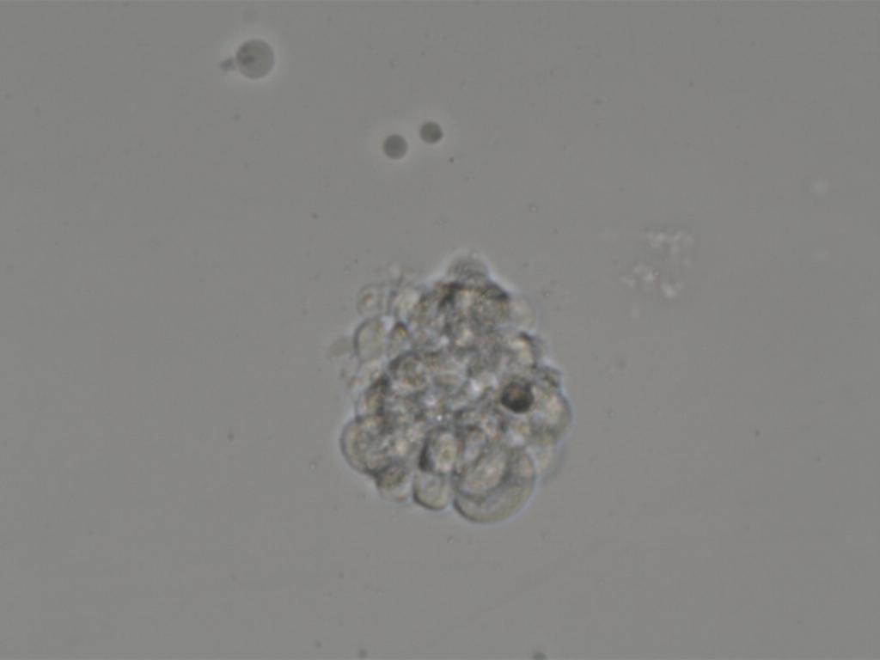
Embryo 1, TE, after dissection

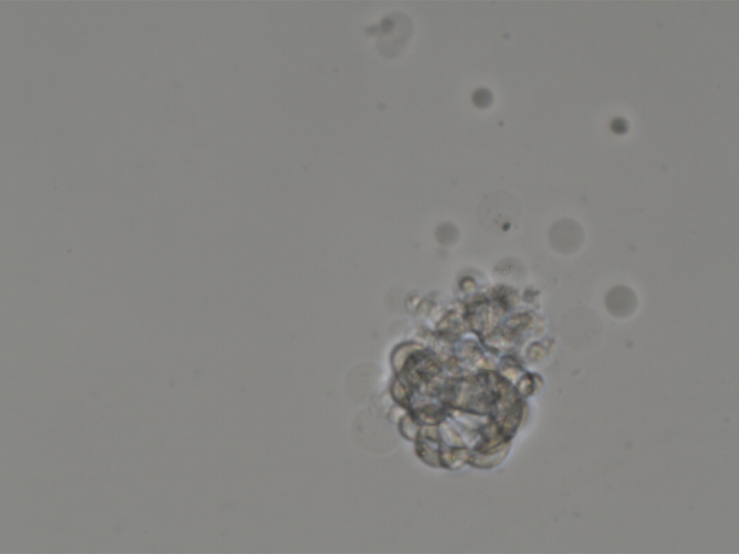
Embryo 1, TE, tubing

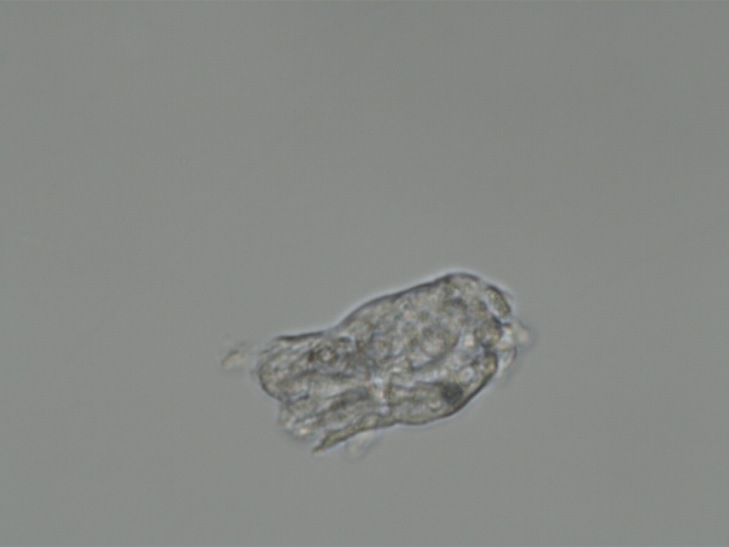
Embryo 1, ICM+, after dissection

Embryo 1, ICM+, tubing

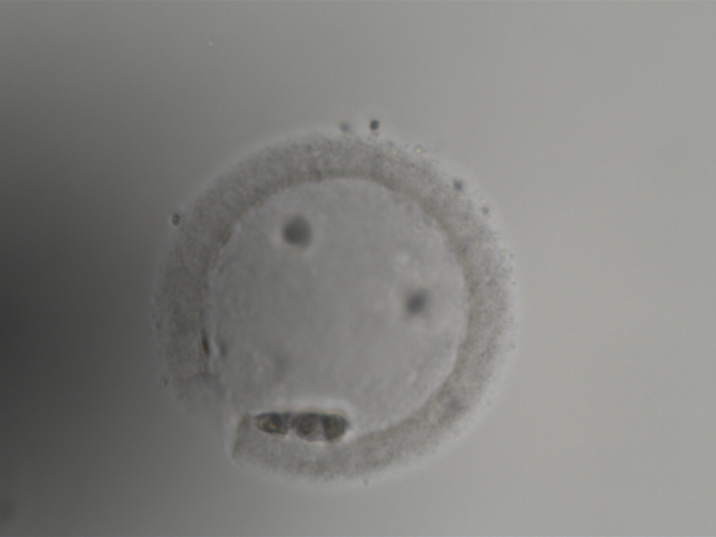
Embryo 1, EC, tubing

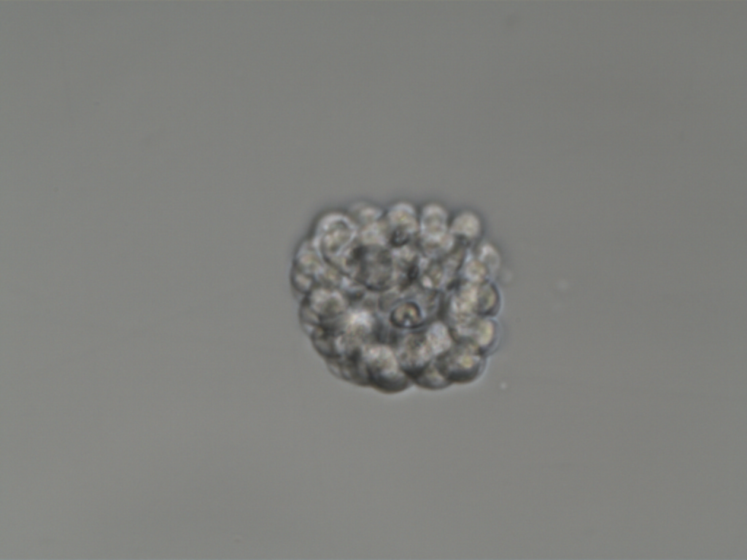
Embryo 2, TE, after dissection

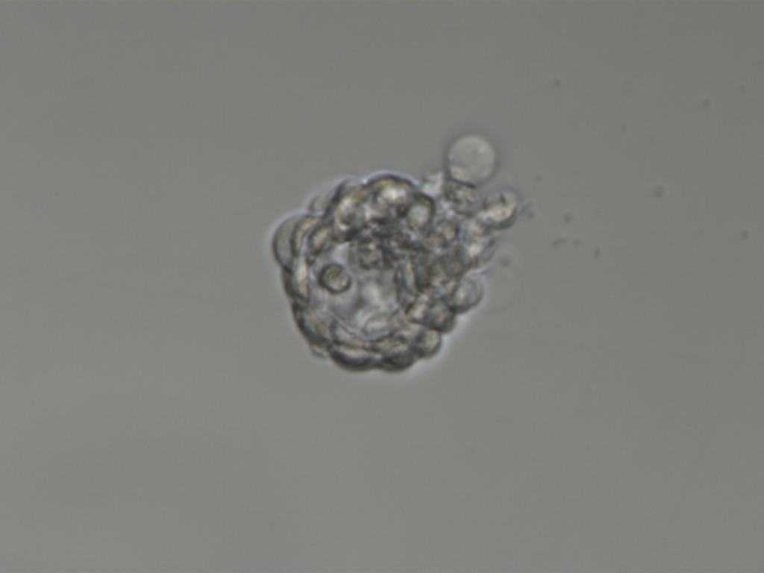
Embryo 2, TE, tubing

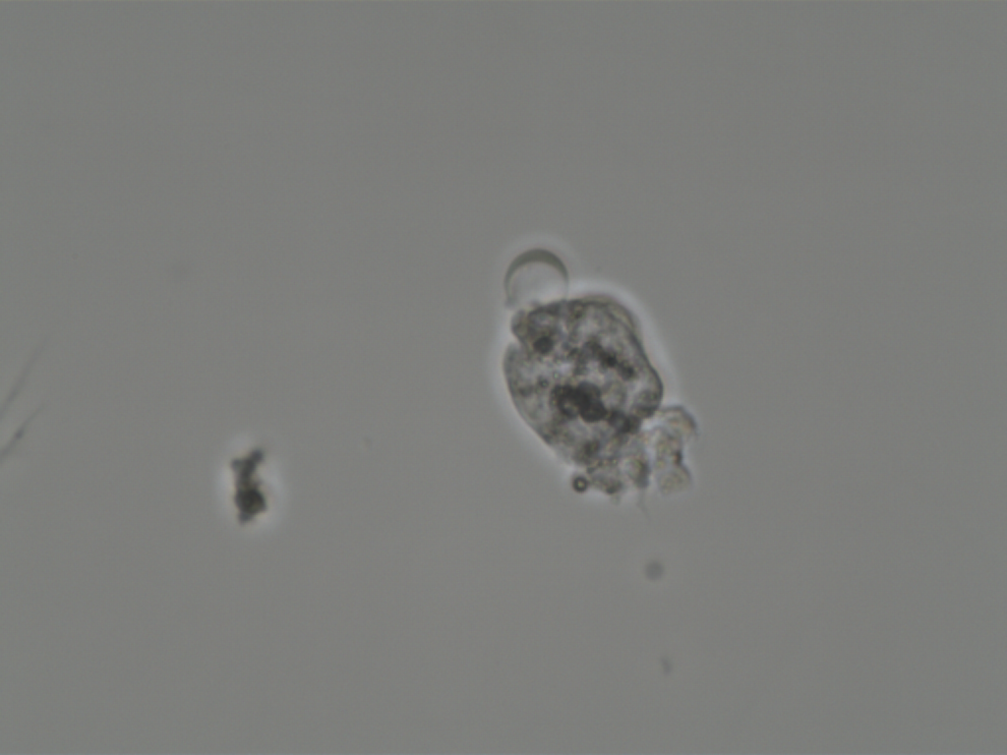
Embryo 2, ICM+, after dissection

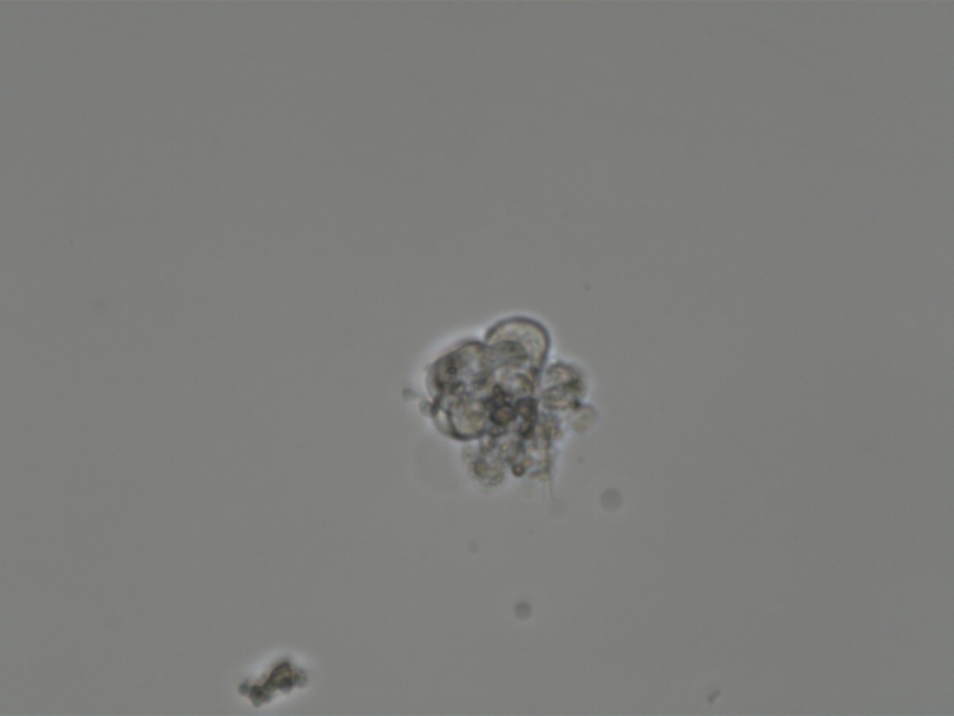
Embryo 2, ICM+, tubing

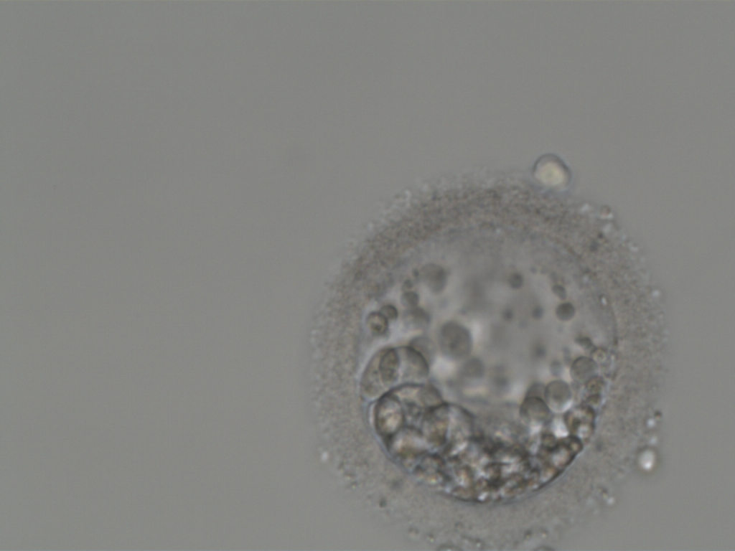
Embryo 2, EC, tubing

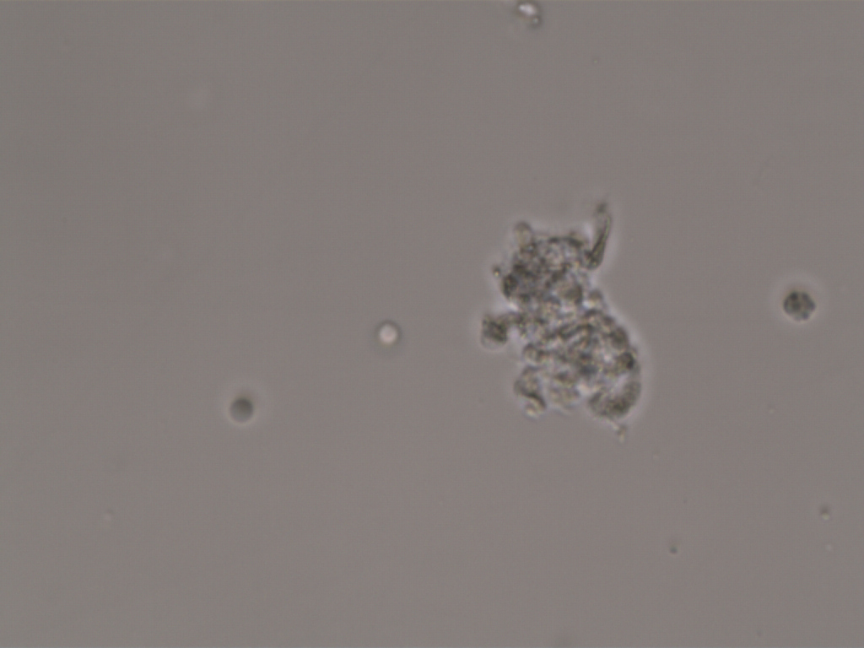
Embryo 3, TE+ICM, after dissection

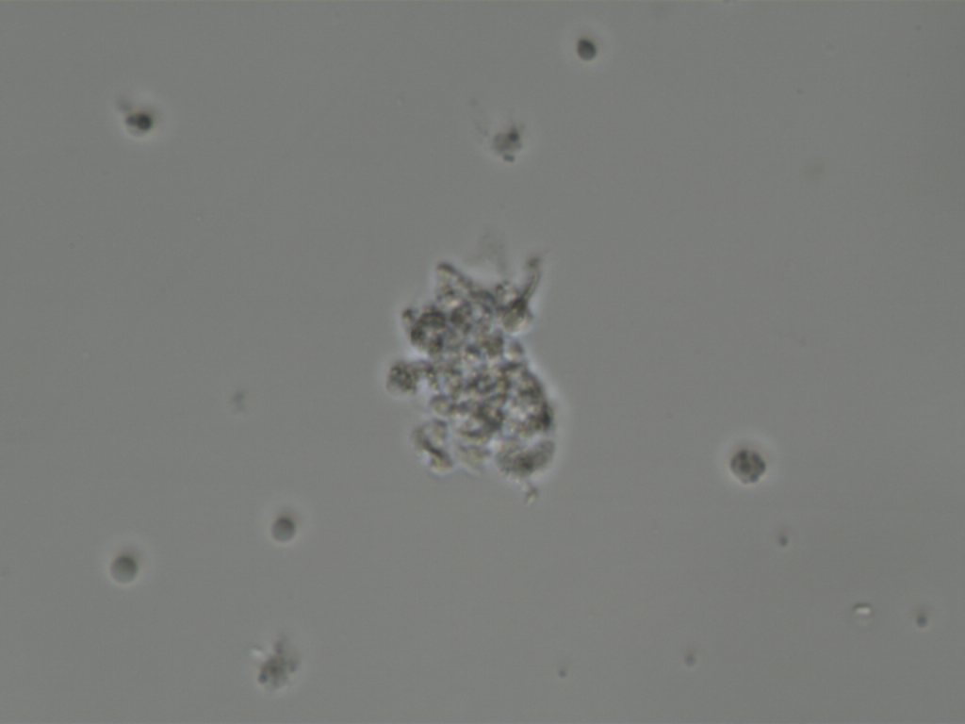
Embryo 3, TE+ICM, tubing

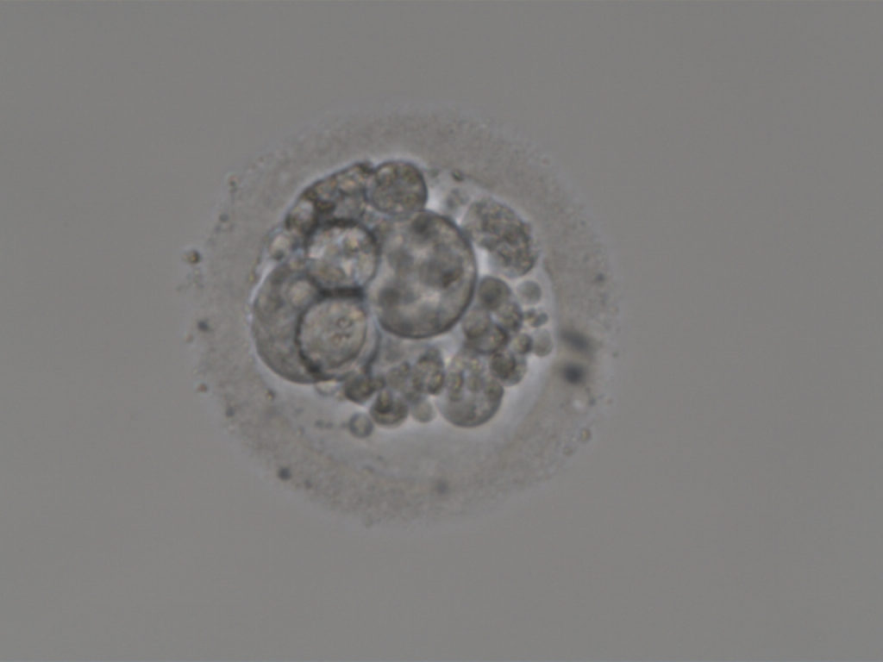
Embryo 3, EC, tubing

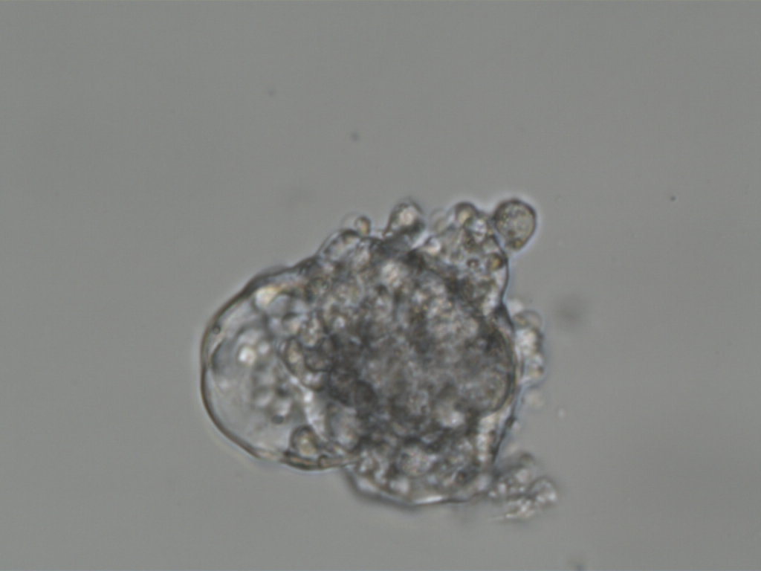
Embryo 4, TE+ICM, after dissection

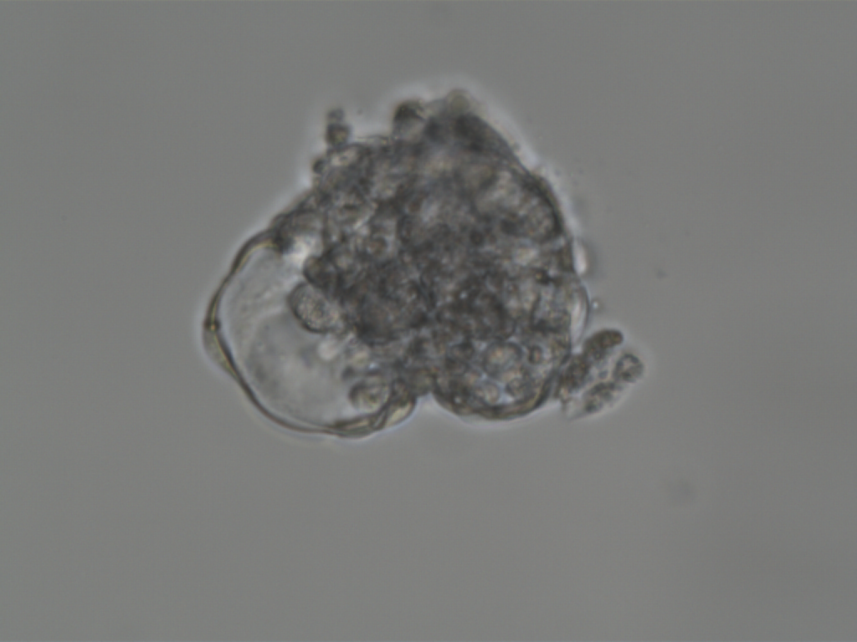
Embryo 4, TE+ICM, tubing

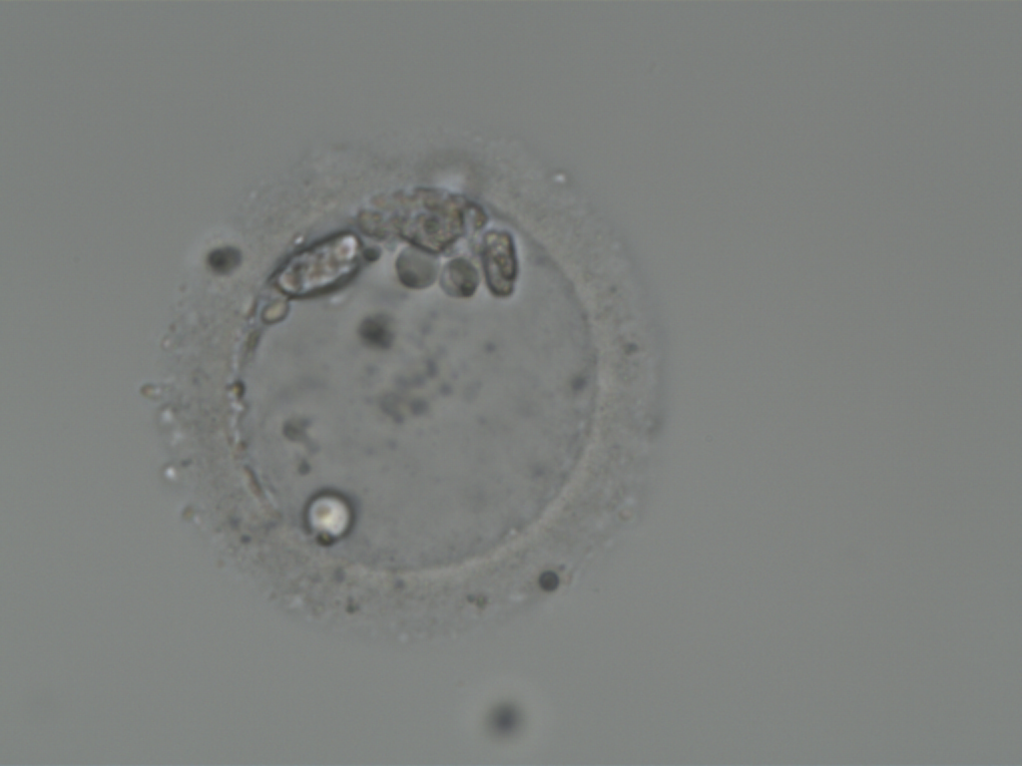
Embryo 4, EC, tubing

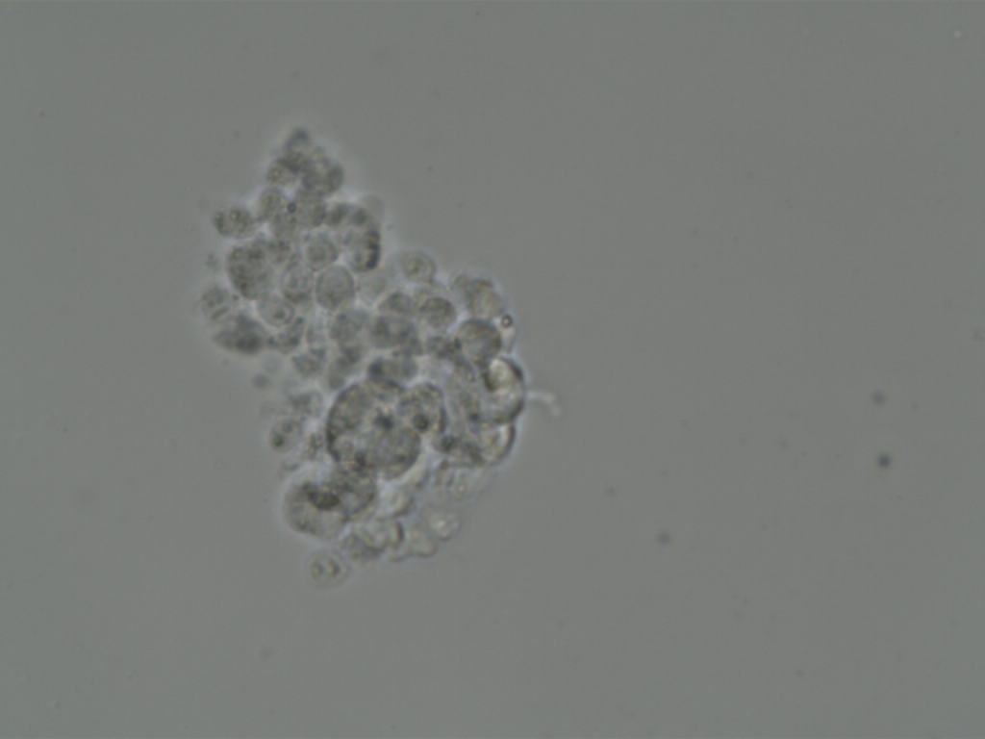
Embryo 5, TE, after dissection

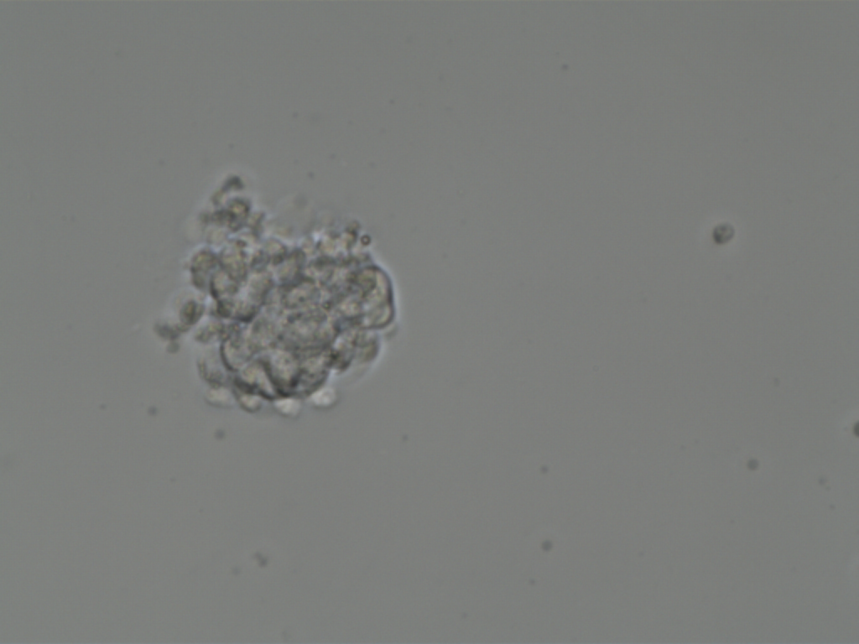
Embryo 5, TE, tubing

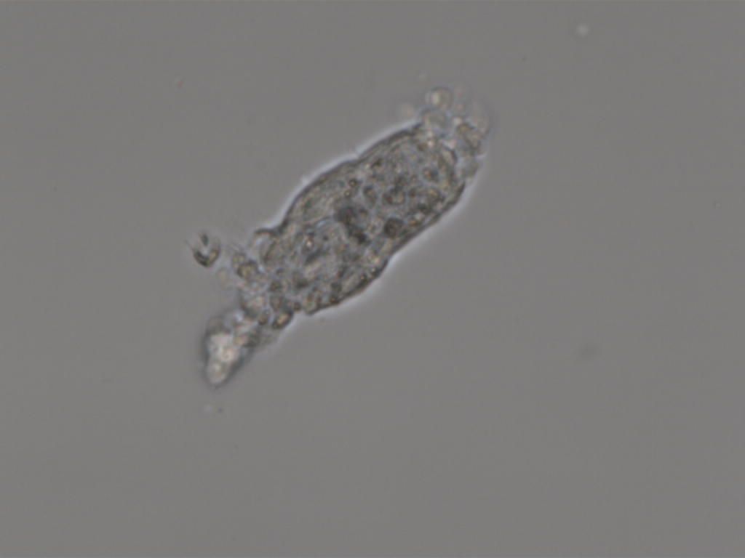
Embryo 5, ICM+, after dissection

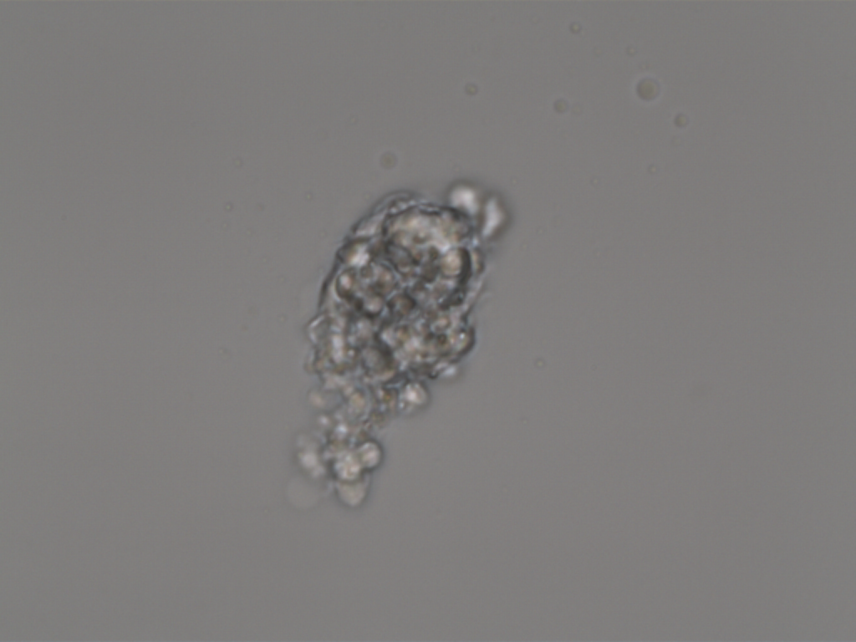
Embryo 5, ICM+, tubing

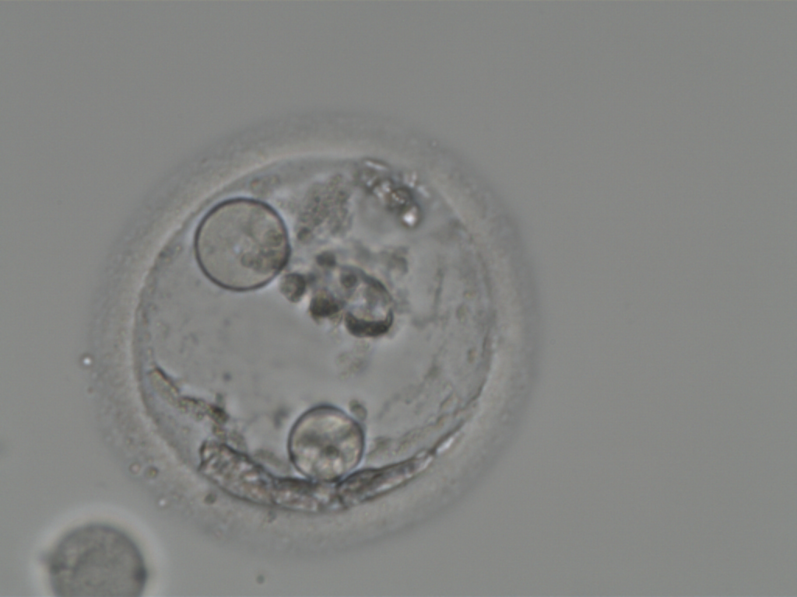
Embryo 5, EC, tubing

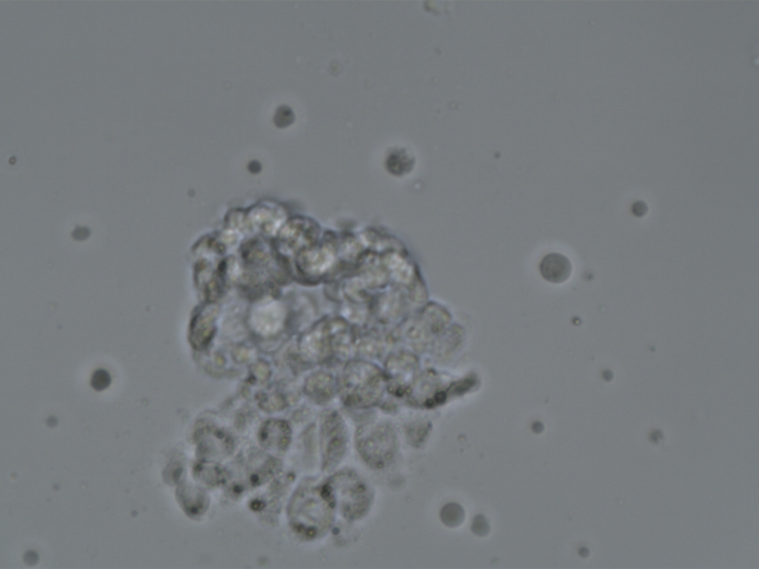
Embryo 6, TE, after dissection

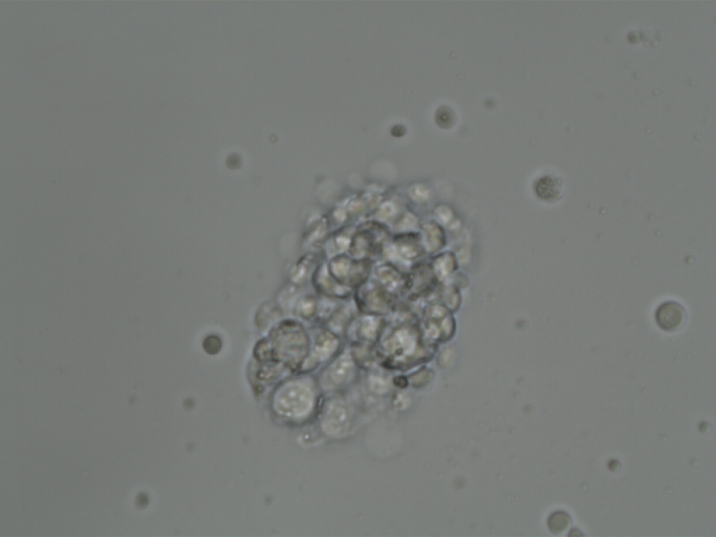
Embryo 6, TE, tubing

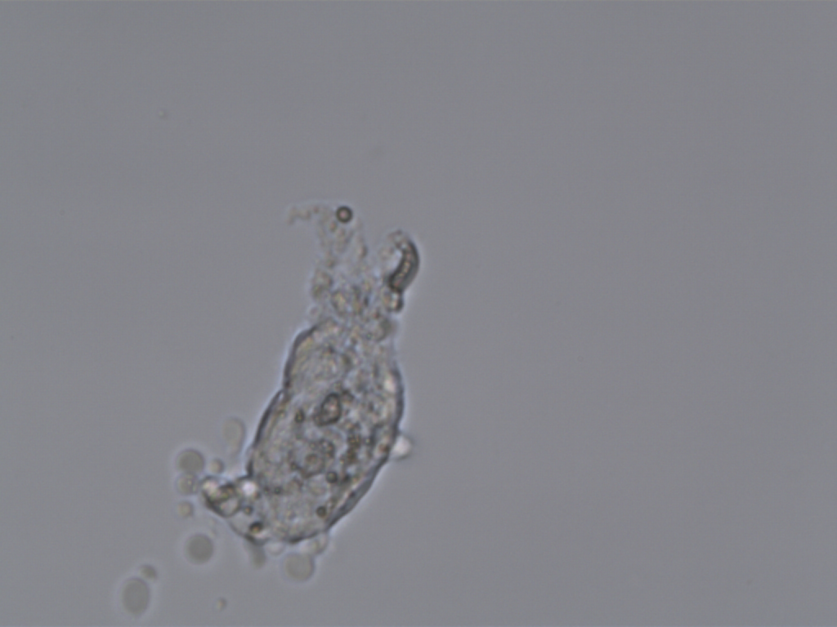
Embryo 6, ICM+, after dissection

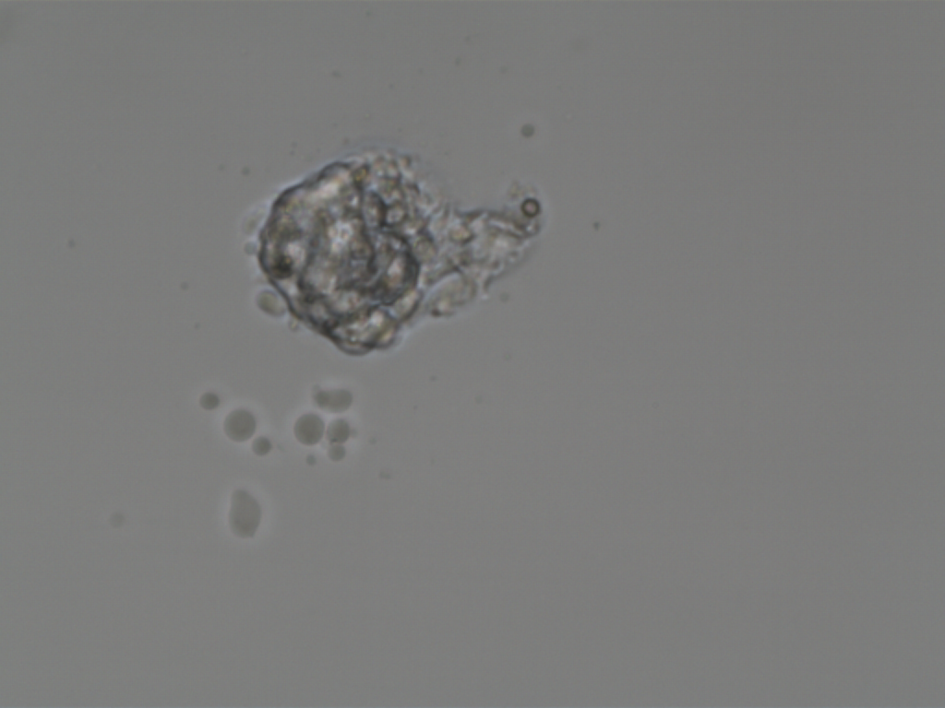
Embryo 6, ICM+, tubing

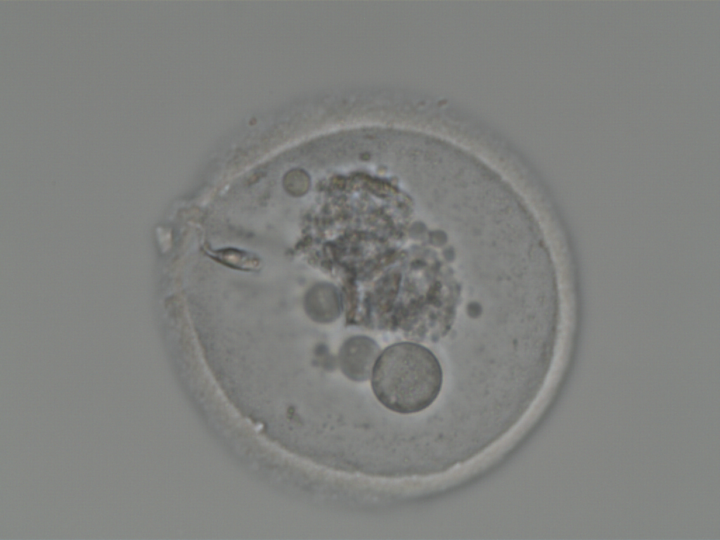
Embryo 6, EC, tubing

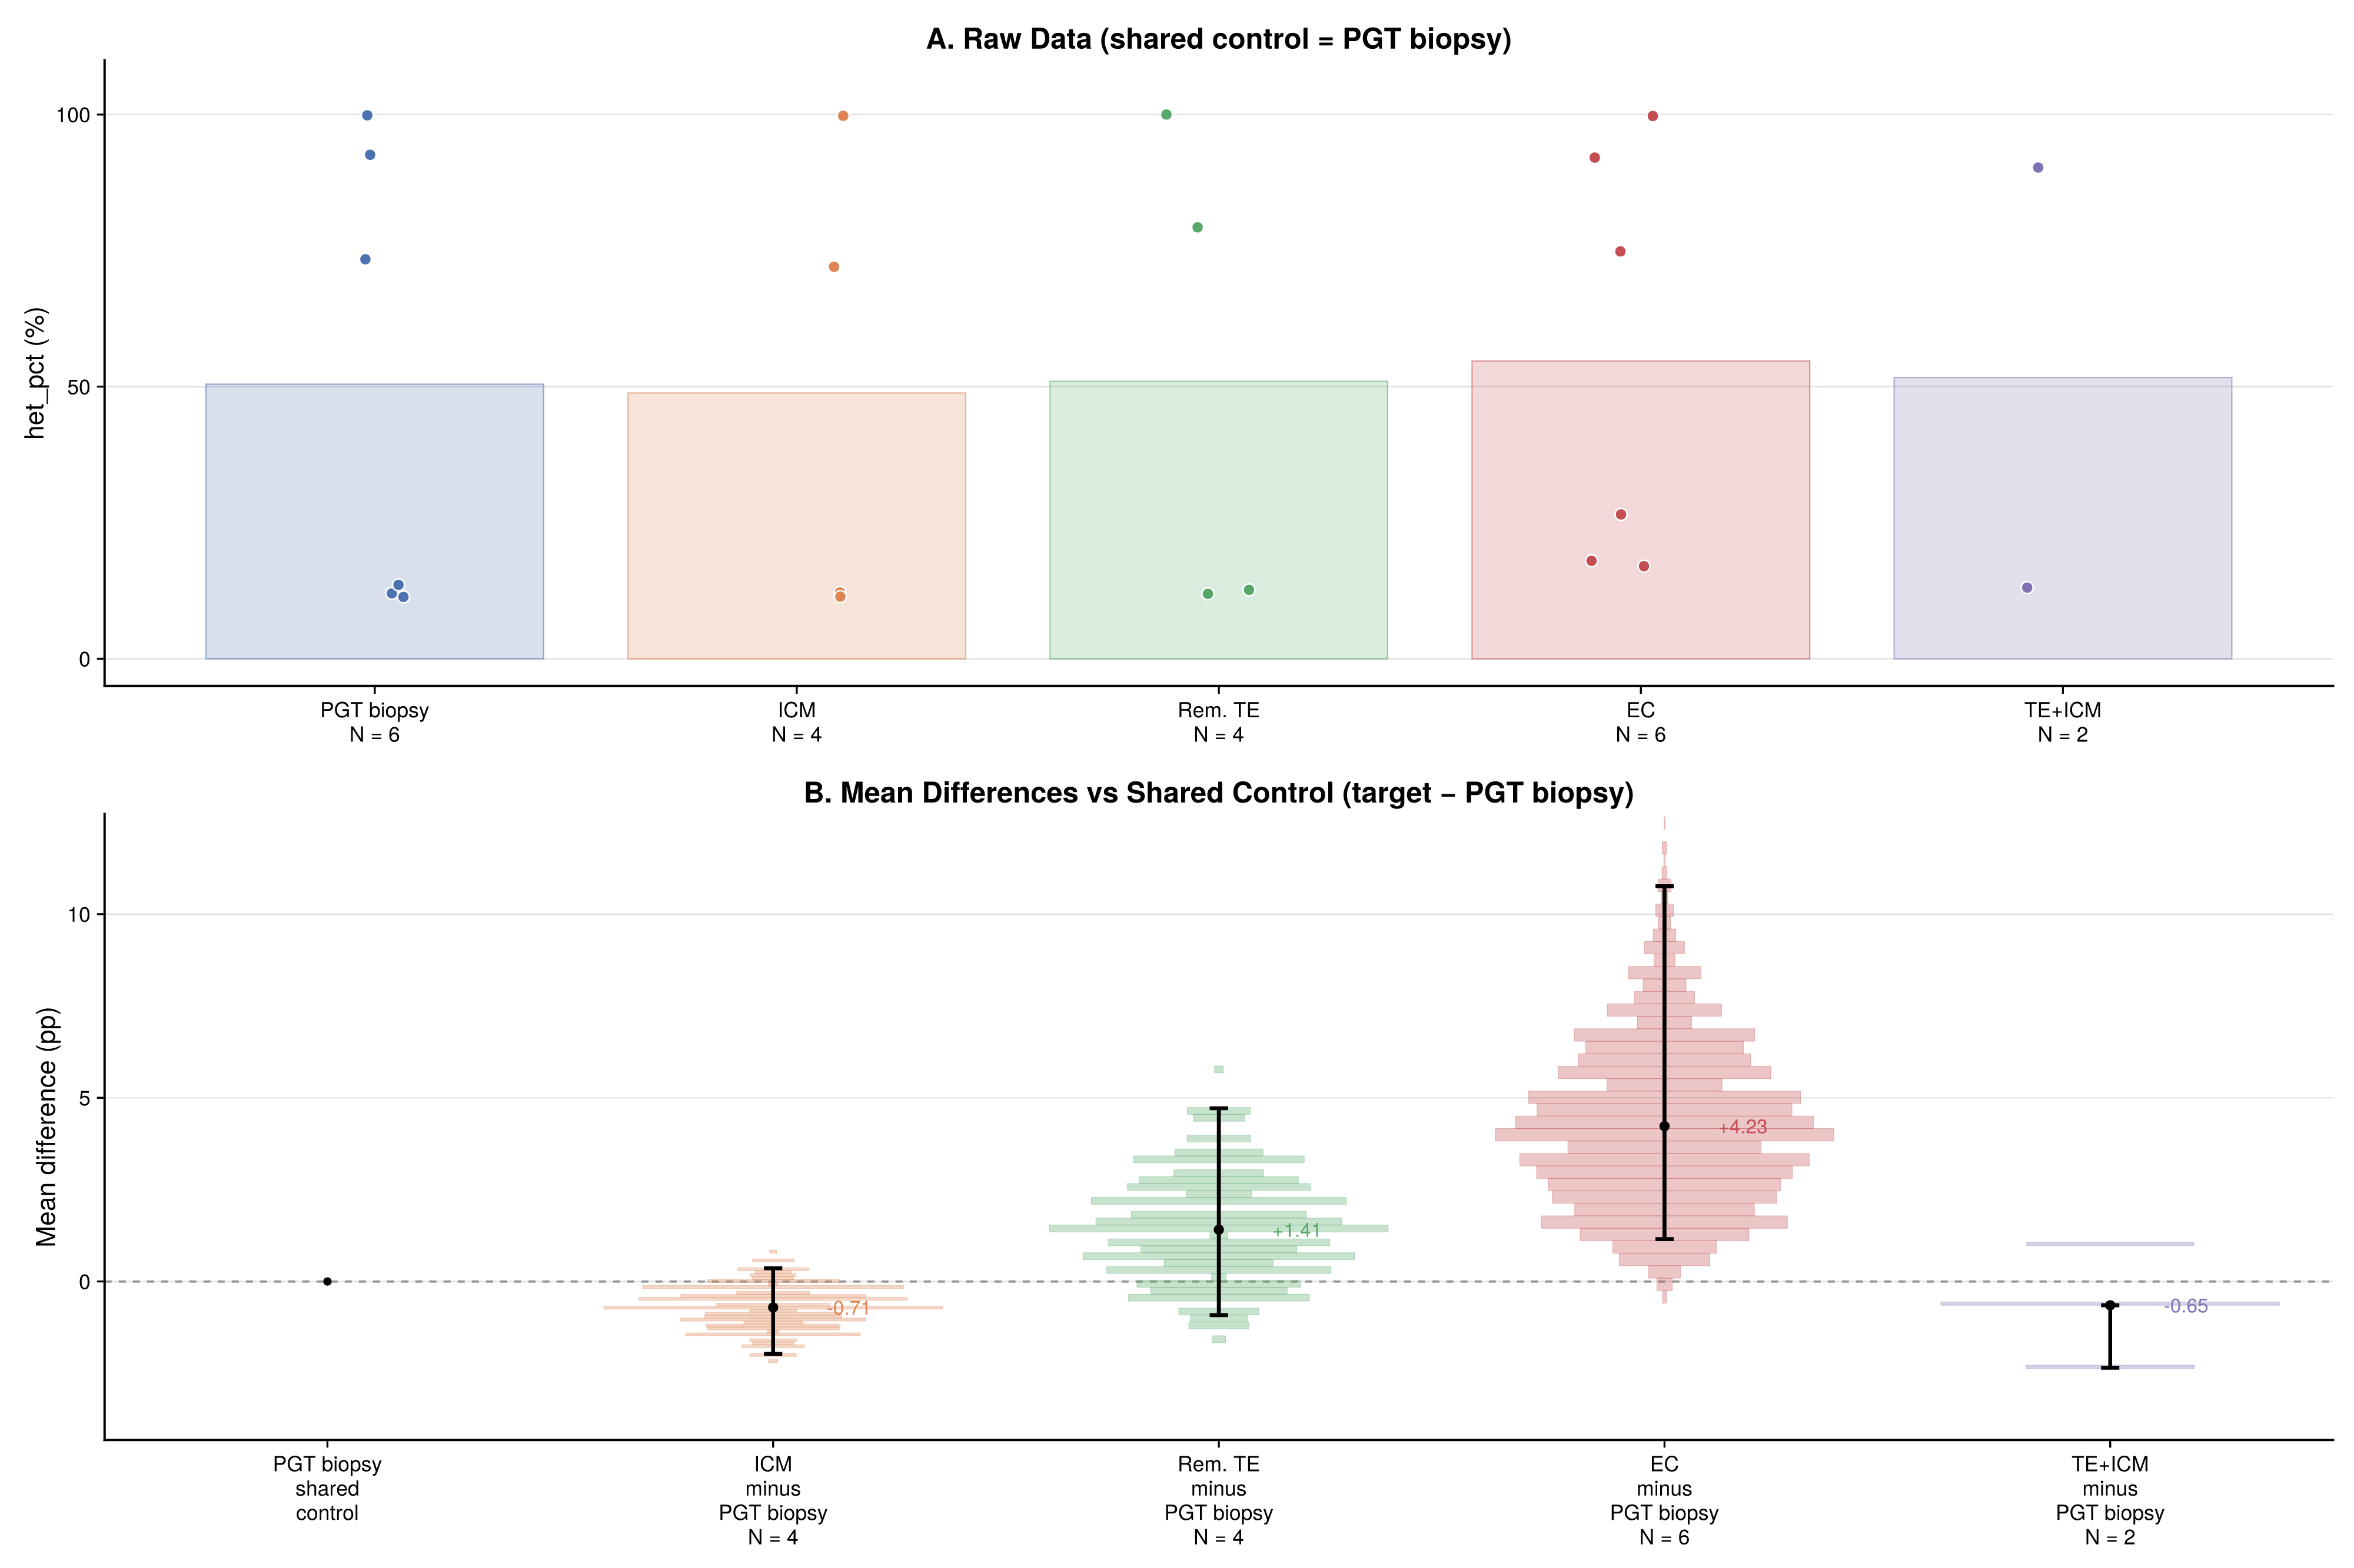
Supplementary Figure S3

Fig. S3. Shared-control DABEST-style estimation plot (control = PGT biopsy). Top panel: raw heteroplasmy values by fraction with group means (translucent bars) and jittered embryo-level points. Bottom panel: explicit shared-control reference column at 0, plus bootstrap distributions (10,000 resamples) of mean differences for each target fraction versus PGT biopsy (target − control), with BCa 95% confidence intervals and point estimates aligned under their top-panel groups.

Supplementary Figure S4
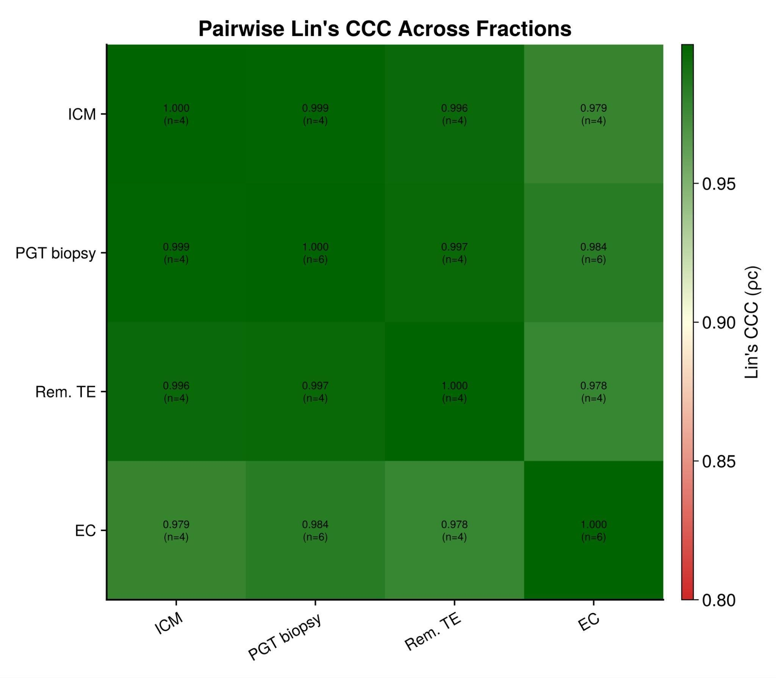

Fig. S4. Pairwise Lin’s CCC matrix across tissue fractions. Cells show Lin’s concordance correlation coefficient for each pair of fractions, computed on embryos where both fractions are available. Values near 1.0 (green) indicate excellent agreement; values below 0.9 (orange/red) indicate potential discordance. N indicates the number of embryos contributing to each comparison.

Supplementary Code

Complete system snapshot to replicate the statistical analysis (https://eugot.github.io/m14487/heteroplasmy_stability.html) in a reproducible environment:

```toml
# Manifest.toml
# This file is machine-generated - editing it directly is not advised

julia_version = "1.11.7"
manifest_format = "2.0"
project_hash = "6f81dd9b84074646dff0d96114ac43e35052eb9c"

[[deps.AbstractFFTs]]
deps = ["LinearAlgebra"]
git-tree-sha1 = "d92ad398961a3ed262d8bf04a1a2b8340f915fef"
uuid = "621f4979-c628-5d54-868e-fcf4e3e8185c"
version = "1.5.0"

[deps.AbstractFFTs.extensions]
AbstractFFTsChainRulesCoreExt = "ChainRulesCore"
AbstractFFTsTestExt = "Test"

[deps.AbstractFFTs.weakdeps]
ChainRulesCore = "d360d2e6-b24c-11e9-a2a3-2a2ae2dbcce4"
Test = "8dfed614-e22c-5e08-85e1-65c5234f0b40"

[[deps.AbstractTrees]]
git-tree-sha1 = "2d9c9a55f9c93e8887ad391fbae72f8ef55e1177"
uuid = "1520ce14-60c1-5f80-bbc7-55ef81b5835c"
version = "0.4.5"

[[deps.Accessors]]
deps = ["CompositionsBase", "ConstructionBase", "Dates", "InverseFunctions", "MacroTools"]
git-tree-sha1 = "856ecd7cebb68e5fc87abecd2326ad59f0f911f3"
uuid = "7d9f7c33-5ae7-4f3b-8dc6-eff91059b697"
version = "0.1.43"

[deps.Accessors.extensions]
AxisKeysExt = "AxisKeys"
IntervalSetsExt = "IntervalSets"
LinearAlgebraExt = "LinearAlgebra"
StaticArraysExt = "StaticArrays"
StructArraysExt = "StructArrays"
TestExt = "Test"
UnitfulExt = "Unitful"

[deps.Accessors.weakdeps]
AxisKeys = "94b1ba4f-4ee9-5380-92f1-94cde586c3c5"
IntervalSets = "8197267c-284f-5f27-9208-e0e47529a953"
LinearAlgebra = "37e2e46d-f89d-539d-b4ee-838fcccc9c8e"
StaticArrays = "90137ffa-7385-5640-81b9-e52037218182"
StructArrays = "09ab397b-f2b6-538f-b94a-2f83cf4a842a"
Test = "8dfed614-e22c-5e08-85e1-65c5234f0b40"
Unitful = "1986cc42-f94f-5a68-af5c-568840ba703d"

[[deps.Adapt]]
deps = ["LinearAlgebra", "Requires"]
git-tree-sha1 = "7e35fca2bdfba44d797c53dfe63a51fabf39bfc0"
uuid = "79e6a3ab-5dfb-504d-930d-738a2a938a0e"
version = "4.4.0"
weakdeps = ["SparseArrays", "StaticArrays"]

[deps.Adapt.extensions]
AdaptSparseArraysExt = "SparseArrays"
AdaptStaticArraysExt = "StaticArrays"

[[deps.AdaptivePredicates]]
git-tree-sha1 = "7e651ea8d262d2d74ce75fdf47c4d63c07dba7a6"
uuid = "35492f91-a3bd-45ad-95db-fcad7dcfedb7"
version = "1.2.0"

[[deps.AliasTables]]
deps = ["PtrArrays", "Random"]
git-tree-sha1 = "9876e1e164b144ca45e9e3198d0b689cadfed9ff"
uuid = "66dad0bd-aa9a-41b7-9441-69ab47430ed8"
version = "1.1.3"

[[deps.Animations]]
deps = ["Colors"]
git-tree-sha1 = "e092fa223bf66a3c41f9c022bd074d916dc303e7"
uuid = "27a7e980-b3e6-11e9-2bcd-0b925532e340"
version = "0.4.2"

[[deps.ArgTools]]
uuid = "0dad84c5-d112-42e6-8d28-ef12dabb789f"
version = "1.1.2"

[[deps.Artifacts]]
uuid = "56f22d72-fd6d-98f1-02f0-08ddc0907c33"
version = "1.11.0"

[[deps.Automa]]
deps = ["PrecompileTools", "SIMD", "TranscodingStreams"]
git-tree-sha1 = "a8f503e8e1a5f583fbef15a8440c8c7e32185df2"
uuid = "67c07d97-cdcb-5c2c-af73-a7f9c32a568b"
version = "1.1.0"

[[deps.AxisAlgorithms]]
deps = ["LinearAlgebra", "Random", "SparseArrays", "WoodburyMatrices"]
git-tree-sha1 = "01b8ccb13d68535d73d2b0c23e39bd23155fb712"
uuid = "13072b0f-2c55-5437-9ae7-d433b7a33950"
version = "1.1.0"

[[deps.AxisArrays]]
deps = ["Dates", "IntervalSets", "IterTools", "RangeArrays"]
git-tree-sha1 = "4126b08903b777c88edf1754288144a0492c05ad"
uuid = "39de3d68-74b9-583c-8d2d-e117c070f3a9"
version = "0.4.8"

[[deps.Base64]]
uuid = "2a0f44e3-6c83-55bd-87e4-b1978d98bd5f"
version = "1.11.0"

[[deps.BaseDirs]]
git-tree-sha1 = "bca794632b8a9bbe159d56bf9e31c422671b35e0"
uuid = "18cc8868-cbac-4acf-b575-c8ff214dc66f"
version = "1.3.2"

[[deps.Bootstrap]]
deps = ["DataFrames", "Distributions", "Random", "Statistics", "StatsBase", "StatsModels"]
git-tree-sha1 = "b605e84e7236671cae810accaf20b7678849ac6a"
uuid = "e28b5b4c-05e8-5b66-bc03-6f0c0a0a06e0"
version = "2.4.0"

[[deps.Bzip2_jll]]
deps = ["Artifacts", "JLLWrappers", "Libdl"]
git-tree-sha1 = "1b96ea4a01afe0ea4090c5c8039690672dd13f2e"
uuid = "6e34b625-4abd-537c-b88f-471c36dfa7a0"
version = "1.0.9+0"

[[deps.CEnum]]
git-tree-sha1 = "389ad5c84de1ae7cf0e28e381131c98ea87d54fc"
uuid = "fa961155-64e5-5f13-b03f-caf6b980ea82"
version = "0.5.0"

[[deps.CRC32c]]
uuid = "8bf52ea8-c179-5cab-976a-9e18b702a9bc"
version = "1.11.0"

[[deps.CRlibm]]
deps = ["CRlibm_jll"]
git-tree-sha1 = "66188d9d103b92b6cd705214242e27f5737a1e5e"
uuid = "96374032-68de-5a5b-8d9e-752f78720389"
version = "1.0.2"

[[deps.CRlibm_jll]]
deps = ["Artifacts", "JLLWrappers", "Libdl", "Pkg"]
git-tree-sha1 = "e329286945d0cfc04456972ea732551869af1cfc"
uuid = "4e9b3aee-d8a1-5a3d-ad8b-7d824db253f0"
version = "1.0.1+0"

[[deps.CSV]]
deps = ["CodecZlib", "Dates", "FilePathsBase", "InlineStrings", "Mmap", "Parsers", "PooledArrays", "PrecompileTools", "SentinelArrays", "Tables", "Unicode", "WeakRefStrings", "WorkerUtilities"]
git-tree-sha1 = "deddd8725e5e1cc49ee205a1964256043720a6c3"
uuid = "336ed68f-0bac-5ca0-87d4-7b16caf5d00b"
version = "0.10.15"

[[deps.Cairo]]
deps = ["Cairo_jll", "Colors", "Glib_jll", "Graphics", "Libdl", "Pango_jll"]
git-tree-sha1 = "71aa551c5c33f1a4415867fe06b7844faadb0ae9"
uuid = "159f3aea-2a34-519c-b102-8c37f9878175"
version = "1.1.1"

[[deps.CairoMakie]]
deps = ["CRC32c", "Cairo", "Cairo_jll", "Colors", "FileIO", "FreeType", "GeometryBasics", "LinearAlgebra", "Makie", "PrecompileTools"]
git-tree-sha1 = "5017d6849aff775febd36049f7d926a5fb6677ec"
uuid = "13f3f980-e62b-5c42-98c6-ff1f3baf88f0"
version = "0.15.8"

[[deps.Cairo_jll]]
deps = ["Artifacts", "Bzip2_jll", "CompilerSupportLibraries_jll", "Fontconfig_jll", "FreeType2_jll", "Glib_jll", "JLLWrappers", "LZO_jll", "Libdl", "Pixman_jll", "Xorg_libXext_jll", "Xorg_libXrender_jll", "Zlib_jll", "libpng_jll"]
git-tree-sha1 = "fde3bf89aead2e723284a8ff9cdf5b551ed700e8"
uuid = "83423d85-b0ee-5818-9007-b63ccbeb887a"
version = "1.18.5+0"

[[deps.ChainRulesCore]]
deps = ["Compat", "LinearAlgebra"]
git-tree-sha1 = "e4c6a16e77171a5f5e25e9646617ab1c276c5607"
uuid = "d360d2e6-b24c-11e9-a2a3-2a2ae2dbcce4"
version = "1.26.0"
weakdeps = ["SparseArrays"]

[deps.ChainRulesCore.extensions]
ChainRulesCoreSparseArraysExt = "SparseArrays"

[[deps.CodecZlib]]
deps = ["TranscodingStreams", "Zlib_jll"]
git-tree-sha1 = "962834c22b66e32aa10f7611c08c8ca4e20749a9"
uuid = "944b1d66-785c-5afd-91f1-9de20f533193"
version = "0.7.8"

[[deps.ColorBrewer]]
deps = ["Colors", "JSON"]
git-tree-sha1 = "07da79661b919001e6863b81fc572497daa58349"
uuid = "a2cac450-b92f-5266-8821-25eda20663c8"
version = "0.4.2"

[[deps.ColorSchemes]]
deps = ["ColorTypes", "ColorVectorSpace", "Colors", "FixedPointNumbers", "PrecompileTools", "Random"]
git-tree-sha1 = "b0fd3f56fa442f81e0a47815c92245acfaaa4e34"
uuid = "35d6a980-a343-548e-a6ea-1d62b119f2f4"
version = "3.31.0"

[[deps.ColorTypes]]
deps = ["FixedPointNumbers", "Random"]
git-tree-sha1 = "67e11ee83a43eb71ddc950302c53bf33f0690dfe"
uuid = "3da002f7-5984-5a60-b8a6-cbb66c0b333f"
version = "0.12.1"
weakdeps = ["StyledStrings"]

[deps.ColorTypes.extensions]
StyledStringsExt = "StyledStrings"

[[deps.ColorVectorSpace]]
deps = ["ColorTypes", "FixedPointNumbers", "LinearAlgebra", "Requires", "Statistics", "TensorCore"]
git-tree-sha1 = "8b3b6f87ce8f65a2b4f857528fd8d70086cd72b1"
uuid = "c3611d14-8923-5661-9e6a-0046d554d3a4"
version = "0.11.0"
weakdeps = ["SpecialFunctions"]

[deps.ColorVectorSpace.extensions]
SpecialFunctionsExt = "SpecialFunctions"

[[deps.Colors]]
deps = ["ColorTypes", "FixedPointNumbers", "Reexport"]
git-tree-sha1 = "37ea44092930b1811e666c3bc38065d7d87fcc74"
uuid = "5ae59095-9a9b-59fe-a467-6f913c188581"
version = "0.13.1"

[[deps.Combinatorics]]
git-tree-sha1 = "c761b00e7755700f9cdf5b02039939d1359330e1"
uuid = "861a8166-3701-5b0c-9a16-15d98fcdc6aa"
version = "1.1.0"

[[deps.CommonSolve]]
git-tree-sha1 = "78ea4ddbcf9c241827e7035c3a03e2e456711470"
uuid = "38540f10-b2f7-11e9-35d8-d573e4eb0ff2"
version = "0.2.6"

[[deps.Compat]]
deps = ["TOML", "UUIDs"]
git-tree-sha1 = "9d8a54ce4b17aa5bdce0ea5c34bc5e7c340d16ad"
uuid = "34da2185-b29b-5c13-b0c7-acf172513d20"
version = "4.18.1"
weakdeps = ["Dates", "LinearAlgebra"]

[deps.Compat.extensions]
CompatLinearAlgebraExt = "LinearAlgebra"

[[deps.CompilerSupportLibraries_jll]]
deps = ["Artifacts", "Libdl"]
uuid = "e66e0078-7015-5450-92f7-15fbd957f2ae"
version = "1.1.1+0"

[[deps.CompositionsBase]]
git-tree-sha1 = "802bb88cd69dfd1509f6670416bd4434015693ad"
uuid = "a33af91c-f02d-484b-be07-31d278c5ca2b"
version = "0.1.2"
weakdeps = ["InverseFunctions"]

[deps.CompositionsBase.extensions]
CompositionsBaseInverseFunctionsExt = "InverseFunctions"

[[deps.ComputePipeline]]
deps = ["Observables", "Preferences"]
git-tree-sha1 = "76dab592fa553e378f9dd8adea16fe2591aa3daa"
uuid = "95dc2771-c249-4cd0-9c9f-1f3b4330693c"
version = "0.1.6"

[[deps.ConstructionBase]]
git-tree-sha1 = "b4b092499347b18a015186eae3042f72267106cb"
uuid = "187b0558-2788-49d3-abe0-74a17ed4e7c9"
version = "1.6.0"
weakdeps = ["IntervalSets", "LinearAlgebra", "StaticArrays"]

[deps.ConstructionBase.extensions]
ConstructionBaseIntervalSetsExt = "IntervalSets"
ConstructionBaseLinearAlgebraExt = "LinearAlgebra"
ConstructionBaseStaticArraysExt = "StaticArrays"

[[deps.Contour]]
git-tree-sha1 = "439e35b0b36e2e5881738abc8857bd92ad6ff9a8"
uuid = "d38c429a-6771-53c6-b99e-75d170b6e991"
version = "0.6.3"

[[deps.Crayons]]
git-tree-sha1 = "249fe38abf76d48563e2f4556bebd215aa317e15"
uuid = "a8cc5b0e-0ffa-5ad4-8c14-923d3ee1735f"
version = "4.1.1"

[[deps.DataAPI]]
git-tree-sha1 = "abe83f3a2f1b857aac70ef8b269080af17764bbe"
uuid = "9a962f9c-6df0-11e9-0e5d-c546b8b5ee8a"
version = "1.16.0"

[[deps.DataFrames]]
deps = ["Compat", "DataAPI", "DataStructures", "Future", "InlineStrings", "InvertedIndices", "IteratorInterfaceExtensions", "LinearAlgebra", "Markdown", "Missings", "PooledArrays", "PrecompileTools", "PrettyTables", "Printf", "Random", "Reexport", "SentinelArrays", "SortingAlgorithms", "Statistics", "TableTraits", "Tables", "Unicode"]
git-tree-sha1 = "d8928e9169ff76c6281f39a659f9bca3a573f24c"
uuid = "a93c6f00-e57d-5684-b7b6-d8193f3e46c0"
version = "1.8.1"

[[deps.DataStructures]]
deps = ["OrderedCollections"]
git-tree-sha1 = "e357641bb3e0638d353c4b29ea0e40ea644066a6"
uuid = "864edb3b-99cc-5e75-8d2d-829cb0a9cfe8"
version = "0.19.3"

[[deps.DataValueInterfaces]]
git-tree-sha1 = "bfc1187b79289637fa0ef6d4436ebdfe6905cbd6"
uuid = "e2d170a0-9d28-54be-80f0-106bbe20a464"
version = "1.0.0"

[[deps.Dates]]
deps = ["Printf"]
uuid = "ade2ca70-3891-5945-98fb-dc099432e06a"
version = "1.11.0"

[[deps.DelaunayTriangulation]]
deps = ["AdaptivePredicates", "EnumX", "ExactPredicates", "Random"]
git-tree-sha1 = "c55f5a9fd67bdbc8e089b5a3111fe4292986a8e8"
uuid = "927a84f5-c5f4-47a5-9785-b46e178433df"
version = "1.6.6"

[[deps.Distributed]]
deps = ["Random", "Serialization", "Sockets"]
uuid = "8ba89e20-285c-5b6f-9357-94700520ee1b"
version = "1.11.0"

[[deps.Distributions]]
deps = ["AliasTables", "FillArrays", "LinearAlgebra", "PDMats", "Printf", "QuadGK", "Random", "SpecialFunctions", "Statistics", "StatsAPI", "StatsBase", "StatsFuns"]
git-tree-sha1 = "fbcc7610f6d8348428f722ecbe0e6cfe22e672c6"
uuid = "31c24e10-a181-5473-b8eb-7969acd0382f"
version = "0.25.123"

[deps.Distributions.extensions]
DistributionsChainRulesCoreExt = "ChainRulesCore"
DistributionsDensityInterfaceExt = "DensityInterface"
DistributionsTestExt = "Test"

[deps.Distributions.weakdeps]
ChainRulesCore = "d360d2e6-b24c-11e9-a2a3-2a2ae2dbcce4"
DensityInterface = "b429d917-457f-4dbc-8f4c-0cc954292b1d"
Test = "8dfed614-e22c-5e08-85e1-65c5234f0b40"

[[deps.DocStringExtensions]]
git-tree-sha1 = "7442a5dfe1ebb773c29cc2962a8980f47221d76c"
uuid = "ffbed154-4ef7-542d-bbb7-c09d3a79fcae"
version = "0.9.5"

[[deps.Downloads]]
deps = ["ArgTools", "FileWatching", "LibCURL", "NetworkOptions"]
uuid = "f43a241f-c20a-4ad4-852c-f6b1247861c6"
version = "1.6.0"

[[deps.EarCut_jll]]
deps = ["Artifacts", "JLLWrappers", "Libdl", "Pkg"]
git-tree-sha1 = "e3290f2d49e661fbd94046d7e3726ffcb2d41053"
uuid = "5ae413db-bbd1-5e63-b57d-d24a61df00f5"
version = "2.2.4+0"

[[deps.EnumX]]
git-tree-sha1 = "7bebc8aad6ee6217c78c5ddcf7ed289d65d0263e"
uuid = "4e289a0a-7415-4d19-859d-a7e5c4648b56"
version = "1.0.6"

[[deps.ExactPredicates]]
deps = ["IntervalArithmetic", "Random", "StaticArrays"]
git-tree-sha1 = "83231673ea4d3d6008ac74dc5079e77ab2209d8f"
uuid = "429591f6-91af-11e9-00e2-59fbe8cec110"
version = "2.2.9"

[[deps.Expat_jll]]
deps = ["Artifacts", "JLLWrappers", "Libdl"]
git-tree-sha1 = "27af30de8b5445644e8ffe3bcb0d72049c089cf1"
uuid = "2e619515-83b5-522b-bb60-26c02a35a201"
version = "2.7.3+0"

[[deps.Extents]]
git-tree-sha1 = "b309b36a9e02fe7be71270dd8c0fd873625332b4"
uuid = "411431e0-e8b7-467b-b5e0-f676ba4f2910"
version = "0.1.6"

[[deps.FFMPEG_jll]]
deps = ["Artifacts", "Bzip2_jll", "FreeType2_jll", "FriBidi_jll", "JLLWrappers", "LAME_jll", "Libdl", "Ogg_jll", "OpenSSL_jll", "Opus_jll", "PCRE2_jll", "Zlib_jll", "libaom_jll", "libass_jll", "libfdk_aac_jll", "libvorbis_jll", "x264_jll", "x265_jll"]
git-tree-sha1 = "01ba9d15e9eae375dc1eb9589df76b3572acd3f2"
uuid = "b22a6f82-2f65-5046-a5b2-351ab43fb4e5"
version = "8.0.1+0"

[[deps.FFTA]]
deps = ["AbstractFFTs", "DocStringExtensions", "LinearAlgebra", "MuladdMacro", "Primes", "Random", "Reexport"]
git-tree-sha1 = "65e55303b72f4a567a51b174dd2c47496efeb95a"
uuid = "b86e33f2-c0db-4aa1-a6e0-ab43e668529e"
version = "0.3.1"

[[deps.FileIO]]
deps = ["Pkg", "Requires", "UUIDs"]
git-tree-sha1 = "6522cfb3b8fe97bec632252263057996cbd3de20"
uuid = "5789e2e9-d7fb-5bc7-8068-2c6fae9b9549"
version = "1.18.0"

[deps.FileIO.extensions]
HTTPExt = "HTTP"

[deps.FileIO.weakdeps]
HTTP = "cd3eb016-35fb-5094-929b-558a96fad6f3"

[[deps.FilePaths]]
deps = ["FilePathsBase", "MacroTools", "Reexport"]
git-tree-sha1 = "a1b2fbfe98503f15b665ed45b3d149e5d8895e4c"
uuid = "8fc22ac5-c921-52a6-82fd-178b2807b824"
version = "0.9.0"

[deps.FilePaths.extensions]
FilePathsGlobExt = "Glob"
FilePathsURIParserExt = "URIParser"
FilePathsURIsExt = "URIs"

[deps.FilePaths.weakdeps]
Glob = "c27321d9-0574-5035-807b-f59d2c89b15c"
URIParser = "30578b45-9adc-5946-b283-645ec420af67"
URIs = "5c2747f8-b7ea-4ff2-ba2e-563bfd36b1d4"

[[deps.FilePathsBase]]
deps = ["Compat", "Dates"]
git-tree-sha1 = "3bab2c5aa25e7840a4b065805c0cdfc01f3068d2"
uuid = "48062228-2e41-5def-b9a4-89aafe57970f"
version = "0.9.24"

[deps.FilePathsBase.extensions]
FilePathsBaseMmapExt = "Mmap"
FilePathsBaseTestExt = "Test"

[deps.FilePathsBase.weakdeps]
Mmap = "a63ad114-7e13-5084-954f-fe012c677804"
Test = "8dfed614-e22c-5e08-85e1-65c5234f0b40"

[[deps.FileWatching]]
uuid = "7b1f6079-737a-58dc-b8bc-7a2ca5c1b5ee"
version = "1.11.0"

[[deps.FillArrays]]
deps = ["LinearAlgebra"]
git-tree-sha1 = "2f979084d1e13948a3352cf64a25df6bd3b4dca3"
uuid = "1a297f60-69ca-5386-bcde-b61e274b549b"
version = "1.16.0"
weakdeps = ["PDMats", "SparseArrays", "StaticArrays", "Statistics"]

[deps.FillArrays.extensions]
FillArraysPDMatsExt = "PDMats"
FillArraysSparseArraysExt = "SparseArrays"
FillArraysStaticArraysExt = "StaticArrays"
FillArraysStatisticsExt = "Statistics"

[[deps.FixedPointNumbers]]
deps = ["Statistics"]
git-tree-sha1 = "05882d6995ae5c12bb5f36dd2ed3f61c98cbb172"
uuid = "53c48c17-4a7d-5ca2-90c5-79b7896eea93"
version = "0.8.5"

[[deps.Fontconfig_jll]]
deps = ["Artifacts", "Bzip2_jll", "Expat_jll", "FreeType2_jll", "JLLWrappers", "Libdl", "Libuuid_jll", "Zlib_jll"]
git-tree-sha1 = "f85dac9a96a01087df6e3a749840015a0ca3817d"
uuid = "a3f928ae-7b40-5064-980b-68af3947d34b"
version = "2.17.1+0"

[[deps.Format]]
git-tree-sha1 = "9c68794ef81b08086aeb32eeaf33531668d5f5fc"
uuid = "1fa38f19-a742-5d3f-a2b9-30dd87b9d5f8"
version = "1.3.7"

[[deps.FreeType]]
deps = ["CEnum", "FreeType2_jll"]
git-tree-sha1 = "907369da0f8e80728ab49c1c7e09327bf0d6d999"
uuid = "b38be410-82b0-50bf-ab77-7b57e271db43"
version = "4.1.1"

[[deps.FreeType2_jll]]
deps = ["Artifacts", "Bzip2_jll", "JLLWrappers", "Libdl", "Zlib_jll"]
git-tree-sha1 = "2c5512e11c791d1baed2049c5652441b28fc6a31"
uuid = "d7e528f0-a631-5988-bf34-fe36492bcfd7"
version = "2.13.4+0"

[[deps.FreeTypeAbstraction]]
deps = ["BaseDirs", "ColorVectorSpace", "Colors", "FreeType", "GeometryBasics", "Mmap"]
git-tree-sha1 = "4ebb930ef4a43817991ba35db6317a05e59abd11"
uuid = "663a7486-cb36-511b-a19d-713bb74d65c9"
version = "0.10.8"

[[deps.FriBidi_jll]]
deps = ["Artifacts", "JLLWrappers", "Libdl"]
git-tree-sha1 = "7a214fdac5ed5f59a22c2d9a885a16da1c74bbc7"
uuid = "559328eb-81f9-559d-9380-de523a88c83c"
version = "1.0.17+0"

[[deps.Future]]
deps = ["Random"]
uuid = "9fa8497b-333b-5362-9e8d-4d0656e87820"
version = "1.11.0"

[[deps.GeometryBasics]]
deps = ["EarCut_jll", "Extents", "IterTools", "LinearAlgebra", "PrecompileTools", "Random", "StaticArrays"]
git-tree-sha1 = "1f5a80f4ed9f5a4aada88fc2db456e637676414b"
uuid = "5c1252a2-5f33-56bf-86c9-59e7332b4326"
version = "0.5.10"

[deps.GeometryBasics.extensions]
GeometryBasicsGeoInterfaceExt = "GeoInterface"

[deps.GeometryBasics.weakdeps]
GeoInterface = "cf35fbd7-0cd7-5166-be24-54bfbe79505f"

[[deps.GettextRuntime_jll]]
deps = ["Artifacts", "CompilerSupportLibraries_jll", "JLLWrappers", "Libdl", "Libiconv_jll"]
git-tree-sha1 = "45288942190db7c5f760f59c04495064eedf9340"
uuid = "b0724c58-0f36-5564-988d-3bb0596ebc4a"
version = "0.22.4+0"

[[deps.Giflib_jll]]
deps = ["Artifacts", "JLLWrappers", "Libdl"]
git-tree-sha1 = "6570366d757b50fabae9f4315ad74d2e40c0560a"
uuid = "59f7168a-df46-5410-90c8-f2779963d0ec"
version = "5.2.3+0"

[[deps.Glib_jll]]
deps = ["Artifacts", "GettextRuntime_jll", "JLLWrappers", "Libdl", "Libffi_jll", "Libiconv_jll", "Libmount_jll", "PCRE2_jll", "Zlib_jll"]
git-tree-sha1 = "24f6def62397474a297bfcec22384101609142ed"
uuid = "7746bdde-850d-59dc-9ae8-88ece973131d"
version = "2.86.3+0"

[[deps.Graphics]]
deps = ["Colors", "LinearAlgebra", "NaNMath"]
git-tree-sha1 = "a641238db938fff9b2f60d08ed9030387daf428c"
uuid = "a2bd30eb-e257-5431-a919-1863eab51364"
version = "1.1.3"

[[deps.Graphite2_jll]]
deps = ["Artifacts", "JLLWrappers", "Libdl"]
git-tree-sha1 = "8a6dbda1fd736d60cc477d99f2e7a042acfa46e8"
uuid = "3b182d85-2403-5c21-9c21-1e1f0cc25472"
version = "1.3.15+0"

[[deps.GridLayoutBase]]
deps = ["GeometryBasics", "InteractiveUtils", "Observables"]
git-tree-sha1 = "93d5c27c8de51687a2c70ec0716e6e76f298416f"
uuid = "3955a311-db13-416c-9275-1d80ed98e5e9"
version = "0.11.2"

[[deps.Grisu]]
git-tree-sha1 = "53bb909d1151e57e2484c3d1b53e19552b887fb2"
uuid = "42e2da0e-8278-4e71-bc24-59509adca0fe"
version = "1.0.2"

[[deps.HarfBuzz_jll]]
deps = ["Artifacts", "Cairo_jll", "Fontconfig_jll", "FreeType2_jll", "Glib_jll", "Graphite2_jll", "JLLWrappers", "Libdl", "Libffi_jll"]
git-tree-sha1 = "f923f9a774fcf3f5cb761bfa43aeadd689714813"
uuid = "2e76f6c2-a576-52d4-95c1-20adfe4de566"
version = "8.5.1+0"

[[deps.HypergeometricFunctions]]
deps = ["LinearAlgebra", "OpenLibm_jll", "SpecialFunctions"]
git-tree-sha1 = "68c173f4f449de5b438ee67ed0c9c748dc31a2ec"
uuid = "34004b35-14d8-5ef3-9330-4cdb6864b03a"
version = "0.3.28"

[[deps.HypothesisTests]]
deps = ["Combinatorics", "Distributions", "LinearAlgebra", "Printf", "Random", "Roots", "Statistics", "StatsAPI", "StatsBase", "StatsFuns"]
git-tree-sha1 = "b67985bd11331ccef26109a6269dbaae01474a72"
uuid = "09f84164-cd44-5f33-b23f-e6b0d136a0d5"
version = "0.11.6"

[[deps.ImageAxes]]
deps = ["AxisArrays", "ImageBase", "ImageCore", "Reexport", "SimpleTraits"]
git-tree-sha1 = "e12629406c6c4442539436581041d372d69c55ba"
uuid = "2803e5a7-5153-5ecf-9a86-9b4c37f5f5ac"
version = "0.6.12"

[[deps.ImageBase]]
deps = ["ImageCore", "Reexport"]
git-tree-sha1 = "eb49b82c172811fd2c86759fa0553a2221feb909"
uuid = "c817782e-172a-44cc-b673-b171935fbb9e"
version = "0.1.7"

[[deps.ImageCore]]
deps = ["ColorVectorSpace", "Colors", "FixedPointNumbers", "MappedArrays", "MosaicViews", "OffsetArrays", "PaddedViews", "PrecompileTools", "Reexport"]
git-tree-sha1 = "8c193230235bbcee22c8066b0374f63b5683c2d3"
uuid = "a09fc81d-aa75-5fe9-8630-4744c3626534"
version = "0.10.5"

[[deps.ImageIO]]
deps = ["FileIO", "IndirectArrays", "JpegTurbo", "LazyModules", "Netpbm", "OpenEXR", "PNGFiles", "QOI", "Sixel", "TiffImages", "UUIDs", "WebP"]
git-tree-sha1 = "696144904b76e1ca433b886b4e7edd067d76cbf7"
uuid = "82e4d734-157c-48bb-816b-45c225c6df19"
version = "0.6.9"

[[deps.ImageMetadata]]
deps = ["AxisArrays", "ImageAxes", "ImageBase", "ImageCore"]
git-tree-sha1 = "2a81c3897be6fbcde0802a0ebe6796d0562f63ec"
uuid = "bc367c6b-8a6b-528e-b4bd-a4b897500b49"
version = "0.9.10"

[[deps.Imath_jll]]
deps = ["Artifacts", "JLLWrappers", "Libdl"]
git-tree-sha1 = "dcc8d0cd653e55213df9b75ebc6fe4a8d3254c65"
uuid = "905a6f67-0a94-5f89-b386-d35d92009cd1"
version = "3.2.2+0"

[[deps.IndirectArrays]]
git-tree-sha1 = "012e604e1c7458645cb8b436f8fba789a51b257f"
uuid = "9b13fd28-a010-5f03-acff-a1bbcff69959"
version = "1.0.0"

[[deps.Inflate]]
git-tree-sha1 = "d1b1b796e47d94588b3757fe84fbf65a5ec4a80d"
uuid = "d25df0c9-e2be-5dd7-82c8-3ad0b3e990b9"
version = "0.1.5"

[[deps.InlineStrings]]
git-tree-sha1 = "8f3d257792a522b4601c24a577954b0a8cd7334d"
uuid = "842dd82b-1e85-43dc-bf29-5d0ee9dffc48"
version = "1.4.5"

[deps.InlineStrings.extensions]
ArrowTypesExt = "ArrowTypes"
ParsersExt = "Parsers"

[deps.InlineStrings.weakdeps]
ArrowTypes = "31f734f8-188a-4ce0-8406-c8a06bd891cd"
Parsers = "69de0a69-1ddd-5017-9359-2bf0b02dc9f0"

[[deps.IntegerMathUtils]]
git-tree-sha1 = "4c1acff2dc6b6967e7e750633c50bc3b8d83e617"
uuid = "18e54dd8-cb9d-406c-a71d-865a43cbb235"
version = "0.1.3"

[[deps.InteractiveUtils]]
deps = ["Markdown"]
uuid = "b77e0a4c-d291-57a0-90e8-8db25a27a240"
version = "1.11.0"

[[deps.Interpolations]]
deps = ["Adapt", "AxisAlgorithms", "ChainRulesCore", "LinearAlgebra", "OffsetArrays", "Random", "Ratios", "SharedArrays", "SparseArrays", "StaticArrays", "WoodburyMatrices"]
git-tree-sha1 = "65d505fa4c0d7072990d659ef3fc086eb6da8208"
uuid = "a98d9a8b-a2ab-59e6-89dd-64a1c18fca59"
version = "0.16.2"

[deps.Interpolations.extensions]
InterpolationsForwardDiffExt = "ForwardDiff"
InterpolationsUnitfulExt = "Unitful"

[deps.Interpolations.weakdeps]
ForwardDiff = "f6369f11-7733-5829-9624-2563aa707210"
Unitful = "1986cc42-f94f-5a68-af5c-568840ba703d"

[[deps.IntervalArithmetic]]
deps = ["CRlibm", "MacroTools", "OpenBLASConsistentFPCSR_jll", "Printf", "Random", "RoundingEmulator"]
git-tree-sha1 = "02b61501dbe6da3b927cc25dacd7ce32390ee970"
uuid = "d1acc4aa-44c8-5952-acd4-ba5d80a2a253"
version = "1.0.2"

[deps.IntervalArithmetic.extensions]
IntervalArithmeticArblibExt = "Arblib"
IntervalArithmeticDiffRulesExt = "DiffRules"
IntervalArithmeticForwardDiffExt = "ForwardDiff"
IntervalArithmeticIntervalSetsExt = "IntervalSets"
IntervalArithmeticLinearAlgebraExt = "LinearAlgebra"
IntervalArithmeticRecipesBaseExt = "RecipesBase"
IntervalArithmeticSparseArraysExt = "SparseArrays"

[deps.IntervalArithmetic.weakdeps]
Arblib = "fb37089c-8514-4489-9461-98f9c8763369"
DiffRules = "b552c78f-8df3-52c6-915a-8e097449b14b"
ForwardDiff = "f6369f11-7733-5829-9624-2563aa707210"
IntervalSets = "8197267c-284f-5f27-9208-e0e47529a953"
LinearAlgebra = "37e2e46d-f89d-539d-b4ee-838fcccc9c8e"
RecipesBase = "3cdcf5f2-1ef4-517c-9805-6587b60abb01"
SparseArrays = "2f01184e-e22b-5df5-ae63-d93ebab69eaf"

[[deps.IntervalSets]]
git-tree-sha1 = "d966f85b3b7a8e49d034d27a189e9a4874b4391a"
uuid = "8197267c-284f-5f27-9208-e0e47529a953"
version = "0.7.13"

[deps.IntervalSets.extensions]
IntervalSetsRandomExt = "Random"
IntervalSetsRecipesBaseExt = "RecipesBase"
IntervalSetsStatisticsExt = "Statistics"

[deps.IntervalSets.weakdeps]
Random = "9a3f8284-a2c9-5f02-9a11-845980a1fd5c"
RecipesBase = "3cdcf5f2-1ef4-517c-9805-6587b60abb01"
Statistics = "10745b16-79ce-11e8-11f9-7d13ad32a3b2"

[[deps.InverseFunctions]]
git-tree-sha1 = "a779299d77cd080bf77b97535acecd73e1c5e5cb"
uuid = "3587e190-3f89-42d0-90ee-14403ec27112"
version = "0.1.17"

[deps.InverseFunctions.extensions]
InverseFunctionsDatesExt = "Dates"
InverseFunctionsTestExt = "Test"

[deps.InverseFunctions.weakdeps]
Dates = "ade2ca70-3891-5945-98fb-dc099432e06a"
Test = "8dfed614-e22c-5e08-85e1-65c5234f0b40"

[[deps.InvertedIndices]]
git-tree-sha1 = "6da3c4316095de0f5ee2ebd875df8721e7e0bdbe"
uuid = "41ab1584-1d38-5bbf-9106-f11c6c58b48f"
version = "1.3.1"

[[deps.IrrationalConstants]]
git-tree-sha1 = "b2d91fe939cae05960e760110b328288867b5758"
uuid = "92d709cd-6900-40b7-9082-c6be49f344b6"
version = "0.2.6"

[[deps.Isoband]]
deps = ["isoband_jll"]
git-tree-sha1 = "f9b6d97355599074dc867318950adaa6f9946137"
uuid = "f1662d9f-8043-43de-a69a-05efc1cc6ff4"
version = "0.1.1"

[[deps.IterTools]]
git-tree-sha1 = "42d5f897009e7ff2cf88db414a389e5ed1bdd023"
uuid = "c8e1da08-722c-5040-9ed9-7db0dc04731e"
version = "1.10.0"

[[deps.IteratorInterfaceExtensions]]
git-tree-sha1 = "a3f24677c21f5bbe9d2a714f95dcd58337fb2856"
uuid = "82899510-4779-5014-852e-03e436cf321d"
version = "1.0.0"

[[deps.JLLWrappers]]
deps = ["Artifacts", "Preferences"]
git-tree-sha1 = "0533e564aae234aff59ab625543145446d8b6ec2"
uuid = "692b3bcd-3c85-4b1f-b108-f13ce0eb3210"
version = "1.7.1"

[[deps.JSON]]
deps = ["Dates", "Logging", "Parsers", "PrecompileTools", "StructUtils", "UUIDs", "Unicode"]
git-tree-sha1 = "b3ad4a0255688dcb895a52fafbaae3023b588a90"
uuid = "682c06a0-de6a-54ab-a142-c8b1cf79cde6"
version = "1.4.0"

[deps.JSON.extensions]
JSONArrowExt = ["ArrowTypes"]

[deps.JSON.weakdeps]
ArrowTypes = "31f734f8-188a-4ce0-8406-c8a06bd891cd"

[[deps.JpegTurbo]]
deps = ["CEnum", "FileIO", "ImageCore", "JpegTurbo_jll", "TOML"]
git-tree-sha1 = "9496de8fb52c224a2e3f9ff403947674517317d9"
uuid = "b835a17e-a41a-41e7-81f0-2f016b05efe0"
version = "0.1.6"

[[deps.JpegTurbo_jll]]
deps = ["Artifacts", "JLLWrappers", "Libdl"]
git-tree-sha1 = "b6893345fd6658c8e475d40155789f4860ac3b21"
uuid = "aacddb02-875f-59d6-b918-886e6ef4fbf8"
version = "3.1.4+0"

[[deps.KernelDensity]]
deps = ["Distributions", "DocStringExtensions", "FFTA", "Interpolations", "StatsBase"]
git-tree-sha1 = "4260cfc991b8885bf747801fb60dd4503250e478"
uuid = "5ab0869b-81aa-558d-bb23-cbf5423bbe9b"
version = "0.6.11"

[[deps.LAME_jll]]
deps = ["Artifacts", "JLLWrappers", "Libdl"]
git-tree-sha1 = "059aabebaa7c82ccb853dd4a0ee9d17796f7e1bc"
uuid = "c1c5ebd0-6772-5130-a774-d5fcae4a789d"
version = "3.100.3+0"

[[deps.LERC_jll]]
deps = ["Artifacts", "JLLWrappers", "Libdl"]
git-tree-sha1 = "aaafe88dccbd957a8d82f7d05be9b69172e0cee3"
uuid = "88015f11-f218-50d7-93a8-a6af411a945d"
version = "4.0.1+0"

[[deps.LLVMOpenMP_jll]]
deps = ["Artifacts", "JLLWrappers", "Libdl"]
git-tree-sha1 = "eb62a3deb62fc6d8822c0c4bef73e4412419c5d8"
uuid = "1d63c593-3942-5779-bab2-d838dc0a180e"
version = "18.1.8+0"

[[deps.LZO_jll]]
deps = ["Artifacts", "JLLWrappers", "Libdl"]
git-tree-sha1 = "1c602b1127f4751facb671441ca72715cc95938a"
uuid = "dd4b983a-f0e5-5f8d-a1b7-129d4a5fb1ac"
version = "2.10.3+0"

[[deps.LaTeXStrings]]
git-tree-sha1 = "dda21b8cbd6a6c40d9d02a73230f9d70fed6918c"
uuid = "b964fa9f-0449-5b57-a5c2-d3ea65f4040f"
version = "1.4.0"

[[deps.LazyModules]]
git-tree-sha1 = "a560dd966b386ac9ae60bdd3a3d3a326062d3c3e"
uuid = "8cdb02fc-e678-4876-92c5-9defec4f444e"
version = "0.3.1"

[[deps.LibCURL]]
deps = ["LibCURL_jll", "MozillaCACerts_jll"]
uuid = "b27032c2-a3e7-50c8-80cd-2d36dbcbfd21"
version = "0.6.4"

[[deps.LibCURL_jll]]
deps = ["Artifacts", "LibSSH2_jll", "Libdl", "MbedTLS_jll", "Zlib_jll", "nghttp2_jll"]
uuid = "deac9b47-8bc7-5906-a0fe-35ac56dc84c0"
version = "8.6.0+0"

[[deps.LibGit2]]
deps = ["Base64", "LibGit2_jll", "NetworkOptions", "Printf", "SHA"]
uuid = "76f85450-5226-5b5a-8eaa-529ad045b433"
version = "1.11.0"

[[deps.LibGit2_jll]]
deps = ["Artifacts", "LibSSH2_jll", "Libdl", "MbedTLS_jll"]
uuid = "e37daf67-58a4-590a-8e99-b0245dd2ffc5"
version = "1.7.2+0"

[[deps.LibSSH2_jll]]
deps = ["Artifacts", "Libdl", "MbedTLS_jll"]
uuid = "29816b5a-b9ab-546f-933c-edad1886dfa8"
version = "1.11.0+1"

[[deps.Libdl]]
uuid = "8f399da3-3557-5675-b5ff-fb832c97cbdb"
version = "1.11.0"

[[deps.Libffi_jll]]
deps = ["Artifacts", "JLLWrappers", "Libdl"]
git-tree-sha1 = "c8da7e6a91781c41a863611c7e966098d783c57a"
uuid = "e9f186c6-92d2-5b65-8a66-fee21dc1b490"
version = "3.4.7+0"

[[deps.Libglvnd_jll]]
deps = ["Artifacts", "JLLWrappers", "Libdl", "Xorg_libX11_jll", "Xorg_libXext_jll"]
git-tree-sha1 = "d36c21b9e7c172a44a10484125024495e2625ac0"
uuid = "7e76a0d4-f3c7-5321-8279-8d96eeed0f29"
version = "1.7.1+1"

[[deps.Libiconv_jll]]
deps = ["Artifacts", "JLLWrappers", "Libdl"]
git-tree-sha1 = "be484f5c92fad0bd8acfef35fe017900b0b73809"
uuid = "94ce4f54-9a6c-5748-9c1c-f9c7231a4531"
version = "1.18.0+0"

[[deps.Libmount_jll]]
deps = ["Artifacts", "JLLWrappers", "Libdl"]
git-tree-sha1 = "97bbca976196f2a1eb9607131cb108c69ec3f8a6"
uuid = "4b2f31a3-9ecc-558c-b454-b3730dcb73e9"
version = "2.41.3+0"

[[deps.Libtiff_jll]]
deps = ["Artifacts", "JLLWrappers", "JpegTurbo_jll", "LERC_jll", "Libdl", "XZ_jll", "Zlib_jll", "Zstd_jll"]
git-tree-sha1 = "f04133fe05eff1667d2054c53d59f9122383fe05"
uuid = "89763e89-9b03-5906-acba-b20f662cd828"
version = "4.7.2+0"

[[deps.Libuuid_jll]]
deps = ["Artifacts", "JLLWrappers", "Libdl"]
git-tree-sha1 = "d0205286d9eceadc518742860bf23f703779a3d6"
uuid = "38a345b3-de98-5d2b-a5d3-14cd9215e700"
version = "2.41.3+0"

[[deps.LinearAlgebra]]
deps = ["Libdl", "OpenBLAS_jll", "libblastrampoline_jll"]
uuid = "37e2e46d-f89d-539d-b4ee-838fcccc9c8e"
version = "1.11.0"

[[deps.LogExpFunctions]]
deps = ["DocStringExtensions", "IrrationalConstants", "LinearAlgebra"]
git-tree-sha1 = "13ca9e2586b89836fd20cccf56e57e2b9ae7f38f"
uuid = "2ab3a3ac-af41-5b50-aa03-7779005ae688"
version = "0.3.29"

[deps.LogExpFunctions.extensions]
LogExpFunctionsChainRulesCoreExt = "ChainRulesCore"
LogExpFunctionsChangesOfVariablesExt = "ChangesOfVariables"
LogExpFunctionsInverseFunctionsExt = "InverseFunctions"

[deps.LogExpFunctions.weakdeps]
ChainRulesCore = "d360d2e6-b24c-11e9-a2a3-2a2ae2dbcce4"
ChangesOfVariables = "9e997f8a-9a97-42d5-a9f1-ce6bfc15e2c0"
InverseFunctions = "3587e190-3f89-42d0-90ee-14403ec27112"

[[deps.Logging]]
uuid = "56ddb016-857b-54e1-b83d-db4d58db5568"
version = "1.11.0"

[[deps.MacroTools]]
git-tree-sha1 = "1e0228a030642014fe5cfe68c2c0a818f9e3f522"
uuid = "1914dd2f-81c6-5fcd-8719-6d5c9610ff09"
version = "0.5.16"

[[deps.Makie]]
deps = ["Animations", "Base64", "CRC32c", "ColorBrewer", "ColorSchemes", "ColorTypes", "Colors", "ComputePipeline", "Contour", "Dates", "DelaunayTriangulation", "Distributions", "DocStringExtensions", "Downloads", "FFMPEG_jll", "FileIO", "FilePaths", "FixedPointNumbers", "Format", "FreeType", "FreeTypeAbstraction", "GeometryBasics", "GridLayoutBase", "ImageBase", "ImageIO", "InteractiveUtils", "Interpolations", "IntervalSets", "InverseFunctions", "Isoband", "KernelDensity", "LaTeXStrings", "LinearAlgebra", "MacroTools", "Markdown", "MathTeXEngine", "Observables", "OffsetArrays", "PNGFiles", "Packing", "Pkg", "PlotUtils", "PolygonOps", "PrecompileTools", "Printf", "REPL", "Random", "RelocatableFolders", "Scratch", "ShaderAbstractions", "Showoff", "SignedDistanceFields", "SparseArrays", "Statistics", "StatsBase", "StatsFuns", "StructArrays", "TriplotBase", "UnicodeFun", "Unitful"]
git-tree-sha1 = "d1b974f376c24dad02c873e951c5cd4e351cd7c2"
uuid = "ee78f7c6-11fb-53f2-987a-cfe4a2b5a57a"
version = "0.24.8"

[deps.Makie.extensions]
MakieDynamicQuantitiesExt = "DynamicQuantities"

[deps.Makie.weakdeps]
DynamicQuantities = "06fc5a27-2a28-4c7c-a15d-362465fb6821"

[[deps.MappedArrays]]
git-tree-sha1 = "0ee4497a4e80dbd29c058fcee6493f5219556f40"
uuid = "dbb5928d-eab1-5f90-85c2-b9b0edb7c900"
version = "0.4.3"

[[deps.Markdown]]
deps = ["Base64"]
uuid = "d6f4376e-aef5-505a-96c1-9c027394607a"
version = "1.11.0"

[[deps.MathTeXEngine]]
deps = ["AbstractTrees", "Automa", "DataStructures", "FreeTypeAbstraction", "GeometryBasics", "LaTeXStrings", "REPL", "RelocatableFolders", "UnicodeFun"]
git-tree-sha1 = "7eb8cdaa6f0e8081616367c10b31b9d9b34bb02a"
uuid = "0a4f8689-d25c-4efe-a92b-7142dfc1aa53"
version = "0.6.7"

[[deps.MbedTLS_jll]]
deps = ["Artifacts", "Libdl"]
uuid = "c8ffd9c3-330d-5841-b78e-0817d7145fa1"
version = "2.28.6+0"

[[deps.Missings]]
deps = ["DataAPI"]
git-tree-sha1 = "ec4f7fbeab05d7747bdf98eb74d130a2a2ed298d"
uuid = "e1d29d7a-bbdc-5cf2-9ac0-f12de2c33e28"
version = "1.2.0"

[[deps.Mmap]]
uuid = "a63ad114-7e13-5084-954f-fe012c677804"
version = "1.11.0"

[[deps.MosaicViews]]
deps = ["MappedArrays", "OffsetArrays", "PaddedViews", "StackViews"]
git-tree-sha1 = "7b86a5d4d70a9f5cdf2dacb3cbe6d251d1a61dbe"
uuid = "e94cdb99-869f-56ef-bcf0-1ae2bcbe0389"
version = "0.3.4"

[[deps.MozillaCACerts_jll]]
uuid = "14a3606d-f60d-562e-9121-12d972cd8159"
version = "2023.12.12"

[[deps.MuladdMacro]]
git-tree-sha1 = "cac9cc5499c25554cba55cd3c30543cff5ca4fab"
uuid = "46d2c3a1-f734-5fdb-9937-b9b9aeba4221"
version = "0.2.4"

[[deps.NaNMath]]
deps = ["OpenLibm_jll"]
git-tree-sha1 = "9b8215b1ee9e78a293f99797cd31375471b2bcae"
uuid = "77ba4419-2d1f-58cd-9bb1-8ffee604a2e3"
version = "1.1.3"

[[deps.Netpbm]]
deps = ["FileIO", "ImageCore", "ImageMetadata"]
git-tree-sha1 = "d92b107dbb887293622df7697a2223f9f8176fcd"
uuid = "f09324ee-3d7c-5217-9330-fc30815ba969"
version = "1.1.1"

[[deps.NetworkOptions]]
uuid = "ca575930-c2e3-43a9-ace4-1e988b2c1908"
version = "1.2.0"

[[deps.Observables]]
git-tree-sha1 = "7438a59546cf62428fc9d1bc94729146d37a7225"
uuid = "510215fc-4207-5dde-b226-833fc4488ee2"
version = "0.5.5"

[[deps.OffsetArrays]]
git-tree-sha1 = "117432e406b5c023f665fa73dc26e79ec3630151"
uuid = "6fe1bfb0-de20-5000-8ca7-80f57d26f881"
version = "1.17.0"
weakdeps = ["Adapt"]

[deps.OffsetArrays.extensions]
OffsetArraysAdaptExt = "Adapt"

[[deps.Ogg_jll]]
deps = ["Artifacts", "JLLWrappers", "Libdl"]
git-tree-sha1 = "b6aa4566bb7ae78498a5e68943863fa8b5231b59"
uuid = "e7412a2a-1a6e-54c0-be00-318e2571c051"
version = "1.3.6+0"

[[deps.OpenBLASConsistentFPCSR_jll]]
deps = ["Artifacts", "CompilerSupportLibraries_jll", "JLLWrappers", "Libdl"]
git-tree-sha1 = "f2b3b9e52a5eb6a3434c8cca67ad2dde011194f4"
uuid = "6cdc7f73-28fd-5e50-80fb-958a8875b1af"
version = "0.3.30+0"

[[deps.OpenBLAS_jll]]
deps = ["Artifacts", "CompilerSupportLibraries_jll", "Libdl"]
uuid = "4536629a-c528-5b80-bd46-f80d51c5b363"
version = "0.3.27+1"

[[deps.OpenEXR]]
deps = ["Colors", "FileIO", "OpenEXR_jll"]
git-tree-sha1 = "97db9e07fe2091882c765380ef58ec553074e9c7"
uuid = "52e1d378-f018-4a11-a4be-720524705ac7"
version = "0.3.3"

[[deps.OpenEXR_jll]]
deps = ["Artifacts", "Imath_jll", "JLLWrappers", "Libdl", "Zlib_jll"]
git-tree-sha1 = "df9b7c88c2e7a2e77146223c526bf9e236d5f450"
uuid = "18a262bb-aa17-5467-a713-aee519bc75cb"
version = "3.4.4+0"

[[deps.OpenLibm_jll]]
deps = ["Artifacts", "Libdl"]
uuid = "05823500-19ac-5b8b-9628-191a04bc5112"
version = "0.8.5+0"

[[deps.OpenSSL_jll]]
deps = ["Artifacts", "JLLWrappers", "Libdl"]
git-tree-sha1 = "c9cbeda6aceffc52d8a0017e71db27c7a7c0beaf"
uuid = "458c3c95-2e84-50aa-8efc-19380b2a3a95"
version = "3.5.5+0"

[[deps.OpenSpecFun_jll]]
deps = ["Artifacts", "CompilerSupportLibraries_jll", "JLLWrappers", "Libdl"]
git-tree-sha1 = "1346c9208249809840c91b26703912dff463d335"
uuid = "efe28fd5-8261-553b-a9e1-b2916fc3738e"
version = "0.5.6+0"

[[deps.Opus_jll]]
deps = ["Artifacts", "JLLWrappers", "Libdl"]
git-tree-sha1 = "e2bb57a313a74b8104064b7efd01406c0a50d2ff"
uuid = "91d4177d-7536-5919-b921-800302f37372"
version = "1.6.1+0"

[[deps.OrderedCollections]]
git-tree-sha1 = "05868e21324cede2207c6f0f466b4bfef6d5e7ee"
uuid = "bac558e1-5e72-5ebc-8fee-abe8a469f55d"
version = "1.8.1"

[[deps.PCRE2_jll]]
deps = ["Artifacts", "Libdl"]
uuid = "efcefdf7-47ab-520b-bdef-62a2eaa19f15"
version = "10.42.0+1"

[[deps.PDMats]]
deps = ["LinearAlgebra", "SparseArrays", "SuiteSparse"]
git-tree-sha1 = "e4cff168707d441cd6bf3ff7e4832bdf34278e4a"
uuid = "90014a1f-27ba-587c-ab20-58faa44d9150"
version = "0.11.37"
weakdeps = ["StatsBase"]

[deps.PDMats.extensions]
StatsBaseExt = "StatsBase"

[[deps.PNGFiles]]
deps = ["Base64", "CEnum", "ImageCore", "IndirectArrays", "OffsetArrays", "libpng_jll"]
git-tree-sha1 = "cf181f0b1e6a18dfeb0ee8acc4a9d1672499626c"
uuid = "f57f5aa1-a3ce-4bc8-8ab9-96f992907883"
version = "0.4.4"

[[deps.Packing]]
deps = ["GeometryBasics"]
git-tree-sha1 = "bc5bf2ea3d5351edf285a06b0016788a121ce92c"
uuid = "19eb6ba3-879d-56ad-ad62-d5c202156566"
version = "0.5.1"

[[deps.PaddedViews]]
deps = ["OffsetArrays"]
git-tree-sha1 = "0fac6313486baae819364c52b4f483450a9d793f"
uuid = "5432bcbf-9aad-5242-b902-cca2824c8663"
version = "0.5.12"

[[deps.Pango_jll]]
deps = ["Artifacts", "Cairo_jll", "Fontconfig_jll", "FreeType2_jll", "FriBidi_jll", "Glib_jll", "HarfBuzz_jll", "JLLWrappers", "Libdl"]
git-tree-sha1 = "0662b083e11420952f2e62e17eddae7fc07d5997"
uuid = "36c8627f-9965-5494-a995-c6b170f724f3"
version = "1.57.0+0"

[[deps.Parsers]]
deps = ["Dates", "PrecompileTools", "UUIDs"]
git-tree-sha1 = "7d2f8f21da5db6a806faf7b9b292296da42b2810"
uuid = "69de0a69-1ddd-5017-9359-2bf0b02dc9f0"
version = "2.8.3"

[[deps.Pixman_jll]]
deps = ["Artifacts", "CompilerSupportLibraries_jll", "JLLWrappers", "LLVMOpenMP_jll", "Libdl"]
git-tree-sha1 = "db76b1ecd5e9715f3d043cec13b2ec93ce015d53"
uuid = "30392449-352a-5448-841d-b1acce4e97dc"
version = "0.44.2+0"

[[deps.Pkg]]
deps = ["Artifacts", "Dates", "Downloads", "FileWatching", "LibGit2", "Libdl", "Logging", "Markdown", "Printf", "Random", "SHA", "TOML", "Tar", "UUIDs", "p7zip_jll"]
uuid = "44cfe95a-1eb2-52ea-b672-e2afdf69b78f"
version = "1.11.0"
weakdeps = ["REPL"]

[deps.Pkg.extensions]
REPLExt = "REPL"

[[deps.PkgVersion]]
deps = ["Pkg"]
git-tree-sha1 = "f9501cc0430a26bc3d156ae1b5b0c1b47af4d6da"
uuid = "eebad327-c553-4316-9ea0-9fa01ccd7688"
version = "0.3.3"

[[deps.PlotUtils]]
deps = ["ColorSchemes", "Colors", "Dates", "PrecompileTools", "Printf", "Random", "Reexport", "StableRNGs", "Statistics"]
git-tree-sha1 = "26ca162858917496748aad52bb5d3be4d26a228a"
uuid = "995b91a9-d308-5afd-9ec6-746e21dbc043"
version = "1.4.4"

[[deps.PolygonOps]]
git-tree-sha1 = "77b3d3605fc1cd0b42d95eba87dfcd2bf67d5ff6"
uuid = "647866c9-e3ac-4575-94e7-e3d426903924"
version = "0.1.2"

[[deps.PooledArrays]]
deps = ["DataAPI", "Future"]
git-tree-sha1 = "36d8b4b899628fb92c2749eb488d884a926614d3"
uuid = "2dfb63ee-cc39-5dd5-95bd-886bf059d720"
version = "1.4.3"

[[deps.PrecompileTools]]
deps = ["Preferences"]
git-tree-sha1 = "5aa36f7049a63a1528fe8f7c3f2113413ffd4e1f"
uuid = "aea7be01-6a6a-4083-8856-8a6e6704d82a"
version = "1.2.1"

[[deps.Preferences]]
deps = ["TOML"]
git-tree-sha1 = "522f093a29b31a93e34eaea17ba055d850edea28"
uuid = "21216c6a-2e73-6563-6e65-726566657250"
version = "1.5.1"

[[deps.PrettyTables]]
deps = ["Crayons", "LaTeXStrings", "Markdown", "PrecompileTools", "Printf", "REPL", "Reexport", "StringManipulation", "Tables"]
git-tree-sha1 = "c5a07210bd060d6a8491b0ccdee2fa0235fc00bf"
uuid = "08abe8d2-0d0c-5749-adfa-8a2ac140af0d"
version = "3.1.2"

[[deps.Primes]]
deps = ["IntegerMathUtils"]
git-tree-sha1 = "25cdd1d20cd005b52fc12cb6be3f75faaf59bb9b"
uuid = "27ebfcd6-29c5-5fa9-bf4b-fb8fc14df3ae"
version = "0.5.7"

[[deps.Printf]]
deps = ["Unicode"]
uuid = "de0858da-6303-5e67-8744-51eddeeeb8d7"
version = "1.11.0"

[[deps.ProgressMeter]]
deps = ["Distributed", "Printf"]
git-tree-sha1 = "fbb92c6c56b34e1a2c4c36058f68f332bec840e7"
uuid = "92933f4c-e287-5a05-a399-4b506db050ca"
version = "1.11.0"

[[deps.PtrArrays]]
git-tree-sha1 = "1d36ef11a9aaf1e8b74dacc6a731dd1de8fd493d"
uuid = "43287f4e-b6f4-7ad1-bb20-aadabca52c3d"
version = "1.3.0"

[[deps.QOI]]
deps = ["ColorTypes", "FileIO", "FixedPointNumbers"]
git-tree-sha1 = "472daaa816895cb7aee81658d4e7aec901fa1106"
uuid = "4b34888f-f399-49d4-9bb3-47ed5cae4e65"
version = "1.0.2"

[[deps.QuadGK]]
deps = ["DataStructures", "LinearAlgebra"]
git-tree-sha1 = "9da16da70037ba9d701192e27befedefb91ec284"
uuid = "1fd47b50-473d-5c70-9696-f719f8f3bcdc"
version = "2.11.2"

[deps.QuadGK.extensions]
QuadGKEnzymeExt = "Enzyme"

[deps.QuadGK.weakdeps]
Enzyme = "7da242da-08ed-463a-9acd-ee780be4f1d9"

[[deps.REPL]]
deps = ["InteractiveUtils", "Markdown", "Sockets", "StyledStrings", "Unicode"]
uuid = "3fa0cd96-eef1-5676-8a61-b3b8758bbffb"
version = "1.11.0"

[[deps.Random]]
deps = ["SHA"]
uuid = "9a3f8284-a2c9-5f02-9a11-845980a1fd5c"
version = "1.11.0"

[[deps.RangeArrays]]
git-tree-sha1 = "b9039e93773ddcfc828f12aadf7115b4b4d225f5"
uuid = "b3c3ace0-ae52-54e7-9d0b-2c1406fd6b9d"
version = "0.3.2"

[[deps.Ratios]]
deps = ["Requires"]
git-tree-sha1 = "1342a47bf3260ee108163042310d26f2be5ec90b"
uuid = "c84ed2f1-dad5-54f0-aa8e-dbefe2724439"
version = "0.4.5"
weakdeps = ["FixedPointNumbers"]

[deps.Ratios.extensions]
RatiosFixedPointNumbersExt = "FixedPointNumbers"

[[deps.Reexport]]
git-tree-sha1 = "45e428421666073eab6f2da5c9d310d99bb12f9b"
uuid = "189a3867-3050-52da-a836-e630ba90ab69"
version = "1.2.2"

[[deps.RelocatableFolders]]
deps = ["SHA", "Scratch"]
git-tree-sha1 = "ffdaf70d81cf6ff22c2b6e733c900c3321cab864"
uuid = "05181044-ff0b-4ac5-8273-598c1e38db00"
version = "1.0.1"

[[deps.Requires]]
deps = ["UUIDs"]
git-tree-sha1 = "62389eeff14780bfe55195b7204c0d8738436d64"
uuid = "ae029012-a4dd-5104-9daa-d747884805df"
version = "1.3.1"

[[deps.Rmath]]
deps = ["Random", "Rmath_jll"]
git-tree-sha1 = "5b3d50eb374cea306873b371d3f8d3915a018f0b"
uuid = "79098fc4-a85e-5d69-aa6a-4863f24498fa"
version = "0.9.0"

[[deps.Rmath_jll]]
deps = ["Artifacts", "JLLWrappers", "Libdl"]
git-tree-sha1 = "58cdd8fb2201a6267e1db87ff148dd6c1dbd8ad8"
uuid = "f50d1b31-88e8-58de-be2c-1cc44531875f"
version = "0.5.1+0"

[[deps.Roots]]
deps = ["Accessors", "CommonSolve", "Printf"]
git-tree-sha1 = "8a433b1ede5e9be9a7ba5b1cc6698daa8d718f1d"
uuid = "f2b01f46-fcfa-551c-844a-d8ac1e96c665"
version = "2.2.10"

[deps.Roots.extensions]
RootsChainRulesCoreExt = "ChainRulesCore"
RootsForwardDiffExt = "ForwardDiff"
RootsIntervalRootFindingExt = "IntervalRootFinding"
RootsSymPyExt = "SymPy"
RootsSymPyPythonCallExt = "SymPyPythonCall"
RootsUnitfulExt = "Unitful"

[deps.Roots.weakdeps]
ChainRulesCore = "d360d2e6-b24c-11e9-a2a3-2a2ae2dbcce4"
ForwardDiff = "f6369f11-7733-5829-9624-2563aa707210"
IntervalRootFinding = "d2bf35a9-74e0-55ec-b149-d360ff49b807"
SymPy = "24249f21-da20-56a4-8eb1-6a02cf4ae2e6"
SymPyPythonCall = "bc8888f7-b21e-4b7c-a06a-5d9c9496438c"
Unitful = "1986cc42-f94f-5a68-af5c-568840ba703d"

[[deps.RoundingEmulator]]
git-tree-sha1 = "40b9edad2e5287e05bd413a38f61a8ff55b9557b"
uuid = "5eaf0fd0-dfba-4ccb-bf02-d820a40db705"
version = "0.2.1"

[[deps.SHA]]
uuid = "ea8e919c-243c-51af-8825-aaa63cd721ce"
version = "0.7.0"

[[deps.SIMD]]
deps = ["PrecompileTools"]
git-tree-sha1 = "e24dc23107d426a096d3eae6c165b921e74c18e4"
uuid = "fdea26ae-647d-5447-a871-4b548cad5224"
version = "3.7.2"

[[deps.Scratch]]
deps = ["Dates"]
git-tree-sha1 = "9b81b8393e50b7d4e6d0a9f14e192294d3b7c109"
uuid = "6c6a2e73-6563-6170-7368-637461726353"
version = "1.3.0"

[[deps.SentinelArrays]]
deps = ["Dates", "Random"]
git-tree-sha1 = "ebe7e59b37c400f694f52b58c93d26201387da70"
uuid = "91c51154-3ec4-41a3-a24f-3f23e20d615c"
version = "1.4.9"

[[deps.Serialization]]
uuid = "9e88b42a-f829-5b0c-bbe9-9e923198166b"
version = "1.11.0"

[[deps.ShaderAbstractions]]
deps = ["ColorTypes", "FixedPointNumbers", "GeometryBasics", "LinearAlgebra", "Observables", "StaticArrays"]
git-tree-sha1 = "818554664a2e01fc3784becb2eb3a82326a604b6"
uuid = "65257c39-d410-5151-9873-9b3e5be5013e"
version = "0.5.0"

[[deps.SharedArrays]]
deps = ["Distributed", "Mmap", "Random", "Serialization"]
uuid = "1a1011a3-84de-559e-8e89-a11a2f7dc383"
version = "1.11.0"

[[deps.ShiftedArrays]]
git-tree-sha1 = "503688b59397b3307443af35cd953a13e8005c16"
uuid = "1277b4bf-5013-50f5-be3d-901d8477a67a"
version = "2.0.0"

[[deps.Showoff]]
deps = ["Dates", "Grisu"]
git-tree-sha1 = "91eddf657aca81df9ae6ceb20b959ae5653ad1de"
uuid = "992d4aef-0814-514b-bc4d-f2e9a6c4116f"
version = "1.0.3"

[[deps.SignedDistanceFields]]
deps = ["Statistics"]
git-tree-sha1 = "3949ad92e1c9d2ff0cd4a1317d5ecbba682f4b92"
uuid = "73760f76-fbc4-59ce-8f25-708e95d2df96"
version = "0.4.1"

[[deps.SimpleTraits]]
deps = ["InteractiveUtils", "MacroTools"]
git-tree-sha1 = "be8eeac05ec97d379347584fa9fe2f5f76795bcb"
uuid = "699a6c99-e7fa-54fc-8d76-47d257e15c1d"
version = "0.9.5"

[[deps.Sixel]]
deps = ["Dates", "FileIO", "ImageCore", "IndirectArrays", "OffsetArrays", "REPL", "libsixel_jll"]
git-tree-sha1 = "0494aed9501e7fb65daba895fb7fd57cc38bc743"
uuid = "45858cf5-a6b0-47a3-bbea-62219f50df47"
version = "0.1.5"

[[deps.Sockets]]
uuid = "6462fe0b-24de-5631-8697-dd941f90decc"
version = "1.11.0"

[[deps.SortingAlgorithms]]
deps = ["DataStructures"]
git-tree-sha1 = "64d974c2e6fdf07f8155b5b2ca2ffa9069b608d9"
uuid = "a2af1166-a08f-5f64-846c-94a0d3cef48c"
version = "1.2.2"

[[deps.SparseArrays]]
deps = ["Libdl", "LinearAlgebra", "Random", "Serialization", "SuiteSparse_jll"]
uuid = "2f01184e-e22b-5df5-ae63-d93ebab69eaf"
version = "1.11.0"

[[deps.SpecialFunctions]]
deps = ["IrrationalConstants", "LogExpFunctions", "OpenLibm_jll", "OpenSpecFun_jll"]
git-tree-sha1 = "f2685b435df2613e25fc10ad8c26dddb8640f547"
uuid = "276daf66-3868-5448-9aa4-cd146d93841b"
version = "2.6.1"
weakdeps = ["ChainRulesCore"]

[deps.SpecialFunctions.extensions]
SpecialFunctionsChainRulesCoreExt = "ChainRulesCore"

[[deps.StableRNGs]]
deps = ["Random"]
git-tree-sha1 = "4f96c596b8c8258cc7d3b19797854d368f243ddc"
uuid = "860ef19b-820b-49d6-a774-d7a799459cd3"
version = "1.0.4"

[[deps.StackViews]]
deps = ["OffsetArrays"]
git-tree-sha1 = "be1cf4eb0ac528d96f5115b4ed80c26a8d8ae621"
uuid = "cae243ae-269e-4f55-b966-ac2d0dc13c15"
version = "0.1.2"

[[deps.StaticArrays]]
deps = ["LinearAlgebra", "PrecompileTools", "Random", "StaticArraysCore"]
git-tree-sha1 = "eee1b9ad8b29ef0d936e3ec9838c7ec089620308"
uuid = "90137ffa-7385-5640-81b9-e52037218182"
version = "1.9.16"
weakdeps = ["ChainRulesCore", "Statistics"]

[deps.StaticArrays.extensions]
StaticArraysChainRulesCoreExt = "ChainRulesCore"
StaticArraysStatisticsExt = "Statistics"

[[deps.StaticArraysCore]]
git-tree-sha1 = "6ab403037779dae8c514bad259f32a447262455a"
uuid = "1e83bf80-4336-4d27-bf5d-d5a4f845583c"
version = "1.4.4"

[[deps.Statistics]]
deps = ["LinearAlgebra"]
git-tree-sha1 = "ae3bb1eb3bba077cd276bc5cfc337cc65c3075c0"
uuid = "10745b16-79ce-11e8-11f9-7d13ad32a3b2"
version = "1.11.1"
weakdeps = ["SparseArrays"]

[deps.Statistics.extensions]
SparseArraysExt = ["SparseArrays"]

[[deps.StatsAPI]]
deps = ["LinearAlgebra"]
git-tree-sha1 = "178ed29fd5b2a2cfc3bd31c13375ae925623ff36"
uuid = "82ae8749-77ed-4fe6-ae5f-f523153014b0"
version = "1.8.0"

[[deps.StatsBase]]
deps = ["AliasTables", "DataAPI", "DataStructures", "IrrationalConstants", "LinearAlgebra", "LogExpFunctions", "Missings", "Printf", "Random", "SortingAlgorithms", "SparseArrays", "Statistics", "StatsAPI"]
git-tree-sha1 = "aceda6f4e598d331548e04cc6b2124a6148138e3"
uuid = "2913bbd2-ae8a-5f71-8c99-4fb6c76f3a91"
version = "0.34.10"

[[deps.StatsFuns]]
deps = ["HypergeometricFunctions", "IrrationalConstants", "LogExpFunctions", "Reexport", "Rmath", "SpecialFunctions"]
git-tree-sha1 = "91f091a8716a6bb38417a6e6f274602a19aaa685"
uuid = "4c63d2b9-4356-54db-8cca-17b64c39e42c"
version = "1.5.2"
weakdeps = ["ChainRulesCore", "InverseFunctions"]

[deps.StatsFuns.extensions]
StatsFunsChainRulesCoreExt = "ChainRulesCore"
StatsFunsInverseFunctionsExt = "InverseFunctions"

[[deps.StatsModels]]
deps = ["DataAPI", "DataStructures", "LinearAlgebra", "Printf", "REPL", "ShiftedArrays", "SparseArrays", "StatsAPI", "StatsBase", "StatsFuns", "Tables"]
git-tree-sha1 = "b12d37d25a2378f01abba02591cfd39a6cc4936f"
uuid = "3eaba693-59b7-5ba5-a881-562e759f1c8d"
version = "0.7.8"

[[deps.StringManipulation]]
deps = ["PrecompileTools"]
git-tree-sha1 = "a3c1536470bf8c5e02096ad4853606d7c8f62721"
uuid = "892a3eda-7b42-436c-8928-eab12a02cf0e"
version = "0.4.2"

[[deps.StructArrays]]
deps = ["ConstructionBase", "DataAPI", "Tables"]
git-tree-sha1 = "a2c37d815bf00575332b7bd0389f771cb7987214"
uuid = "09ab397b-f2b6-538f-b94a-2f83cf4a842a"
version = "0.7.2"

[deps.StructArrays.extensions]
StructArraysAdaptExt = "Adapt"
StructArraysGPUArraysCoreExt = ["GPUArraysCore", "KernelAbstractions"]
StructArraysLinearAlgebraExt = "LinearAlgebra"
StructArraysSparseArraysExt = "SparseArrays"
StructArraysStaticArraysExt = "StaticArrays"

[deps.StructArrays.weakdeps]
Adapt = "79e6a3ab-5dfb-504d-930d-738a2a938a0e"
GPUArraysCore = "46192b85-c4d5-4398-a991-12ede77f4527"
KernelAbstractions = "63c18a36-062a-441e-b654-da1e3ab1ce7c"
LinearAlgebra = "37e2e46d-f89d-539d-b4ee-838fcccc9c8e"
SparseArrays = "2f01184e-e22b-5df5-ae63-d93ebab69eaf"
StaticArrays = "90137ffa-7385-5640-81b9-e52037218182"

[[deps.StructUtils]]
deps = ["Dates", "UUIDs"]
git-tree-sha1 = "9297459be9e338e546f5c4bedb59b3b5674da7f1"
uuid = "ec057cc2-7a8d-4b58-b3b3-92acb9f63b42"
version = "2.6.2"

[deps.StructUtils.extensions]
StructUtilsMeasurementsExt = ["Measurements"]
StructUtilsTablesExt = ["Tables"]

[deps.StructUtils.weakdeps]
Measurements = "eff96d63-e80a-5855-80a2-b1b0885c5ab7"
Tables = "bd369af6-aec1-5ad0-b16a-f7cc5008161c"

[[deps.StyledStrings]]
uuid = "f489334b-da3d-4c2e-b8f0-e476e12c162b"
version = "1.11.0"

[[deps.SuiteSparse]]
deps = ["Libdl", "LinearAlgebra", "Serialization", "SparseArrays"]
uuid = "4607b0f0-06f3-5cda-b6b1-a6196a1729e9"

[[deps.SuiteSparse_jll]]
deps = ["Artifacts", "Libdl", "libblastrampoline_jll"]
uuid = "bea87d4a-7f5b-5778-9afe-8cc45184846c"
version = "7.7.0+0"

[[deps.TOML]]
deps = ["Dates"]
uuid = "fa267f1f-6049-4f14-aa54-33bafae1ed76"
version = "1.0.3"

[[deps.TableTraits]]
deps = ["IteratorInterfaceExtensions"]
git-tree-sha1 = "c06b2f539df1c6efa794486abfb6ed2022561a39"
uuid = "3783bdb8-4a98-5b6b-af9a-565f29a5fe9c"
version = "1.0.1"

[[deps.Tables]]
deps = ["DataAPI", "DataValueInterfaces", "IteratorInterfaceExtensions", "OrderedCollections", "TableTraits"]
git-tree-sha1 = "f2c1efbc8f3a609aadf318094f8fc5204bdaf344"
uuid = "bd369af6-aec1-5ad0-b16a-f7cc5008161c"
version = "1.12.1"

[[deps.Tar]]
deps = ["ArgTools", "SHA"]
uuid = "a4e569a6-e804-4fa4-b0f3-eef7a1d5b13e"
version = "1.10.0"

[[deps.TensorCore]]
deps = ["LinearAlgebra"]
git-tree-sha1 = "1feb45f88d133a655e001435632f019a9a1bcdb6"
uuid = "62fd8b95-f654-4bbd-a8a5-9c27f68ccd50"
version = "0.1.1"

[[deps.TiffImages]]
deps = ["ColorTypes", "DataStructures", "DocStringExtensions", "FileIO", "FixedPointNumbers", "IndirectArrays", "Inflate", "Mmap", "OffsetArrays", "PkgVersion", "PrecompileTools", "ProgressMeter", "SIMD", "UUIDs"]
git-tree-sha1 = "98b9352a24cb6a2066f9ababcc6802de9aed8ad8"
uuid = "731e570b-9d59-4bfa-96dc-6df516fadf69"
version = "0.11.6"

[[deps.TranscodingStreams]]
git-tree-sha1 = "0c45878dcfdcfa8480052b6ab162cdd138781742"
uuid = "3bb67fe8-82b1-5028-8e26-92a6c54297fa"
version = "0.11.3"

[[deps.TriplotBase]]
git-tree-sha1 = "4d4ed7f294cda19382ff7de4c137d24d16adc89b"
uuid = "981d1d27-644d-49a2-9326-4793e63143c3"
version = "0.1.0"

[[deps.UUIDs]]
deps = ["Random", "SHA"]
uuid = "cf7118a7-6976-5b1a-9a39-7adc72f591a4"
version = "1.11.0"

[[deps.Unicode]]
uuid = "4ec0a83e-493e-50e2-b9ac-8f72acf5a8f5"
version = "1.11.0"

[[deps.UnicodeFun]]
deps = ["REPL"]
git-tree-sha1 = "53915e50200959667e78a92a418594b428dffddf"
uuid = "1cfade01-22cf-5700-b092-accc4b62d6e1"
version = "0.4.1"

[[deps.Unitful]]
deps = ["Dates", "LinearAlgebra", "Random"]
git-tree-sha1 = "57e1b2c9de4bd6f40ecb9de4ac1797b81970d008"
uuid = "1986cc42-f94f-5a68-af5c-568840ba703d"
version = "1.28.0"

[deps.Unitful.extensions]
ConstructionBaseUnitfulExt = "ConstructionBase"
ForwardDiffExt = "ForwardDiff"
InverseFunctionsUnitfulExt = "InverseFunctions"
LatexifyExt = ["Latexify", "LaTeXStrings"]
NaNMathExt = "NaNMath"
PrintfExt = "Printf"

[deps.Unitful.weakdeps]
ConstructionBase = "187b0558-2788-49d3-abe0-74a17ed4e7c9"
ForwardDiff = "f6369f11-7733-5829-9624-2563aa707210"
InverseFunctions = "3587e190-3f89-42d0-90ee-14403ec27112"
LaTeXStrings = "b964fa9f-0449-5b57-a5c2-d3ea65f4040f"
Latexify = "23fbe1c1-3f47-55db-b15f-69d7ec21a316"
NaNMath = "77ba4419-2d1f-58cd-9bb1-8ffee604a2e3"
Printf = "de0858da-6303-5e67-8744-51eddeeeb8d7"

[[deps.WeakRefStrings]]
deps = ["DataAPI", "InlineStrings", "Parsers"]
git-tree-sha1 = "b1be2855ed9ed8eac54e5caff2afcdb442d52c23"
uuid = "ea10d353-3f73-51f8-a26c-33c1cb351aa5"
version = "1.4.2"

[[deps.WebP]]
deps = ["CEnum", "ColorTypes", "FileIO", "FixedPointNumbers", "ImageCore", "libwebp_jll"]
git-tree-sha1 = "aa1ca3c47f119fbdae8770c29820e5e6119b83f2"
uuid = "e3aaa7dc-3e4b-44e0-be63-ffb868ccd7c1"
version = "0.1.3"

[[deps.WoodburyMatrices]]
deps = ["LinearAlgebra", "SparseArrays"]
git-tree-sha1 = "248a7031b3da79a127f14e5dc5f417e26f9f6db7"
uuid = "efce3f68-66dc-5838-9240-27a6d6f5f9b6"
version = "1.1.0"

[[deps.WorkerUtilities]]
git-tree-sha1 = "cd1659ba0d57b71a464a29e64dbc67cfe83d54e7"
uuid = "76eceee3-57b5-4d4a-8e66-0e911cebbf60"
version = "1.6.1"

[[deps.XZ_jll]]
deps = ["Artifacts", "JLLWrappers", "Libdl"]
git-tree-sha1 = "9cce64c0fdd1960b597ba7ecda2950b5ed957438"
uuid = "ffd25f8a-64ca-5728-b0f7-c24cf3aae800"
version = "5.8.2+0"

[[deps.Xorg_libX11_jll]]
deps = ["Artifacts", "JLLWrappers", "Libdl", "Xorg_libxcb_jll", "Xorg_xtrans_jll"]
git-tree-sha1 = "b5899b25d17bf1889d25906fb9deed5da0c15b3b"
uuid = "4f6342f7-b3d2-589e-9d20-edeb45f2b2bc"
version = "1.8.12+0"

[[deps.Xorg_libXau_jll]]
deps = ["Artifacts", "JLLWrappers", "Libdl"]
git-tree-sha1 = "aa1261ebbac3ccc8d16558ae6799524c450ed16b"
uuid = "0c0b7dd1-d40b-584c-a123-a41640f87eec"
version = "1.0.13+0"

[[deps.Xorg_libXdmcp_jll]]
deps = ["Artifacts", "JLLWrappers", "Libdl"]
git-tree-sha1 = "52858d64353db33a56e13c341d7bf44cd0d7b309"
uuid = "a3789734-cfe1-5b06-b2d0-1dd0d9d62d05"
version = "1.1.6+0"

[[deps.Xorg_libXext_jll]]
deps = ["Artifacts", "JLLWrappers", "Libdl", "Xorg_libX11_jll"]
git-tree-sha1 = "a4c0ee07ad36bf8bbce1c3bb52d21fb1e0b987fb"
uuid = "1082639a-0dae-5f34-9b06-72781eeb8cb3"
version = "1.3.7+0"

[[deps.Xorg_libXrender_jll]]
deps = ["Artifacts", "JLLWrappers", "Libdl", "Xorg_libX11_jll"]
git-tree-sha1 = "7ed9347888fac59a618302ee38216dd0379c480d"
uuid = "ea2f1a96-1ddc-540d-b46f-429655e07cfa"
version = "0.9.12+0"

[[deps.Xorg_libxcb_jll]]
deps = ["Artifacts", "JLLWrappers", "Libdl", "Xorg_libXau_jll", "Xorg_libXdmcp_jll"]
git-tree-sha1 = "bfcaf7ec088eaba362093393fe11aa141fa15422"
uuid = "c7cfdc94-dc32-55de-ac96-5a1b8d977c5b"
version = "1.17.1+0"

[[deps.Xorg_xtrans_jll]]
deps = ["Artifacts", "JLLWrappers", "Libdl"]
git-tree-sha1 = "a63799ff68005991f9d9491b6e95bd3478d783cb"
uuid = "c5fb5394-a638-5e4d-96e5-b29de1b5cf10"
version = "1.6.0+0"

[[deps.Zlib_jll]]
deps = ["Libdl"]
uuid = "83775a58-1f1d-513f-b197-d71354ab007a"
version = "1.2.13+1"

[[deps.Zstd_jll]]
deps = ["Artifacts", "JLLWrappers", "Libdl"]
git-tree-sha1 = "446b23e73536f84e8037f5dce465e92275f6a308"
uuid = "3161d3a3-bdf6-5164-811a-617609db77b4"
version = "1.5.7+1"

[[deps.isoband_jll]]
deps = ["Artifacts", "JLLWrappers", "Libdl", "Pkg"]
git-tree-sha1 = "51b5eeb3f98367157a7a12a1fb0aa5328946c03c"
uuid = "9a68df92-36a6-505f-a73e-abb412b6bfb4"
version = "0.2.3+0"

[[deps.libaom_jll]]
deps = ["Artifacts", "JLLWrappers", "Libdl"]
git-tree-sha1 = "371cc681c00a3ccc3fbc5c0fb91f58ba9bec1ecf"
uuid = "a4ae2306-e953-59d6-aa16-d00cac43593b"
version = "3.13.1+0"

[[deps.libass_jll]]
deps = ["Artifacts", "Bzip2_jll", "FreeType2_jll", "FriBidi_jll", "HarfBuzz_jll", "JLLWrappers", "Libdl", "Zlib_jll"]
git-tree-sha1 = "125eedcb0a4a0bba65b657251ce1d27c8714e9d6"
uuid = "0ac62f75-1d6f-5e53-bd7c-93b484bb37c0"
version = "0.17.4+0"

[[deps.libblastrampoline_jll]]
deps = ["Artifacts", "Libdl"]
uuid = "8e850b90-86db-534c-a0d3-1478176c7d93"
version = "5.11.0+0"

[[deps.libfdk_aac_jll]]
deps = ["Artifacts", "JLLWrappers", "Libdl"]
git-tree-sha1 = "646634dd19587a56ee2f1199563ec056c5f228df"
uuid = "f638f0a6-7fb0-5443-88ba-1cc74229b280"
version = "2.0.4+0"

[[deps.libpng_jll]]
deps = ["Artifacts", "JLLWrappers", "Libdl", "Zlib_jll"]
git-tree-sha1 = "6ab498eaf50e0495f89e7a5b582816e2efb95f64"
uuid = "b53b4c65-9356-5827-b1ea-8c7a1a84506f"
version = "1.6.54+0"

[[deps.libsixel_jll]]
deps = ["Artifacts", "JLLWrappers", "JpegTurbo_jll", "Libdl", "libpng_jll"]
git-tree-sha1 = "c1733e347283df07689d71d61e14be986e49e47a"
uuid = "075b6546-f08a-558a-be8f-8157d0f608a5"
version = "1.10.5+0"

[[deps.libvorbis_jll]]
deps = ["Artifacts", "JLLWrappers", "Libdl", "Ogg_jll"]
git-tree-sha1 = "11e1772e7f3cc987e9d3de991dd4f6b2602663a5"
uuid = "f27f6e37-5d2b-51aa-960f-b287f2bc3b7a"
version = "1.3.8+0"

[[deps.libwebp_jll]]
deps = ["Artifacts", "Giflib_jll", "JLLWrappers", "JpegTurbo_jll", "Libdl", "Libglvnd_jll", "Libtiff_jll", "libpng_jll"]
git-tree-sha1 = "4e4282c4d846e11dce56d74fa8040130b7a95cb3"
uuid = "c5f90fcd-3b7e-5836-afba-fc50a0988cb2"
version = "1.6.0+0"

[[deps.nghttp2_jll]]
deps = ["Artifacts", "Libdl"]
uuid = "8e850ede-7688-5339-a07c-302acd2aaf8d"
version = "1.59.0+0"

[[deps.p7zip_jll]]
deps = ["Artifacts", "Libdl"]
uuid = "3f19e933-33d8-53b3-aaab-bd5110c3b7a0"
version = "17.4.0+2"

[[deps.x264_jll]]
deps = ["Artifacts", "JLLWrappers", "Libdl"]
git-tree-sha1 = "14cc7083fc6dff3cc44f2bc435ee96d06ed79aa7"
uuid = "1270edf5-f2f9-52d2-97e9-ab00b5d0237a"
version = "10164.0.1+0"

[[deps.x265_jll]]
deps = ["Artifacts", "JLLWrappers", "Libdl"]
git-tree-sha1 = "e7b67590c14d487e734dcb925924c5dc43ec85f3"
uuid = "dfaa095f-4041-5dcd-9319-2fabd8486b76"
version = "4.1.0+0"
```

