CMPE 490: Project Proposal

Automated Life Preserver Launcher

Curtis Sand, curtissand@gmail.com

Zach Byrne, zbyrne@ualberta.ca

Preferred lab sections: Monday, Tuesday, Wednesday lab sections

Abstract
When you're a fisherman if the coast of Labrador or a passenger on a Caribbean cruise there is always a chance of falling overboard. In a man overboard situation the two main things that another crew member must attempt to do are keep a finger pointed at the victim and to get a life preserver to the victim. Even in perfect conditions these can be overwhelming tasks. We propose an automated system designed to locate a man overboard and accurately fire a life preserver to them. The Automated Life Preserver Launcher will consist of three functional modules: a camera system, a micro-controller, and a life preserver launching turret. The camera system will consist of two cameras that will be used to locate an infra-red light source. The micro-controller will then calculate the distance to the object using a binocular range finding algorithm and calculate the required trajectory for the turret. The turret module will use targeting data from the micro-controller to aim and then fire the life preserver projectile. Some assumptions or simplifications that will be made are that the target is stationary, an infra-red LED can be substituted for a human infra-red light source and a toy Nerf gun can stand in for an actual life preserver launcher. As a proof of concept we plan to show that an infra-red heat source can be detected and accurately located by two cameras and that the targets location can be used to calculate an accurate trajectory for the turret.

Functional Requirements and Optional Extensions
For the Automated Life Preserver Launcher to be considered a %100 successful project we would expect the following functionality: A button is pressed to alert the machine of an overboard crew member and the system automatically acquires the infra-red target, aims and accurately fires a life saving flotation device at the location of the crew member. Due to scope issues and availability of mechanical parts, we will be making a few simplifications and two very important assumptions to make a proof-of-concept prototype of this system attainable.

The first of the two assumptions that will be made is that the target is stationary. Motion tracking, and compensation for motion in targeting would be a requirement if this were to be mounted on a boat; however, we are attempting to show that a system that uses an infra-red beacon as a target can calculate the distance of the target, determine an appropriate ballistic trajectory and fire a projectile with reasonable accuracy. The second assumption that we will make is that the infra-red beacon that we will use is the brightest infra-red source within the view of the camera.

Some simplifications in the setup that we will use include using a toy Nerf gun to stand in for a life preserver launcher, an LED to stand in for a human infra-red source, and that targeting time is not an issue. We would like to show that it is possible to use pictures from two parallel facing cameras to calculate the distance of an object and to subsequently calculate the appropriate trajectory for a projectile to hit the target.

One thing that we are not very sure about yet is whether or not an infra-red LED will be an easily identified object in the output of our cameras. A backup plan that we have considered for this possibility is that we can use a bright LED in the visible light spectrum in a dark room to cause our target to stand out in the picture.

Another problem that we have also considered is the amount of work that may be required to interface the micro-controller with the two cameras. This work may impede integration of other parts of our project. As a preventative measure we have split the project up into essentially three functional sections (see the Design and Description of Operation section for more information.). In this way the two of us can develop each section in parallel and show working functionality in each section separately if need be.

Additions and extensions that could be added to this are many. Due to the use of infra-red light for targeting this type of system could be used to fight fires, or track vehicles with a video camera. An obvious next step from using an infra-red beacon and and standard digital camera would be to use an infra-red camera and image detection to recognize a human. As mentioned earlier, motion tracking would be a logical next step for a system such as this. Another extension that could be added would be an actual life preserver launcher with a cable and a winch for retrieving the target and multiple target recognition and prioritization so that a multiple man-overboard situation could be dealt with.

Design and Description of Operation
The Automated Life Preserver Launcher (ALPL) will be broken down into three functional modules or sections. The first section is the interface between the two cameras and the micro-controller The goal of this section is to successfully acquire a single frame from each camera and store it temporarily in RAM on the micro-controller The second section is a software section that will analyze the two images from the cameras and identify the infra-red target, calculate the distance to the target and then, based on the location of the target, calculate the appropriate angle to aim the turret. The third section will be the turret section which will take a digital signal, decode the signal and then adjust the turret to the appropriate trajectory.

The ALPL System will use the Atmel AT91EB55 micro-controller as its brains. Connected to two of the UARTs on the Atmel micro-controller will be a SEN-09334 JPEG Color Camera. Finally connected to the IO bus of the Atmel micro-controller will be a custom built circuit that will decode a digital signal and drive the servos in the turret to adjust the trajectory of the turret and fire the projectile. See the Hardware Requirements and Proposed Parts Order List sections for more information on these parts.

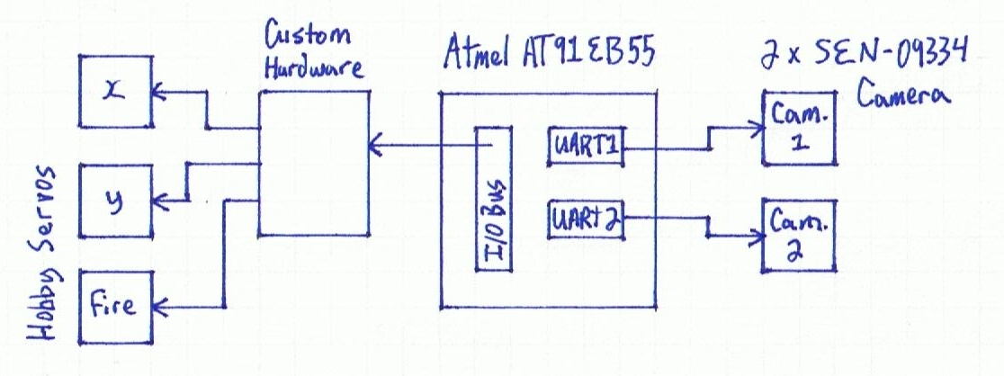

In order for the system to accurately calculate the distance of the target, the two cameras will need to be securely mounted so that they face in parallel directions. In this way the difference in the location of the target in the images from the two cameras can be used to calculate both the horizontal position and the distance of the target.

After we have acquired a suitable Nerf gun to stand in for the Life Preserver Launcher we will need to do a series of experiments to determine a ballistic model that can be used to translate the distance to the target into the required angle that is needed to hit the target. A requirement of the mechanical turret is that its range of motion be sufficient that the angle required to hit the target for any distance between the range of the Nerf gun and the minimum range of the binocular camera system.

The software that is required to make this system can be broken down into logical subroutines. First we will need a targeting subroutine. Given a requested trajectory for the turret to face the software will have to generate an encoded signal that will be sent to our custom hardware to aim the turret. Next we will need a firing subroutine that will generate a signal that will cause the turret to fire the projectile. The cameras will need to talk to some software that can properly request an image from each of the cameras and save the images in RAM. Once the images are saved into memory another subroutine will need to analyze the images and identify the location of the target. The x and y positions of the target in each image will then be passed into a range finding subroutine that will use a binocular range finding algorithm to estimate the distance between the infra-red beacon and the cameras. Once the distance to the target is known it will be passed into another subroutine that will calculate the required trajectory for the projectile. Finally this can be passed into the previously mentioned targeting subroutine. To make the target acquisition easier we plan to manipulate the physical world to ensure that the infra-red beacon stands out clearly in the resulting image from the cameras.

The design of the turret is a simple two axis design so that there will be both horizontal and vertical articulation. The turret will need to be strong enough to hold a small plastic Nerf gun and a firing mechanism. To fire the Nerf gun programatically we originally thought of using a solenoid In looking at the available parts sites we found that solenoids were very expensive for such a simple operation. As a backup plan we have determined that we can use a servo in one of two configurations. The first configuration would have an arm attached at a ninety degree angle to the drive shaft of the servo in such a way that when the servo turns the arm is pressed against the trigger. This setup however may require more torque than the readily available servos may be able to proved so the second configuration addresses that. In the second configuration the servo is mounted behind the handle of the Nerf gun and would act as a winch which would pull a string around the trigger of the Nerf gun until the firing mechanism is triggered.

Hardware Requirements
To construct the ALPL system we will need a micro-controller (processor speed has been made irrelevant by our stationary target assumption), three servos for the turret, 2 digital cameras and a piece of custom hardware to decode a digital signal and drive the servos on the turret.

The micro-controller that we plan to use is the Atmel AT91EB55 board that is available in the lab. The cameras that we plan to use will connect to the Atmel board via two of the available UARTs. The servos that drive the turret will be connected to a custom piece of hardware. The custom hardware will receive a digital signal from the micro-controller which it will decode into a choice of which servo to move, what direction to move the servo, and how much to move the servo.

The camera model that we are planning to use can output a single JPEG frame at a time at 640x480 resolution. In the standard JPEG encoding there are three bytes of information for each pixel which boils down to approx. 900kb per image at maximum resolution. Considering that the Atmel board has about 128Kb of space for user code and that we will also need space for a second image, we will need to interface some ram with the micro-controller We will most likely use the lowest resolution available on our cameras but this gives an estimate to our space requirements. As an educated guess, we can say that we will need at maximum 2000Kb of RAM.

Proposed Parts Order List
- 2 digital cameras: SEN-09334 JPEG Color Camera with a UART Interface
  - $54.95 from sparkfun.com
  - data-sheet: http://www.sparkfun.com/datasheets/Sensors/Imaging/C328.pdf
  - manual: http://www.sparkfun.com/datasheets/Sensors/Imaging/C328_UM.pdf
  - requires some parts (from digikey) for making connections:
    - WM-8289-ND -- 2mm connection Receptacle housing (4 position female)
http://parts.digikey.com/1/parts/1210042-conn-rcpt-hsng-2mm-4pos-single-51090-0400.html
      - $0.33 from digikey.com
    - WM-6050-ND -- crimps, female 24-30AWG, 2mm http://parts.digikey.com/1/parts/271044-conn-term-female-24-30awg-tin-50212-8100.html
      - $3.54/10units from digikey.com
- 3 servos
  - After talking to Nancy Minderman the recommended servos are either HS422HB or HS635HB by Hitec. These servos are in stock at the school.
  - Hitec HS422:
    - data-sheet: http://www.robotshop.ca/PDF/hs422.pdf
    - User Manual: http://www.robotshop.ca/PDF/Servomanual.pdf
  - Hitec HS635HB:
    - data-sheet: http://www.hitecrcd.com/product_file/file/56/HS635.pdf
    - User Manual: http://www.hitecrcd.com/product_file/file/55/Servomanual.pdf

Table of User IO Signals
Camera1-TxD | ARM-PA15/TXD0
Camera1-RxD | ARM-PA16/RXD0
Camera2-TxD | ARM-PA21TXD2
Camera2-RxD | ARM-PA22RXD2

As for the signals to our custom hardware, we have not yet had time to think about the design and thus do not have very much information.

Schedule
The following time estimates are based on the concept of a man week. With two people on the project and 7 weeks to work with we have 14 man weeks in which to allocate time. The following tasks then leave 2 man weeks as a fudge factor.
- Fabricate a turret platform with two axis of motion that can hold the Nerf gun mechanism and the firing servo
  - Approx. 0.5 Week
  - Group Member: Unknown
- Fabricate a hardware decoder and circuits to drive the servos on the turret platform.
  - Approx. 3 Weeks
  - Group Member: Unknown
- Fabricate a mount system to hold the two cameras with a parallel point of view.
  - Approx. 0.5 Week
  - Group Member: Unknown
- Interface the cameras with the micro-controller
  - Approx. 2 weeks
  - Group Member: Unknown
- Interface additional RAM with the micro-controller
  - Approx. 1 week
  - Group Member: Unknown
- Firing Subroutine:
  - Approx. 1 week
  - Group Member: Unknown
- Targeting Subroutine
  - Approx. 1 week
  - Group Member: Unknown
- Target Finding Subroutine
  - Approx. 1 week
  - Group Member: Unknown
- Range Finding Subroutine
  - Approx. 1 week
  - Group Member: Unknown
- Ballistic Model Subroutine
  - Approx. 1 week
  - Group Member: Unknown

