Basic Electric Concepts Exercise

Author(s) | Gerard Elbers
Version | 0.1
Date | 01-02-2026

Document history
Date | Version | Change
01-12-2025 | 0.1 | Initial version
01-02-2026 | 1.0 | Introduction updated

Inhoud
Document history 2
Introduction 4
Assignment 5
Part 1 5
Part 2 5
Part 3 6

Introduction
With this exercise the student can demonstrate his proficiency in the Basic of Electronics part of Learning Outcome 3:
- You understand the relationship between current, voltage and resistance and are able to make substantiated statements about basic electrical circuits with respect to those quantities using Ohm's Law and Kirchhoff's law.
- You can describe the electrical properties of LEDs and diodes
- You can calculate the equivalent resistance of series and parallel circuits of resistors
- You can lookup, derive and use the relevant properties of components from datasheets

Assignment

Part 1
Choose three different resistors and determine their values in three different ways:
- Using the colour codes
- Measuring the resistance with a multimeter
- Measuring the current through the resistor and the voltage over the resistor and using Ohm's law.

Make a table containing for each resistor the colours, the measured resistance, the current, the voltage and the calculated resistance. Include the table in the report
Colour codes | Multimeter | Current
Yellow, violet, red en gold = 4.7kohm | 4.67 kohm | 1.06 mA
Brown, red, brown en gold = 120 ohm | 118 ohms | 0.04 A
Orange, orange, brown en gold = 330 ohm | 325.6 ohms | 0.015 A

Part 2
Given the following simple network of resistors in parallel and series.

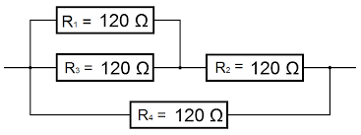
Figure 1 Simple resistor network

Calculate the equivalent resistor R₁₃ of R₁//R₃, R₁₂₃ of R₁₃+R₂ and R₁₂₃₄ of R₁₂₃//R₄.
Include the picture and your calculations in the report.

R13 | 60 Ohm
R123 | 180 Ohm
R1234 | 72 Ohm
R13 = R1 // R3 (parallel)
Twee weerstanden parallel: 1/R = 1/R1 + 1/R3
1/R13 = 1/120 + 1/120 = 2/120
R13 = 120/2 = 60 Ω

R123 = R13 + R2 (serie)
R123 = 60 + 120 = 180 Ω

R1234 = R123 // R4 (parallel)
1/R1234 = 1/R123 + 1/R4 = 1/180 + 1/120
Om dit op te tellen, gemeenschappelijke noemer = 360:
1/180 = 2/360 en 1/120 = 3/360
1/R1234 = 2/360 + 3/360 = 5/360
R1234 = 360/5 = 72 Ω

Part 3
Given the following schematic and formula’s

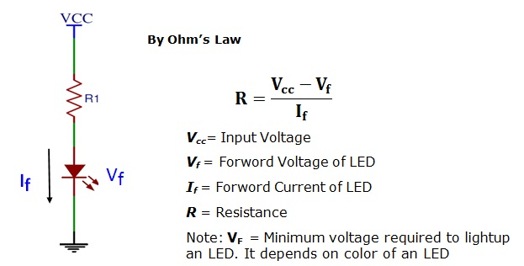
Figure 2 LED with current limitting resistor
Use the data sheet of the LED to calculate the needed resitors for the RED, GREEN and YELLOW LEDs.
Use the typical values from the data sheet.
Include in the report:
- The given picture
- Snapshots of parts of the data sheet that you used
- The calculations

Why is the resistor needed? What would happen if you remove it?

To not let too much voltage trough the LED,

The LED would shine a bright light in its given color and then break after to be never able to be used again.

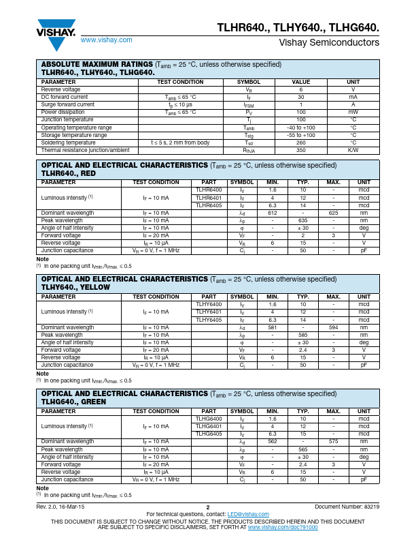

red
max
5-3 : 20 = 0.1 x 1000 = 100
typ
5-2 : 20 = 0.15 x 1000 = 150
green
max
5-3 : 20 = 0.1 x 1000 = 100
typ
5-2.4 : 20 = 0.13 x 1000 = 130
yellow
max
5-3 : 20 = 0.1 x 1000 = 100
typ
5-2.4 : 20 = 0.13 x 1000 = 130

Submission Guidelines:
  - Students should submit a short report (1-5 pages) with answers to all questions.
  - Include calculations, graphs, or diagrams where applicable.

