**MAIN MENU PANEL**

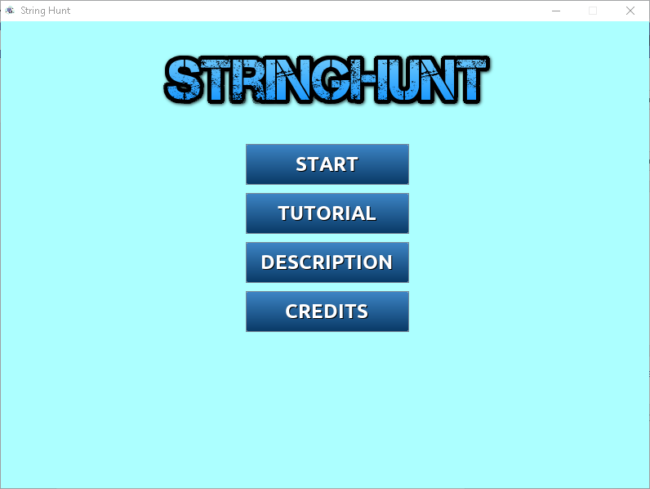

**TUTORIAL PANEL**

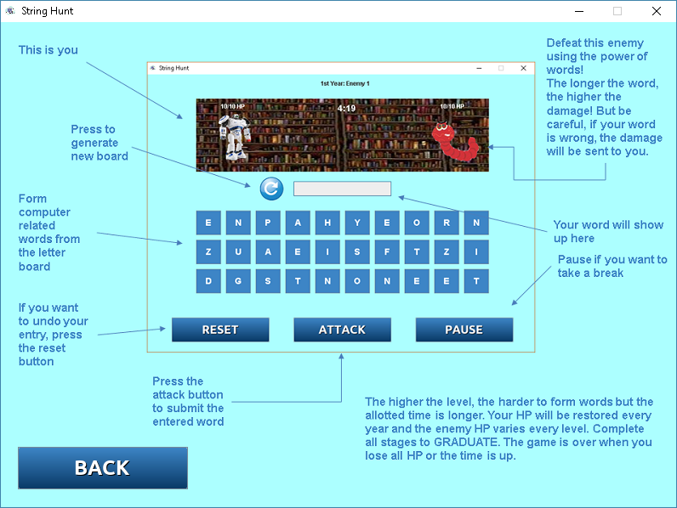

**DESCRIPTION PANEL**

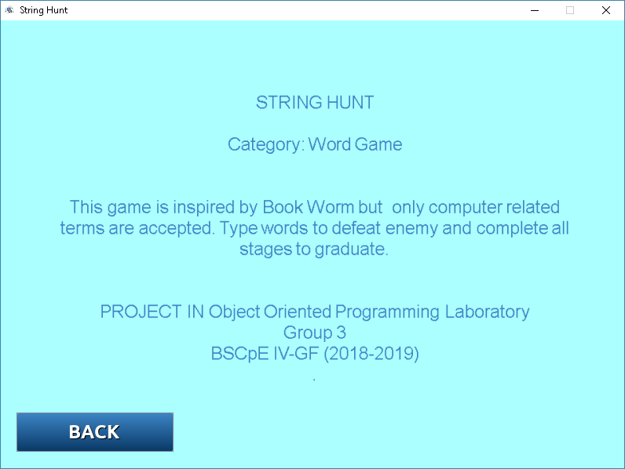

**CREDITS PANEL**

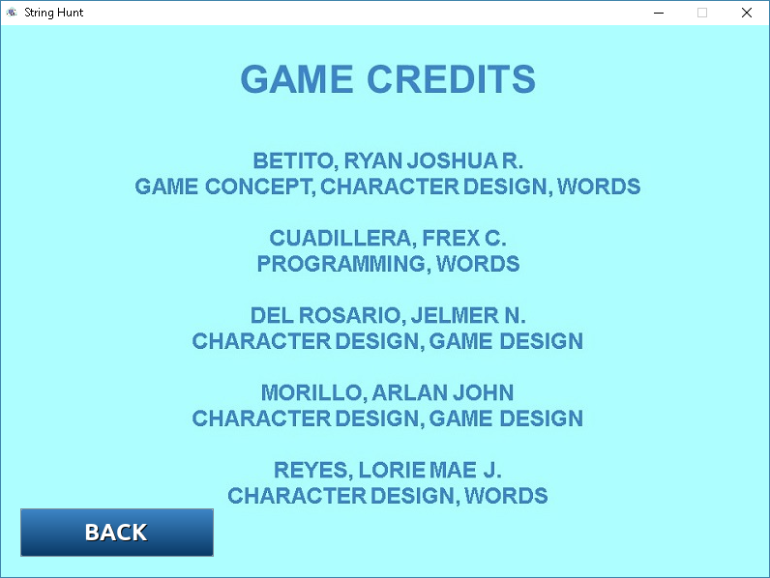

**GAME PANEL**

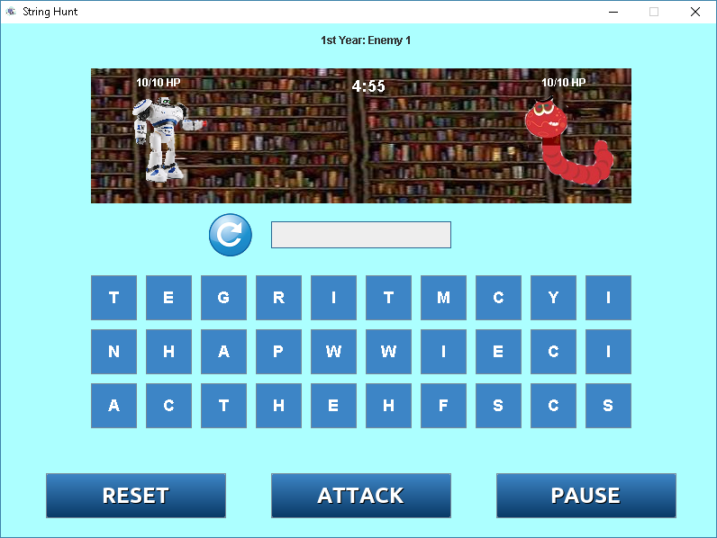

**ENTERING A WORD**

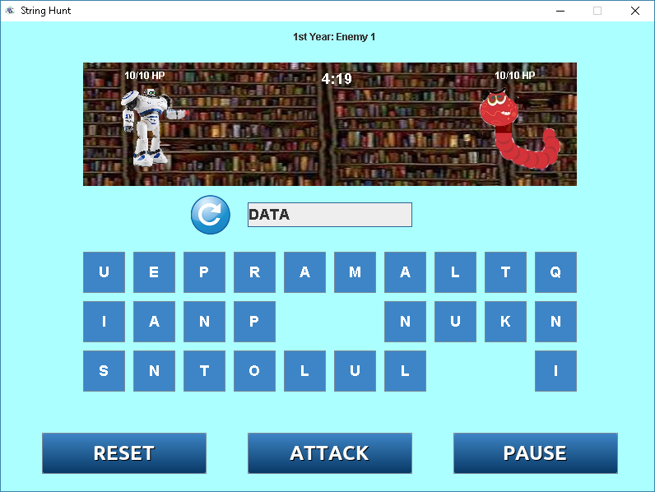

**ATTACKING, ENEMY RECEIVED DAMAGE**

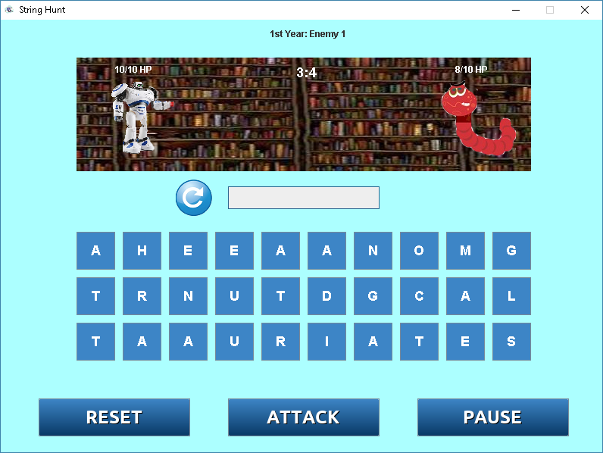

**ENTERING INVALID WORD**

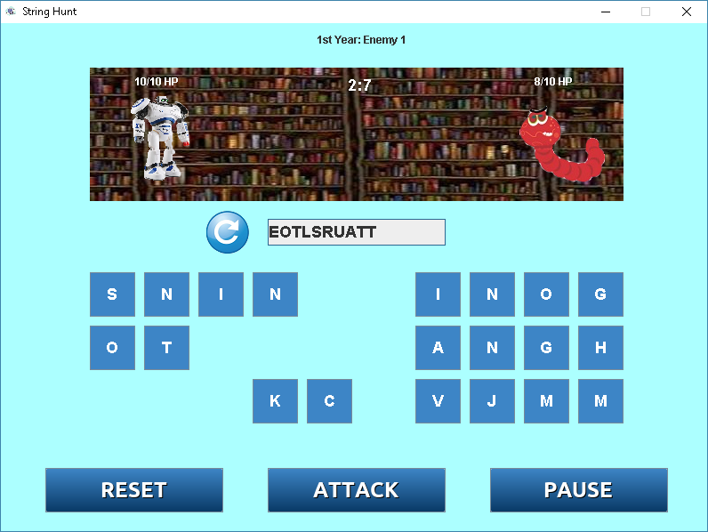

**PLAYER RECEIVED DAMAGE**

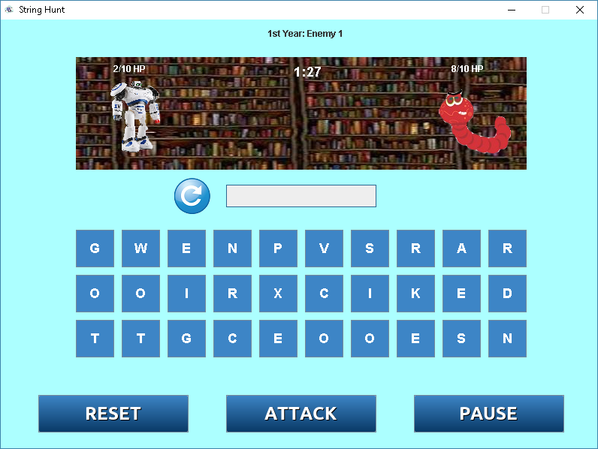

**GAME OVER BECAUSE TIME RUNS OUT**

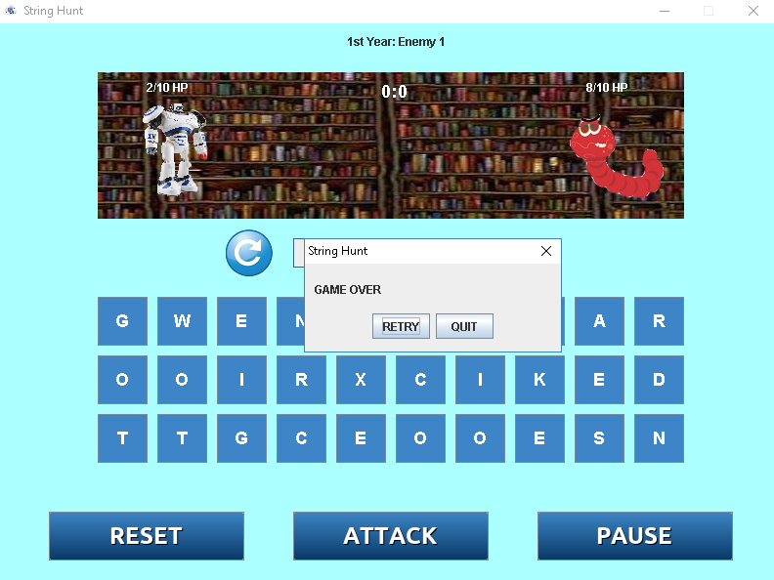

**GAME OVER BECAUSE PLAYER HP REACHES ZERO**

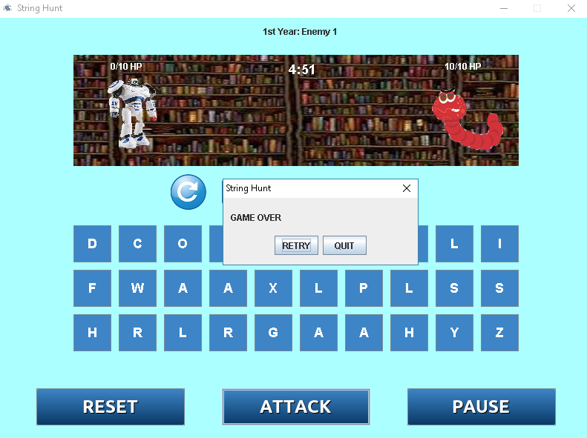

**PAUSING THE GAME**

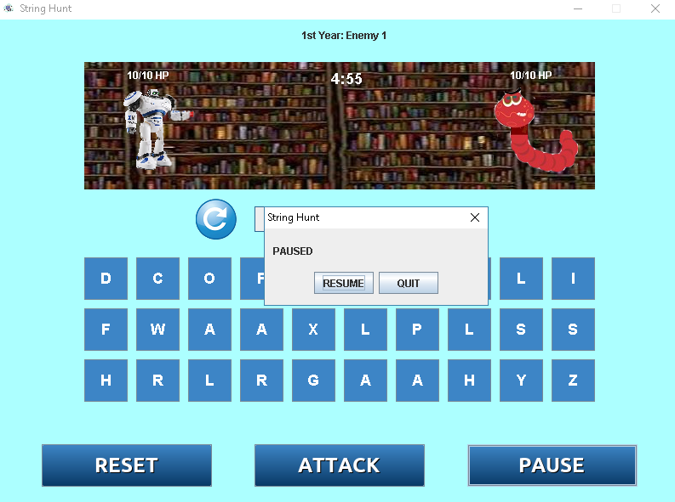

**OTHER EXAMPLE OF ENEMIES**

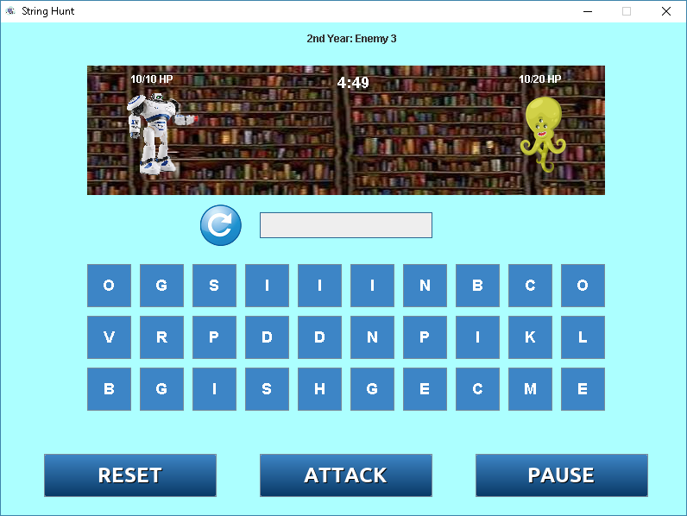

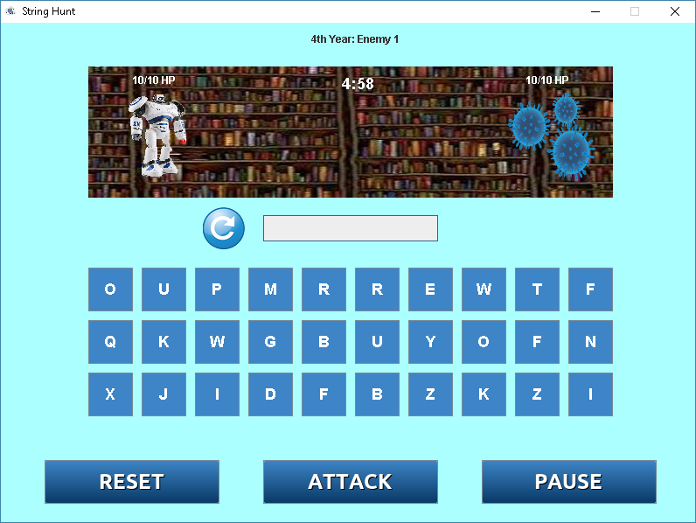

**FINAL BOSS**

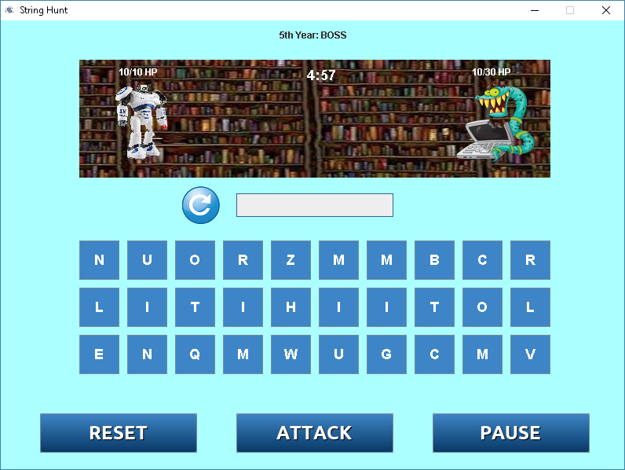

**DEFEATING FINAL BOSS, WINNING THE GAME, GRADUATE**

