Competitive Analysis: Chosen Foods Recipe & Blog Experience

What works:
- Beautiful, High-Resolution Imagery: Every recipe features gorgeous, high-resolution hero images showing the final dish in bright, natural light, making them look highly professional and appetizing.
- Sensible Product-Specific Integrations: Rather than just pushing products, the recipes creatively integrate Chosen Foods items in logical ways—like using Avocado Oil Mayo in the Chocolate Mayo Cake to add incredible moisture, or using Avocado Oil Spray to get perfect crunch on Air Fryer Wings.
- Inspirational Brand Partnerships: Collaborating with other high-quality, health-conscious brands (like Hu Kitchen chocolate chips or Bob's Red Mill flours) builds culinary trust and appeals directly to premium grocery shoppers.
- Clear Health-Oriented Positioning: Every recipe aligns with a "healthy pantry replacement" philosophy, emphasizing swapping out highly processed seed oils with pure avocado oil.
- Broad Culinary Scope: There is a vast selection of recipes covering everything from quick 30-minute weeknight dinners to breakfast bakes, side salads, dipping sauces, and baking.

What doesn’t work:
- Static, Non-Interactive Experience: There are no interactive recipe card features. Ingredients and directions are formatted as flat text on a blog post.
- No Scaling Tool: There is no way to scale the serving size (e.g., doubling the recipe for a larger dinner party or halving it for two people). Users have to do all the math manually.
- No Checklist Functionality: Users cannot check off ingredients as they gather them or mark directions steps as completed during active cooking, leading to lost place when cooking.
- No Print Recipe Button: There is no dedicated print widget. Attempting to print a recipe prints the entire webpage—complete with header menus, promotional banners, sidebars, and footers—resulting in highly cluttered and wasteful paper printouts.
- No Built-in Rating/Review System: Individual recipes do not show star ratings or comment sections where other home cooks have left feedback, leaving users uncertain if a recipe is proven and reliable.
- Inconsistent Meta-Information: Basic culinary stats (prep time, cook time, total time, calorie counts, or yield/serving size) are not standardized in a prominent info card at the top. Some recipes omit prep/cook times entirely and jump straight into the text.

Recipe library patterns:
- Visual Grid Layout: The main recipe index uses a clean, grid-based card layout. Each card consists of a large, high-quality photograph, the recipe name, and a link to read the full post.
- Cohesive Aesthetics: The color palette features a premium, clean look with soft cream and white backgrounds, charcoal typography, and vibrant green accents that evoke avocado and wellness.
- Product-Centric Categorization: The recipe library has clear labels and filter tags that match Chosen Foods product lines (e.g., Avocado Oil Mayo, Avocado Oil Spray, Avocado Oil Dressing) so you can browse recipes based on what's in your pantry.
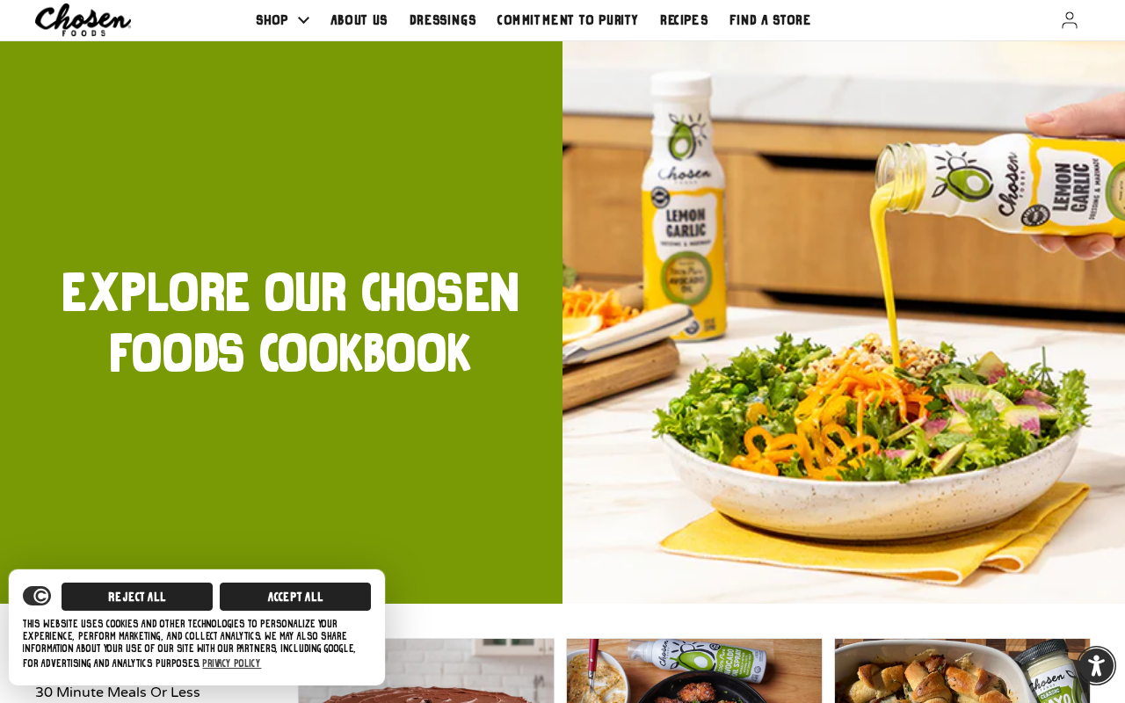
Figure: Recipe Hub Landing Grid

Recipe detail patterns:
- Blog-Style Formatting: Individual recipe pages are structured like traditional blog posts rather than database-driven recipe cards. They start with an engaging, casual introductory story explaining the dish's flavor profile.
- Raw Paragraph Lists: Ingredients are presented in flat paragraphs rather than a standard bulleted list, often calling out specific brand partners (e.g., *Bob's Red Mill*, *Hu Dark Chocolate Baking Chips*).
- Numbered Directions: The instructions are written in numbered steps, but are quite dense and require manual scrolling.
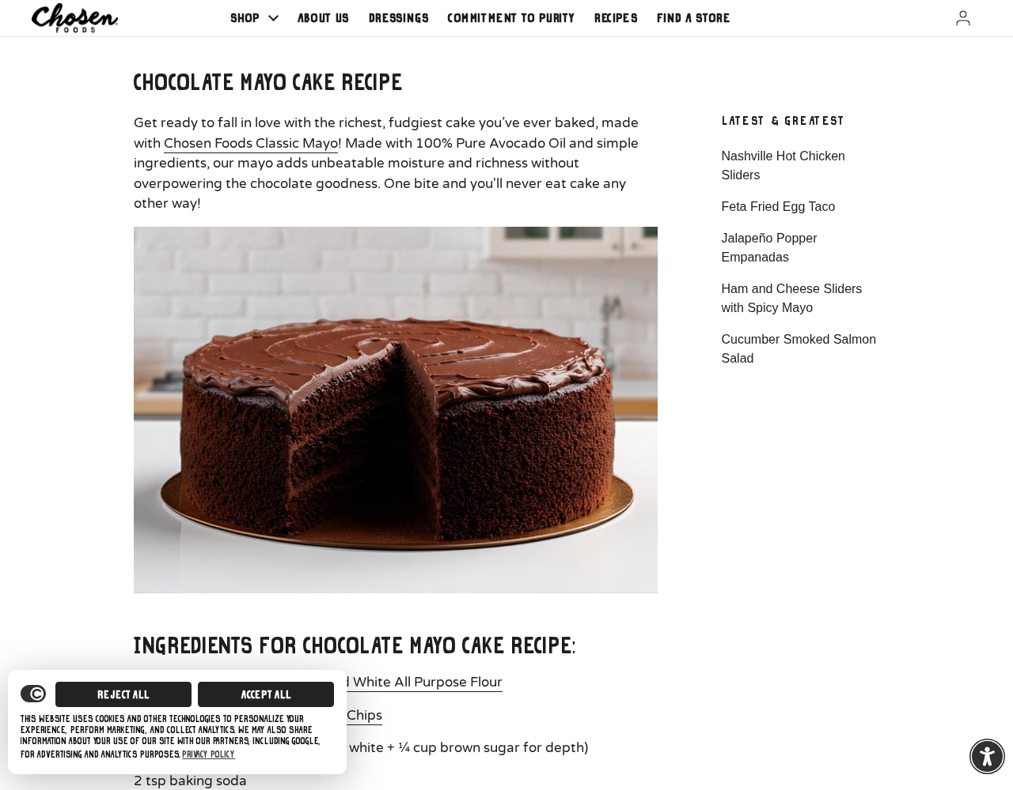
Figure: Chocolate Mayo Cake Recipe Detail
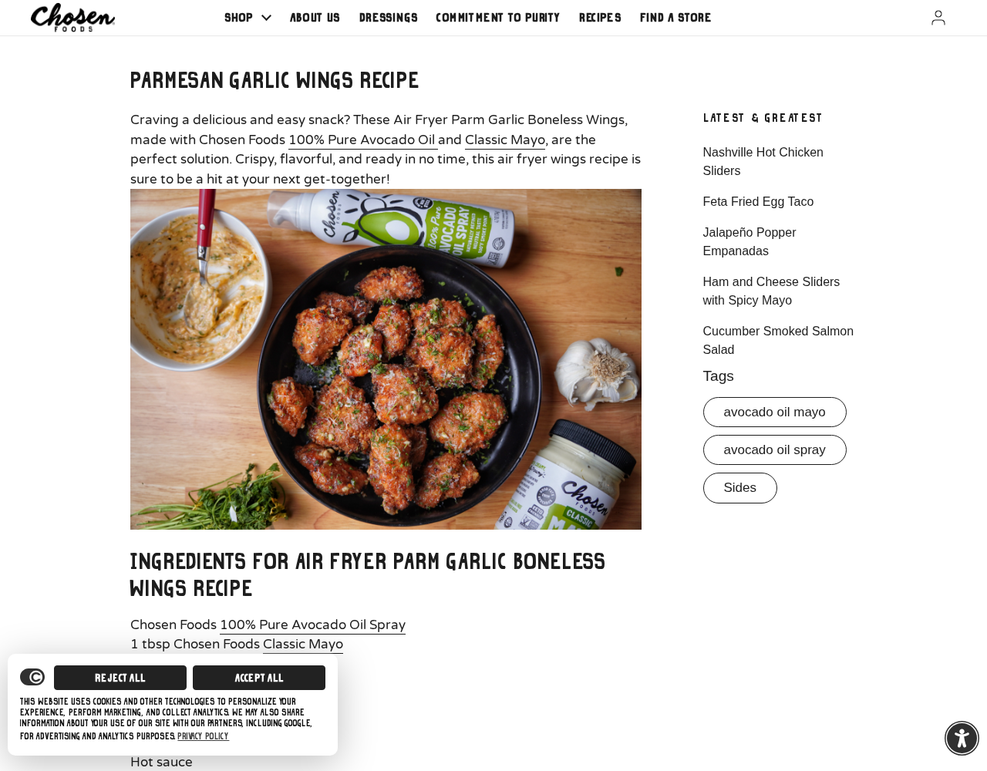
Figure: Air Fryer Parm Garlic Wings Recipe Detail
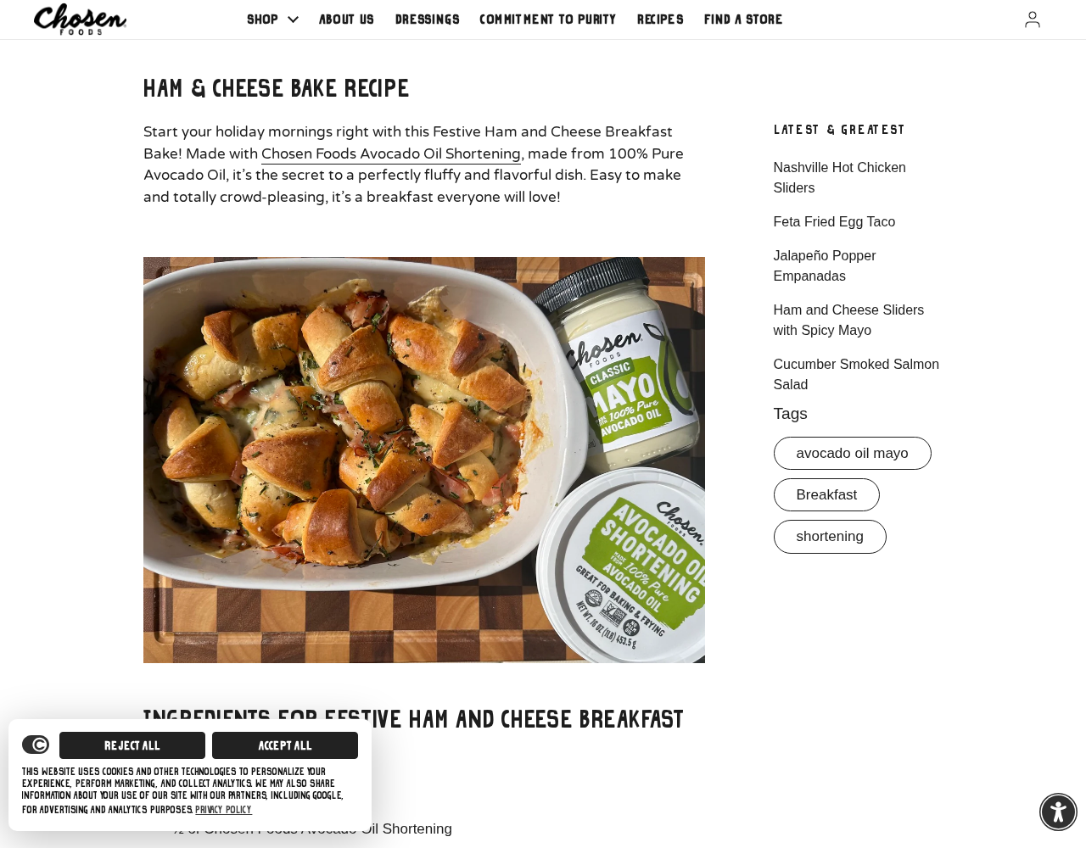
Figure: Festive Ham & Cheese Breakfast Bake Detail

Search/filter patterns:
- Tag-Based Filtering: Navigation on the recipe library page relies heavily on horizontal tags or lists of categories (e.g., *30 Minute Meals Or Less*, *Avocado Oil Spray*, *Baking And Desserts*, *Breakfast*, *Dinner*, *Salads*, *Sides*). Clicking a tag filters the blog index to display only matching posts.
- Generic Global Search: There is a standard, rounded global search input in the header, but no advanced, recipe-specific search filters (like searching by ingredients, dietary restrictions like gluten-free/keto, or cook time).

Guided cooking patterns:
- No Guided Cooking Features: The website lacks any form of step-by-step guided cooking interface. There is no "Cooking Mode" that locks the screen from sleeping, no audio instructions, and no split-screen progress indicators.
- Dense Paragraph Steps: Home cooks must read and follow the recipe steps directly off their phone or laptop screen, manually scrolling up and down between the ingredient list and the instructions.

Save/share patterns:
- No Native Saving: There is no user login or "Recipe Box" feature to save recipes to a personal profile for later.
- Browser-Only Sharing: The page lacks dedicated Pinterest "Pin It" or Facebook "Share" hover buttons on individual images, forcing users to rely on default browser sharing or copying the URL.

Additional features worth noting:
- Avocado Oil 101 Educational Content: The blog features an active "Avocado Oil 101" section that educates users on smoke points, monounsaturated fats, and healthy fat swaps, turning the recipe site into a valuable educational resource.
- Shop-The-Recipe Integration: Some pages link directly to Chosen Foods' store collections, allowing users to buy the exact oil or mayo used in the recipe with a single click.

App Profile
- App: Chosen Foods
- Best known for: Avocado oil, mayo, dressings, sprays
- Core angle: Healthy pantry replacement recipes
- Key Features:
- Large recipe/blog archive with product-specific recipes across salads, wings, tacos, shrimp, baking, and meal prep
- Clear product categories: avocado oils, mayos, dressings, sprays, baking products
- Health-oriented positioning around replacing less-preferred fats with avocado oil
- Utility-forward recipes that make sense for grocery shoppers and families

