Generalized Additive Modelling Workshop

### Held August 12-14, 2020 via Microsoft Teams

### Led by Eric Pedersen, Gavin Simpson, David Miller, and Noam Ross

### Organized by the Maritimes Region R Learning and Development Initiative

### Report produced by Freya Keyser and Catalina Gomez

# Executive Summary

Insert text here

# Attendance

Insert text here

# Evaluation by participants

Forum participants were asked to complete an evaluation survey at the end of the forum. Of the 51 registered participants, 18 responses were received (35% response rate). Responses were received from various DFO Science regions, working in various research areas (Figure 1).

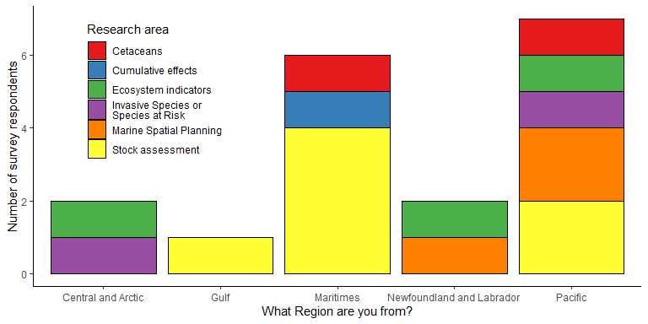

*Figure 1. Survey responses by region and research area.*

Participants were asked to rate the forum on various factors on a scale of 0-5 (low to high). The minimum rating for any question was 3, and median ratings were 4-5 (Figure 2).

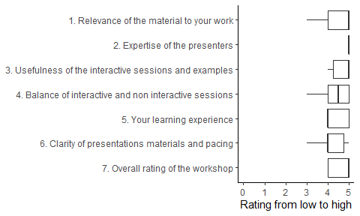

*Figure 2. Summary of responses to rating questions. Each rating question was answered by all 18 respondents.*

All participants responded that they would recommend this course. Their reasons included:

* Code and slides were well organized and presented
* Clear explanations
* Knowledgeable and engaging instructors
* Accessibility of remote learning

All participants but one responded that they would use the techniques demonstrated during the course. Ten participants commented that the course material was directly applicable to their current work.

There were 6 responses to the question “What were you hoping to learn in this workshop that you did not?”. Responses included:

* Spatio-temporal examples
* Predicting from GAMs
* More details on underlying statistical theory
* More examples and exercises

There were 7 responses to the question “What topics would you be interested in covering in future workshops?”. Responses included:

* R-INLA
* Time series modelling
* GAMs and GAMLs
* Zero-inflated models
* Mixed models
* EDM

Participants also offered additional comments, including: * Excellent instructors * Positive feedback on the remote online format and timing * Well organized * Usefulness of materials for future reference

Survey respondents reported that they would be most available for future workshops from October to May (Figure 3).

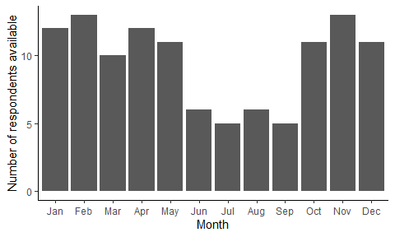

*Figure 3. Participant availability by month.*