Rasters, Interactive Maps, and Coding Applications Workshop

### Held January 12-13, 2021 via Microsoft Teams

### Instructors: David Beauchesne and Kevin Cazelles

### Organizer: Catalina Gomez

### Report produced by Freya Keyser and Catalina Gomez

# Executive Summary

Insert text here

# Attendance

Insert text here

# Evaluation by participants

Forum participants were asked to complete an evaluation survey at the end of the forum. Of the **n** attendees, 17 responses were received (**25%** response rate). Responses were received from DFO and ECCC participants based in the Pacific, Maritimes, Gulf, and Ontario and Prairie regions (Figure 1). Participants worked in a wide range of research areas (Figure 2).

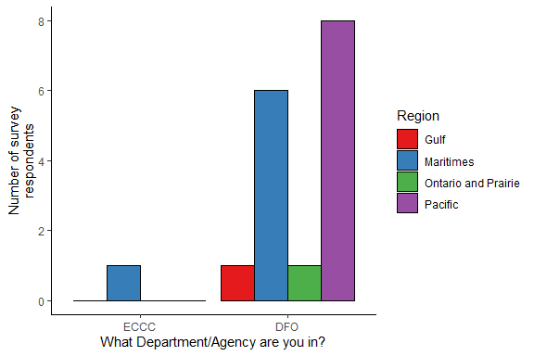

*Figure 1. Survey responses by department and region.*

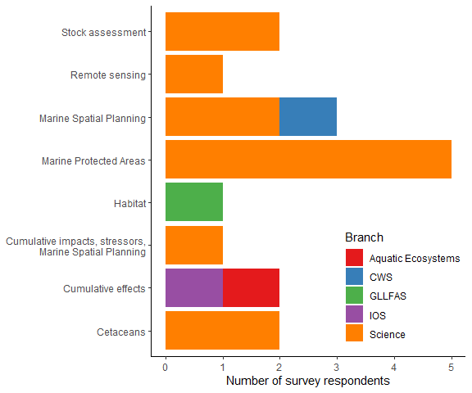

*Figure 2. Survey responses by research area.*

Participants were asked to rate the forum on various factors on a scale of 0-5 (low to high). The minimum rating for any question was 1, and median ratings were 3, 4 or 5 (Figure 3).

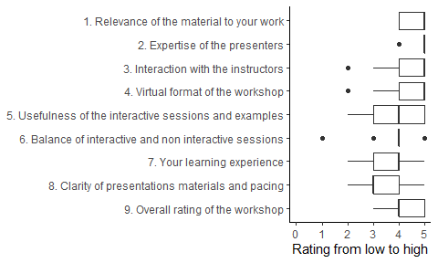

Regarding the learning level of the workshop, participants mostly found the difficulty and time allocations appropriate for their level.

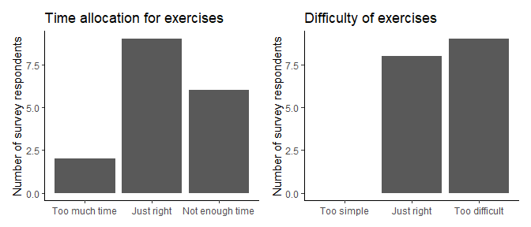

*Figure 3. Summary of responses to course level questions. Each question was answered by all 17 respondents.*

All survey respondents said they would recommend this forum to others. Some noted that the course was best for advanced users. Participants commented on:

* Relevant and up-to-date information
* Broad overview
* Technical expertise of the instructors
* Useful reference materials

All of the respondents will try to use the methods presented in the workshop, primarily because they find these approaches useful for communicating results, and for making analyses accessible.

Several respondents still did not feel confident in their skills upon completing the workshop, but felt that the reference materials would be useful in the future. Survey respondents had remaining questions on:

* Basics of spatial analysis (using rasters and polygons)
* Shiny apps
* Map/figure design and formatting

For future training opportunities, respondents suggested the following topics:

* Shiny
* CSASdown
* Science communication
* Spatial analysis in R
* Map design
* Statistical modelling
* Accessing remotely sensed data