Power of Reproducible Workflows Workshop

### Held March 1-2, 2021 via Microsoft Teams

### Instructors: Kevin Cazelles, Steve Vissault, and David Beauchesne

### Organizer: Catalina Gomez

### Report produced by Freya Keyser and Catalina Gomez

# Executive Summary

Insert text here

# Attendance

Insert text here

# Evaluation by participants

Forum participants were asked to complete an evaluation survey at the end of the forum. Of the **n** attendees, 38 responses were received (**25%** response rate). Responses were received from DFO and ECCC participants based in the Pacific, Maritimes, Gulf, Ontario and Prairie, Newfoundland and Labrador, and Quebec regions (Figure 1). Participants worked in a wide range of research areas (Figure 2).

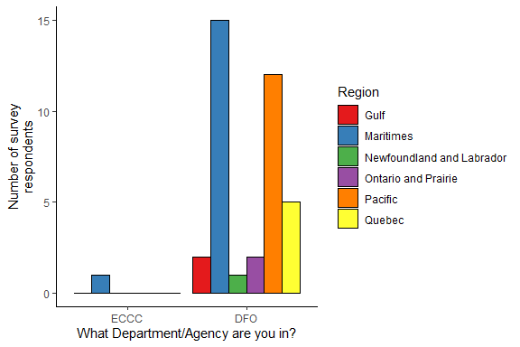

*Figure 1. Survey responses by department and region.*

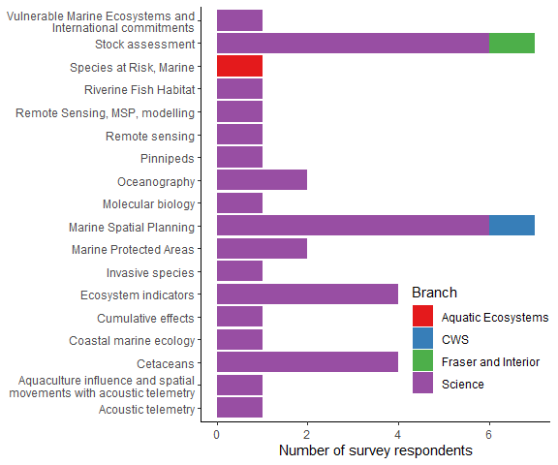

*Figure 2. Survey responses by research area.*

Participants were asked to rate the forum on various factors on a scale of 0-5 (low to high). The minimum rating for any question was 1, and median ratings were 4 or 5 (Figure 3).

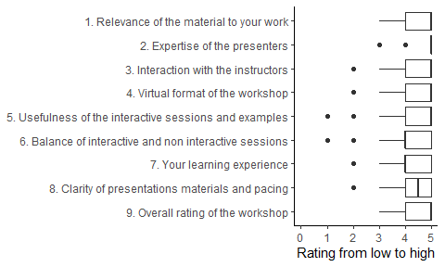

Regarding the learning level of the workshop, participants mostly found the difficulty and time allocations appropriate for their level.

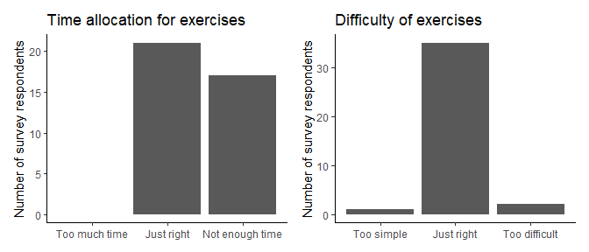

*Figure 3. Summary of responses to course level questions. Each question was answered by all 17 respondents.*

The majority (95%) of survey respondents said they would recommend this forum to others. Some participants found the pace too fast, and would have preferred having the solutions available while completing the exercises. Others felt confident in applying their skills after the workshop. Participants also commented on:

* The potential for increased efficiencies from adopting a reproducive workflow
* Highly relevant information
* Broad overview
* Technical expertise of the instructors
* Useful reference materials

The majority of respondents (97%) will try to use the methods presented in the workshop. They felt that reproducible workflows would increase efficiency and reduce errors in their work. While some felt that adopting this approach would be challenging at first, they agreed that it would be beneficial long-term.

Survey respondents had remaining questions on:

* Using Git/Github for version control
* Implementing a reproducible workflow for their particular project
* Modifying tables and figures

Survey respondents were divided on the amount of technical support required for course software installation. Of 11 responses, 5 participants would have preferred extra support or instruction on the technical set-up. It was also noted that using a cloud project could have prevented these challenges.

For future training opportunities, respondents suggested the following topics:

* Shiny
* CSASdown
* ggplot2
* Git/Github/Gitlab
* More on reproducibility, but in a smaller group and working on real data
* Introduction to Python (the general language, workflows, and its use in web development)
* Relational database basics (SQL)
* Creating R packages
* docker
* Spatial analysis in R