Spatial Approaches for Stock Assessment Workshop

### Held March 3-4, 2020 at BIO

### Led by Eric Pedersen, Concordia University

### Organized by the Maritimes region R Learning and Development Initiative

### Report produced by Freya Keyser, Jessica Sameoto and Catalina Gomez

# Executive Summary

Insert text here

# Attendance

Insert text here

# Evaluation by participants

Forum participants were asked to complete an evaluation survey at the end of the forum. Of the 21 attendees, 15 responses were received (71% response rate). Responses were received from various DFO Science regions (Figure 1).

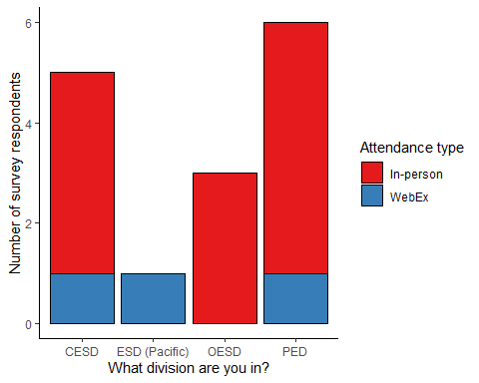

*Figure 1. Survey responses by division (in Maritimes Region unless otherwise stated) and attendance type.*

Participants were asked to rate the forum on various factors on a scale of 0-5 (low to high). The minimum rating for any question was 3, and median ratings were 5, except for the question regarding the venue (Figure 2).

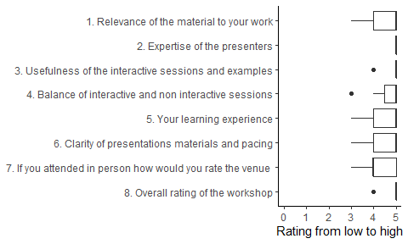

*Figure 2. Summary of responses to rating questions. Each rating question was answered by all 15 respondents.*

All participants responded that they would recommend this course. Their reasons included:

* the format, organization, and pacing of the content and instruction
* the instructor’s abilities to teach the content to an audience of varied experience levels
* the degree of preparedness and expertise demonstrated by the instructor
* the anticipated future utility of the coding examples and materials provided
* the balance of activities (lectures, examples, and exercises)
* the effectiveness of the instruction despite the short duration (participants learned a lot in a short time)

All participants responded that they would use the techniques demonstrated during the course. Their reasons included:

* the techniques are directly relevant to their work tasks/research goals
* the techniques are important to ensure proper analysis
* the techniques were presented in a manner that would be adaptable

There were 5 responses to the question “What were you hoping to learn in this workshop that you did not?”. Responses included:

* New tools for implementing spatial analyses
* Spatial interpolation with boundaries and exclusions
* Approaches for use in a data-limited context
* Additional focus on GAMs
* A more complete process and application to fisheries

There were 7 responses to the question “What topics would you be interested in covering in future workshops?”. Responses included:

* GAMs
* Machine learning
* Tidyverse
* Model testing and diagnostics
* A course that builds on this one (e.g. advanced spatial statistics for stock assessment)
* This same course but with more time
* A similar course that demonstrates the application of these methods in a fisheries stock assessment and management process

Participants also offered additional comments, including:

* additional praise and thanks to the instructor (everyone really liked him), as well as the organizers.
* a request for updated R files
* “This was a very useful short course that I think was an effective use of time and money”
* there was a “dichotomy” between advanced and beginner/intermediate participants in the course, which created an unapproachable atmosphere for beginners

Survey respondents reported that they would be most available for future workshops from January to May, or in September (Figure 3).

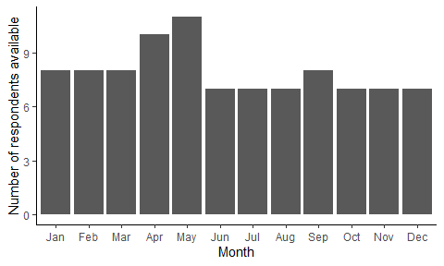

*Figure 3. Participant availability by month.*