A general framework for estimating the spatio-temporal distribution of a species using multiple data types

### Held February 17-19, 2021 via Microsoft Teams

### Instructors: Joe Watson and Marie Auger-Méthé (UBC)

### Organizers: Shelley Lang and Catalina Gomez

### Report produced by Freya Keyser and Catalina Gomez

# Executive Summary

Insert text here

# Attendance

Insert text here

# Evaluation by participants

Forum participants were asked to complete an evaluation survey at the end of the forum. Of the **n** attendees, 23 responses were received (**25%** response rate). Responses were received from DFO and ECCC participants based in the Pacific, Maritimes, Gulf, Ontario and Prairie, Quebec, and Newfoundland and Labrador regions (Figure 1). Participants worked in a wide range of research areas (Figure 2).

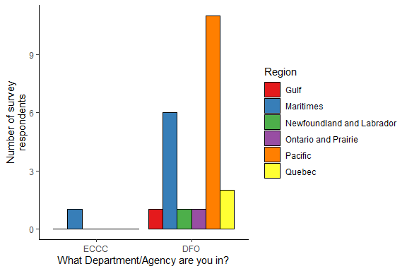

*Figure 1. Survey responses by department and region.*

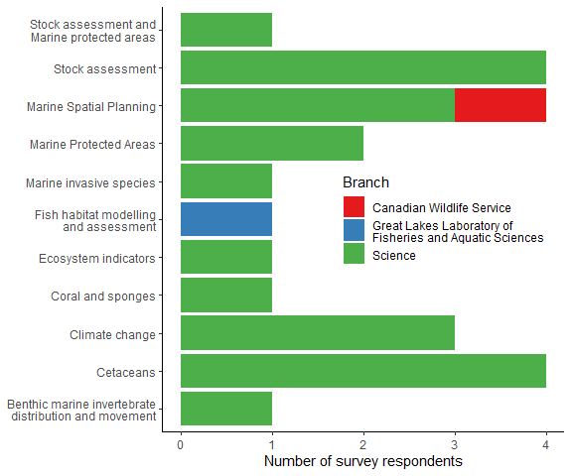

*Figure 2. Survey responses by research area.*

Participants were asked to rate the forum on various factors on a scale of 0-5 (low to high). The minimum rating for any question was 2, and median ratings were 4 or 5 (Figure 3).

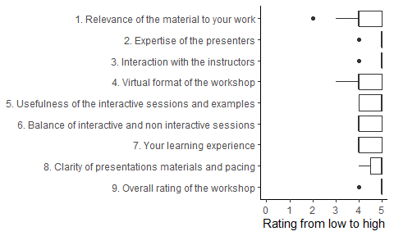

Regarding the learning level of the workshop, participants mostly found the difficulty and time allocations appropriate for their level.

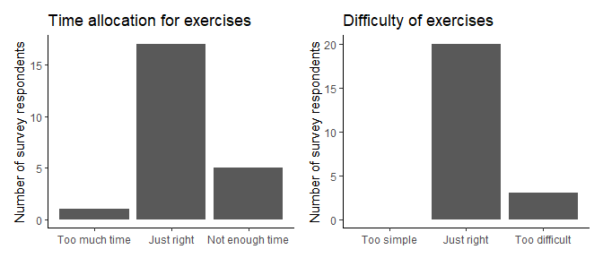

*Figure 3. Summary of responses to course level questions. Each question was answered by all 23 respondents.*

All survey respondents said they would recommend this forum to others. Reasons provided were:

* Highly relevant topic
* Clear explanations
* Technical expertise of the instructors
* Well-organized online delivery
* Useful reference materials

The majority (96%) of respondents will try to use the methods presented in the forum, partly due to the flexibility and accessibility of the approach. They also felt that the course activities and materials would allow them to successfully apply the framework to their own projects in the future.

Survey respondents had remaining questions on:

* Bayesian inference
* Code syntax for model components and formulae
* Incorporating dynamic or temporal environmental covariates

Survey respondents were divided on the amount of technical support required for course software installation. Of 12 responses, 3 participants would have preferred extra support. The remaining 9 respondents were able to install without issue, however some of these participants noted that they had previously installed the software for other purposes and had encountered issues in the past, or that they had administrative privileges on their computer.

For future training opportunities, respondents suggested the following topics:

* Applying this framework on acoustic telemetry data, perhaps in collaboration with OTN
* Bayesian inference
* Applying the framework for spatio-temporal models
* Causality
* Multispecies or community models
* Analysis of autocorrelated data