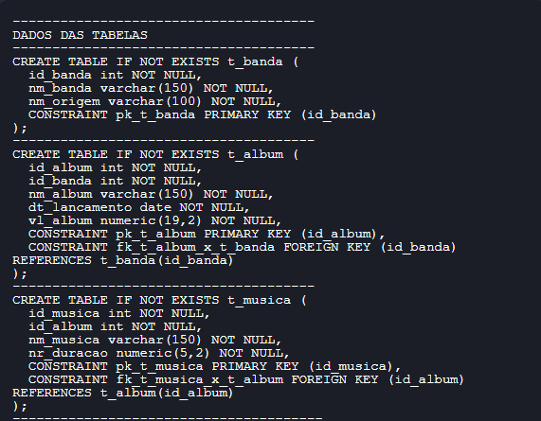

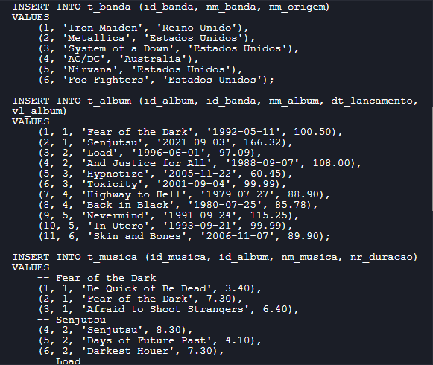

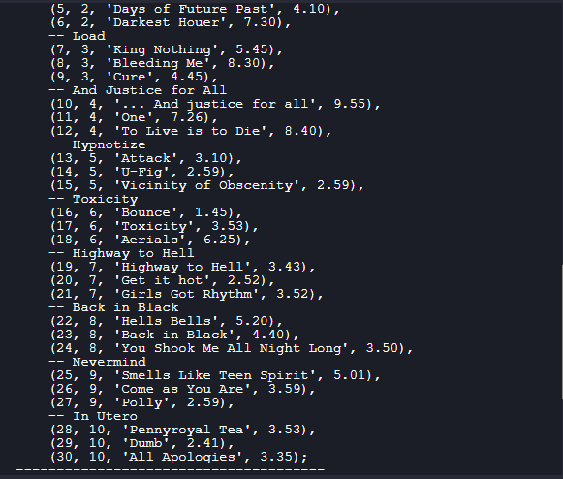

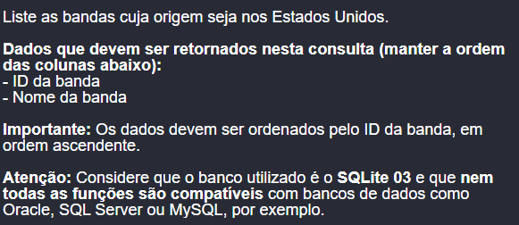

Select a.id_banda, a.nm_banda

From t_banda a

Where a.nm_origem = 'Estados Unidos'

Order By a.id_banda Asc;

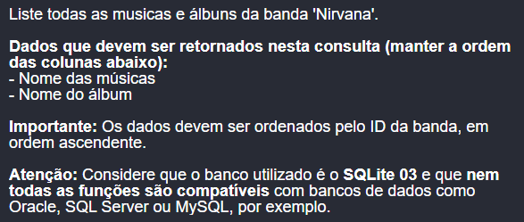

Select c.nm_musica,

b.nm_album

From t_banda a

Join t_album b On a.id_banda = b.id_banda

Join t_musica c On b.id_album = c.id_album

Where nm_banda = 'Nirvana'

Order By a.id_banda Asc;

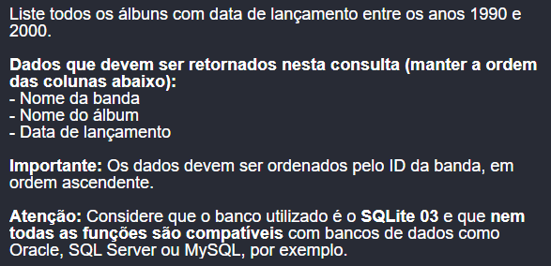

Select a.nm_banda,

b.nm_album, b.dt_lancamento

From t_banda a

Join t_album b On a.id_banda = b.id_banda

Where Year(b.dt_lancamento) >= 1990

And Year(b.dt_lancamento) <= 2000

Order By a.id_banda Asc;

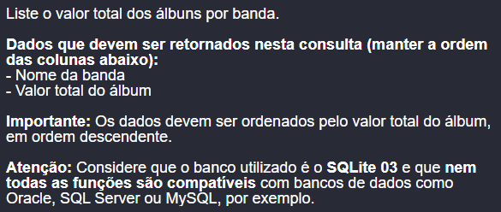

Select a.nm_banda,

b.vl_album

From t_banda a

Join t_album b On a.id_banda = b.id_banda

Order By b.vl_album Desc;

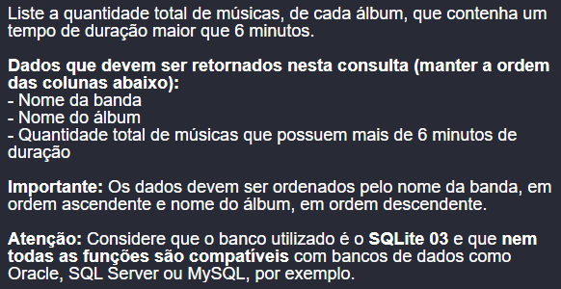

Select a.nm_banda,

b.nm_album,

Count(1) qtde_musicas

From t_banda a

Join t_album b On a.id_banda = b.id_banda

Join t_musica c On b.id_album = c.id_album

Where c.nr_duracao > 6

Group By a.nm_banda,

b.nm_album

Order By a.nm_banda Asc, b.nm_album Desc;

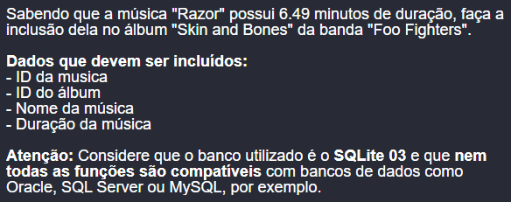

Insert Into t_musica

(id_musica, id_album, nm_musica, nr_duracao)

Select iif((Select Top 1 1

From t_musica) Is Null,

1,

(Select Max(id_musica) + 1

From t_musica)) id_musica,

b.id_album,

'Razor' nm_musica, 6.49 nr_duracao

From t_banda a

Join t_album b On a.id_banda = b.id_banda

Where a.nm_banda = 'Foo Fighters'

And b.nm_album = 'Skin and Bones';

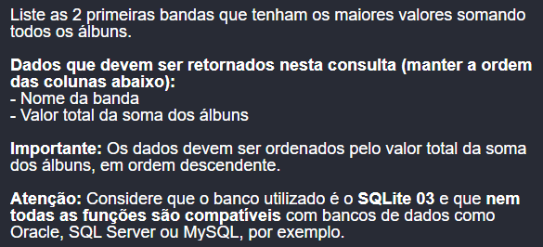

Select Top 2 a.nm_banda,

Sum(b.vl_album) vl_album_sum

From t_banda a

Join t_album b On a.id_banda = b.id_banda

Group By a.nm_banda

Order By vl_album_sum Desc;

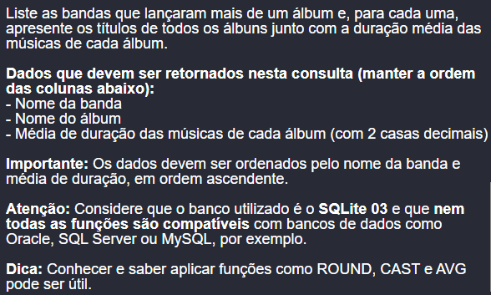

Select a.nm_banda,

a.nm_album,

a.nr_duracao_avg

From (Select a.nm_banda,

b.nm_album,

Cast(Round(Avg(c.nr_duracao), 2) As Decimal(3, 2)) nr_duracao_avg,

Count(1) qtde_album

From t_banda a

Join t_album b On a.id_banda = b.id_banda

Join t_musica c On b.id_album = c.id_album

Group By a.nm_banda,

b.nm_album) a

Where qtde_album > 1

Order By a.nm_banda Asc, a.nr_duracao_avg Asc;

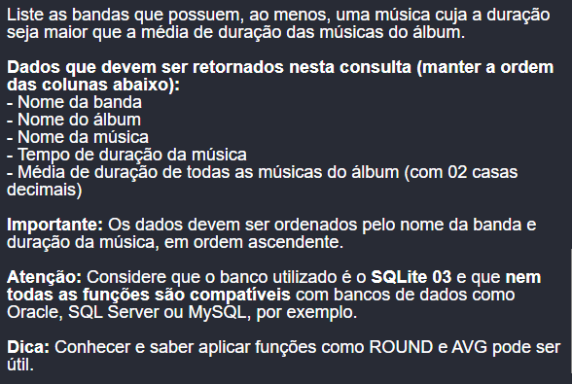

Select b.nm_banda,

c.nm_album,

d.nm_musica, d.nr_duracao,

a.nr_duracao_avg

From (Select a.id_banda,

a.id_album,

Cast(Round(Avg(b.nr_duracao), 2) As Decimal(3, 2)) nr_duracao_avg

From t_album a

Join t_musica b On a.id_album = b.id_album

Group By a.id_banda,

a.id_album) a

Join t_banda b On a.id_banda = b.id_banda

Join t_album c On a.id_banda = c.id_banda

And a.id_album = c.id_album

Join t_musica d On c.id_album = d.id_album

Where d.nr_duracao > a.nr_duracao_avg

Order By b.nm_banda Asc, d.nr_duracao Asc;

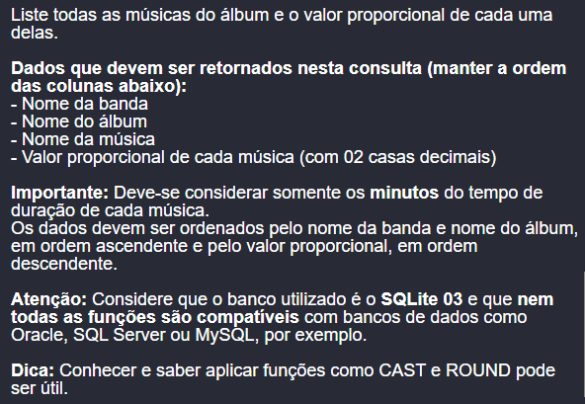

Select a.nm_banda,

a.nm_album,

a.nm_musica,

(a.nr_duracao_segundos * a.vl_album_nr_duracao_divisao) valor_proporcional

From (Select b.nm_banda,

c.nm_album,

d.nm_musica,

(Cast(d.nr_duracao As Integer) * 60) + (Cast(((d.nr_duracao - Cast(d.nr_duracao As Integer)) * 100) As Integer)) nr_duracao_segundos,

Cast((c.vl_album / a.nr_duracao_segundos_soma) As Decimal(12, 2)) vl_album_nr_duracao_divisao

From (Select a.id_album, a.id_banda,

Sum((Cast(b.nr_duracao As Integer) * 60) + (Cast(((b.nr_duracao - Cast(b.nr_duracao As Integer)) * 100) As Integer))) nr_duracao_segundos_soma

From t_album a

Join t_musica b On a.id_album = b.id_album

Group By a.id_album, a.id_banda) a

Join t_banda b On a.id_banda = b.id_banda

Join t_album c On a.id_album = c.id_album

And a.id_banda = c.id_banda

Join t_musica d On c.id_album = d.id_album) a

Order By a.nm_banda Asc, a.nm_album Asc, valor_proporcional Desc;