Seedance 1.5 pro: A Native Audio-Visual Joint Generation Foundation Model
ByteDance Seed
UTF8gbsn
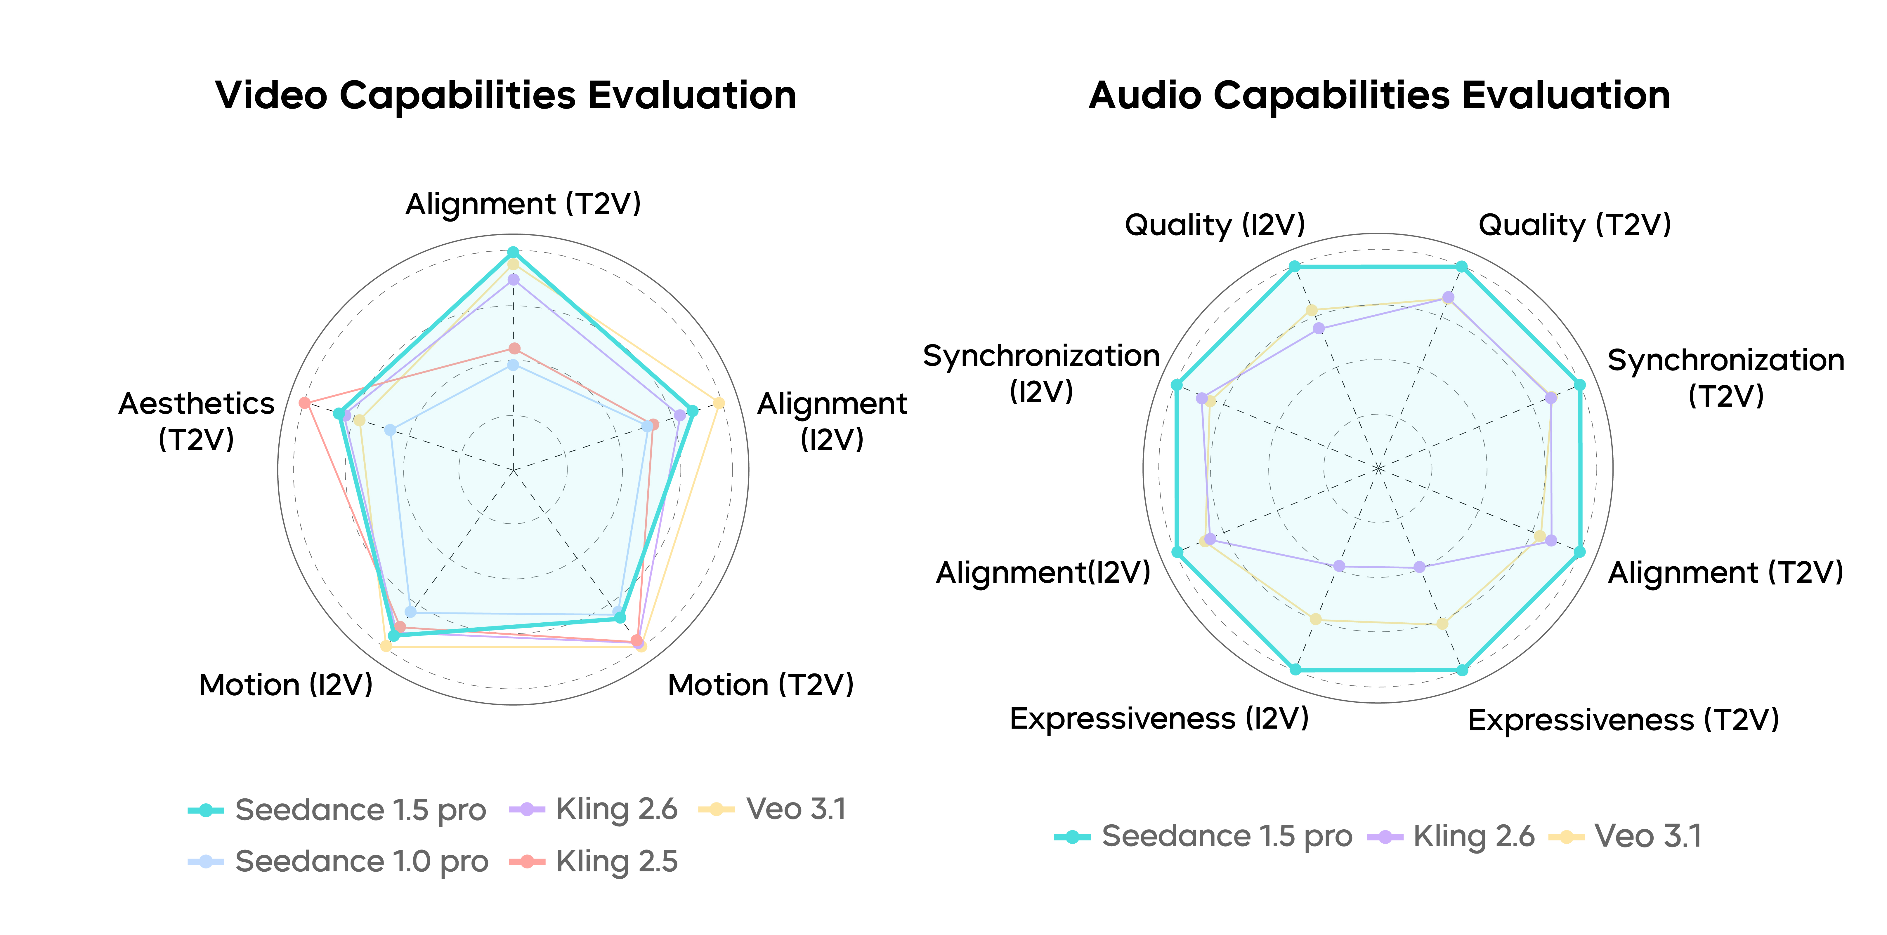
Overall Evaluation. Left: Video Evaluation; Right: Audio Evaluation.

Introduction
Over the past year, the field of visual (video) generation has seen rapid development. The emergence of proprietary commercial systems, such as Veo, Sora, Kling series and Seedance , alongside open-source models like Wan and Hunyuan Video 1.5 , has significantly propelled the widespread adoption of video generation technologies across both academia and industry. More recently, substantial progress has been made in joint audio-video generation. The release of Wan 2.5, Kling 2.6, and Sora 2 marks a solid step forward, transforming video generation capabilities into practical, utility-driven tools.
In this work, we present Seedance 1.5 pro, a foundational model designed with native support for joint video-audio generation. It is capable of performing a diverse range of tasks, including text-to-audio-video synthesis and image-guided audio-video generation. Seedance 1.5 pro incorporates the following key technical advancements:
- Comprehensive Audio–Visual Data Framework. We present a holistic data framework for high-quality video–audio generation that integrates a multi-stage curation pipeline, an advanced captioning system, and scalable infrastructure. The pipeline prioritizes video–audio coherence, motion expressiveness, and curriculum-based data scheduling, while our captioning system provides rich, professional-grade descriptions for both video and audio modalities. This robust framework is underpinned by an efficient engineering infrastructure optimized for massive multi-modal data processing.
- Unified Multimodal Joint Generation Architecture. To achieve native video–audio joint synthesis, we propose a unified framework based on the MMDiT architecture. This design facilitates deep cross-modal interaction, ensuring precise temporal synchronization and semantic consistency between visual and auditory streams. By leveraging multi-task pre-training on large-scale mixed-modality datasets, our model achieves robust generalization across diverse downstream tasks, including Text-to-Video-Audio (T2VA), Image-to-Video-Audio (I2VA), and unimodal video generation (T2V, I2V).
- Meticulous Post-training Optimization. We utilized high-quality audio-video datasets for Supervised Fine-Tuning (SFT), followed by a Reinforcement Learning from Human Feedback (RLHF) algorithm specifically tailored for audio-video contexts. Specifically, our multi-dimensional reward model enhances performance in Text-to-Video (T2V) and Image-to-Video (I2V) tasks, improving motion quality, visual aesthetics, and audio fidelity. Moreover, targeted infrastructure optimizations to our RLHF pipeline have yielded a nearly 3$×$ improvement in training speed.
- Efficient Inference Acceleration. We further optimized a multi-stage distillation framework to substantially reduce the Number of Function Evaluations (NFE) required during generation. By integrating inference infrastructure optimizations—such as quantization and parallelism, we achieved an end-to-end acceleration exceeding 10× while preserving model performance.
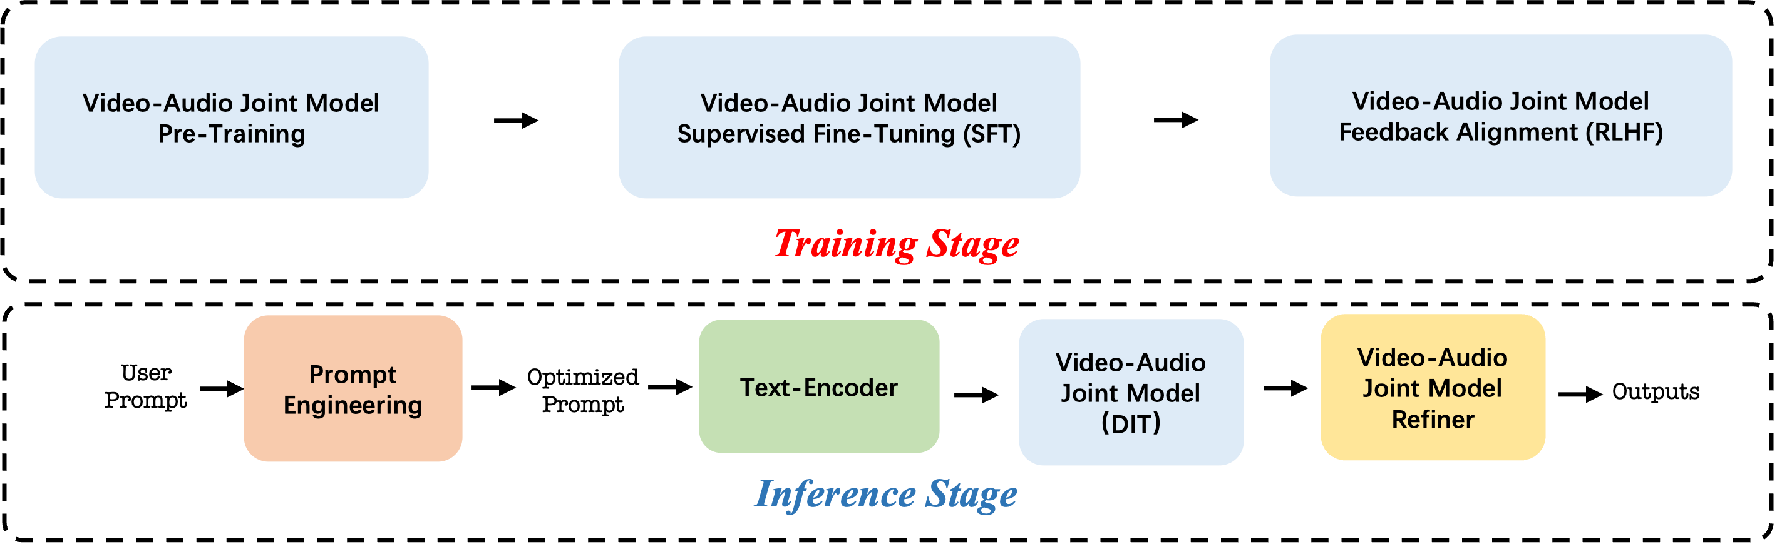
Overview of training and inference pipeline of Seedance 1.5 pro.
Seedance 1.5 pro aims to elevate the ceiling of visual impact and motion expressiveness. Seedance 1.5 pro demonstrates comprehensive advancements in multilingual adaptation, motion expressiveness, camera scheduling, and dialect delivery. Its performance in scenarios such as Chinese film production, short dramas, and traditional performing arts demonstrates significant potential for practical application in multi-shot video generation workflows:
- Precise Audio-Visual Synchronization and Multilingual Support. The model realizes high audio-visual consistency during generation, significantly improving the alignment accuracy of lip movements, intonation, and performance rhythm. It natively supports multiple languages and regional dialects, accurately capturing their unique vocal prosody and emotional tension. This capability imparts a natural performance quality to stylized narratives, such as comedies and animations, thereby greatly enhancing character atmosphere and expressiveness.
- Cinematic Camera Control and Dynamic Tension. The model possesses autonomous camera scheduling capabilities, enabling the execution of complex movements such as continuous long takes and dolly zooms (Hitchcock zoom). Additionally, it achieves cinematic scene transitions and professional color grading, substantially enhancing the dynamic tension of the video.
- Enhanced Semantic Understanding and Narrative Coherence. Through strengthened semantic understanding, Seedance 1.5 pro achieves precise analysis of narrative contexts. It significantly improves the overall narrative coordination of audio-visual segments, providing strong support for professional-grade content creation.
Seedance 1.5 pro is scheduled to be integrated into multiple platforms, including Doubaoand Jimeng, by December 2025. We envision this model serving as a vital productivity tool, designed to enhance both professional workflows and daily creative applications.

Model Design

Variational Autoencoder
Variational Autoencoders (VAEs) play a pivotal role in reducing the computational burden of diffusion models by compressing high-dimensional raw signals into compact latent representations, thereby facilitating efficient training and inference. The proposed Seedance 1.5 pro leverages two distinct VAE models to handle multimodal data. Specifically, we adopt the pre-trained 3D video VAE from Seedance 1.0 to compress visual data, and develop a universal audio VAE that efficiently compresses complex audio encompassing speech, sound effects, and music.

Diffusion Transformer
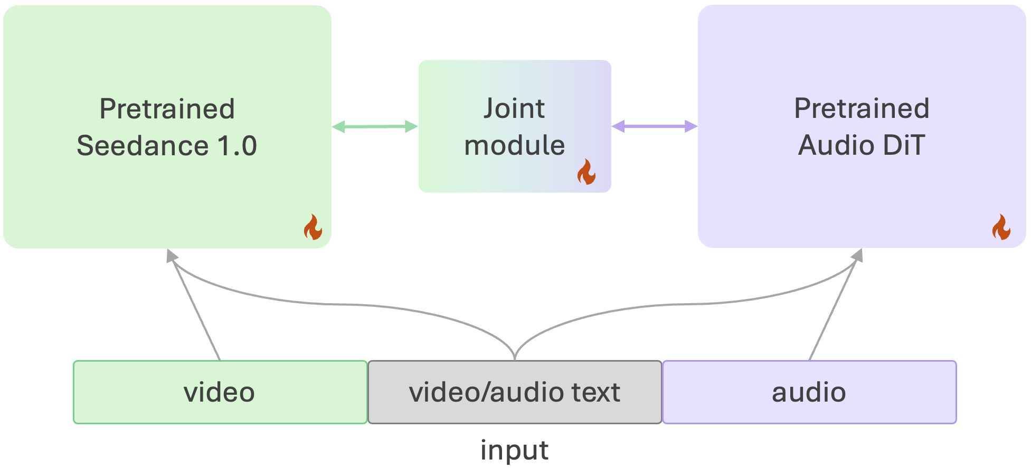
The proposed diffusion transformer model of Seedance 1.5 pro .
The proposed diffusion transformer architecture of Seedance 1.5 pro is constructed upon the MMDiT architecture , as illustrated in Figure 3. To accelerate convergence, the system employs a dual-branch topology. Specifically, we initialize the video branch using weights from the pre-trained Seedance 1.0 Pro model, while the MMDiT-based audio branch is pre-trained from scratch to serve as a robust initialization. To facilitate the synthesis of multimodal representations, we introduce specialized cross-modal joint modules that interconnect the two DiT backbones. During joint training, the video DiT processes visual and textual inputs, while the audio DiT concurrently handles auditory and textual data. The joint modules function as a structural bridge, enabling the effective learning of cross-modality information. During training, the parameters of all modules are trained.

Diffusion Refiner
For high-resolution audio-video generation, we employ a cascaded diffusion framework analogous to Seedance 1.0, distinguished primarily by the integration of an additional audio signal input to support joint generation.

Prompt Engineering (PE)
The role of the Prompt Engineering model is to understand the content and intention of users’ input (user prompt) and convert it into a Caption-style format recognizable by the DiT model. We sampled a large amount of high-quality data from the Continue Training (CT) and Supervised Fine-Tuning (SFT) stages, spanning multiple domains. Based on the caption model, we trained the model to acquire rewriting capabilities for Image-to-Video (I2V) and Text-to-Video (T2V) tasks. To enhance the model’s performance in the test time, we manually annotated a batch of data with rich expressiveness and narrative qualities. This enables the model to demonstrate more comprehensive and reasonable creative capabilities under crude and generalized user prompts.

Data

Data Curation Pipeline
To construct a dataset capable of high-fidelity audio–visual generation, we design a comprehensive multi-stage data curation pipeline. Compared with the earlier vision-only version, the upgraded pipeline pays more attention to audio–visual coherence, motion expressiveness, and a curriculum-oriented data stage. Each component of the pipeline is listed below in detail.
Holistic Audio–Visual Sourcing. Firstly, we collecting data that captures the full spectrum of interactions between visual dynamics and acoustic environments. The sourcing strategy maintains diversity across subjects, scenes, styles, and motion patterns, while simultaneously ensuring wide coverage of audio modalities. This includes variations in human speech across languages and speaking styles, environmental ambience spanning natural and urban contexts, mechanical and object-induced sound events, and other acoustic cues that tightly correlate with visual motion. The goal is to obtain a balanced corpus in which vision features are matched with equally diverse and representative audio ones.
Audio-Aware Temporal Segmentation. Traditional segmentation pipelines rely solely on visual shot boundaries, which often disrupt coherent audio events. To mitigate this issue, we introduce an audio-aware segmentation mechanism that jointly analyzes visual transitions and short-time acoustic cues. A segment boundary is retained only when visual discontinuities coincide with audio-level evidence, such as a natural pause or a low-activity interval in the soundtrack. This produces clips that preserve semantic continuity in both modalities and ensure that each segment forms a meaningful unit for training audio–visual generation models.
Multimodal Quality Filtering. We apply a rigorous filtering stage to enforce high perceptual quality and safety requirements across both audio and visual channels. Visual quality screening uses a combination of fidelity predictors, aesthetic scoring models, and color consistency metrics. Low-resolution or poorly composed clips are removed. To further improve temporal expressiveness, motion characteristics are evaluated to enable the exclusion of segments with weak, trivial, or uninformative motion. Audio quality is examined through signal-level diagnostics that detect silence, low signal-to-noise ratio, excessive amplification, and other forms of degradation. We use an audio–visual synchronization estimator to measure temporal correspondence between audio and visual actions. Clips exhibiting severe misalignment are discarded to guarantee reliable temporal pairing between modalities.
Joint Audio–Visual Distribution Rebalancing. Large-scale raw collections display substantial long-tail imbalances across both visual and acoustic dimensions. To achieve a well-behaved training distribution, we rebalance the data jointly across visual categories (e.g., object-centric scenes, human-centric activities, and landscape environments) and audio categories (including speech, ambient noise, music, and mechanical or natural sound events). The joint distribution over the Cartesian product of these categories reveals underrepresented combinations that arise infrequently in web-scale data, such as uncommon actions paired with rare environmental acoustics. We increase the sampling weight of such sparse pairs while reducing redundancy among overwhelmingly frequent ones. This recalibration improves the diversity of cross-modal contexts and encourages robust generalization over the full audio–visual manifold.
Curriculum-Based Data Staging. The curated dataset is organized into a multi-stage curriculum designed to gradually strengthen the model’s capacity for audio–visual alignment and generative fidelity. The first stage focuses on enabling the model to acquire fundamental cross-modal correspondence and temporal grounding. The second stage introduces more complex motion patterns, challenging acoustic conditions, multi-speaker or multi-source environments, and scenes where overlapping or rapidly changing sound events occur. As the model progresses through the curriculum, it experiences increasingly difficult audio–visual interactions, ultimately building the ability to synthesize coherent, realistic, and contextually appropriate audio for a wide variety of dynamic visual scenarios.

Video Captioning
Based on the captioner of Seedance 1.0, we further enhanced the richness of content descriptions, encompassing more detailed depictions of camera movements, actions, and aesthetic elements. Additionally, we have improved the accuracy of shot transition detection and text recognition capabilities. While ensuring accuracy, we also strengthened the professionalism of domain-specific descriptions and the differentiation between descriptions of content with varying quality, tailored to data from different fields.
To enable audio generation, we further added audio descriptions in the caption, covering multiple types such as dialogue, music, and sound effects. Similar to video descriptions, audio descriptions also maintain the richness of content.
We utilized the in-house Seed Omni Model to train our captioner, which possesses strong video understanding, text recognition and audio recognition capabilities. Simultaneously, we performed quantization acceleration on the model, enabling it to handle annotation for massive volumes of training data.

Efficient Engineering Infrastructure
The data pipeline for video generation is required to process multi-modal inputs from videos, images, audio, and text. Sustaining a daily processing throughput of several hundreds of millions imposes stringent requirements on performance optimization. Firstly, at the resource level, our engineering pipeline is equipped with exceptional flexibility, reflected in its ability to inference with various forms of unstable computing resources. Examples include on-demand preemptive resources, reserved resources available only within specific time windows, and low-cost CPU resources. Meanwhile, through a well-designed pipeline parallelism mechanism, we achieve high levels of asynchronous parallelism to maximize the utilization of CPUs and GPUs. Finally, by building automation infrastructure, we minimize human intervention in the data processing workflow, reduce operational dependency and intermediate waiting time, and fully leverage available computing resources.

Model Training
As shown in Figure 4, we illustrate the training and inference phases of Seedance 1.5. Our training process consists of three sub-stages, including Pre-training, Supervised Fine-Tuning (SFT), and Human Feedback Alignment (RLHF). During inference, the Prompt Engineering model parses the user prompt into audio and visual prompts and then feeds them together into the Audio-Video joint model.

Overview of training and inference pipeline.

Pre-Training
To achieve native video-audio joint synthesis, we propose a cross-modality joint-model based on the MMDiT architecture, which facilitates deep cross-modality information interaction, ensuring temporal synchronization and semantic consistency between visual and auditory streams. The pre-training stage employs multi-task joint training on a large-scale mixed-modality dataset, enabling the model to generalize across diverse downstream tasks, including Text-to-Audio-Video (T2AV), Image-to-Audio-Video (I2AV), as well as unimodal video generation (T2V, I2V).

Supervised Fine-Tuning (SFT)
After Pre-Training stage, we conduct a supervised fine-tuning stage (SFT) to further align the model’s generative capabilities with human preferences. Specifically, targeting improving visual aesthetics, motion coherence, and audio fidelity, we construct a high-quality dataset of audio-visual-text triplets, meticulously curated across hundreds of categories that define specific visual styles, motion dynamics, and acoustic attributes. During the training process, we adopt a refined stepwise annealing strategy. This approach allows us to progressively adjust the learning rate and data distribution, ensuring that the model stabilizes effectively while retaining precise text controllability. Furthermore, to fully leverage high-quality data, we train different expert models on distinct sub-domains and subsequently integrate their strengths via the model merging technique. This combination of curated data, strategic annealing, and parameter fusion significantly enhances the performance of the model, resulting in superior visual quality, fluid motion, and synchronized audio in video generation.

Human Feedback Alignment (RLHF)
Reinforcement Learning from Human Feedback (RLHF) has become a pivotal optimization technique in visual generation, widely adopted by prominent models such as Qwen-Image, Hunyuan-Video 1.5, the Seedream series , and Seedance 1.0. To advance our joint audio-video generation capabilities, we have designed a multi-component reward system comprising three specialized models (RMs): Audio-Video Alignment, Motion Dynamics, and Aesthetics. The annotation process for each RM is meticulously designed to capture fine-grained, domain-specific corresponding sub-dimensions. Architecturally, the Audio-Video Alignment RM is built upon our in-house Seed Vision-Language Omni Model (mulitimodal VLM), while the Motion Dynamics and Aesthetics RMs follow the established practices of Seedance 1.0. Our RLHF optimization strategy is to maximize the aggregate reward score of these three RMs across a range of generation tasks (e.g., T2V, T2VA, I2VA), thereby holistically enhancing the model’s performance across all corresponding qualitative dimensions. Moreover, targeted infrastructure optimizations to our RLHF pipeline have yielded a nearly 3x improvement in training speed.

Inference Optimizations

Model Acceleration
We employ diffusion distillation to expedite DiT inference by lowering the number of required function evaluations (NFE) during generation. Building on the distillation scheme used in Seedance 1.0, we further refine the TSCD pipeline in HyperSD by incorporating meanflow distillation strategy. Specifically, we apply multi-segment average-velocity transformations to the original joint video–audio generation trajectories. This design enables our model to perform coupled video–audio generation more efficiently. To further enhance acceleration, we adopt a score-based distillation scheme inspired by RayFlow . The student is trained to approximate the teacher’s score via an expected noise-consistency objective, enabling trajectory-level optimization. This yields more reliable sampling at low NFEs and reduces artifacts during fast inference. Finally, a human-preference-guided adversarial training mitigates low-step inference artifacts.Human evaluation confirms that the accelerated model maintains video and audio quality on par with the original.

Inference Infrastructure
Following Seedance 1.0, we further integrate a suite of proprietary optimization algorithms—including kernel fusion, fine‑grained mixed‑precision quantization, and adaptive sparsity—to enhance the performance of key components across the inference pipeline, such as the DiT, VAE, and prompt‑engineering modules. Tailored hybrid parallelization strategies are applied to both the DiT and VAE models, reducing runtime memory while improving multi‑GPU scaling efficiency. By combining decomposition‑based and fusion‑based computation‑communication overlap techniques, we design a comprehensive topology‑aware overlapping scheme that avoids SM contention and enhances kernel efficiency through carefully tuned granularity. To further reduce communication volume, we introduce an 8‑bit communication strategy co‑designed with a model quantization approach to achieve comparable performance. Additionally, an automatic hardware‑aware asynchronous offloading mechanism is implemented to resolve out‑of‑memory issues on heterogeneous GPU settings. With comprehensive pipeline optimizations, we substantially improve inference throughput, reduce communication and memory overhead, and achieve a significant leap in end-to-end efficiency while maintaining high generation quality.

Training Infrastructures
To enable efficient large-scale pre-training of the DiT model, we design a highly optimized training system that emphasizes hardware efficiency, scalability, and robustness. The key components are summarized as follows. Parallelism and Memory Optimization. We employ Hybrid Sharded Data Parallelism (HSDP) to efficiently shard weights and support large-scale training without resorting to tensor or expert parallelism. Memory usage is optimized through timely release of hidden states, activation offloading, and enhanced FSDP support, enabling training of large models within available GPU resources. Kernel and Workload Optimization. Performance-critical operations are accelerated by combining torch.compile with handcrafted CUDA kernels and operator fusion, reducing redundant memory access. To address workload imbalance from variable sequence lengths, we introduce a global greedy sample allocation strategy with asynchronous pipelines, achieving more balanced per-GPU utilization. Fault Tolerance. Multi-level fault tolerance is built into the system, including periodic checkpointing of model, optimizer, and dataloader states, pre-launch health checks to exclude faulty nodes, and reduced initialization overhead. These measures ensure stability and sustained throughput during long-term distributed training.

