**Assg-4 CSS**

Khela Friday

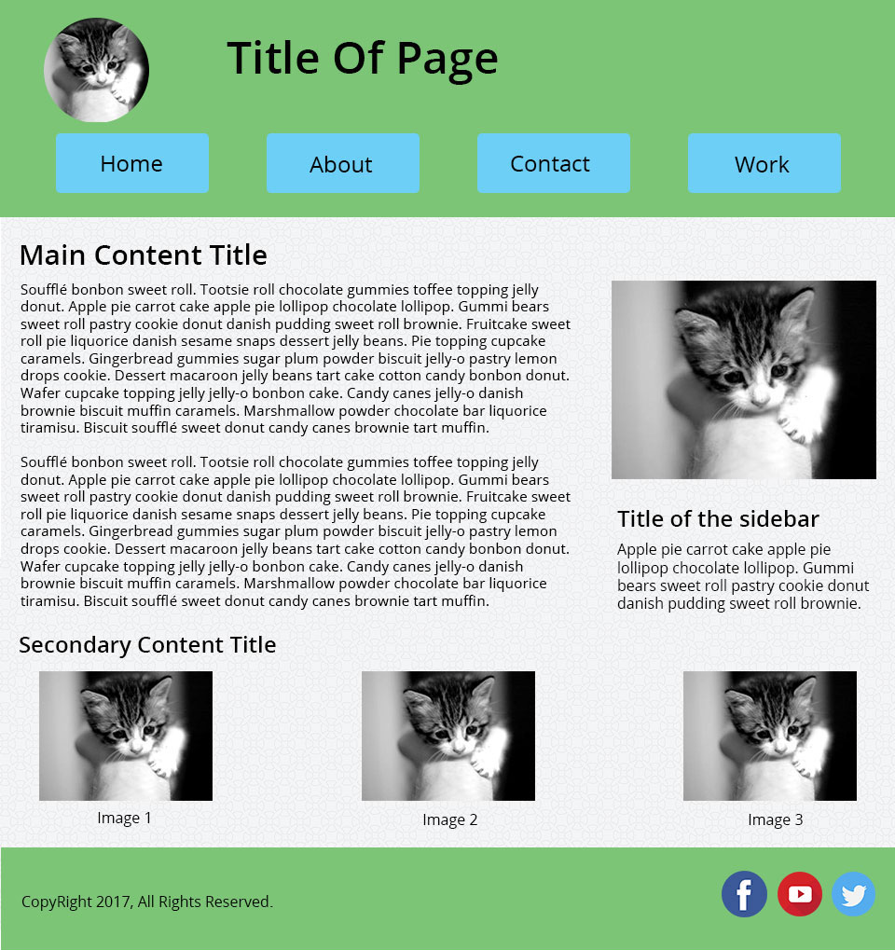

**Colours:**

*Color Used for Used as RGB Values*

Black Text Primary

Green Background Primary - RGB(124,197,118)

Blue Navigation Accent - RGB(109,207,246)

**Background Images:**

URL: https://www.toptal.com/designers/subtlepatterns/white-waves-pattern/

Style: White Waves Pattern