МИНИСТЕРСТВО ОБРАЗОВАНИЯ И НАУКИ РОССИЙСКОЙ ФЕДЕРАЦИИ

Федеральное автономное бюджетное образовательное учреждение высшего образования

«Севастопольский государственный университет»

кафедра Информационных систем

Куркчи Ариф Эрнестович

Институт информационных технологий и управления в технических системах

курс 3 группа ИС/б-31-о

09.03.02 Информационные системы и технологии (уровень бакалавриата)

ОТЧЕТ

по лабораторной работе №1

по дисциплине «Технологии баз данных»

на тему «Анализ предметной области, подлежащей информатизации. Информационное моделирование в MySQL Workbench»

Отметка о зачете ____________________ ________

(дата)

Руководитель практикума

ст. преподаватель   И. С. Тимофеев

(должность) (подпись) (инициалы, фамилия)

Севастополь 2016

1. ЦЕЛЬ РАБОТЫ

Осуществление исследования и анализа предметной области, построение диаграммы «сущность-связь», модели данных, основанной на ключах и получение навыков работы с инструментом MySQL Workbench.

1. ПОСТАНОВКА ЗАДАЧИ

Персональный вариант «Электронный журнал старосты»

База данных должна хранить списки групп, занятий, преподавателей и преподаваемые дисциплины, списки университетов, институтов и кафедр. Должна присутствовать возможность подсчёта пропусков, а учёт пропусков должен предусматривать наличие уважительной причины пропуска и хранение справки.

1. МОДЕЛЬ БАЗЫ ДАННЫХ

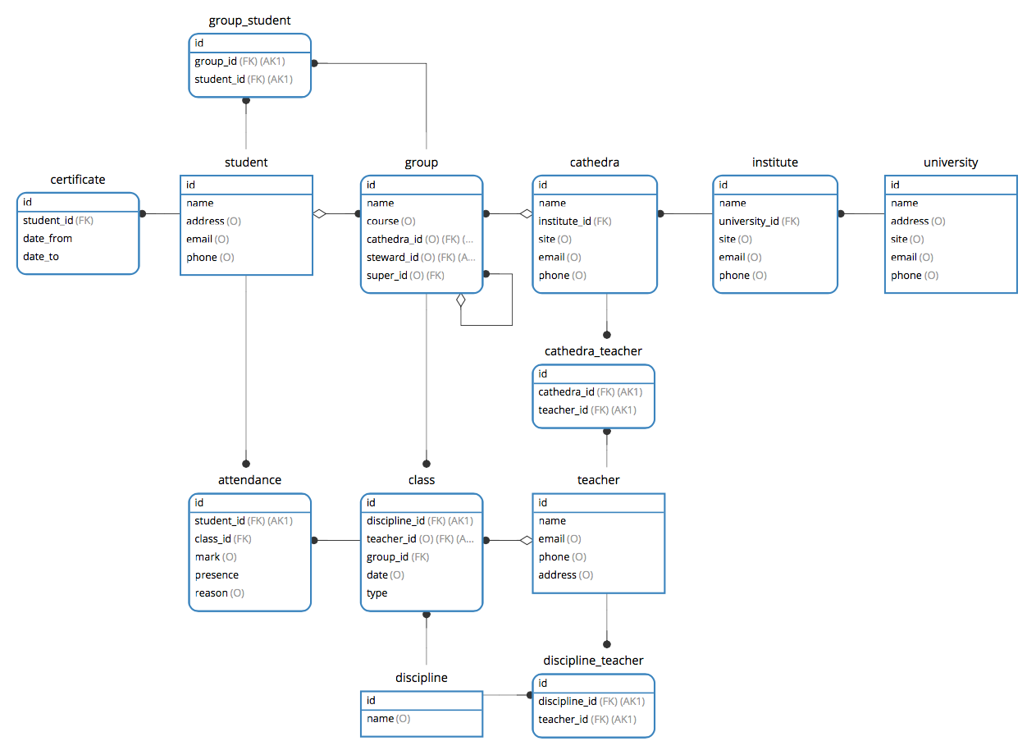

Рисунок 1 – Модель базы данных по методологии IDEF1

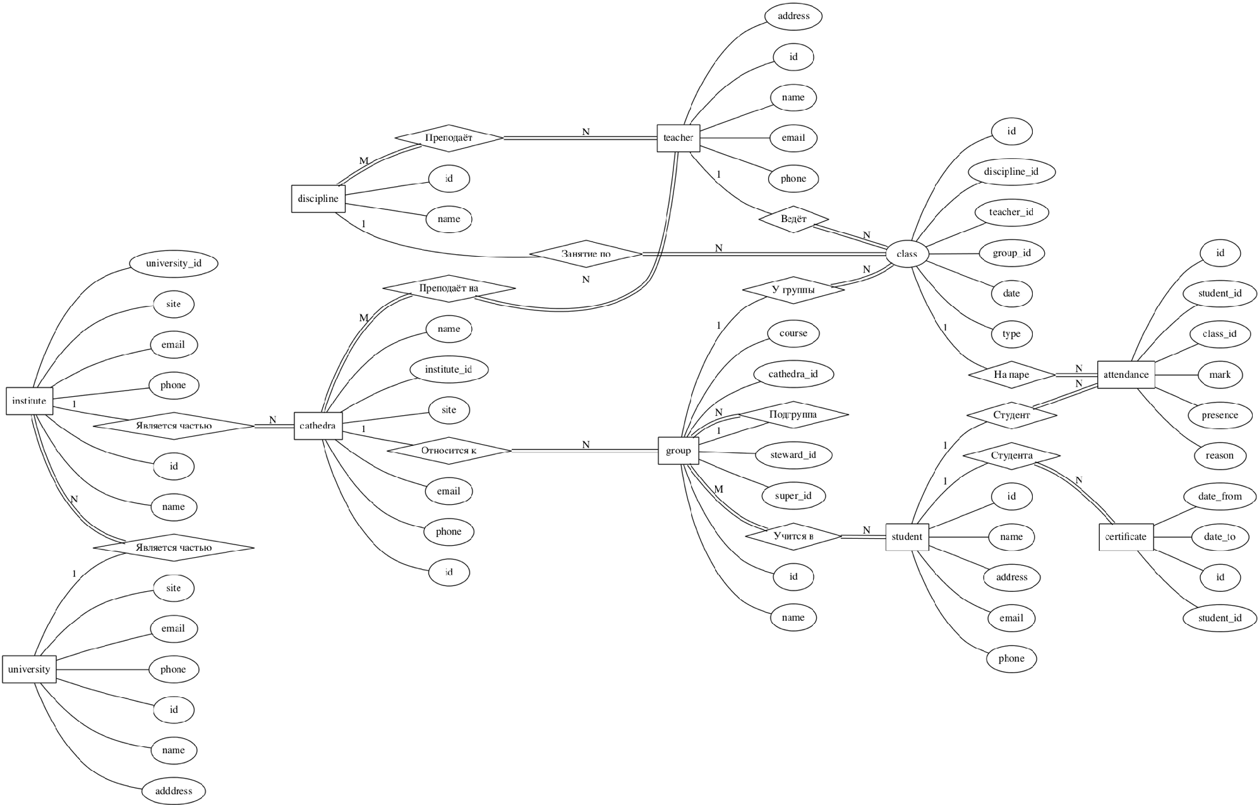

Рисунок 2 – Модель базы данных в нотации П. Ченна

1. СОЗДАНИЕ БАЗЫ ДАННЫХ

|  |  |  |  |  |  |  |  |  |  |  |  |  |  |  |  |  |  |  |  |  |  |  |  |  |  |  |  |  |  |  |  |  |  |  |  |  |  |  |  |  |  |  |  |  |  |  |  |  |  |  |  |  |  |  |  |  |  |  |  |  |  |  |  |  |  |  |  |  |  |  |  |  |  |  |  |  |  |  |  |  |  |  |  |  |  |  |  |  |  |  |  |  |  |  |  |  |  |  |  |  |  |  |  |  |  |  |  |  |  |  |  |  |  |  |  |  |  |  |  |  |  |  |  |  |  |  |  |  |  |  |  |  |  |  |  |  |  |  |  |  |  |  |  |  |  |  |  |  |  |  |  |  |  |  |  |  |  |  |  |  |  |  |  |  |  |  |  |  |  |  |  |  |  |  |  |  |  |  |  |  |  |  |  |  |  |  |  |  |  |  |  |  |  |  |  |  |  |  |  |  |  |  |  |  |  |  |  |  |  |  |  |  |  |  |  |  |  |  |  |  |  |  |  |  |  |  |  |  |  |  |  |  |  |  |  |  |  |  |  |  |  |  |  |  |  |  |  |  |  |  |  |  |  |  |  |  |  |  |  |  |  |  |  |  |  |  |  |  |  |  |  |  |  |  |  |  |  |  |  |  |  |  |  |  |  |  |  |  |  |  |  |  |  |  |  |  |  |  |  |  |  |  |  |  |  |  |  |  |  |  |  |  |  |  |  |  |  |  |  |  |  |  |  |  |  |  |  |  |  |  |  |  |  |  |  |  |  |  |  |  |  |  |  |  |  |  |  |  |  |  |  |  |  |  |  |  |  |  |  |  |  |  |  |  |  |  |  |  |  |  |  |  |  |  |  |  |  |  |  |  |  |  |  |  |  |  |  |  |  |  |  |  |  |  |  |  |  |  |  |  |  |  |  |  |  |  |  |  |  |
| --- | --- | --- | --- | --- | --- | --- | --- | --- | --- | --- | --- | --- | --- | --- | --- | --- | --- | --- | --- | --- | --- | --- | --- | --- | --- | --- | --- | --- | --- | --- | --- | --- | --- | --- | --- | --- | --- | --- | --- | --- | --- | --- | --- | --- | --- | --- | --- | --- | --- | --- | --- | --- | --- | --- | --- | --- | --- | --- | --- | --- | --- | --- | --- | --- | --- | --- | --- | --- | --- | --- | --- | --- | --- | --- | --- | --- | --- | --- | --- | --- | --- | --- | --- | --- | --- | --- | --- | --- | --- | --- | --- | --- | --- | --- | --- | --- | --- | --- | --- | --- | --- | --- | --- | --- | --- | --- | --- | --- | --- | --- | --- | --- | --- | --- | --- | --- | --- | --- | --- | --- | --- | --- | --- | --- | --- | --- | --- | --- | --- | --- | --- | --- | --- | --- | --- | --- | --- | --- | --- | --- | --- | --- | --- | --- | --- | --- | --- | --- | --- | --- | --- | --- | --- | --- | --- | --- | --- | --- | --- | --- | --- | --- | --- | --- | --- | --- | --- | --- | --- | --- | --- | --- | --- | --- | --- | --- | --- | --- | --- | --- | --- | --- | --- | --- | --- | --- | --- | --- | --- | --- | --- | --- | --- | --- | --- | --- | --- | --- | --- | --- | --- | --- | --- | --- | --- | --- | --- | --- | --- | --- | --- | --- | --- | --- | --- | --- | --- | --- | --- | --- | --- | --- | --- | --- | --- | --- | --- | --- | --- | --- | --- | --- | --- | --- | --- | --- | --- | --- | --- | --- | --- | --- | --- | --- | --- | --- | --- | --- | --- | --- | --- | --- | --- | --- | --- | --- | --- | --- | --- | --- | --- | --- | --- | --- | --- | --- | --- | --- | --- | --- | --- | --- | --- | --- | --- | --- | --- | --- | --- | --- | --- | --- | --- | --- | --- | --- | --- | --- | --- | --- | --- | --- | --- | --- | --- | --- | --- | --- | --- | --- | --- | --- | --- | --- | --- | --- | --- | --- | --- | --- | --- | --- | --- | --- | --- | --- | --- | --- | --- | --- | --- | --- | --- | --- | --- | --- | --- | --- | --- | --- | --- | --- | --- | --- | --- | --- | --- | --- | --- | --- | --- | --- | --- | --- | --- | --- | --- | --- | --- | --- | --- | --- | --- | --- | --- | --- | --- | --- | --- | --- | --- | --- | --- | --- | --- | --- | --- | --- | --- | --- | --- | --- | --- | --- | --- | --- | --- | --- | --- | --- | --- | --- | --- | --- | --- | --- | --- | --- | --- | --- | --- | --- | --- | --- | --- | --- | --- | --- | --- | --- | --- | --- | --- | --- | --- | --- | --- | --- | --- |
| |  |  | | --- | --- | | 1 | SET NAMES utf8; | | 2 | SET FOREIGN_KEY_CHECKS = 0; | | 3 |  | | 4 | -- ---------------------------- | | 5 | --  Table structure for `attendance` | | 6 | -- ---------------------------- | | 7 | DROP TABLE IF EXISTS `attendance`; | | 8 | CREATE TABLE `attendance` ( | | 9 | `id` *int*(11) NOT NULL AUTO_INCREMENT, | | 10 | `student_id` *int*(11) NOT NULL, | | 11 | `class_id` *int*(11) NOT NULL, | | 12 | `mark` *int*(10) DEFAULT NULL, | | 13 | `presence` *tinyint*(1) NOT NULL, | | 14 | `reason` enum('ill','conference','other') DEFAULT NULL, | | 15 | PRIMARY KEY (`id`), | | 16 | KEY `attendance_student_id_fk` (`student_id`), | | 17 | KEY `attendance_class_id_fk` (`class_id`), | | 18 | CONSTRAINT `attendance_class_id_fk` FOREIGN KEY (`class_id`) REFERENCES `class` (`id`) ON DELETE CASCADE ON UPDATE CASCADE, | | 19 | CONSTRAINT `attendance_student_id_fk` FOREIGN KEY (`student_id`) REFERENCES `student` (`id`) ON DELETE CASCADE ON UPDATE CASCADE | | 20 | ) ENGINE=InnoDB DEFAULT CHARSET=utf8; | | 21 |  | | 22 | -- ---------------------------- | | 23 | --  Table structure for `cathedra` | | 24 | -- ---------------------------- | | 25 | DROP TABLE IF EXISTS `cathedra`; | | 26 | CREATE TABLE `cathedra` ( | | 27 | `id` *int*(11) NOT NULL AUTO_INCREMENT, | | 28 | `name` *varchar*(255) NOT NULL, | | 29 | `institute_id` *int*(11) NOT NULL, | | 30 | `site` *varchar*(255) DEFAULT NULL, | | 31 | `email` *varchar*(255) DEFAULT NULL, | | 32 | `phone` *varchar*(255) DEFAULT NULL, | | 33 | PRIMARY KEY (`id`), | | 34 | KEY `cathedra_institute_id_fk` (`institute_id`), | | 35 | CONSTRAINT `cathedra_institute_id_fk` FOREIGN KEY (`institute_id`) REFERENCES `institute` (`id`) | | 36 | ) ENGINE=InnoDB DEFAULT CHARSET=utf8; | | 37 |  | | 38 | -- ---------------------------- | | 39 | --  Table structure for `cathedra_teacher` | | 40 | -- ---------------------------- | | 41 | DROP TABLE IF EXISTS `cathedra_teacher`; | | 42 | CREATE TABLE `cathedra_teacher` ( | | 43 | `id` *int*(11) NOT NULL AUTO_INCREMENT, | | 44 | `cathedra_id` *int*(11) NOT NULL, | | 45 | `teacher_id` *int*(11) NOT NULL, | | 46 | PRIMARY KEY (`id`), | | 47 | UNIQUE KEY `cathedra_teacher_cathedra_id_teacher_id_uindex` (`cathedra_id`,`teacher_id`), | | 48 | KEY `cathedra_teacher_teacher_id_fk` (`teacher_id`), | | 49 | CONSTRAINT `cathedra_teacher_cathedra_id_fk` FOREIGN KEY (`cathedra_id`) REFERENCES `cathedra` (`id`) ON DELETE CASCADE ON UPDATE CASCADE, | | 50 | CONSTRAINT `cathedra_teacher_teacher_id_fk` FOREIGN KEY (`teacher_id`) REFERENCES `teacher` (`id`) ON DELETE CASCADE ON UPDATE CASCADE | | 51 | ) ENGINE=InnoDB DEFAULT CHARSET=utf8; | | 52 |  | | 53 | -- ---------------------------- | | 54 | --  Table structure for `certificate` | | 55 | -- ---------------------------- | | 56 | DROP TABLE IF EXISTS `certificate`; | | 57 | CREATE TABLE `certificate` ( | | 58 | `id` *int*(11) NOT NULL AUTO_INCREMENT, | | 59 | `student_id` *int*(11) NOT NULL, | | 60 | `date_from` *date* NOT NULL, | | 61 | `date_to` *date* NOT NULL, | | 62 | PRIMARY KEY (`id`), | | 63 | KEY `certificate_student_id_fk` (`student_id`), | | 64 | CONSTRAINT `certificate_student_id_fk` FOREIGN KEY (`student_id`) REFERENCES `student` (`id`) ON DELETE CASCADE ON UPDATE CASCADE | | 65 | ) ENGINE=InnoDB DEFAULT CHARSET=utf8; | | 66 |  | | 67 | -- ---------------------------- | | 68 | --  Table structure for `class` | | 69 | -- ---------------------------- | | 70 | DROP TABLE IF EXISTS `class`; | | 71 | CREATE TABLE `class` ( | | 72 | `id` *int*(11) NOT NULL AUTO_INCREMENT, | | 73 | `discipline_id` *int*(11) NOT NULL, | | 74 | `teacher_id` *int*(11) DEFAULT NULL, | | 75 | `group_id` *int*(11) NOT NULL, | | 76 | `date` *datetime* DEFAULT NULL, | | 77 | `type` enum('lection','laboratory','practice','seminar','course') NOT NULL, | | 78 | PRIMARY KEY (`id`), | | 79 | KEY `class_discipline_id_fk` (`discipline_id`), | | 80 | KEY `class_teacher_id_fk` (`teacher_id`), | | 81 | KEY `class_group_id_fk` (`group_id`), | | 82 | CONSTRAINT `class_discipline_id_fk` FOREIGN KEY (`discipline_id`) REFERENCES `discipline` (`id`) ON DELETE CASCADE ON UPDATE CASCADE, | | 83 | CONSTRAINT `class_group_id_fk` FOREIGN KEY (`group_id`) REFERENCES `group` (`id`) ON DELETE CASCADE ON UPDATE CASCADE, | | 84 | CONSTRAINT `class_teacher_id_fk` FOREIGN KEY (`teacher_id`) REFERENCES `teacher` (`id`) ON DELETE SET NULL ON UPDATE CASCADE | | 85 | ) ENGINE=InnoDB DEFAULT CHARSET=utf8; | | 86 |  | | 87 | -- ---------------------------- | | 88 | --  Table structure for `discipline` | | 89 | -- ---------------------------- | | 90 | DROP TABLE IF EXISTS `discipline`; | | 91 | CREATE TABLE `discipline` ( | | 92 | `id` *int*(11) NOT NULL AUTO_INCREMENT, | | 93 | `name` *varchar*(64) DEFAULT NULL, | | 94 | PRIMARY KEY (`id`) | | 95 | ) ENGINE=InnoDB DEFAULT CHARSET=utf8; | | 96 |  | | 97 | -- ---------------------------- | | 98 | --  Table structure for `discipline_teacher` | | 99 | -- ---------------------------- | | 100 | DROP TABLE IF EXISTS `discipline_teacher`; | | 101 | CREATE TABLE `discipline_teacher` ( | | 102 | `id` *int*(11) NOT NULL AUTO_INCREMENT, | | 103 | `discipline_id` *int*(11) NOT NULL, | | 104 | `teacher_id` *int*(11) NOT NULL, | | 105 | PRIMARY KEY (`id`), | | 106 | UNIQUE KEY `discipline_teacher_discipline_id_teacher_id_uindex` (`discipline_id`,`teacher_id`), | | 107 | KEY `discipline_teacher_teacher_id_fk` (`teacher_id`), | | 108 | CONSTRAINT `discipline_teacher_discipline_id_fk` FOREIGN KEY (`discipline_id`) REFERENCES `discipline` (`id`) ON DELETE CASCADE ON UPDATE CASCADE, | | 109 | CONSTRAINT `discipline_teacher_teacher_id_fk` FOREIGN KEY (`teacher_id`) REFERENCES `teacher` (`id`) ON DELETE CASCADE ON UPDATE CASCADE | | 110 | ) ENGINE=InnoDB DEFAULT CHARSET=utf8; | | 111 |  | | 112 | -- ---------------------------- | | 113 | --  Table structure for `group` | | 114 | -- ---------------------------- | | 115 | DROP TABLE IF EXISTS `group`; | | 116 | CREATE TABLE `group` ( | | 117 | `id` *int*(11) NOT NULL AUTO_INCREMENT, | | 118 | `name` *varchar*(64) NOT NULL, | | 119 | `course` *int*(2) DEFAULT NULL, | | 120 | `cathedra_id` *int*(11) DEFAULT NULL, | | 121 | `steward_id` *int*(11) DEFAULT NULL, | | 122 | `super_id` *int*(11) DEFAULT NULL, | | 123 | PRIMARY KEY (`id`), | | 124 | KEY `group_cathedra_id_fk` (`cathedra_id`), | | 125 | KEY `group_student_id_fk` (`steward_id`), | | 126 | KEY `group_group_id_fk` (`super_id`), | | 127 | CONSTRAINT `group_cathedra_id_fk` FOREIGN KEY (`cathedra_id`) REFERENCES `cathedra` (`id`) ON DELETE SET NULL ON UPDATE CASCADE, | | 128 | CONSTRAINT `group_group_id_fk` FOREIGN KEY (`super_id`) REFERENCES `group` (`id`) ON DELETE CASCADE ON UPDATE CASCADE, | | 129 | CONSTRAINT `group_student_id_fk` FOREIGN KEY (`steward_id`) REFERENCES `student` (`id`) ON DELETE SET NULL ON UPDATE CASCADE | | 130 | ) ENGINE=InnoDB DEFAULT CHARSET=utf8; | | 131 |  | | 132 | -- ---------------------------- | | 133 | --  Table structure for `group_student` | | 134 | -- ---------------------------- | | 135 | DROP TABLE IF EXISTS `group_student`; | | 136 | CREATE TABLE `group_student` ( | | 137 | `id` *int*(11) NOT NULL AUTO_INCREMENT, | | 138 | `group_id` *int*(11) NOT NULL, | | 139 | `student_id` *int*(11) NOT NULL, | | 140 | PRIMARY KEY (`id`), | | 141 | UNIQUE KEY `group_student_group_id_student_id_uindex` (`group_id`,`student_id`), | | 142 | KEY `group_student_student_id_fk` (`student_id`), | | 143 | CONSTRAINT `group_student_group_id_fk` FOREIGN KEY (`group_id`) REFERENCES `group` (`id`) ON DELETE CASCADE ON UPDATE CASCADE, | | 144 | CONSTRAINT `group_student_student_id_fk` FOREIGN KEY (`student_id`) REFERENCES `student` (`id`) ON DELETE CASCADE ON UPDATE CASCADE | | 145 | ) ENGINE=InnoDB DEFAULT CHARSET=utf8; | | 146 |  | | 147 | -- ---------------------------- | | 148 | --  Table structure for `institute` | | 149 | -- ---------------------------- | | 150 | DROP TABLE IF EXISTS `institute`; | | 151 | CREATE TABLE `institute` ( | | 152 | `id` *int*(11) NOT NULL AUTO_INCREMENT, | | 153 | `name` *varchar*(255) NOT NULL, | | 154 | `university_id` *int*(11) NOT NULL, | | 155 | `site` *varchar*(255) DEFAULT NULL, | | 156 | `email` *varchar*(255) DEFAULT NULL, | | 157 | `phone` *varchar*(255) DEFAULT NULL, | | 158 | PRIMARY KEY (`id`), | | 159 | KEY `institute_university_id_fk` (`university_id`), | | 160 | CONSTRAINT `institute_university_id_fk` FOREIGN KEY (`university_id`) REFERENCES `university` (`id`) ON DELETE CASCADE ON UPDATE CASCADE | | 161 | ) ENGINE=InnoDB DEFAULT CHARSET=utf8; | | 162 |  | | 163 | -- ---------------------------- | | 164 | --  Table structure for `student` | | 165 | -- ---------------------------- | | 166 | DROP TABLE IF EXISTS `student`; | | 167 | CREATE TABLE `student` ( | | 168 | `id` *int*(11) NOT NULL AUTO_INCREMENT, | | 169 | `name` *varchar*(255) NOT NULL, | | 170 | `address` *varchar*(255) DEFAULT NULL, | | 171 | `email` *varchar*(255) DEFAULT NULL, | | 172 | `phone` *varchar*(255) DEFAULT NULL, | | 173 | PRIMARY KEY (`id`) | | 174 | ) ENGINE=InnoDB DEFAULT CHARSET=utf8; | | 175 |  | | 176 | -- ---------------------------- | | 177 | --  Table structure for `teacher` | | 178 | -- ---------------------------- | | 179 | DROP TABLE IF EXISTS `teacher`; | | 180 | CREATE TABLE `teacher` ( | | 181 | `id` *int*(11) NOT NULL AUTO_INCREMENT, | | 182 | `name` *varchar*(255) NOT NULL, | | 183 | `email` *varchar*(255) DEFAULT NULL, | | 184 | `phone` *varchar*(255) DEFAULT NULL, | | 185 | `address` *varchar*(255) DEFAULT NULL, | | 186 | PRIMARY KEY (`id`) | | 187 | ) ENGINE=InnoDB DEFAULT CHARSET=utf8; | | 188 |  | | 189 | -- ---------------------------- | | 190 | --  Table structure for `university` | | 191 | -- ---------------------------- | | 192 | DROP TABLE IF EXISTS `university`; | | 193 | CREATE TABLE `university` ( | | 194 | `id` *int*(11) NOT NULL AUTO_INCREMENT, | | 195 | `name` *varchar*(255) NOT NULL, | | 196 | `address` *varchar*(255) DEFAULT NULL, | | 197 | `site` *varchar*(255) DEFAULT NULL, | | 198 | `email` *varchar*(255) DEFAULT NULL, | | 199 | `phone` *varchar*(255) DEFAULT NULL, | | 200 | PRIMARY KEY (`id`), | | 201 | UNIQUE KEY `university_name_uindex` (`name`) | | 202 | ) ENGINE=InnoDB DEFAULT CHARSET=utf8; | | 203 |  | | 204 | SET FOREIGN_KEY_CHECKS = 1; | |  |

ВЫВОДЫ

В ходе выполнения лабораторной работы была разработана база данных. Начальным этапом проектирования был анализ ПО, определение всех сущностей и атрибутов. Полученные сущности были отображены на диаграмме, при помощи которой были определены связи между таблицами. Далее была построена модель данных, основанная на ключах. В итоге были созданы необходимые сущности. При помощи foreign key определены связи между таблицами. Как результат была получена структуру БД.