**Examining Cryptocurrency Correlations with Heatmaps using Windowed Look Backs**

**Sameeullah Babar**

**Table of Contents:**

1. **Introduction: pg 3**
2. **Literature Review: pg3**
3. **Data and Methodology:**
4. **Results: pg 8**
5. **Conclusion: pg 13**
6. **Works Cited: pg 14**

**1. Introduction:**

In the last decade, cryptocurrency has become a juggernaut of non-traditional assets. Starting as a quaint form of decentralized payment, cryptocurrency is now at the forefront of the public zeitgeist, with investors ranging from Blue Collar Workers to major corporations and private equity firms. While cryptocurrency is an accessible and potentially profitable investment, the decentralized nature of cryptocurrency assets causes prices to fluctuate wildly. The Covid-19 pandemic caused an explosion in the price and exposure of cryptocurrency, with the drawback of increasing the volatility of said prices(Zhang and Mani 2021). This heavy volatility causes confusion and frustration in attempts to analyze and predict cryptocurrency trends as the price from week to week, even day to day, varies wildly with no real scale or benchmark to measure by. Using daily cryptocurrency data from March of 2021 through March of 2022, I seek to analyze correlation between cryptocurrencies over time using heat maps with windowed look backs of 365 days, 90 days, 60 days and 30 days in addition to the heatmap of the whole dataset.

**2. Literature Review:**

The main hallmark of cryptocurrencies is their use of peer to peer transactions in a decentralized environment, which has allowed cryptocurrency to expand into an alternative to traditional financial markets (Pham et al 2022). There are currently over 10,000 types of cryptocurrency, each with their own distinct take on blockchain technology. The most well known of these coins is also one of the oldest, Bitcoin. With a market cap of over 1 trillion dollars, Bitcoin is considered the market leader in cryptocurrency and the most secure coin (Mantha 2021). When most people hear of cryptocurrency, they think of Bitcoin. On approximately equal footing with Bitcoin is Ethereum, a cryptocurrency that uses smart-contracts to verify and record transactions on the blockchain, with Ether being the underlying token (Zhang and Mani 2021).Bitcoin and Etherium are the cryptocurrencies most frequently compared to traditional stocks and commodities to conduct financial analysis.

Bitcoin and Ethereum have grown to the point of being significantly correlated to other markets in addition to cross correlation with other cryptocurrencies(Pham et al 2022). However, what separates cryptocurrencies, even coins as large and secure as Bitcoin and Ethereum, from conventional investments is the high volatility of cryptocurrency value.With traditional assets, the value shifts due to changes in laws, regulation, and overall market conditions. In contrast, cryptocurrency prices mostly fluctuate as a result of "sentiment-driven investor reasoning”(James 2022). This is especially true with smaller cryptocurrencies, which are almost entirely dependent on their popularity to increase their value. A hallmark of cryptocurrency volatility is the “herding behavior” exhibited by investors, who feel a strong attachment and sense of community to their chosen coins, resulting in wild price fluctuations due to the fickle emotional cues of investors(Cary 2021). Even more stable coins like Bitcoin and Ethereum prices are partially determined due to their large following and investor hype, which has led to severe price drops and hikes in the past.

Social Media is the main catalyst for the herding behavior exhibited in cryptocurrency investors. Investors and cryptocurrency companies often use social media to hype up their coin to raise the value and acquire more investors. This behavior has led to the rise of certain social media influencers becoming “crypto-tastemakers”, whose opinions can heavily sway the price and value of coins they discuss(Cary 2021). The most famous example of a crypto-tastemaker influencing the price of a cryptocurrency is Elon Musk and his relationship with Dogecoin. During the first half of 2021, Tesla and SpaceX CEO Elon Musk began hyping up Dogecoin, a popular memecoin(a cryptocurrency that is bought mainly because investors think it’s funny), via twitter. These tweets included claims that “SpaceX is going to put a literal Dogecoin on the literal moon”, crowning himself as the “Dogefather”, and even allowing Tesla sales to be conducted in Dogecoin. Such tweets can be seen below. 



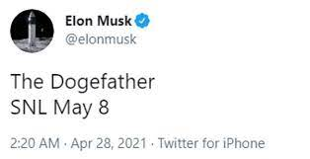

These tweets caused the price of Dogecoin to skyrocket, taking a coin with an average price of less than a cent to a price of 73 cents(Zhang and Mani 2021). This saga culminated in Elon Musk’s hosting of Saturday Night Live on May 8, 2021. Musk’s abysmal performance on the legendary sketch comedy show caused the price of Dogecoin to drop by 23.4 percent in real time with the broadcast(Cary 2021). Even now, Elon Musk’s influence continues to influence the price of Dogecoin despite his lack of tweets regarding the coin. In the wake of Elon Musk buying Twitter, the price of Dogecoin increased by approximately 27 percent(Macheel 2022).

The misadventures of Elon Musk and Dogecoin exemplify the issue in making informed investments in cryptocurrency. The fickle nature of cryptocurrency investors and the influence of crypto-tastemakers have led to volatility far exceeding that of traditional assets, even with some coins being significantly linked to other markets. Instead of comparing cryptocurrencies to standard markets, perhaps comparing cryptocurrencies to other cryptocurrencies can lead to improvements in prediction and analysis of cryptocurrency investments. By utilizing a heatmap with windowed look-back options, we can examine the correlations between cryptocurrencies at various points in time, accounting for any possible booms or drops due to cryptocurrency volatility. Additionally, because Bitcoin and Ethereum are correlated with standard markets, we can use cross-correlation to determine which coins are most responsive to standard market conditions.

**3. Data and Methodology:**

The data used for this analysis is sourced by Kaggle. It contains time series data on various coins starting on 12/31/2020 and ending at 03/06/2022. The dataset contained over 20 coins. I have narrowed this down to the 12 most well known coins. These coins are Cardano(ADA), Binance Coin(BNB), Bitcoin(BTC), Cronos(CRO), Dai(DAI), Dogecoin(Doge), Ether(ETH), Litecoin(LTC), Terra(LUNA), Solana(SOL), TRON(TRX), and Ripple(XRP). The Pearson correlation will be used for this analysis as it provides global synchrony across time series data.

**4. Results:**

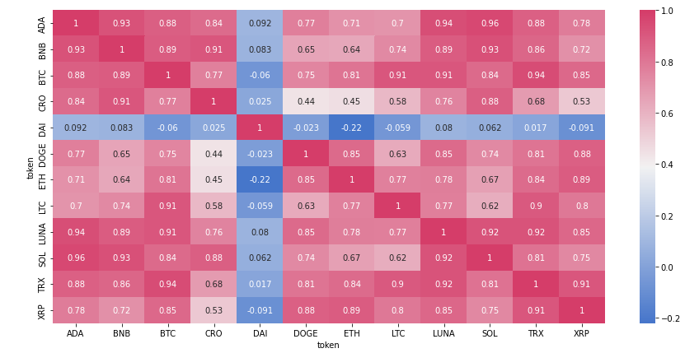

Starting with the windowed look back at 365 days, the heatmap is almost entirely red, with all the coins being highly correlated with each other. The exception to this rule is DAI, a stable coin which strives to maintain a price of 1 USD per coin and is generally uncorrelated with other non-stable coins. This heatmap was generated using observations from the peak of the 2021 cryptocurrency boom, where all prices of non-stable coins were skyrocketing. As a result, it is unlikely we will reach any meaningful conclusions from this heatmap.

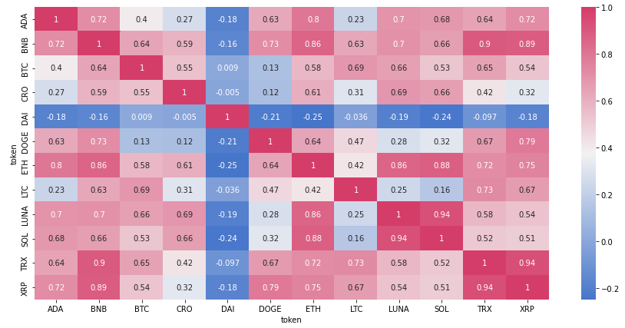

Moving on to the 90 day look back, we see a much more reasonable heatmap. From here, we can make some key observations of the data. Ethereum is highly correlated with a majority of the coins, with the exceptions being Bitcoin(BTC), Cronus(CRO), DAI, Dogecoin(DOGE), and Litecoin(LTC). Bitcoin has no strong correlations with the highest correlation being with Binance Coin(BNB) at 0.64. With the exception of Litecoin(LTC), Ethereum has stronger correlations with all of the coins compared to Bitcoin. Binance coin(BNB) is also a strong performer, with many pairs including the coin being either strong or coming close to strong. There are other strong correlations amongst smaller coins, but the only ones of note are the relations between Ripple(XRP) and Tron(TRX), Solana(SOL) and Terra(LUNA), Binance coin(BNB) and Ripple(XRP), and Binance coin(BNB) and TRON(TRX) as all of these asset pairs have correlations close to 1.

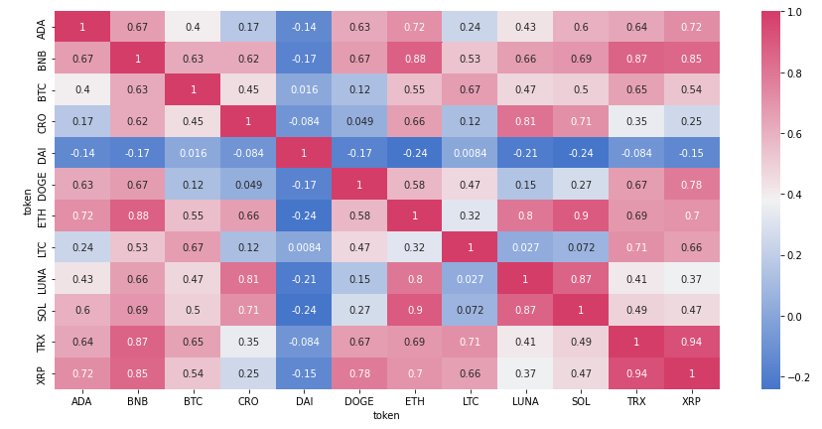

At the 60 day look back, we begin to see more stable correlation patterns in addition to a shift in cryptocurrency preferences. In this heatmap, Ethereum(ETH) has higher correlations with the other coins than Bitcoin(BTC) with the exception of Litecoin(LTC), which is still more correlated with Bitcoin than Ethereum. It appears that the cryptocurrency market is beginning to shift away from Bitcoin to Ethereum as it’s standard coin. This phenomena is something we will be looking for in the coming heatmaps. Binance coin(BNB) still remains strong despite some decreases in correlations, especially with regards to Ripple(XRP) and TRON(TRX). As for the other coins, the correlations are beginning to cool down. The exception to this is the XRP/TRX pair, which are still very highly correlated at 0.94.

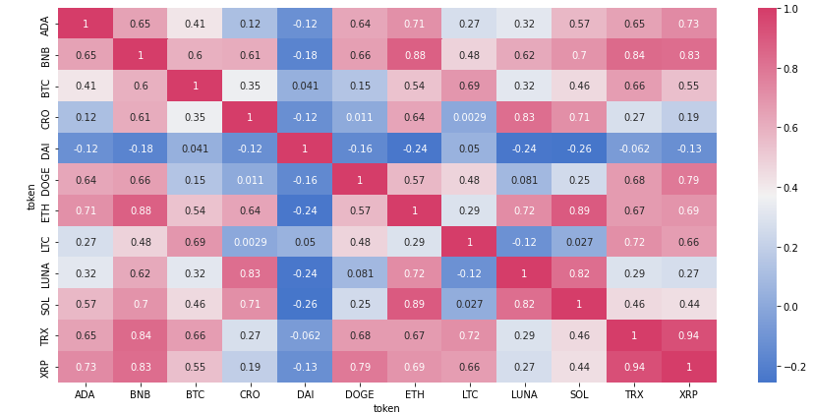

Upon reaching the 30 day look back, we really see the shift in preference towards Ethereum. While Litecoin is still more highly correlated with Bitcoin, the other coins are much more favorable towards Ethereum. With most of the correlations to Ethereum exceeding that of Bitcoin by 0.3 to 0.4, the cryptocurrency market is demonstrating a clear shift towards Ethereum as the coin of preference. Binance Coin(BNB)’s correlations remain the same, however, it is becoming clear that Binance Coin is also overtaking Bitcoin’s market position.

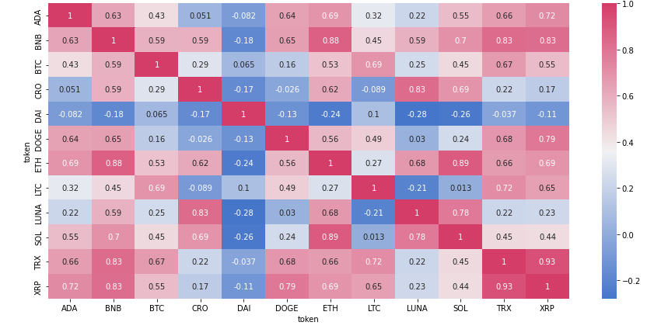

The heat map constructed with all of the observations effectively mirrors the 30-day look back. Ethereum(ETH) and Binance Coin(BNB), having middling to strong correlations with almost all of the other coins. They are both especially strong with regards to smaller coins such as TRON(TRX), Ripple(XRP), and Solana(SOL). Bitcoin(BTC) has only one strong correlation, a 0.69 with Litecoin(LTC), and that’s just on the borderline of what’s considered a strong correlation. Based on the last 3 heatmaps, it is evident that Bitcoin is no longer the standard bearer for cryptocurrency and has been eclipsed by Ethereum and Binance coin as the market leader.

**6. Conclusion:**

Upon utilizing Pearson correlation heatmaps to measure the correlations between various cryptocurrencies with windowed look backs at 365 days, 90 days, 60 days, and 30 days, we conclude that Bitcoin is no longer the market leader in cryptocurrency. Once considered “millennial gold”, Bitcoin’s place in the cryptocurrency landscape has been overtaken by Ethereum and Binance Coin(BNB). Other cryptocurrencies are now moving with these 2 coins and are less driven by the price of Bitcoin. Additionally, as Ethereum is correlated with traditional markets, coins with strong correlations to Ethereum, including and especially Binance Coin, are cross-correlated with these markets. Investors looking into cryptocurrency should invest in Ethereum and Binance or coins with strong correlations to said coins to minimize loss as a result of cryptocurrency based volatility. Additionally, those looking to invest in smaller coins hoping to make windfall profits off the growth should invest in coins with strong correlation to Binance coin, as smaller coins show stronger correlation with Binance in comparison to Ethereum.

**7. Works Cited:**

Zhang, Stephen, and Ganesh Mani. “Popular Cryptoassets (Bitcoin, Ethereum, and Dogecoin), Gold, and Their Relationships: Volatility and Correlation Modeling.” Data Science and Management 4 (2021): 30–39. Web.

Pham, Linh et al. “A Tale of Two Tails Among Carbon Prices, Green and Non-Green Cryptocurrencies.” International review of financial analysis 82 (2022): n. pag. Web.

Cary, Michael. “Down with the #Dogefather: Evidence of a Cryptocurrency Responding in Real Time to a Crypto-Tastemaker.” *Journal of theoretical and applied electronic commerce research* 16.6 (2021): 2230–2240. Web.

Mantha, S.S. “Should The Government Be Worried About Cryptocurrency?” *Business World* (2021): n. pag. Print.

Macheel, Tanya. “Dogecoin Jumps More than 20% after Twitter Agrees to Elon Musk's Buyout Deal.” *CNBC*, CNBC, 25 Apr. 2022, https://www.cnbc.com/2022/04/25/dogecoin-jumps-more-than-20percent-after-twitter-agrees-to-elon-musks-buyout-deal.html.

James, Nick. “Evolutionary Correlation, Regime Switching, Spectral Dynamics and Optimal Trading Strategies for Cryptocurrencies and Equities.” *Physica. D* 434 (2022): n. pag. Web.